NAME : SHRISTY CHAUDHARY
ROLL NO. : 29
UNIVERSITY ROLL No. : 2019498
SECTION : AI & ML
PROBLEM STATEMENT 1 :-
Create an html page named as “: Basic_Html_Tags.html” Add the following tags detail.
1. Set the title of the page as “Basic Html Tags”
2. Within the body perform the following
a) Moving text = “Basic HTML Tags”
b) Different heading tags ( h1 to h6)
c) Paragraph
d) Horizontal line
e) Line Break
f) Block Quote
g) Pre tag
h) Different Logical Style ( <b>, <u>, <sub>, <sup>....)
i) Different Physical style ( <code>, <del>, <kbd>...)
j) Listing tags ( 2 types with, & each type provide different “type” attribute)

CODE :
<!DOCTYPE html>
<html lang="en">
<head>
<title>Basic Html Tags</title>
</head>
<body>
<h3><marquee>Basic HTML Tags</marquee></h3>
<h2 align="center" ><FONT COLOR="red">Heading Tags => font size-18 pt, colourRED</FONT></h2>
<h1 align="center">Heading H1 - 24 pt</h1>
<h2 align="right">Heading h2 - 18 pt</h2>
<h3>Heading h3 - 12 pt bold</h3>
<h4>Heading h4 -12 pt</h4>
<h5>Heading h5 - 10 pt</h5>
<h6>Heading h6 - 7 pt</h6>
<p><font size=7>font size-36 pt,</font> <font size=6>font size-24 pt,</font>
<font size=5>font size-18 pt,</font><font size=4><b>font size-12 pt bold,</b></font>
<font size=3>font size-12 pt plain,</font> <font size=2>font size-9 pt.</font> </p><hr>
<h3 align="center"><FONT COLOR="green">Texting Elements => font size-12 pt, colourGREEN</FONT></h3>
<p>The HyperText Markup Language or HTML is the standard markup language for documents designed to be displayed in a web browser.
It defines the content and structure of web content. It is often assisted by technologies such as Cascading Style Sheets (CSS) and scripting languages such as JavaScript.
Web browsers receive HTML documents from a web server or from local storage and render the documents into multimedia web pages.
HTML describes the structure of a web page semantically and originally included cues for its appearance.
HTML elements are the building blocks of HTML pages. With HTML constructs, images and other objects such as interactive forms
may be embedded into the rendered page. HTML provides a means to create structured documents by denoting structural semantics
for text such as headings, paragraphs, lists, links, quotes, and other items. HTML elements are delineated by tags, written using angle brackets.
</p>
</body>
</html>

OUTPUT :
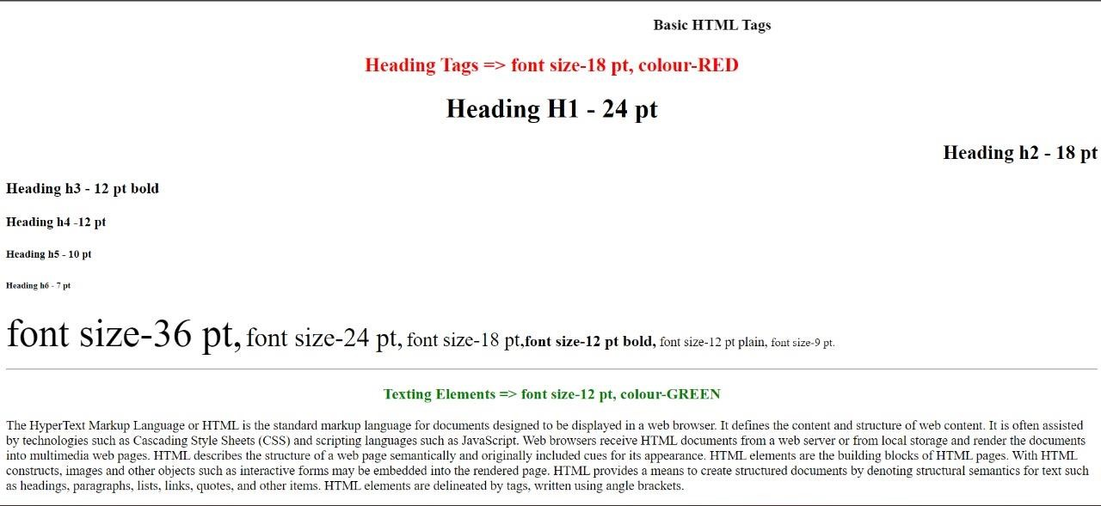

NAME : SHRISTY CHAUDHARY
ROLL NO. : 29
UNIVERSITY ROLL No. : 2019498
SECTION : AI & ML
PROBLEM STATEMENT 2(a) :-
To create a simple html file to demonstrate the use of different List tags.
CODE :
<!DOCTYPE html>
<html lang="en">
<head>
<meta charset="UTF-8">
<meta name="viewport" content="width=device-width, initial-scale=1.0">
<title>Exp:02</title>
</head>
<body>
<h4>Here is a nested ordered list:</h4>
<ol type="I">
<li>Module 1</li>
<li>Module 2</li>
<ol type="i">
<li>Module 2.1</li> <li>Module 2.2</li>
</ol>
<li>Module 3</li>
</ol>

<h4>Disc Bullet Lists</h4>
<ul>
<li>Keyboard</li>
<li>Mouse</li>
<li>Moniter</li>
</ul>
<h4>Circle Bullet List</h4>
<ul type="Circle">
<li>CRT</li>
<li>LCD</li>
<li>LED</li>
</ul>
<h4>Square Bullet List</h4>
<ul type="Square">
<li>Windows</li>
<li>Linux</li>
<li>Android</li>
</ul>
<h4>A Definition List:</h4>
<ul style="list-style-type: none;">
<li>Coffee</li>
<ul style="list-style-type: none;">
<li>Black Coffee OR Milk Coffee</li>
</ul>
<li>Milk</li>
<ul style="list-style-type: none;">
<li>Hot White Milk OR Cold Chocolate Milk</li>
</ul>
</ul>
</body>
</html>
OUTPUT :
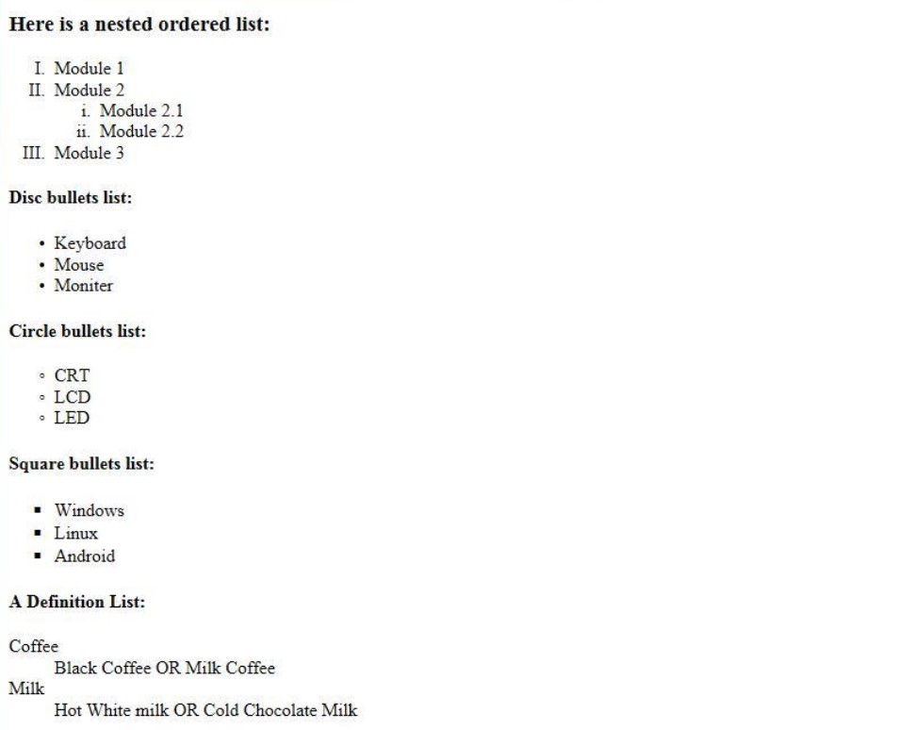

PROBLEM STATEMENT 2(b) :-
To create a simple html file to demonstrate the use of different Table tags.
CODE :
<!DOCTYPE html>
<html lang="en">
<head>
<meta charset="UTF-8">
<meta name="viewport" content="width=device-width, initial-scale=1.0"> <title>Time Table</title>
</head>
<body>
<b><center><h3>
Government Polytechnic College<br>
DEPARTMENT OF Computer Engineering<br>
EFFECTIVE FROM: 01-07-2016<br></center></b></h3>
<table border="2" width="75%" cellspacing="2" cellpadding="25" align=center>
<h3>
<caption align=left>Semester 5 CT
&nbsp;&nbsp;&nbsp;&nbsp;&nbsp;&nbsp;&nbsp;&nbsp;&nbsp;&nbsp;&nbsp;&nbsp;

R.No:306
</caption>
</h3>
<thead>
<tr>
<th bgcolor="gold">Periods</th>
<th ROWSPAN=2 bgcolor="pink">1 <br>09.00 - 09.55</th>
<th ROWSPAN=2 bgcolor="pink">2<br>09.55-10.50</th>
<th ROWSPAN=2 bgcolor="pink">3<br>11.00-11.55</th>
<th ROWSPAN=2 bgcolor="pink">4<br>11.55-01.00</th>
<th ROWSPAN=2 bgcolor="pink">5<br>02.00-02.50</th>
<th ROWSPAN=2 bgcolor="pink">6<br>02.55-03.45</th>
<th ROWSPAN=2 bgcolor="pink">7<br>03.45-04.30</th>
</tr>
<tr bgcolor="coper"><th> Days</th>
</thead>
<tbody>
<tr>
<th bgcolor="silver">Monday</th>
<td>IT0302</td>
<td>IT0306</td>
<td>IT0304</td>
<td>IT0306</td>
<td>IT0302</td>
<td COLSPAN=2><center>IT0324</td>
</tr>
<tr>
<th bgcolor="silver">TuesDay</th>
<td COLSPAN =4 bgcolor="cyan"><center>IT0320/IT0322</td>
<td bgcolor="bras">IT0310</td>
<td>IT0304</td>
<td>IT308</td>
</tr>
<tr>
<th bgcolor="silver">Wednesday</th>
<td COLSPAN =2 bgcolor="yellow"><center>ELETIVE - I</td>
<td>IT0306</td>
<td>IT310</td>
<td>IT304</td>
<td>IT308</td>
<td>COUN</td>
</tr>
<tr>
<th bgcolor="silver">Thursday</th>
<td>IT302</td>
<td>IT0304</td>
<td COLSPAN=2><center>PD0302</td>
<td COLSPAN=3 bgcolor="green"><center>IT0320/IT0322</td>
</tr>
<tr>
<th bgcolor="silver">Friday</th>
<td>IT0308</td>
<td>IT0306</td>
<td>IT0308</td>
<td>IT0302</td>
<td COLSPAN=2 bgcolor="red"><center>ELECTIVE - I</td>
<td></td>
</tr>
</tbody>
</table>
</body>
</html>
OUTPUT :
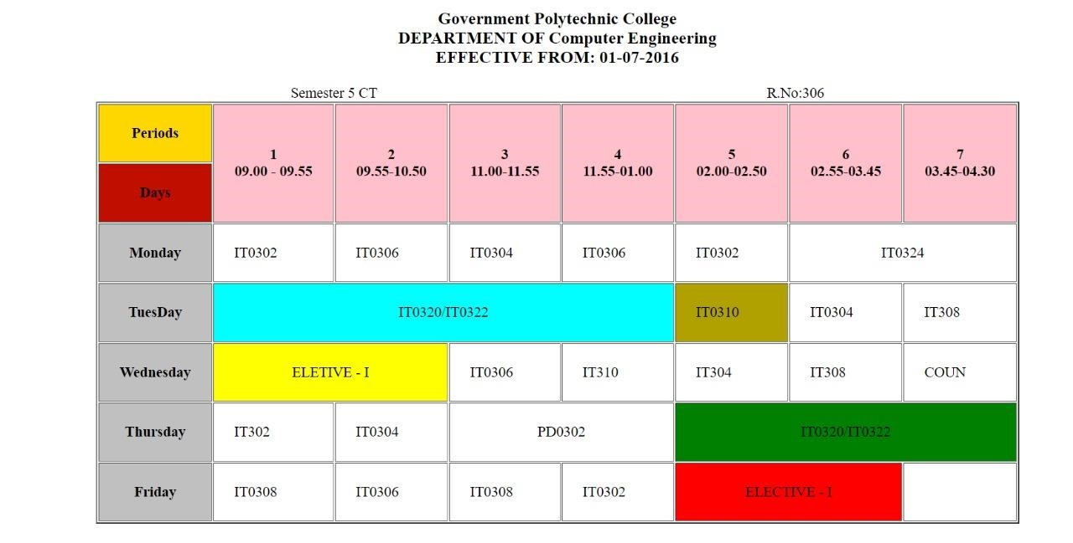

NAME : SHRISTY CHAUDHARY
ROLL NO. : 29
UNIVERSITY ROLL No. : 2019498
SECTION : AI & ML
PROBLEM STATEMENT 3 :-
To create a entry form by simple html file to demonstrate the use of different tags.
CODE :
<!DOCTYPE html>
<html lang="en">
<head>
<meta charset="UTF-8">
<meta name="viewport" content="width=device-width, initial-scale=1.0">
<title>Registration Form Sample</title>
</head>
<body bgcolor="lightblue" text="red">
<p align="center"><font size="7"><b>Entry Form</b></font></p>
<form>
<font size="5">Enter Your Name: &nbsp; &nbsp; &nbsp; &nbsp; &nbsp;<input type="text" name="name" maxlength="30" size="15"></font>
<br><br>
<font size="5">Enter Your Age: &nbsp; &nbsp; &nbsp; &nbsp; &nbsp; &nbsp;&nbsp;<input type="text" name="age" size="3"></font>
<br><br>
<font size="5">Enter Your Address: &nbsp; &nbsp;&nbsp;&nbsp;<textarea name="address" rows="5" cols="15"></textarea></font>
<br><br>
<font size="5">Sex:
<font size="3">
&nbsp; &nbsp; &nbsp; &nbsp; &nbsp; &nbsp; &nbsp; &nbsp; &nbsp; &nbsp; &nbsp;
<input type="radio" name="sex" value="female" checked> Female <br> &nbsp; &nbsp;
&nbsp; &nbsp;&nbsp; &nbsp;&nbsp;&nbsp; &nbsp;&nbsp;
<input type="radio" name="sex" value="male"> Male
</font>
</font>
<br><br>
<font size="5">Nationality:
&nbsp; &nbsp; &nbsp; &nbsp; &nbsp;&nbsp; &nbsp; &nbsp;&nbsp;&nbsp;
<select name="country">
<option selected="" value="Default">(Please select a country)</option>
<option value="india">INDIA
<option value="america">AMERICA
<option value="australia">AUSTRALIA
<option value="new zealand">NEW ZEALAND
<option value="china">CHINA
</select>
</font>
<br><br>
<font size="5">Languages Known:
<font size="3">
&nbsp; &nbsp; &nbsp; &nbsp; &nbsp; (can select more than one) <br> &nbsp; &nbsp;
<input type="checkbox" name="c" checked>C <br> &nbsp; &nbsp; &nbsp; &nbsp; &nbsp; &nbsp; &nbsp; &nbsp;
<input type="checkbox" name="c++">C++ <br> &nbsp; &nbsp; &nbsp; &nbsp; &nbsp;
<input type="checkbox" name="vb">VB <br> &nbsp; &nbsp; &nbsp; &nbsp; &nbsp;
<input type="checkbox" name="java">JAVA <br> &nbsp; &nbsp; &nbsp; &nbsp; &nbsp;
<input type="checkbox" name="asp">ASP <br> &nbsp; &nbsp; &nbsp; &nbsp; &nbsp;
<input type="checkbox" name="others">OTHERS <br> &nbsp; &nbsp; &nbsp; &nbsp;
</font>
</font>
<br><br>
<font size="5">Enter Your Password: &nbsp; &nbsp;<input type="password" name="password"</font>
<br><br>
<input type="reset" name="reset"><input type="submit" name="submit"> </form>
</body>
</html>
OUTPUT :
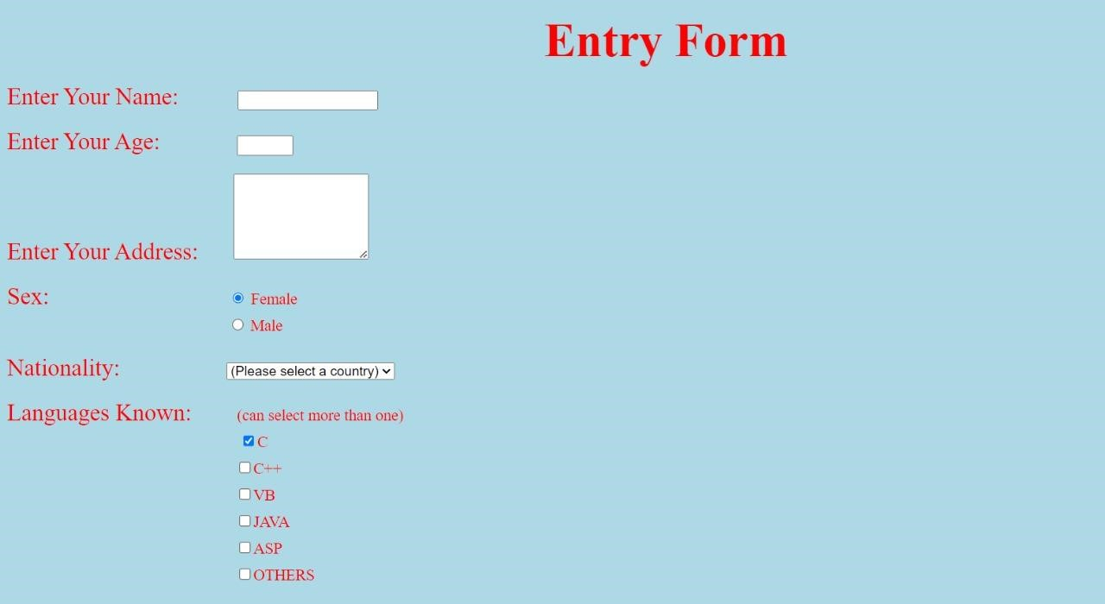

NAME : SHRISTY CHAUDHARY
ROLL NO. : 29
UNIVERSITY ROLL No. : 2019498
SECTION : AI & ML
PROBLEM STATEMENT 4(a) :-
To create an html page with different types of frames such as floating frame, navigation frame & mixed frame.
CODE :
<!DOCTYPE html>
<html lang="en">
<head>
<meta charset="UTF-8">
<meta name="viewport" content="width=device-width, initial-scale=1.0">
<title>Framing Tags</title>
</head>
<frameset cols="20%,80%">
<frame src="merge.html" name="merge">
<frame src="main.html" name="main">
</frameset>
</html>

<!DOCTYPE html>
<html lang="en">
<head>
<meta charset="UTF-8">
<meta name="viewport" content="width=device-width, initial-scale=1.0">
<title>Merge</title>
</head>
<body>
<a href="navigationframes.html" target="main" >Navigation Frame</a>
<hr>
<a href="floatingframes.html" target="main" >Floating Frame</a>
<hr>
<a href="mixedframe.html" target="main" >Mixed Frame</a>
<hr>
</body>
</html>
<!DOCTYPE html>
<html lang="en">
<head>
<meta charset="UTF-8">
<meta name="viewport" content="width=device-width, initial-scale=1.0">
<title>Navigation Frame</title>
</head>
<frameset cols="40%,60%">
<frame src="Experiment1.html" name="Forms">
</frameset>
</html>

<!DOCTYPE html>
<html lang="en">
<head>
<meta charset="UTF-8">
<meta name="viewport" content="width=device-width, initial-scale=1.0">
<title>Floating Frames</title>
</head>
<body>
<p>Floating frames, also known as floating iframes, were used in older versions of HTML to create independent, movable frames
on a webpage. However, the use of frames, including floating frames, has been largely deprecated in modern web development
due to concerns related to accessibility, SEO, and usability. Instead, developers are encouraged to use more modern layout
techniques, such as CSS Flexbox or Grid.
</p>
<a href="Experiment3.html">Forms</a>
</body>
</html>

<!DOCTYPE html>
<html lang="en">
<head>
<meta charset="UTF-8">
<meta name="viewport" content="width=device-width, initial-scale=1.0">
<title>Mixed Frame</title>
</head>
<frameset rows="200,*">
<frame src="image.html" name="image">
</frameset>
</html>

<!DOCTYPE html>
<html lang="en">
<head>
<meta charset="UTF-8">
<meta name="viewport" content="width=device-width, initial-scale=1.0"> <title>Image</title>
</head>
<body>
<img src="https://play-lh.googleusercontent.com/1-
hPxafOxdYpYZEOKzNIkSP43HXCNftVJVttoo4ucl7rsMASXW3Xr6GlXURCubE1tA=w3840-h2160-rw" width="200" height="200">
</body>
</html>
OUTPUT :
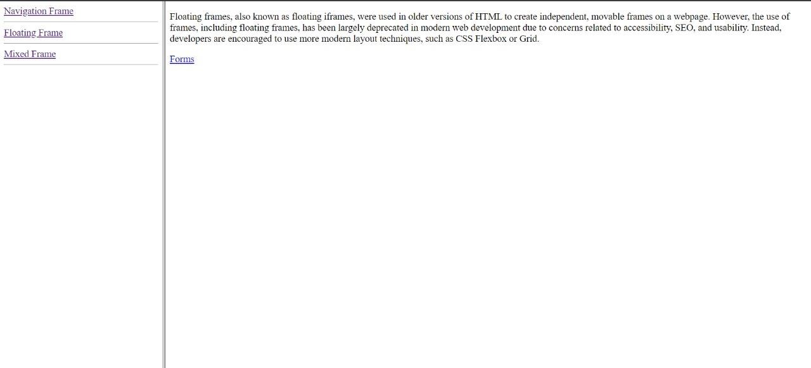

NAME : SHRISTY CHAUDHARY
ROLL NO. : 29
UNIVERSITY ROLL No. : 2019498
SECTION : AI & ML
PROBLEM STATEMENT 4(b) :-
To create an html page with iFrames.
CODE :
<!DOCTYPE html>
<html lang="en">
<head>
<meta charset="UTF-8">
<meta name="viewport" content="width=device-width, initial-scale=1.0"> <title>Iframes</title>
</head>
<body>
<h1>HTML Iframes Demo</h1>
<p>Here we are showing example of Iframe which containing specific Height and width in pixel format.</p>
<iframe src="IframesDemo.html" style="height:200px;width:300px;" title="IframeDemo"></iframe>
</body>
</html>
<!DOCTYPE html>
<html lang="en">
<head>
<meta charset="UTF-8">
<meta name="viewport" content="width=device-width, initial-scale=1.0">
<title>Iframe Demo</title>
</head>
<body>
<p>Presented BY Narendra <br> Modi. <br>
Visit us at: Delhi <br> primeminister.com <br>
Box 104, Red Fort <br>
Delhi <br>
</p>
</body>
</html>
OUTPUT :
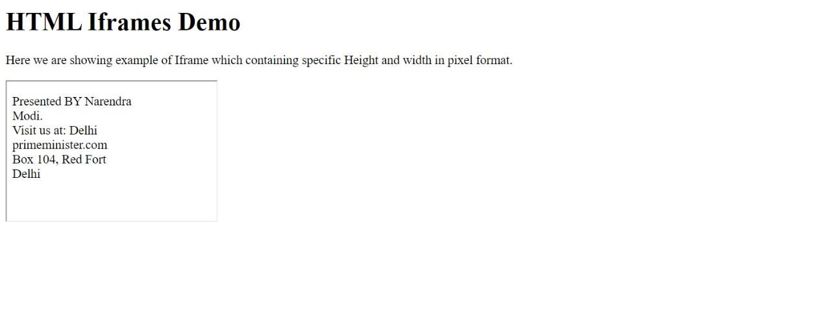

NAME : SHRISTY CHAUDHARY
ROLL NO. : 29
UNIVERSITY ROLL No. : 2019498
SECTION : AI & ML
PROBLEM STATEMENT 5 :-
To display an image on the website and construct a map for all circle buttons, develop the "dialler.html" HTML page. When you click on a circle, a message with a button number, such as "you push button 1," will appear.
CODE :
<!DOCTYPE html>
<html lang="en">
<head>
<meta charset="UTF-8">
<meta name="viewport" content="width=device-width, initial-scale=1.0">
<title>Map</title>
</head>
<body>
<img src="Dial.png" usemap="#workmap">
<map name="workmap">
<area shape="circle" coords="70, 70, 40" href="1.html">
<area shape="circle" coords="175, 70, 40" href="2.html">
<area shape="circle" coords="266, 70, 40" href="3.html">
<area shape="circle" coords="70, 171, 40" href="4.html">
<area shape="circle" coords="175, 171, 40" href="5.html">
<area shape="circle" coords="266, 171, 40" href="6.html">
<area shape="circle" coords="70, 281, 40" href="7.html">
<area shape="circle" coords="175, 281, 40" href="8.html">
<area shape="circle" coords="266, 281, 40" href="9.html"> <area shape="circle" coords="175, 389, 40" href="0.html">
</map>
</body>
</html>

<!DOCTYPE html>
<html lang="en">
<head>
<meta charset="UTF-8">
<meta name="viewport" content="width=device-width, initial-scale=1.0"> <title>0</title>
</head>
<body>
<p>You push button 0</p> //Make 1-9 in same way
</body>
</html>
OUTPUT :
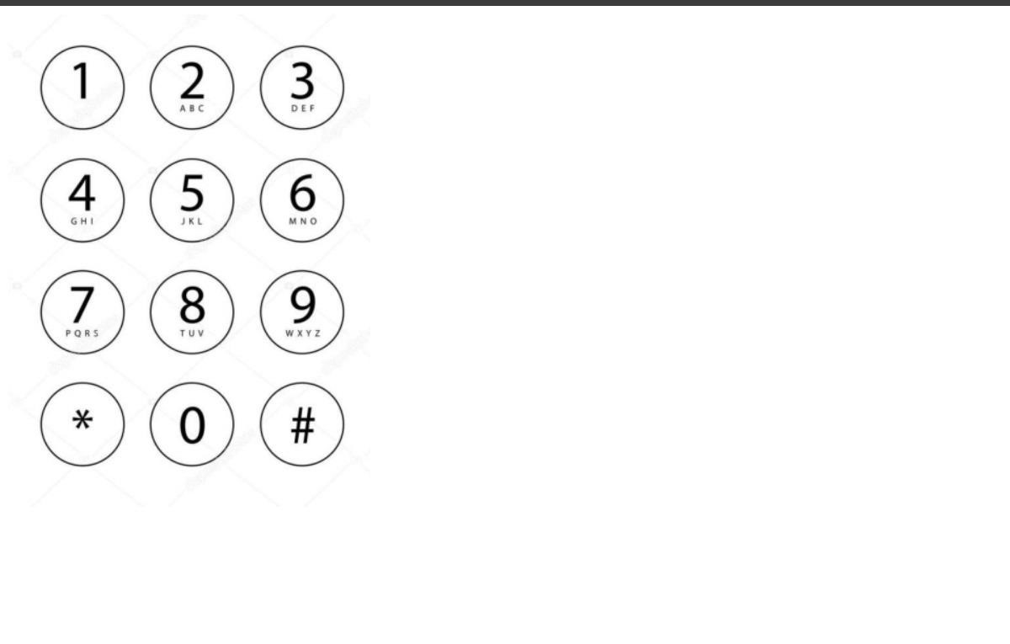

NAME : SHRISTY CHAUDHARY
ROLL NO. : 29
UNIVERSITY ROLL No. : 2019498
SECTION : AI & ML
PROBLEM STATEMENT 6 :-
To create an html file by applying the different styles using inline, external & internal style sheets.
CODE :
<!DOCTYPE html>
<html lang="en">
<head>
<meta charset="UTF-8">
<meta name="viewport" content="width=device-width, initial-scale=1.0">
<title>Experiment 6.1</title>
<style> .mydiv{ padding: 2%; background-color: yellow; text-align: center; color: green; border-style: solid; border-width: 5px; border-color: red;
}
.mydiv1 { overflow: hidden;
}
.mydiv1 a {

float: left; display: block; color: violet;
padding: 14px 150px; text-decoration: none;
}
.mydiv2{ background-color: violet; color: darkmagenta; border-style: dotted; border-width: 5px; border-color: darkmagenta;
} p{
color: darkmagenta;
}
.mydiv3{ padding: 1%; background-color: lightgreen; color: red;
border-style: dashed; border-width: 5px; border-color: blue;
}
.mydiv3 b { font-size: 35px;
}
</style>
</head>
<body>
<div class="mydiv">
<h1>This Is My Stylish Website.</h1>
</div>
<br><br>
<div class="mydiv1">
<a href="#">Home</a>
<a href="#">Backgrounds</a>
<a href="#">Lists</a>
<a href="#">Id vs. Class</a>
</div>
<br><br>
<div class="mydiv2">
<h2>This website is about me!</h2>
</div>
<br><br>
<p><b>My Top Three Favourite Things To Do</b></p>
<br><br>
<div class="mydiv3">
<ol>
<li><b>T</b>ravel</li>
<br>
<li><b>E</b>at ice cream</li>
<br>
<li><b>R</b>ead a book</li>
</ol>
</div>
</body>
</html>
OUTPUT :
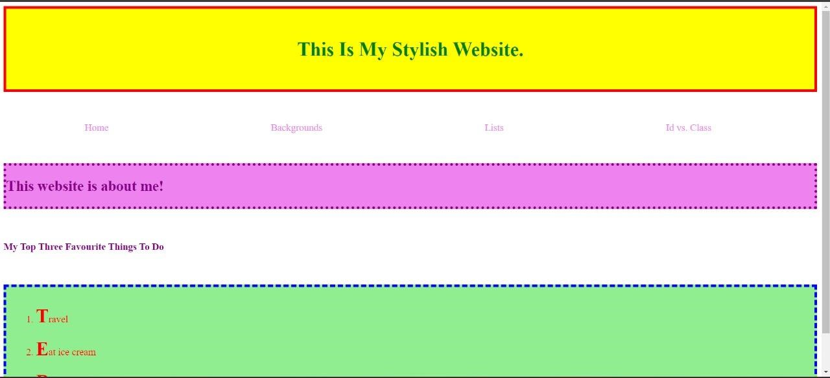

NAME : SHRISTY CHAUDHARY
ROLL NO. : 29
UNIVERSITY ROLL No. : 2019498
SECTION : AI & ML
PROBLEM STATEMENT 7 :-
To create an html file by applying the different styles using inline, external & internal style sheets.
CODE :
<!DOCTYPE html>
<html lang="en">
<head>
<meta charset="UTF-8">
<meta http-equiv="X-UA-Compatible" content="IE=edge">
<meta name="viewport" content="width=device-width, initial-scale=1.0">
<title>Experiment 6.2</title>
<style>
.mydiv{ padding: 0%; background-color: rgb(97, 97, 97); border-style: solid; border-width: 5px; border-color: black;
}
</style>
</head>

<frameset rows="15%,70%,15%" border="0">

<frame src="header.html" name="merge"></frame>

<frameset cols="25%,75%">
<frame src="left_main.html" name="merge3" ></frame>
<frame src="right_main.html" name="merge4" class="mydiv"></frame>
</frameset>

<frame src="footer.html" name="merge2"></frame>

</frameset>

<body>
</body>
</html>

<!DOCTYPE html>
<html lang="en">
<head>
<meta charset="UTF-8">
<meta http-equiv="X-UA-Compatible" content="IE=edge">
<meta name="viewport" content="width=device-width, initial-scale=1.0">
<title>Header</title>
<style> .mydiv{ padding: 0%; background-color: rgb(255, 182, 47);
color: blue; border-style: solid; border-width: 3px; border-color: black;
}
</style>
</head>
<body>
<div class="mydiv">
<h1>header</h1>
</div>
</body>
</html>

<!DOCTYPE html>
<html lang="en">
<head>
<meta charset="UTF-8">
<meta http-equiv="X-UA-Compatible" content="IE=edge">
<meta name="viewport" content="width=device-width, initial-scale=1.0">
<title>Left Main</title>
<style> .mydiv{ padding: 0%; background-color: rgb(255, 182, 47); color: blue; border-style: solid; border-width: 5px; border-color: black;
}
</style>
</head>
<body>
<div class="mydiv">
<h1>menu</h1>
<br><br><br><br><br><br><br><br><br><br><br><br><br><br><br><br><br><br><br>
</div>
</body>
</html>

<!DOCTYPE html>
<html lang="en">
<head>
<meta charset="UTF-8">
<meta http-equiv="X-UA-Compatible" content="IE=edge">
<meta name="viewport" content="width=device-width, initial-scale=1.0">
<title>Right Main</title>
<style> .mydiv{ padding: 0%; background-color: rgb(255, 182, 47); text-align: center; color: black; border-style: solid; border-width: 5px; border-color: black;
}
</style>
</head>
<frameset rows="25%,75%" border="0">
<frame src="smallbox.html" name="smallbox" class="mydiv"></frame>
<frame src="bigbox.html" name="bigbox"></frame>
</frameset>
<body>
</body>
</html>

<!DOCTYPE html>
<html lang="en">
<head>
<meta charset="UTF-8">
<meta http-equiv="X-UA-Compatible" content="IE=edge">
<meta name="viewport" content="width=device-width, initial-scale=1.0">
<title>Small Box</title>
</head>
<frameset cols="25%,25%,25%,25%" border="0">
<frame src="tool1.html" name="tool1">
<frame src="tool2.html" name="tool2">
<frame src="tool3.html" name="tool3">
<frame src="text.html" name="text">
</frameset>
<body>
</body>
</html>

<!DOCTYPE html>
<html lang="en">
<head>
<meta charset="UTF-8">
<meta name="viewport" content="width=device-width, initial-scale=1.0">
<title>Tool 1</title>
<style>
.mydiv{
padding: 0%;
background-color: rgb(50, 254, 235);
text-align: center;
border-style: solid;
border-width: 5px;
border-color: black;
}
</style>
</head>
<body>
<div class="mydiv"> tool1 //Same For tool2 and tool3
</div>
</body> </html>
<!DOCTYPE html>
<html lang="en">
<head>
<meta charset="UTF-8">
<meta http-equiv="X-UA-Compatible" content="IE=edge">
<meta name="viewport" content="width=device-width, initial-scale=1.0">
<title>Big Box</title>
<style>
.mydiv{
padding: 0%;
background-color: rgb(50, 254, 235); text-align: center;
border-style: solid;
border-width: 5px;
border-color: black;
} p{
position:absolute;
top: 50%;
left: 50%;
transform: translateX(-50%);
}
</style>
</head>
<body>
<div class="mydiv">
<p>map (through mapstraction if that matters)</p>
<br><br><br><br><br><br><br><br><br><br><br><br><br><br><br><br><br>
</div>
</body>
</html>

<!DOCTYPE html>
<html lang="en">
<head>
<meta charset="UTF-8">
<meta http-equiv="X-UA-Compatible" content="IE=edge">
<meta name="viewport" content="width=device-width, initial-scale=1.0">
<title>Footer</title>
<style> .mydiv{ padding: 0%; background-color: rgb(255, 182, 47);
color: blue; border-style: solid; border-width: 3px; border-color: black;
}
</style>
</head>
<body>
<div class="mydiv">
<h1>footer</h1>
</div>
</body>
</html>

OUTPUT :
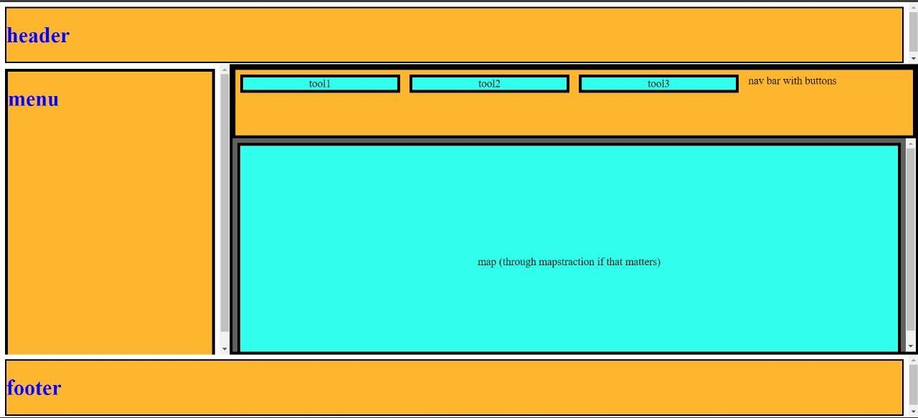

NAME : SHRISTY CHAUDHARY
ROLL NO. : 29
UNIVERSITY ROLL No. : 2019498
SECTION : AI & ML
PROBLEM STATEMENT 8 :-
To create an html file by applying the different styles using inline, external & internal style sheets.
CODE :
<!DOCTYPE html>
<html lang="en">
<head>
<meta charset="UTF-8">
<meta name="viewport" content="width=device-width, initial-scale=1.0">
<title>Experiment 6.3</title>
<style>
.mydiv{ background-color: pink;
}
</style>
</head>
<frameset rows="100%" border="0">
<frame src="maincode.html" name="maincode" class="mydiv">
</frameset>
<body>
</body>
</html>

<!DOCTYPE html>
<html lang="en">
<head>
<meta charset="UTF-8">
<meta http-equiv="X-UA-Compatible" content="IE=edge">
<meta name="viewport" content="width=device-width, initial-scale=1.0">
<title>Main Code</title>
<style> .mydiv1{ padding: 0%; background-color: rgb(233, 107, 128);
color: white; border-style: solid; border-width: 0px;
}
</style>
</head>
<frameset rows="15%,70%,15%" border="0">
<frame src="header.html" name="merge"></frame>
<frameset cols="25%,75%">
<frame src="left_main.html" name="merge3" ></frame>
<frame src="right_main.html" name="merge4" class="mydiv1"></frame>
</frameset>
<frame src="footer.html" name="merge2"></frame>
</frameset>
<body>
</body>
</html>

<!DOCTYPE html>
<html lang="en">
<head>
<meta charset="UTF-8">
<meta http-equiv="X-UA-Compatible" content="IE=edge">
<meta name="viewport" content="width=device-width, initial-scale=1.0">
<title>Header</title>
<style> .mydiv{ padding: 0.2%; background-color: rgb(47, 203, 255); text-align: center;
color: white; border-style: solid; border-width: 0px;
}
</style>
</head>
<body>
<div class="mydiv">
<h1>Header</h1>
</div>
</body>
</html>

<!DOCTYPE html>
<html lang="en">
<head>
<meta charset="UTF-8">
<meta http-equiv="X-UA-Compatible" content="IE=edge">
<meta name="viewport" content="width=device-width, initial-scale=1.0">
<title>Left Main</title>
<style> .mydiv{ padding: 5.5%; background-color: rgb(16, 144, 204);
text-align: center; color: white; border-style: solid; border-width: 0px;
}
</style>
</head>
<body>
<div class="mydiv">
<h1>Aside</h1>
<br><br><br><br><br><br><br><br><br><br><br><br><br><br><br><br><br>
</div>
</body>
</html>

<!DOCTYPE html>
<html lang="en">
<head>
<meta charset="UTF-8">
<meta http-equiv="X-UA-Compatible" content="IE=edge">
<meta name="viewport" content="width=device-width, initial-scale=1.0">
<title>Right Main</title>
</head>
<frameset rows="33%,33%,33%" border="0">
<frame>
<frame src="text.html" name="text">
<frameset cols="33%,33%,33%" border="0">
<frame src="image1.html" name="image1"></frame>
<frame src="image2.html" name="image2"></frame> <frame src="image3.html" name="image3"></frame>
</frameset>
</frameset>
<body>
</body>
</html>

<!DOCTYPE html>
<html lang="en">
<head>
<meta charset="UTF-8">
<meta name="viewport" content="width=device-width, initial-scale=1.0">
<title>Image 1</title> // Same Code For Image 2 and Image 3
<style> .mydiv{ padding: 15%; background-color: rgb(195, 187, 187);
color: white; text-align: center; font-size: 30px;
}
</style>
</head>
<body>
<div class="mydiv">
Image
</div>
</body>
</html>

<!DOCTYPE html>
<html lang="en">
<head>
<meta charset="UTF-8">
<meta http-equiv="X-UA-Compatible" content="IE=edge">
<meta name="viewport" content="width=device-width, initial-scale=1.0">
<title>Footer</title>
<style> .mydiv{ padding: 0.2%; background-color: rgb(47, 203, 255);
text-align: center; color: white; border-style: solid; border-width: 0px;
}
</style>
</head>
<body>
<div class="mydiv">
<h1>Footer</h1>
</div>
</body>
</html>
OUTPUT :
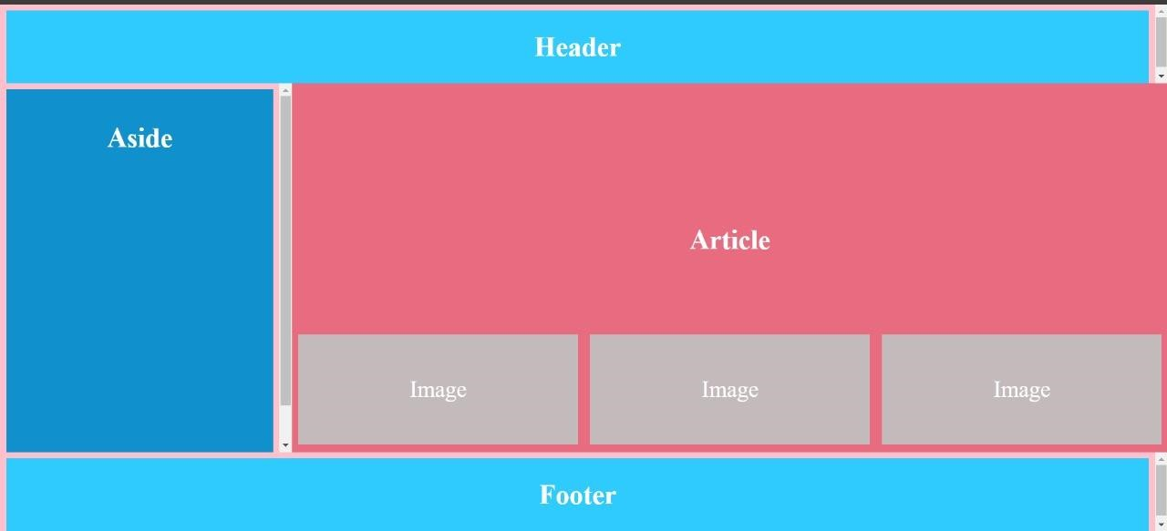

NAME : SHRISTY CHAUDHARY
ROLL NO. : 29
UNIVERSITY ROLL No. : 2019498
SECTION : AI & ML
PROBLEM STATEMENT 9 :-
To create an HTML page to explain input and output using a calculator with the use of
various predefined functions and objects in Javascript.
CODE :
<!DOCTYPE html>
<html>

<head>
<title>JavaScript Calculator</title>
<script src=
"https://cdnjs.cloudflare.com/ajax/libs/mathjs/10.6.4/math.js"
integrity=
"sha512-BbVEDjbqdN3Eow8+empLMrJlxXRj5nEitiCAK5A1pUr66+jLVejo3PmjIaucRnjlB0P9R3rBUs3g5jXc8ti+fQ=="
crossorigin="anonymous"
referrerpolicy="no-referrer"></script>
<script src=
"https://cdnjs.cloudflare.com/ajax/libs/mathjs/10.6.4/math.min.js"
integrity=
"sha512-iphNRh6dPbeuPGIrQbCdbBF/qcqadKWLa35YPVfMZMHBSI6PLJh1om2xCTWhpVpmUyb4IvVS9iYnnYMkleVXLA=="
crossorigin="anonymous"
referrerpolicy="no-referrer"></script>

<!-- For styling -->
<style>
table {
border: 1px solid black;
margin-left: auto;
margin-right: auto;
}

input[type="button"] {
width: 100%;
padding: 20px 40px;
background-color: green;
color: white;
font-size: 24px;
font-weight: bold;
border: none;
border-radius: 5px;
}

input[type="text"] {
padding: 20px 30px;
font-size: 24px;
font-weight: bold;
border: none;
border-radius: 5px;
border: 2px solid black;
}
</style>
</head>

<body>

<!-- Use Table to Create Calculator Structure Design -->
<table id="calcu">
<tr>
<td colspan="3"><input type="text" id="result"></td>
<td><input type="button" value="c" onclick="clr()" /> </td>
</tr>
<tr>
<td><input type="button" value="1" onclick="dis('1')"
onkeydown="myFunction(event)"> </td>
<td><input type="button" value="2" onclick="dis('2')"
onkeydown="myFunction(event)"> </td>
<td><input type="button" value="3" onclick="dis('3')"
onkeydown="myFunction(event)"> </td>
<td><input type="button" value="/" onclick="dis('/')"
onkeydown="myFunction(event)"> </td>
</tr>
<tr>
<td><input type="button" value="4" onclick="dis('4')"
onkeydown="myFunction(event)"> </td>
<td><input type="button" value="5" onclick="dis('5')"
onkeydown="myFunction(event)"> </td>
<td><input type="button" value="6" onclick="dis('6')"
onkeydown="myFunction(event)"> </td>
<td><input type="button" value="*" onclick="dis('*')"
onkeydown="myFunction(event)"> </td>
</tr>
<tr>
<td><input type="button" value="7" onclick="dis('7')"
onkeydown="myFunction(event)"> </td>
<td><input type="button" value="8" onclick="dis('8')"
onkeydown="myFunction(event)"> </td>
<td><input type="button" value="9" onclick="dis('9')"
onkeydown="myFunction(event)"> </td>
<td><input type="button" value="-" onclick="dis('-')"
onkeydown="myFunction(event)"> </td>
</tr>
<tr>
<td><input type="button" value="0" onclick="dis('0')"
onkeydown="myFunction(event)"> </td>
<td><input type="button" value="." onclick="dis('.')"
onkeydown="myFunction(event)"> </td>

<!-- solve function call function solve to evaluate value -->
<td><input type="button" value="=" onclick="solve()"> </td>

<td><input type="button" value="+" onclick="dis('+')"
onkeydown="myFunction(event)"> </td>
</tr>
</table>

<script>

// Function that display value
function dis(val) {
document.getElementById("result").value += val
}

function myFunction(event) {
if (event.key == '0' || event.key == '1'
|| event.key == '2' || event.key == '3'
|| event.key == '4' || event.key == '5'
|| event.key == '6' || event.key == '7'
|| event.key == '8' || event.key == '9'
|| event.key == '+' || event.key == '-'
|| event.key == '*' || event.key == '/')
document.getElementById("result").value += event.key;
}

var cal = document.getElementById("calcu");
cal.onkeyup = function (event) {
if (event.keyCode === 13) {
console.log("Enter");
let x = document.getElementById("result").value
console.log(x);
solve();
}
}

// Function that evaluates the digit and return result
function solve() {
let x = document.getElementById("result").value
let y = math.evaluate(x)
document.getElementById("result").value = y
}

// Function that clear the display
function clr() {
document.getElementById("result").value = ""
}
</script>
</body>

</html>
OUTPUT :
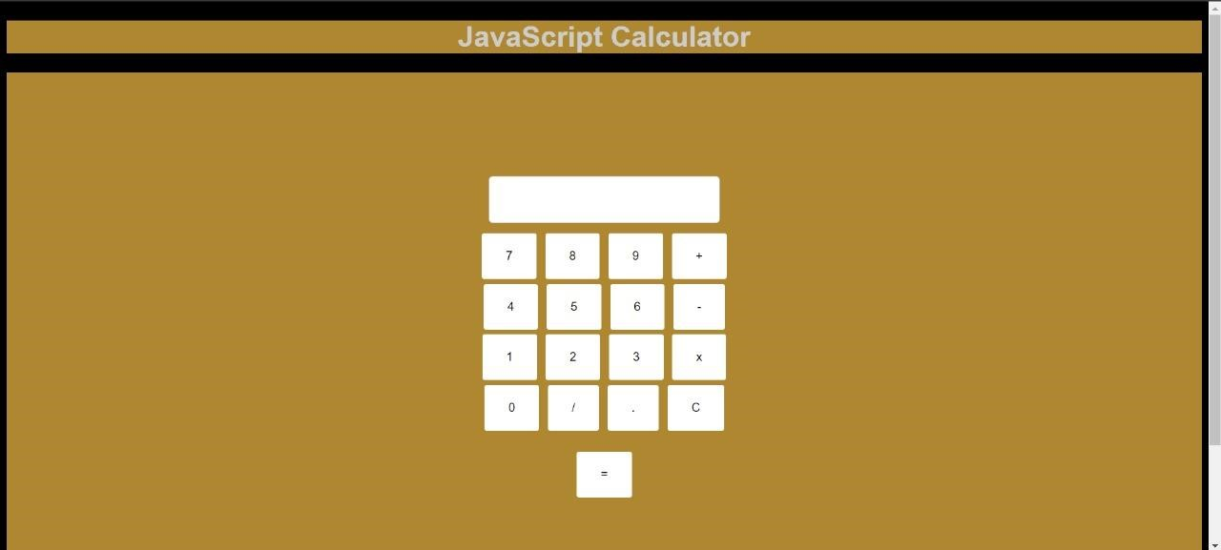

NAME : SHRISTY CHAUDHARY
ROLL NO. : 29
UNIVERSITY ROLL No. : 2019498
SECTION : AI & ML
PROBLEM STATEMENT 10 :-
To create an HTML page to explain input and output using a scientific
calculator with the use of various predefined functions and objects in Javascript.
CODE :
<!DOCTYPE html>
<html lang="en">
<head>
<meta charset="UTF-8">
<meta name="viewport" content="width=device-width, initial-scale=1.0">
<title>Experiment 10</title>
<style> body { font-family: 'Times New Roman';
text-align: center;
}
#calculator { width: auto; margin: auto; border: 1px solid #ccc; padding: 130px; background-color:#b91111;
border: solid; border-color: black;
}
input[type="text"] { width: calc(100% - 20px); margin-bottom: 10px; padding: 5px; border: 1px solid #ccc; border-radius: 3px;
}
button {
/* height: 3px;
width: 3px; */
padding: 20px 30px; margin: 3px;
background-color:rgb(192, 189, 189); border: none; color: black; border-radius: 3px; cursor: pointer;
}
/* button: {
background-color: #d63385;
} */
button:hover { background-color: #ffa13d;
}
#inputField{ background-color: greenyellow;
width: 33%; padding: 20px; border-radius: 5px;
}
</style>
</head>
<body>
<div id="calculator">
<h1>SIMPLE SCIENTIFIC CALCULATOR</h1>
<input type="text" id="inputField" readonly><br>
<button onclick="appendToInput('1')">1</button>
<button onclick="appendToInput('2')">2</button>
<button onclick="appendToInput('3')">3</button>
<button onclick="clearInput()" name="C">C</button> <button onclick="BACKSPC()"><-</button>
<button onclick="calculate()">=</button><br>
<button onclick="appendToInput('4')">4</button>
<button onclick="appendToInput('5')">5</button>
<button onclick="appendToInput('6')">6</button>
<button onclick="appendToInput('-')">-</button>
<button onclick="appendToInput('%')">%</button>
<button onclick="cos()">cos</button><br>
<button onclick="appendToInput('7')">7</button>
<button onclick="appendToInput('8')">8</button>
<button onclick="appendToInput('9')">9</button> <button onclick="appendToInput('*')">*</button>
<button onclick="fact()">n!</button>
<button onclick="sin()">sin</button><br>
<button onclick="appendToInput('.')">.</button>
<button onclick="appendToInput('0')">0</button> <button onclick="appendToInput(',')">,</button>
<button onclick="appendToInput('+')">+</button>
<button onclick="appendToInput('/')">/</button>
<button onclick="tan()">tan</button><br>
<button onclick="E()">E</button>
<button onclick="pi()">pi</button>
<button onclick="xpowy()">x^y</button>
<button onclick="appendToInput('(')">(</button>
<button onclick="appendToInput(')')">)</button>
<button onclick="log()">log</button><br>
<button onclick="sqrt2()">sqrt</button>
<button onclick="LN2()">LN2</button>
<button onclick="LN10()">LN10</button>
<button onclick="log2E()">log2E</button>
<button onclick="log10E()">log10E</button> <button onclick="EXP()">EXP</button>
</div> <script> function fact()
{
function calculatePower(x) { var input = document.getElementById('inputField').value.split(',');
var x = parseInt(input[0]); var y = parseInt(input[2]); var result = Math.pow(x, y);
return result;
}
document.getElementById('inputField').value = calculatePower(x);
}
function xpowy()
{
var x = document.getElementById('inputField').value;
function factorial(x) { let ans = 1; if(x === 0) return 1; for (let i = 2; i <= x; i++) ans = ans * i; return ans;
}
document.getElementById('inputField').value = factorial(x);
}
function sin()
{
document.getElementById('inputField').value = Math.sin(document.getElementById('inputField').value);
}
function cos()
{
document.getElementById('inputField').value = Math.cos(document.getElementById('inputField').value);
}
function tan()
{
document.getElementById('inputField').value = Math.tan(document.getElementById('inputField').value);
}
function sqrt2()
{
document.getElementById('inputField').value =
Math.pow(document.getElementById('inputField').value, 1/2);
}
function log2E()
{
document.getElementById('inputField').value = Math.log2(document.getElementById('inputField').value);
}
function log10E()
{
document.getElementById('inputField').value = Math.log10(document.getElementById('inputField').value);
}
function log()
{
document.getElementById('inputField').value = Math.log(document.getElementById('inputField').value);
}
function E()
{
document.getElementById('inputField').value = Math.E;
}
function pi()
{
document.getElementById('inputField').value = Math.PI;
}
function exp()
{
document.getElementById('inputField').value = Math.exp(document.getElementById('inputField').value);
}
function LN2()
{
var x = Math.LN2;
document.getElementById('inputField').value = x;
}
function LN10()
{
var x = Math.LN10;
document.getElementById('inputField').value = x;
}
function BACKSPC()
{
var a = document.getElementById('inputField').value; document.getElementById('inputField').value = a.substr(0, a.length-1);
}
function appendToInput(value)
{
document.getElementById('inputField').value += value;
}
function clearInput()
{
document.getElementById('inputField').value = '';
}
function calculate()
{
var input = document.getElementById('inputField').value;
var result = eval(input);
document.getElementById('inputField').value = result;
}
</script>
</body>
</html>
OUTPUT :
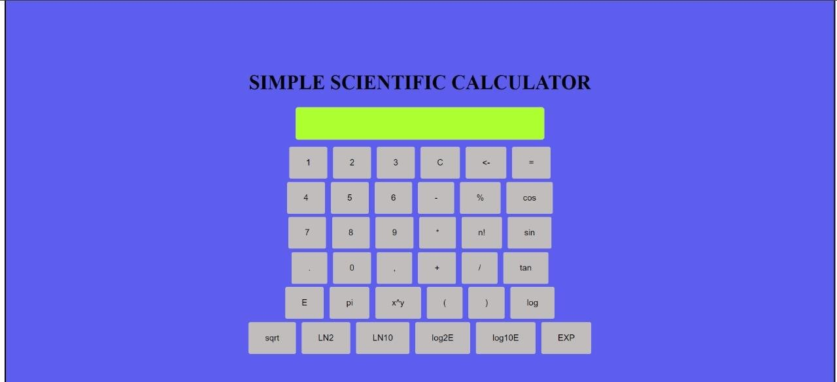

NAME : SHRISTY CHAUDHARY
ROLL NO. : 29
UNIVERSITY ROLL No. : 2019498
SECTION : AI & ML
PROBLEM STATEMENT 11 :-
To create an html page to change the background color for every click of a button using
javascript.
CODE :
<!DOCTYPE html>
<html lang="en">
<head>
<meta charset="UTF-8">
<meta name="viewport" content="width=device-width, initial-scale=1.0">
<title>Experiment 11</title>
</head>
<body>
<h1 onclick="randomcolor()">Click me to change my color!</h1>
<script> function randomcolor()
{
document.body.style.backgroundColor = "maroon";
}
</script>
</body>
</html>
OUTPUT :


NAME : SHRISTY CHAUDHARY
ROLL NO. : 29
UNIVERSITY ROLL No. : 2019498
SECTION : AI & ML
PROBLEM STATEMENT 12 :-
To create an html page with 2 combo box populated with month & year, to display the calendar for the selected month & year from combo box using javascript.
CODE :
<html>
<head>
<title>Calendar</title> <script type="text/javascript"> function generateCalendar()
{
var month = document.getElementById("month").value; var year = document.getElementById("year").value;

// Create the calendar table var calendar = document.createElement("table"); calendar.border = "1";

// Create the calendar header var header = document.createElement("thead"); var headerRow = document.createElement("tr"); var daysOfWeek = ["Sun", "Mon", "Tue", "Wed", "Thu", "Fri", "Sat"]; for (var i = 0; i < daysOfWeek.length; i++)
{
var day = document.createElement("th"); day.textContent = daysOfWeek[i]; headerRow.appendChild(day);
}
header.appendChild(headerRow); calendar.appendChild(header);

// Create the calendar body var body = document.createElement("tbody"); var date = new Date(year, month, 1);
var startDay = date.getDay(); var daysInMonth = new Date(year, month + 1, 0).getDate();
var day = 1; for (var i = 0; i < 6; i++) { var row = document.createElement("tr");
for (var j = 0; j < 7; j++)
{
var cell = document.createElement("td");
if (i === 0 && j < startDay)
{
cell.textContent = "";
}
else if (day > daysInMonth)
{
cell.textContent = "";
} else
{
cell.textContent = day;
day++;
}
row.appendChild(cell);
}
body.appendChild(row);
}
calendar.appendChild(body);

// Add the calendar to the page var calendarDiv = document.getElementById("calendar"); calendarDiv.innerHTML = ""; calendarDiv.appendChild(calendar);
}
</script>
</head>

<body style="background-color: green;">
<h1>Calendar</h1>
<label for="year">Select Year:</label><br><br>
<select id="year">
<option value="2014">2014</option>
<option value="2015">2015</option>
<option value="2016">2016</option> <option value="2017">2017</option>
</select><br><br>
<label for="month">Select Month:</label><br><br>
<select id="month">
<option value="0">January</option>
<option value="1">February</option>
<option value="2">March</option>
<option value="3">April</option>
<option value="4">May</option>
<option value="5">June</option>
<option value="6">July</option>
<option value="7">August</option>
<option value="8">September</option>
<option value="9">October</option>
<option value="10">November</option>
<option value="11">December</option>
</select>
<button onclick="generateCalendar()">OK</button>
<div id="calendar"></div>
</body>
</html>
OUTPUT :
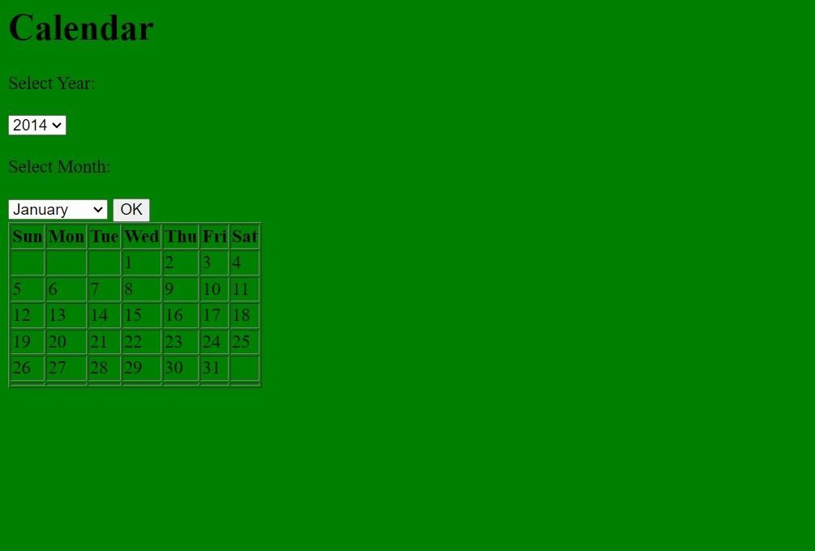

NAME : SHRISTY CHAUDHARY
ROLL NO. : 29
UNIVERSITY ROLL No. : 2019498
SECTION : AI & ML
PROBLEM STATEMENT 13 :-
Create a html page to calculate current date and time, difference between two dates in days, days left until Christmas, days left until birthday, days passed, first Sunday in January using javascript and css wherever needed.
CODE :
<!DOCTYPE html>
<html lang="en">
<head>
<meta charset="UTF-8">
<meta http-equiv="X-UA-Compatible" content="IE=edge">
<meta name="viewport" content="width=device-width, initial-scale=1.0">
<title>Document</title>
<script src="Experiment__13.js"></script>
</head>
<body>
<button type="button" value="a" onclick="getCurrentDateTime()" style="background-color: white; color: black;">A</button><br><br>
<button type="button" value="b" onclick="getCurrentDate()" style="background-color: white; color: black;">B</button><br><br>
<button type="button" value="c" onclick="date_diff_indays('04/02/2014', '11/04/2014')" style="background-color: white; color: black;">C</button><br><br>
<button type="button" value="d" onclick="days_passed(new Date(2015, 0, 15))" style="background-color: white; color: black;">D</button><br><br>
<button type="button" value="e" onclick="findFirstJanSunday(2000, 2024)" style="backgroundcolor: white; color: black;">E</button><br><br>
<button type="button" value="f" onclick="daysUntilChristmas()" style="background-color: white; color: black;">F</button><br><br>
<button type="button" value="g" onclick="daysUntilBirthday(new Date('February 27, 2004'))" style="background-color: white; color: black;">G</button><br><br>
</body> </html> function getCurrentDateTime()
{
let now = new Date();

let days = ['Sunday', 'Monday', 'Tuesday', 'Wednesday', 'Thursday', 'Friday', 'Saturday'];

let day = days[now.getDay()];

let hour = now.getHours() % 12; hour = hour || 12;

let minute = now.getMinutes(); minute = minute < 10 ? '0' + minute : minute;

let second = now.getSeconds(); second = second < 10 ? '0' + second : second;

let period = now.getHours() < 12 ? 'AM' : 'PM';

let currentTime = hour + ' ' + period + ' : ' + minute + ' : ' + second;

console.log('Today is: ' + day + '.'); console.log('Current time is: ' + currentTime);
}

function getCurrentDate()
{

let now = new Date();

let month = now.getMonth() + 1;

let day = now.getDate();

let year = now.getFullYear();

let mm_dd_yyyy = (month < 10 ? '0' : '') + month + '-' + (day < 10 ? '0' : '') + day + '-' + year;

let mm_slash_dd_slash_yyyy = month + '/' + day + '/' + year;

let dd_mm_yyyy = (day < 10 ? '0' : '') + day + '-' + (month < 10 ? '0' : '') + month + '-' + year;

let dd_slash_mm_slash_yyyy = day + '/' + month + '/' + year;

console.log('mm-dd-yyyy format: ' + mm_dd_yyyy); console.log('mm/dd/yyyy format: ' + mm_slash_dd_slash_yyyy); console.log('dd-mm-yyyy format: ' + dd_mm_yyyy); console.log('dd/mm/yyyy format: ' + dd_slash_mm_slash_yyyy);
}

function date_diff_indays(date1, date2) { let dt1 = new Date(date1); let dt2 = new Date(date2);

let diff = Math.abs(dt1 - dt2);

let diffDays = Math.ceil(diff / (1000 * 60 * 60 * 24));

console.log(diffDays);
}

function days_passed(date) {
let startOfYear = new Date(date.getFullYear(), 0, 0);

let diff = date - startOfYear;

let oneDay = 1000 * 60 * 60 * 24; let days = Math.floor(diff / oneDay);

console.log(days);

}

function findFirstJanSunday(year1, year2) {
let years = [];

for (let year = year1; year <= year2; year++) { let janFirst = new Date(year, 0, 1);

if (janFirst.getDay() === 0) { years.push(year);
}
}

console.log("Years where January 1st is a Sunday between " + year1 + " and " + year2 + ":"); console.log(years);
}

function daysUntilChristmas() { let today = new Date();

let currentYear = today.getFullYear();

let christmas = new Date(currentYear, 11, 25);

if (today > christmas) { christmas.setFullYear(currentYear + 1);
}

let timeDiff = christmas.getTime() - today.getTime();

let daysLeft = Math.ceil(timeDiff / (1000 * 3600 * 24));

console.log("Days left until next Christmas: " + daysLeft);
}
function daysUntilBirthday(birthday) { let today = new Date();

let birthMonth = birthday.getMonth(); let birthDay = birthday.getDate();

let currentYear = today.getFullYear();

let nextBirthday = new Date(currentYear, birthMonth, birthDay);

if (today > nextBirthday) { nextBirthday.setFullYear(currentYear + 1);
}
let timeDiff = nextBirthday.getTime() - today.getTime(); let daysLeft = Math.ceil(timeDiff / (1000 * 3600 * 24)); console.log("Days left until your next birthday: " + daysLeft) return daysLeft;
}

NAME : SHRISTY CHAUDHARY
ROLL NO. : 29
UNIVERSITY ROLL No. : 2019498
SECTION : AI & ML
PROBLEM STATEMENT 14 :-
Create a stop watch using html, javascript and css.
CODE :
<!DOCTYPE html>
<html lang= "en">
<head>
<meta charset= "UTF-8">
<meta http-equiv= "X-UA-Compatible"
content= "IE=edge">
<meta name= "viewport" content= "width=device-width, initial-scale=1.0">
<title>Experiment 14</title>
<style> body { margin: 50px;
font-family: Times New Roman;
}
.container { align-items: center; background-color: rgb(195, 195, 195);
height: 350px; width: 550px; text-align: center;
} .digits { font-size: 80px; color: rgb(13, 135, 98);
} .text {
font-size: 80px; color: rgb(13, 135, 98);
}
#buttons { margin-top: 35px;
}
.btn1, .btn2, .btn3{ width: 90px; height: 50px; padding: 8px 5px 8px 2px; margin: 10px 25px 20px 10px;
cursor: pointer; font-size: 20px; transition: 0.7s; color: white; font-weight: 550; border: 0; font-family: Times new Roman;
}
.btn4{ width: 400px; height: 50px; padding: 8px 5px 8px 2px; margin: 10px 25px 20px 10px; cursor: pointer; font-size: 20px; transition: 0.7s; color: white; font-weight: 550; border: 0;
font-family: Times new Roman;
}
.btn1:hover, .btn2:hover, .btn3:hover, .btn4:hover{
color: indigo;
}
#start { background-color: gray;
}
#stop {
background-color: gray;
}
#reset {
background-color: gray;
}
#save_lap { background-color: gray;
}
#start:hover, #stop:hover, #reset:hover , #save_lap:hover { background-color: white;
}
</style>
</head>
<body>
<div class= "container">
<div id= "time">
<span class= "digits" id= "hour">
00</span>
<span class= "text" > : </span>
<span class= "digits" id= "minute">
00</span>
<span class= "text"> : </span>
<span class= "digits" id= "second">
00</span>
<span class= "text"> : </span>
<span class= "digits" id= "count">
00</span>
</div>
<div id= "buttons">
<button class= "btn1" id= "start">
Start </button>
<button class= "btn2" id= "stop">
Stop </button>
<button class= "btn3" id= "reset">
Reset </button><br><br>
<button class= "btn4" id= "save_lap">
Save Lap </button>
</div>
</div> <script> let startButton = document.getElementById('start'); let stopButton = document.getElementById('stop'); let resetButton = document.getElementById('reset'); let savelapButton = document.getElementById('save_lap');

let hour = 0o0; let minute = 0o0; let second = 0o0; let count = 0o0;

startButton.addEventListener('click', function () { timer = true; stopWatch();
});
stopButton.addEventListener('click', function () {
timer = false;
});
resetButton.addEventListener('click', function () {
timer = false; hour = 0; minute = 0; second = 0; count = 0;
document.getElementById('hour').innerHTML = "00"; document.getElementById('minute').innerHTML = "00"; document.getElementById('second').innerHTML = "00"; document.getElementById('count').innerHTML = "00";
});
function saveLap() { let lapTime = document.getElementById("save_lap").innerText; let lapList = document.getElementById("lapList"); let listItem = document.createElement("li"); listItem.innerText = lapTime; lapList.appendChild(listItem);
}
function stopWatch() {
if (timer) { count++; if (count == 100) { second++; count = 0;
}
if (second == 60) { minute++; second = 0;
}
if (minute == 60) { hour++;
minute = 0; second = 0;
}
let hourString = hour; let minuteString = minute; let secondString = second; let countString = count; if (hour < 10) { hourString = "0" + hourString;
}
if (minute < 10) { minuteString = "0" + minuteString;
}
if (second < 10) { secondString = "0" + secondString;
}

if (count < 10) { countString = "0" + countString;
}
document.getElementById('hour').innerHTML = hourString; document.getElementById('minute').innerHTML = minuteString; document.getElementById('second').innerHTML = secondString; document.getElementById('count').innerHTML = countString; setTimeout(stopWatch, 10);
}
}
</script>
</body>
</html>
OUTPUT :
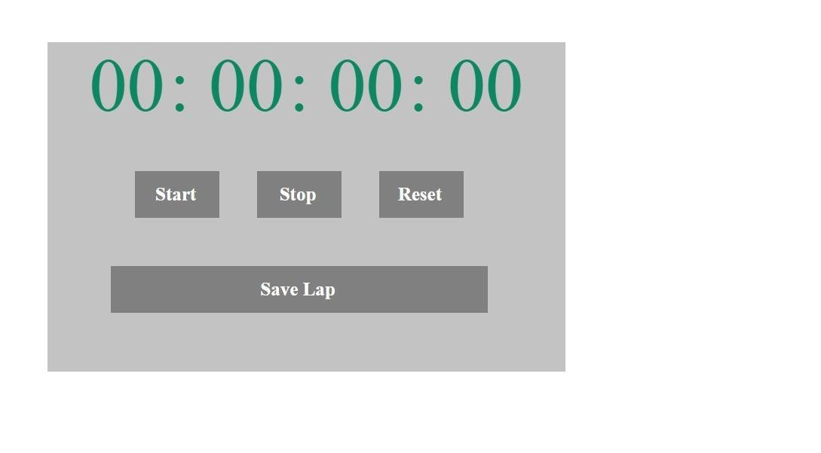

NAME : SHRISTY CHAUDHARY
ROLL NO. : 29
UNIVERSITY ROLL No. : 2019498
SECTION : AI & ML
PROBLEM STATEMENT 15 :-
Write a php code to connect to database and perform all the basic operations.
CODE :
<?php
$servername = "localhost";
$username = "root";
$password = "";
$dbname = "myDatabase";

// Create connection
$conn = new mysqli($servername, $username, $password);

// Check connection if ($conn->connect_error) { die("Connection failed: " . $conn->connect_error);
}
echo "Connected successfully<br>";

// Create database
$sql = "CREATE DATABASE $dbname"; if ($conn->query($sql) === TRUE) { echo "Database created successfully<br>";
} else {
die("Error creating database: " . $conn->error);
}

// Select the database
$conn->select_db($dbname) or die("Database selection failed: " . $conn->error);

// Create table
$sql = "CREATE TABLE myTable (
id INT(6) UNSIGNED AUTO_INCREMENT PRIMARY KEY, firstname VARCHAR(30) NOT NULL, lastname VARCHAR(30) NOT NULL, email VARCHAR(50), reg_date TIMESTAMP
)";
if ($conn->query($sql) === TRUE) { echo "Table myTable created successfully<br>";
} else { die("Error creating table: " . $conn->error);
}
// Insert data
$sql = "INSERT INTO myTable (firstname, lastname, email) VALUES ('John', 'Doe', 'john@example.com')"; if ($conn->query($sql) === TRUE) { echo "New record created successfully<br>";
} else { die("Error: " . $sql . "<br>" . $conn->error);
}
// Update data
$sql = "UPDATE myTable SET lastname='Smith' WHERE firstname='John'"; if ($conn->query($sql) === TRUE) { echo "Record updated successfully<br>";
} else {
die("Error updating record: " . $conn->error);
}
// Delete data
$sql = "DELETE FROM myTable WHERE firstname='John'"; if ($conn->query($sql) === TRUE) { echo "Record deleted successfully<br>";
} else {
die("Error deleting record: " . $conn->error);
}
// Select data
$sql = "SELECT id, firstname, lastname, email FROM myTable";
$result = $conn->query($sql); if ($result->num_rows > 0) { // Output data of each row while($row = $result->fetch_assoc()) {
echo "id: " . $row["id"]. " - Name: " . $row["firstname"]. " " . $row["lastname"]. " - Email: " . $row["email"]. "<br>";
}
} else { echo "0 results";
}
$conn->close();
?>
OUTPUT :
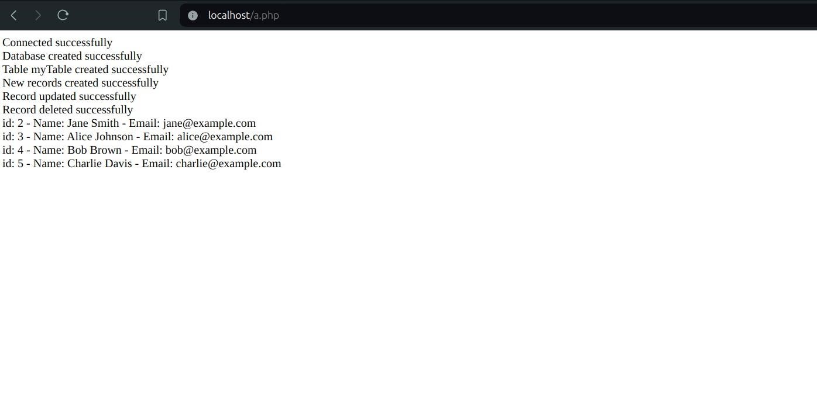

NAME : SHRISTY CHAUDHARY
ROLL NO. : 29
UNIVERSITY ROLL No. : 2019498
SECTION : AI & ML
PROBLEM STATEMENT 16 :-
Write a PHP function to test whether a number is greater than 30, 20 or 10 using ternary operator.
CODE :
<?php
function greater_num($num) { return ($num > 30) ? "Greater than 30" : (($num > 20) ? "Greater than 20" : (($num > 10) ? "Greater than 10" : "Not greater than 10"));
}

echo greater_num(35); echo "<br>"; echo greater_num(25); echo "<br>"; echo greater_num(15); echo "<br>";
echo greater_num(5);

?>

NAME : SHRISTY CHAUDHARY
ROLL NO. : 29
UNIVERSITY ROLL No. : 2019498
SECTION : AI & ML
PROBLEM STATEMENT 17 :-
Write a PHP program to check whether a number is an Armstrong number or not. Return true if the number is Armstrong otherwise return false.
CODE :
<?php function isArmstrong($number) {
// Convert the number to a string to easily access each digit
$numStr = strval($number);
// Get the length of the number string (number of digits)
$numDigits = strlen($numStr);
// Initialize sum to 0
$sum = 0;

// Loop through each digit in the number string for ($i = 0; $i < $numDigits; $i++) {
// Convert the current character back to an integer
$digit = intval($numStr[$i]);
// Add the digit raised to the power of the number of digits to the sum
$sum += pow($digit, $numDigits);
}

// If the sum is equal to the original number, it is an Armstrong number return $sum == $number;
}

// Test the function with some examples $testNumbers = [153, 9474, 54748, 407, 123]; foreach ($testNumbers as $number) {
if (isArmstrong($number)) { echo "$number is an Armstrong number.";
echo "<br>"; } else {
echo "$number is not an Armstrong number.\n"; echo "<br>";
} }
?>

NAME : SHRISTY CHAUDHARY
ROLL NO. : 29
UNIVERSITY ROLL No. : 2019498
SECTION : AI & ML
PROBLEM STATEMENT 18 :-
Write a PHP program to test if a given string occurs at the end of another given string.
CODE :
<?php function endsWith($mainString, $endingString)
{
$endingLength = strlen($endingString);

$mainEnding = substr($mainString, -$endingLength);

return $mainEnding === $endingString;
}

$mainString1 = "Hello world";
$endingString1 = "world"; $mainString2 = "Hello world";
$endingString2 = "hello";

echo endsWith($mainString1, $endingString1) ? "True\n" : "False\n"; echo "<br>";
echo endsWith($mainString2, $endingString2) ? "True\n" : "False\n"; echo "<br>";
?>

NAME : SHRISTY CHAUDHARY
ROLL NO. : 29
UNIVERSITY ROLL No. : 2019498
SECTION : AI & ML
PROBLEM STATEMENT 19 :-
Write a PHP program to compute the amount of the debt in n months. The borrowing amount is $100,000 and the loan adds 5% interest of the debt and rounds it to the nearest 1,000 above month by month.
CODE :
<?php function calculateDebt($months) {
$debt = 100000; $interestRate = 0.05;

for ($i = 0; $i < $months; $i++) { $debt = $debt * (1 + $interestRate);
$debt = ceil($debt / 1000) * 1000;
} return $debt;
}

$testMonths = [1, 6, 12, 24]; foreach ($testMonths as $months)
{
echo "Debt after $months month(s): $" . calculateDebt($months) . "\n"; echo "<br>";
}
?>

NAME : SHRISTY CHAUDHARY
ROLL NO. : 29
UNIVERSITY ROLL No. : 2019498
SECTION : AI & ML
PROBLEM STATEMENT 20 :-
Write a PHP program that accepts six numbers as input and stored into an arrays and sorts them in descending order.
CODE :
<?php
Function sortDescending($numbers) { rsort($numbers); return $numbers;
}

$numbers = []; echo "Enter six numbers:<br>";
for ($i = 0; $i < 6; $i++) {
$numbers[$i] = (int)readline("Number " . ($i + 1) . ": ");
}

$sortedNumbers = sortDescending($numbers);

echo "Numbers in descending order:\n"; foreach ($sortedNumbers as $number)
{
echo $number . "<br>";
}
?>

