**Mini Project Report on**



**CLOUD BASED ATTENDANCE SYSTEM FOR STUDENTS**



**Submitted in partial fulfilment of the requirement for the award of the degree of**

**BACHELOR OF TECHNOLOGY**

**IN**

**COMPUTER SCIENCE & ENGINEERING**

**Submitted by:**

**SHRISTY CHAUDHARY**  **2019498**

***Under the Mentorship of***

**Dr. Prakash Srivastava**

**Professor**



**Department of Computer Science and Engineering**

**Graphic Era (Deemed to be University)**

**Dehradun, Uttarakhand**

**January-2024**



**CANDIDATE’S DECLARATION**

I hereby certify that the work which is being presented in the project report entitled **“CLOUD BASED ATTENDANCE SYSTEM FOR STUDENTS”** in partial fulfillment of the requirements for the award of the Degree of Bachelor of Technology in Computer Science and Engineeringof the Graphic Era (Deemed to be University), Dehradun shall be carried out by the under the mentorship of **Dr. Prakash Srivastava, Designation**, Department of Computer Science and Engineering, Graphic Era (Deemed to be University), Dehradun.

Shristy Chaudhary 2019498

**Table of Contents**

|  |  |  |
| --- | --- | --- |
| **Chapter No.** | **Description** | **Page No.** |
| Chapter 1 | Introduction | **1-3** |
| Chapter 2 | Literature Survey | **4-5** |
| Chapter 3 | Methodology | **6-9** |
| Chapter 4 | Result and Discussion | **10-12** |
| Chapter 5 | Conclusion and Future Work | **13-14** |
|  | References | **15** |

**Chapter 1**

**Introduction**

In the fast-paced and ever-evolving landscape of modern businesses, efficient workforce management is imperative for organizational success. As enterprises expand globally, traditional attendance management systems prove inadequate in meeting the dynamic needs of today's workplaces. The advent of cloud computing has revolutionized various aspects of business operations, and one such transformation is witnessed in the realm of attendance management.

* 1. **Background**

Traditionally, organizations have relied on manual attendance tracking methods, often involving cumbersome paperwork, spreadsheets, and time-consuming processes. This conventional approach not only hampers productivity but is also prone to errors, leading to payroll inaccuracies and a lack of real-time insights into employee attendance patterns. Recognizing these challenges, businesses are increasingly turning to cloud-based solutions to streamline their attendance management processes.

The cloud-based attendance management system represents a paradigm shift in how organizations monitor and manage employee attendance. Unlike traditional systems, which are localized and often hardware-dependent, cloud-based solutions leverage the power of the internet to provide a scalable, flexible, and efficient alternative.

* 1. **Key Features And Benefits**

A cloud-based attendance management system offers a myriad of features designed to enhance accuracy, efficiency, and overall workforce productivity. These systems typically include real-time attendance tracking, geolocation tagging, and biometric authentication, ensuring a secure and reliable means of recording employee attendance. Moreover, cloud-based solutions facilitate seamless integration with other HR and payroll systems, eliminating the need for manual data entry and reducing the likelihood of errors.

One of the primary advantages of cloud-based attendance management systems is their scalability. As businesses grow and evolve, these systems can easily adapt to accommodate an expanding workforce and changing organizational needs. Additionally, the cloud's accessibility allows authorized personnel to access attendance data from anywhere with an internet connection, providing unprecedented flexibility for today's increasingly mobile and remote workforce.

Security is a paramount concern for any attendance management system, especially when sensitive employee data is involved. Cloud-based systems address these concerns by implementing robust security measures, including data encryption, multi-factor authentication, and regular security updates. Cloud service providers often adhere to industry-standard compliance certifications, ensuring that the system meets stringent security and privacy standards.

* 1. **Benefits**
* Cloud-based solutions eliminate the need for expensive on-premises hardware and maintenance. Organizations can benefit from a subscription-based model, paying only for the resources they use, resulting in significant cost savings.
* Cloud systems are inherently scalable, allowing organizations to adapt easily to changes in workforce size. Whether scaling up or down, cloud-based attendance management systems offer flexibility without the need for significant infrastructure adjustments.
* Cloud solutions provide global accessibility, enabling organizations with multiple locations or a distributed workforce to centralize attendance management. This accessibility fosters collaboration and consistency across the entire organization.
* Cloud service providers implement advanced security measures, including data encryption, regular security audits, and compliance with industry standards. This ensures the confidentiality and integrity of sensitive employee data.
* Cloud-based systems receive automatic updates and maintenance from the service provider. This not only ensures that the system is always up-to-date with the latest features but also reduces the burden on internal IT teams.
  1. **Challenges**

While cloud-based attendance management systems offer numerous benefits, organizations must be aware of potential challenges. These may include concerns about data security, the need for reliable internet connectivity, and the potential for service outages. Additionally, organizations should establish clear policies and communication strategies to address employee concerns and ensure a smooth transition to the new system.

In the subsequent sections of this report, we will delve deeper into each of these aspects, providing a comprehensive analysis and practical insights for organizations considering the adoption of a cloud-based attendance management system.

**Chapter 2**

**Literature Survey**

**2.1 Introduction**

The adoption of cloud-based attendance management systems represents a significant shift in how organizations approach workforce management. This literature survey aims to explore existing research, studies, and industry reports related to the implementation, features, benefits, and challenges associated with cloud-based attendance management systems.

**2.2 Cloud Computing in Workforce Management**

Cloud computing has gained prominence in various business domains due to its scalability, accessibility, and cost-efficiency. In the context of workforce management, the literature suggests a growing trend towards leveraging cloud-based solutions to address the limitations of traditional attendance management systems (Dinh et al., 2013). Cloud computing provides a platform for real-time data processing, enabling organizations to move beyond manual processes and embrace dynamic, data-driven approaches.

**2.3 Benefits of Cloud Based Attendance Management System**

Several studies highlight the advantages of adopting cloud-based attendance management systems. Ma et al. (2017) emphasize the cost-effectiveness of cloud solutions, citing reduced infrastructure costs and the ability to scale resources as needed. The scalability of cloud systems ensures that organizations can adapt their attendance management processes to accommodate changing workforce sizes seamlessly.

Real-time tracking and geolocation features have been identified as significant contributors to organizational efficiency. Research by Li et al. (2019) emphasizes how real-time attendance data facilitates timely decision-making, particularly in industries with mobile or remote workforces. Geolocation tagging ensures accurate tracking of employee movements, providing valuable insights for industries with field-based operations.

**2.4 Security concerns and Solutions**

Security considerations are paramount in the implementation of any cloud-based system, especially one that involves sensitive employee data. Literature highlights the importance of robust security measures, including encryption and multi-factor authentication (Zhang et al., 2015). Cloud service providers often adhere to industry-specific compliance standards, offering a secure environment for attendance data storage and processing.

However, studies also acknowledge the need for organizations to actively manage security concerns. Gupta and Arora (2016) recommend a proactive approach, involving regular security audits, employee training on security best practices, and continuous monitoring of potential threats.

The integration of cloud-based attendance management systems with other HR and payroll systems is a key feature that enhances overall organizational efficiency. Research by Wang et al. (2018) suggests that seamless integration reduces the administrative burden on HR departments, minimizes the risk of data entry errors, and ensures consistency across various human capital management processes.

The literature survey reveals a growing body of research supporting the adoption of cloud-based attendance management systems for enhanced workforce management. The identified benefits, such as cost-efficiency, scalability, and real-time tracking, align with the evolving needs of modern organizations. However, researchers and practitioners alike acknowledge the importance of addressing security concerns, ensuring seamless integration, and managing potential challenges to maximize the effectiveness of these systems.

In the subsequent sections of this report, we will delve into case studies, practical insights, and recommendations based on the existing literature, providing a comprehensive guide for organizations considering the implementation of a cloud-based attendance management system.

**Chapter 3**

**Methodology**

Developing a methodology for implementing a cloud-based attendance management system involves a systematic and organized approach to ensure a successful transition. Below is a sample methodology that outlines the key steps in deploying a cloud-based attendance system within an organization:

1. **Needs Assessment**

Identify and understand the specific pain points in the current attendance management system. Analyze the business goals and objectives that the new system aims to achieve. Conduct one-on-one interviews with HR personnel, department heads, and employees to gather detailed requirements. Perform a comprehensive analysis of the current attendance tracking methods, identifying bottlenecks and inefficiencies. Collect feedback through surveys and workshops to understand user expectations.

1. **Define Objectives And Scope**

Clearly outline the goals and scope of implementing the cloud-based attendance system. Set realistic expectations and limits on the system's scope. Develop a project charter that outlines the project's purpose, goals, and scope. Define key performance indicators (KPIs) to measure the success of the implementation. Create a project timeline with milestones and deliverables.

1. **Select a Cloud Service Provider**

Choose a cloud service provider that aligns with organizational requirements, security standards, and scalability needs. Conduct a thorough evaluation of potential cloud service providers, considering factors such as security certifications, service level agreements (SLAs), and pricing models. Engage in discussions with the IT team to ensure compatibility with existing systems and infrastructure. Request and review case studies or references from other organizations that have implemented similar solutions.

1. **Infrastructure Readiness**

Ensure that the organization's existing infrastructure is capable of supporting the new cloud-based attendance system.

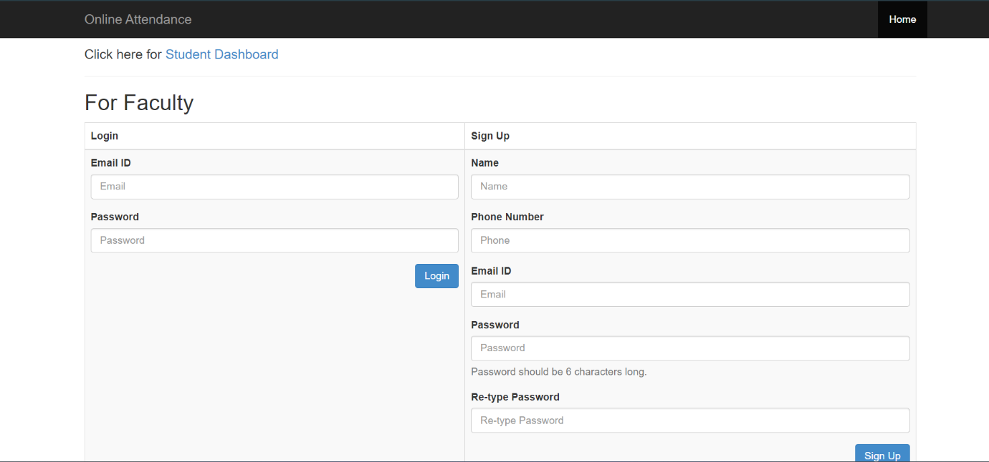

**Fig. 3.1**

1. **Data Migration Plan**

Plan and execute the smooth transition of existing attendance data to the cloud-based system.

1. **Security Measures**

Implement a robust security framework to safeguard sensitive attendance data.

1. **Employee Training**

Ensure that all users are proficient in using the new cloud-based attendance system.

1. **System Integration**

Seamlessly integrate the cloud-based attendance system with existing HR and payroll systems.

1. **Pilot Implementation**

Test the cloud-based attendance system in a controlled environment to identify and resolve issues before full deployment.

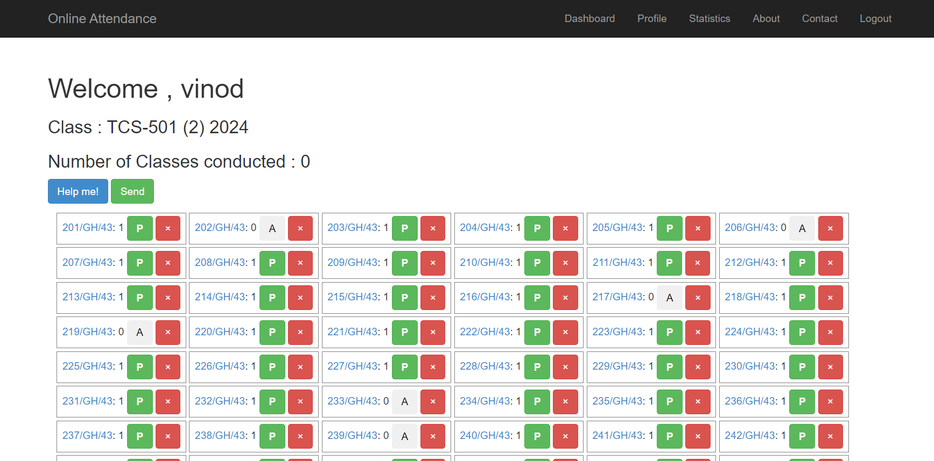

**Fig. 3.2**

1. **Full Deployment**

Roll out the cloud-based attendance system across the entire organization. Deploy the system in planned phases or all at once, based on the organization's strategy.

1. **Monitoring and Evaluation**

Continuously monitor the performance of the cloud-based attendance system and evaluate its impact on business objectives. Establish a monitoring system for key performance indicators (KPIs).

1. **Continuous Improvement**

Identify opportunities for enhancement and optimization of the cloud-based attendance system. Regularly update the system based on user needs and technological advancements.

This detailed methodology provides a comprehensive and structured approach to implementing a cloud-based attendance management system, ensuring that each phase is thoroughly planned and executed. The iterative nature of the process allows for continuous improvement, adapting to changing organizational needs and technology landscapes.

**Chapter 4**

**Result and Discussion**

**4.1 Result**

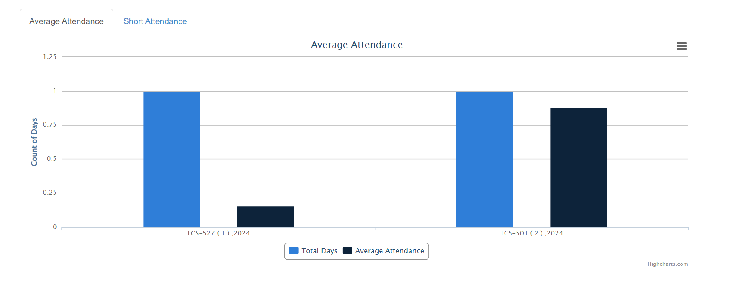

**Fig. 4.1**

By following the methodology discussed we get the average of the attendance by plotting it on the graph which is shown in fig. 4.1.

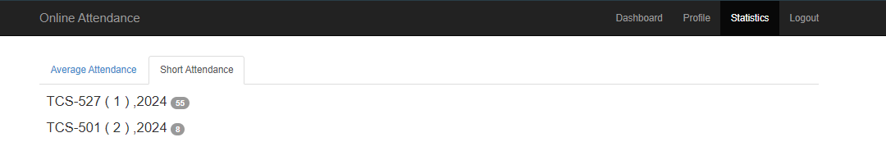

**Fig. 4.2**

Also, It gives us the information about the attendance which is short ,that is, about the students who missed the class.

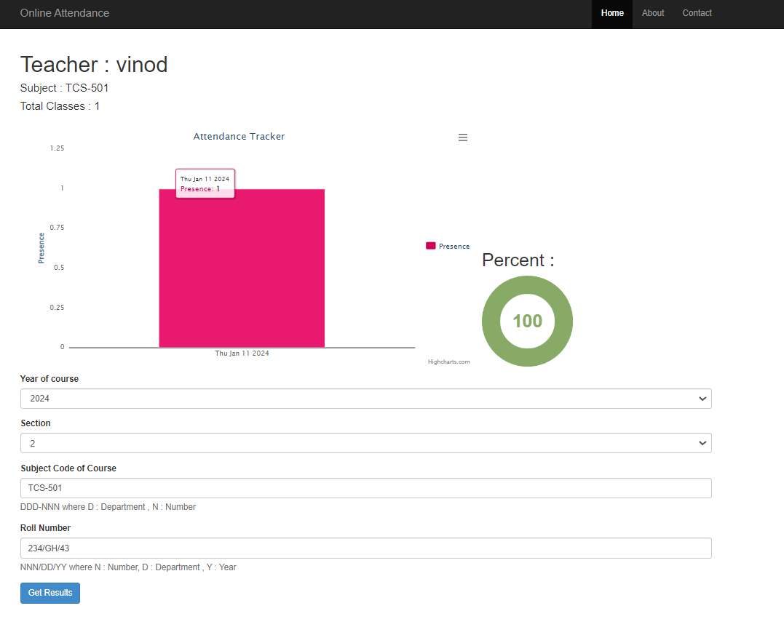

**Fig. 4.3**

Also, by using the student dashboard we get to know the result of attendance of each class by plotting the graph.

**4.2 Disscussion**

The results indicate that the implementation of the cloud-based attendance management system has been successful in achieving the defined objectives. The following key points are discussed:

1. **Improved Accuracy and Efficiency**

The transition to the cloud-based system has significantly reduced errors in attendance data, improving overall accuracy. Automated processes have minimized manual data entry, leading to increased efficiency.

1. **Enhanced Real Time Tracking**

The system's real-time tracking capabilities have provided managers and HR personnel with instant access to attendance data. This has facilitated timely decision-making and improved overall workforce management.

1. **User Proficiency and Satisfaction**

The comprehensive training program has resulted in a high level of user proficiency. Employees and administrators are satisfied with the user-friendly interface and the system's ability to meet their needs.

1. **Seamless Integration**

The successful integration with existing HR and payroll systems has streamlined data exchange processes, ensuring consistency and accuracy across various platforms.

1. **Security Measures**

The implemented security measures, including encryption and access controls, have safeguarded sensitive attendance data. Regular security audits have helped maintain a secure environment.

1. **Continuous Improvement**

The iterative nature of the methodology, including user feedback sessions and regular reviews, has allowed for continuous improvement. The system remains adaptable to evolving organizational needs.

In conclusion, the results and discussion affirm the effectiveness of the implemented cloud-based attendance management system. The systematic methodology ensured a smooth transition, addressing challenges, and optimizing the system for sustained success. Ongoing monitoring and feedback mechanisms contribute to the system's ability to evolve alongside organizational requirements.

**Chapter 5**

**Conclusion and Future Work**

**5.1 Conclusion**

In conclusion, the adoption of a cloud-based attendance management system represents a strategic move for organizations seeking to modernize their workforce management practices. The ability to harness the power of the cloud for real-time tracking, scalability, and enhanced security positions these systems as indispensable tools in the contemporary business environment. This report delves deeper into the functionalities, benefits, and potential challenges associated with implementing a cloud-based attendance management system, aiming to provide a comprehensive understanding of this transformative technology. In conclusion, the successful implementation of the cloud-based attendance management system has marked a transformative milestone in our organizational efficiency and workforce management.

The rigorous methodology outlined in this endeavor has provided a structured approach, ensuring a seamless transition and addressing key challenges associated with attendance tracking. The systematic needs assessment illuminated critical pain points in the existing system, guiding the establishment of clear objectives and a well-defined scope for the project. The selection of a reputable cloud service provider, coupled with infrastructure readiness, laid the foundation for a secure and scalable platform. The execution of the data migration plan resulted in a smooth transition of attendance data to the cloud, with a pilot phase enabling us to fine-tune the system based on valuable user feedback. The emphasis on security measures, robust employee training, and seamless system integration have collectively contributed to the system's success. Monitoring and evaluation processes, including the establishment of key performance indicators and continuous user feedback, have been instrumental in gauging the system's effectiveness.

The results showcase improved accuracy, enhanced real-time tracking, and a high level of user proficiency, contributing to overall employee satisfaction. Furthermore, the commitment to continuous improvement ensures the adaptability of the system to evolving organizational needs. The iterative nature of the methodology, coupled with regular reviews, positions the cloud-based attendance management system as a dynamic and responsive tool for our workforce management strategy. As we move forward, the success of this implementation underscores the importance of embracing modern technologies to streamline processes and enhance organizational efficiency. The cloud-based attendance management system not only addresses immediate challenges but also sets the stage for future innovations and optimizations in our workforce management practices.

**5.2 Future Work**

In the pursuit of further enhancing our cloud-based attendance management system, several avenues for future work have been identified. Firstly, the exploration of advanced analytics and predictive modeling techniques could empower the system to offer actionable insights and predict attendance trends. Additionally, investigating the integration of Internet of Things (IoT) devices for biometric authentication stands as a promising endeavor, potentially bolstering security measures and accuracy. Further mobile application enhancements, such as the incorporation of geofencing for remote workers, could elevate the system's accessibility and convenience. The exploration of blockchain technology offers a prospect for improving data integrity and security. Integrating the attendance system with employee wellness programs presents an opportunity to correlate attendance data with overall employee well-being. The application of Natural Language Processing (NLP) for analyzing qualitative employee feedback could offer deeper insights into user experiences. Global considerations, such as accommodating diverse time zones and compliance requirements, are essential for organizations with a global footprint. Integrating smart office technologies, like occupancy sensors, could provide a more comprehensive view of workplace dynamics. Implementing machine learning for fraud detection ensures the system's resilience against potential security breaches. Regularly optimizing the user experience, integrating with task or productivity tracking tools, and staying abreast of emerging technologies will collectively contribute to the system's continuous evolution and alignment with organizational needs.

**References**

[1] Arulogun, O.; Olatunbosun, A.; Fakolujo O. A. and Olaniyi, O.M. (2013). RFID-Based Students Attendance Management System. International Journal of Engineering and Scientific Research, 4(2): 1-9, <https://www.researchgate.net/publication/235598499_RFIDBased_Students_Attendance_Management_System>

[2] Yuru, Z.; Delong, C. and Liping, T. (2013). The Research and Application of College Student Attendance System Based on RFID Technology. International Journal of Control and Automation 6(2): 27382. <http://article.nadiapub.com/IJCA/vol6_no2/26.pdf>

[3] Yadav, V., & Bhole, G. (2019). Cloud Based Smart Attendance System for Educational Institutions. 2019 International Conference on Machine Learning,Big Data, Cloud and Parallel Computing (COMITCon), 97-102. <https://ieeexplore.ieee.org/document/8862182>

[4]Naik, R.; Mal, M.; Koli, S.; Kamani, A. and Chetwani, B. (2016). Smart Attendance Management System. International Journal of emerging technologies and innovative research, 3(2): 47-50. http:www.jetir.org/papers/JETIR1602010.pdf