FULL STACK PART-3, ASSIGNMENT-1

Create an Express API to read notes, and owner from the URL using get method

Create a folder on desktop and install the express drivers in it using the command ---npm install express –save

Create a file named api.js and install the cors drivers to integrate the node servers at both front-end and backend

Write the handlers code for the api and run the code

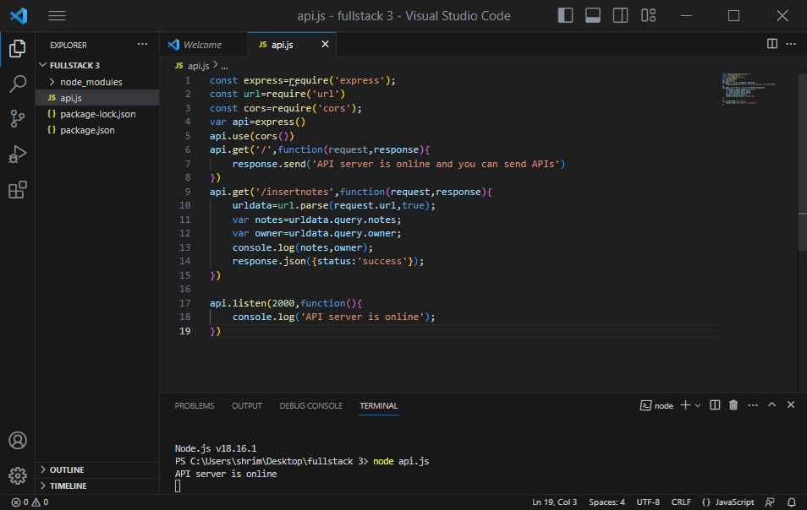

in postman ,we are able to get the output as

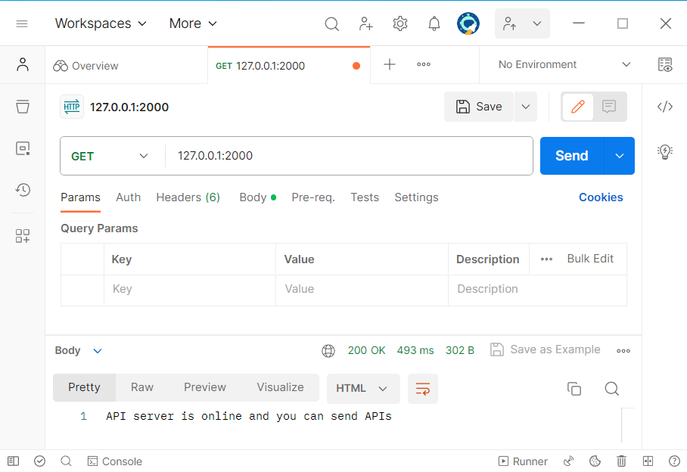

When values are appended as query parameters, the output is as shown

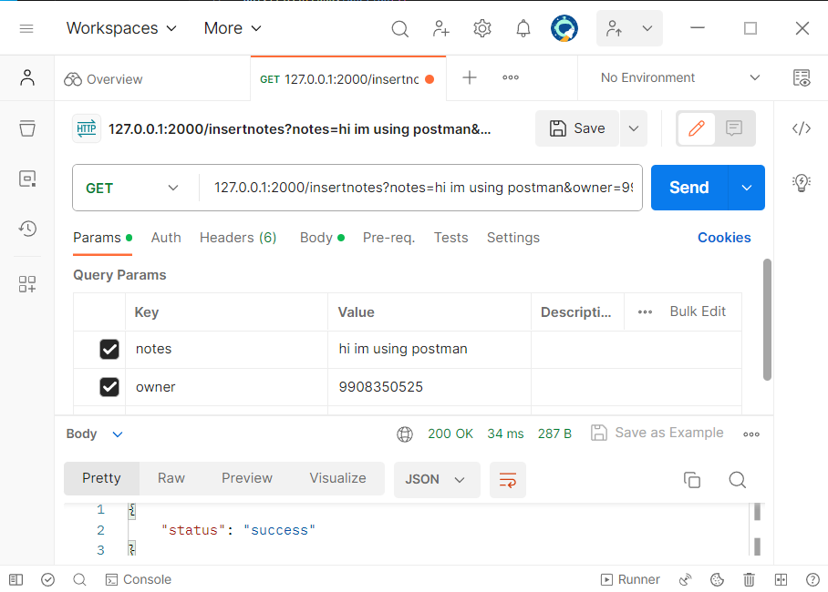

The status is success and the parameter values are read in the terminal.

