FULL STACK PART-3, ASSIGNMENT-2

Create a logic to store these notes and owner in the mongodb

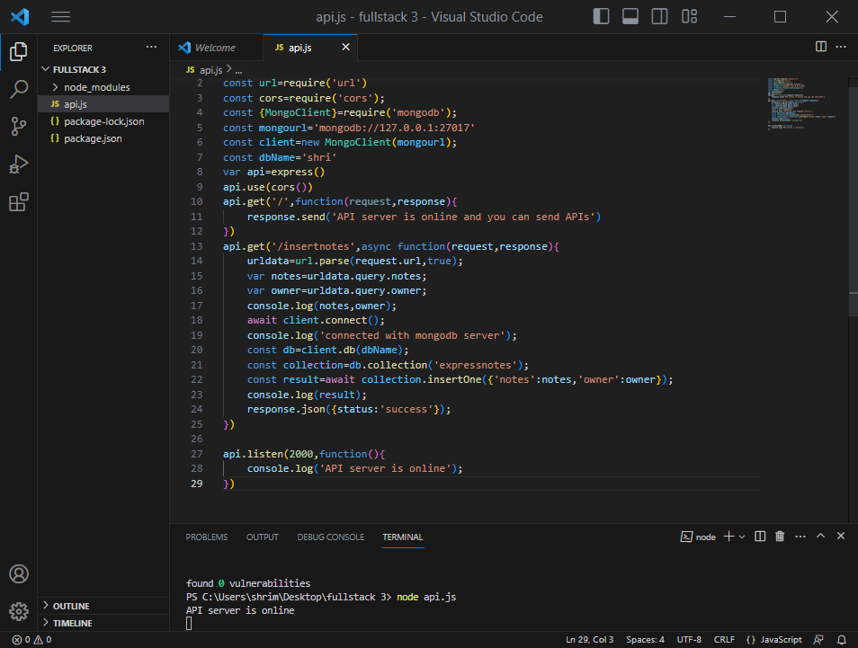

Storing the notes through postman

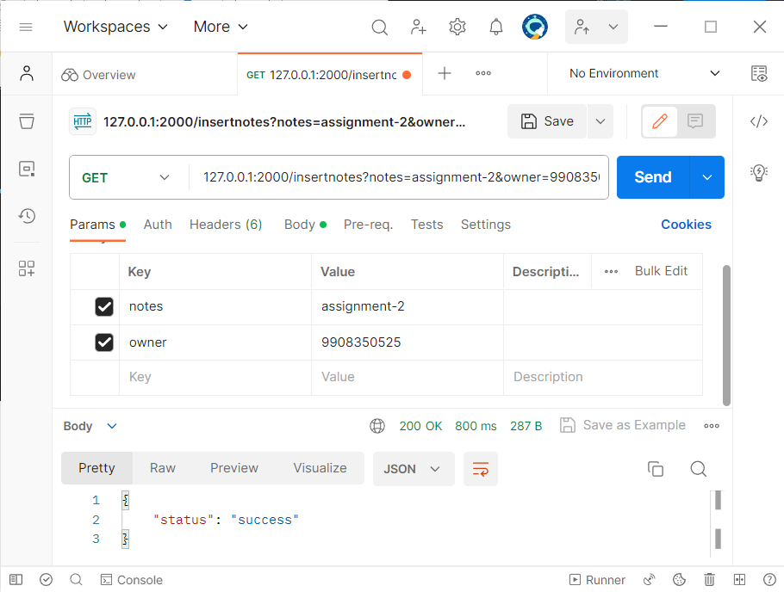

You can see the notes inserted and acknowledged in the terminals

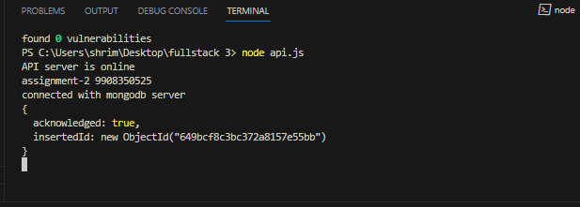

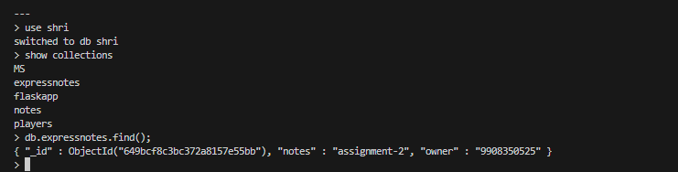

In this way we store the data in mongodb using express and postman