FULL STACK PART-3, ASSIGNMENT-3

Create an Express API to read registration details from the URL

Creating a handler newregistration to create an express api and reading registration details from it.

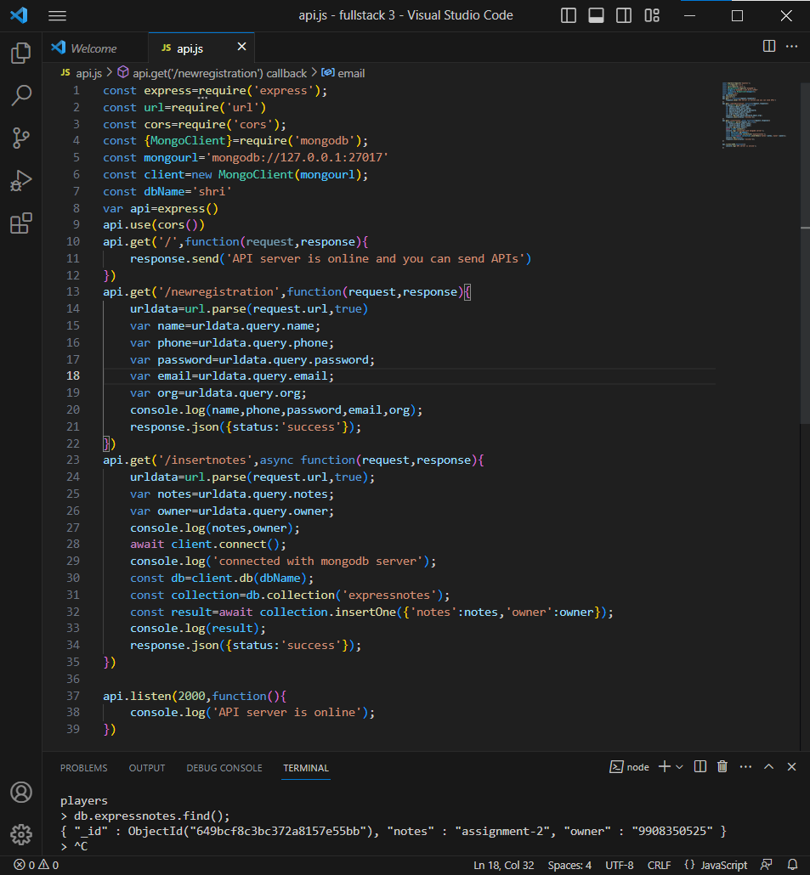

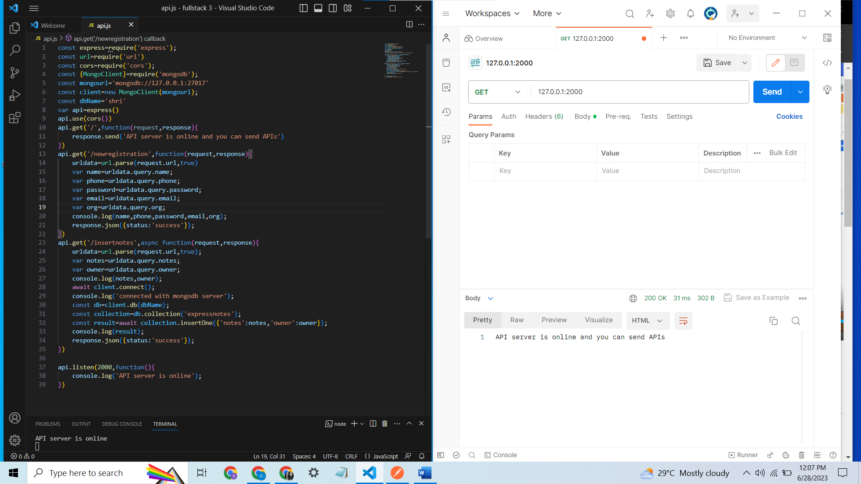

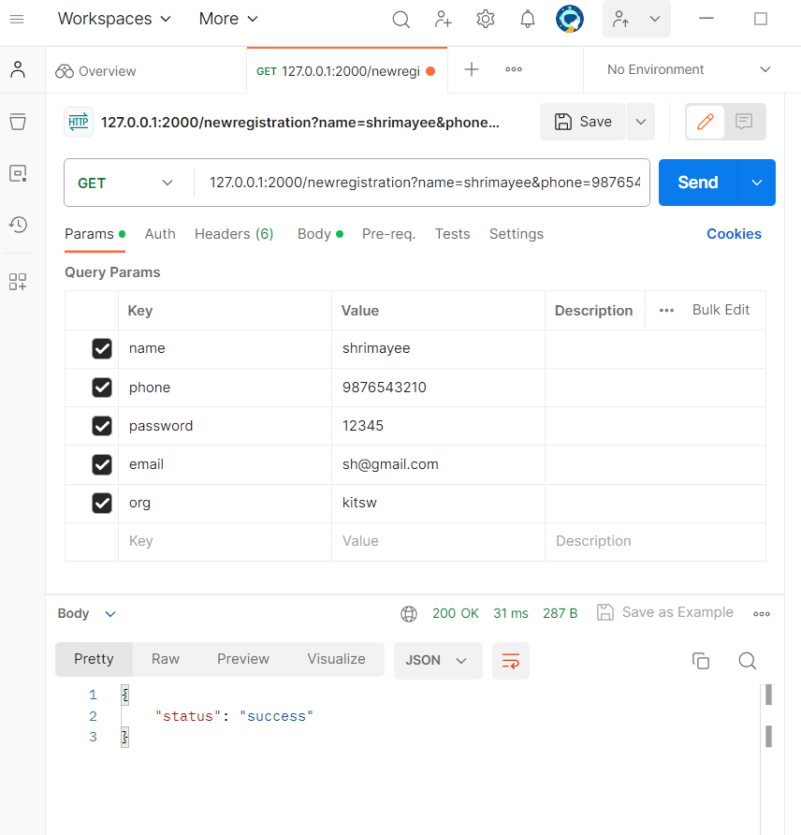

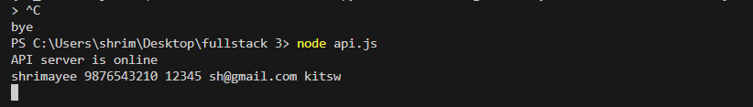

In this wy registration details are read from the url and whatever the values are given in the frontend,the values are stored in the backend.