FULL STACK PART-3, ASSIGNMENT-4

Create a logic to store registration data in the mongodb

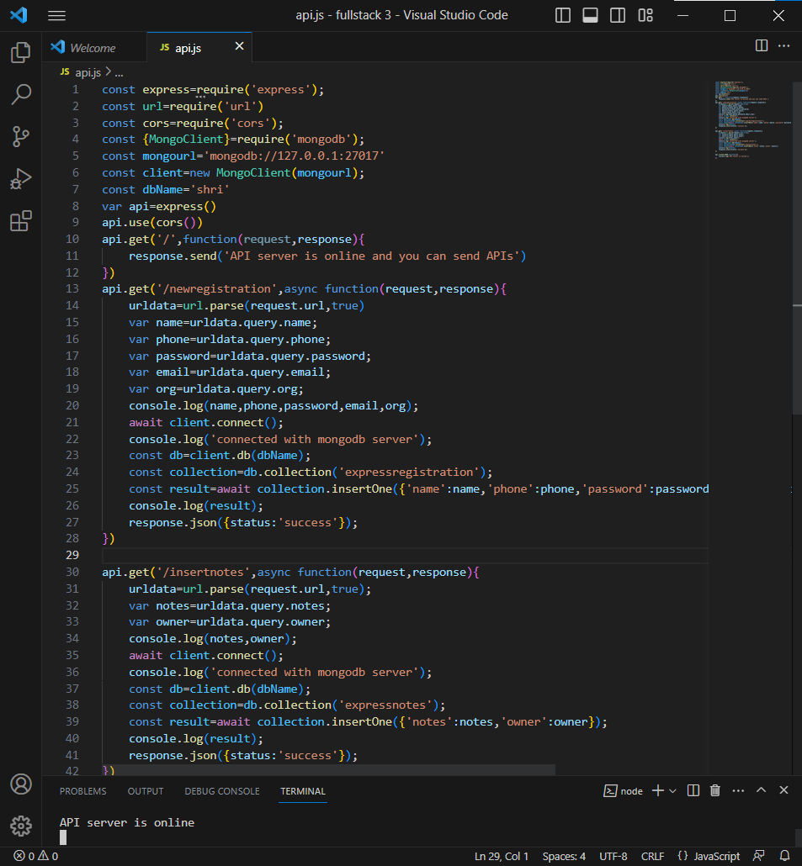

Code to store registration data in mongodb

Adding values through postman to store data

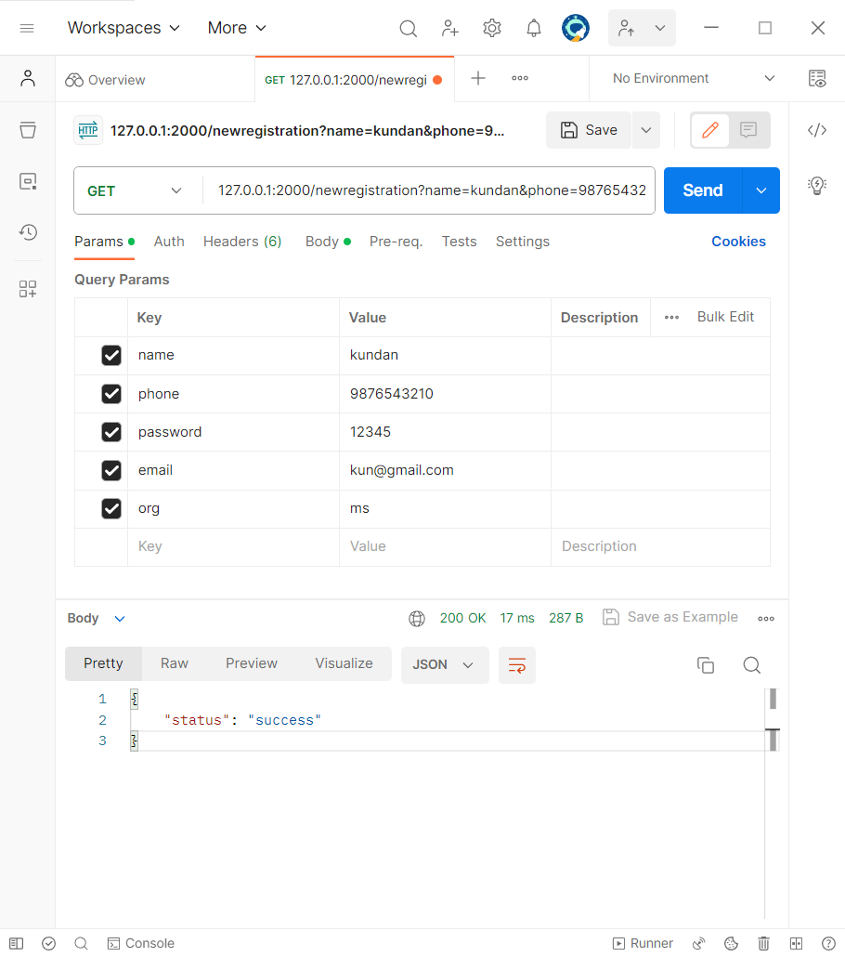

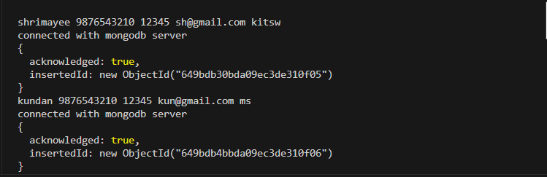

We can see that that the values are stored successfully in the mongo db database.

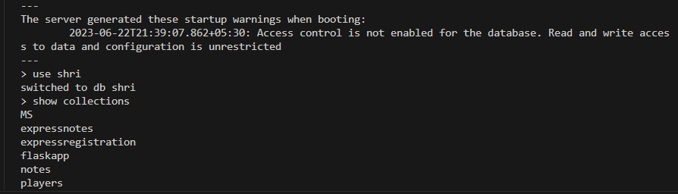

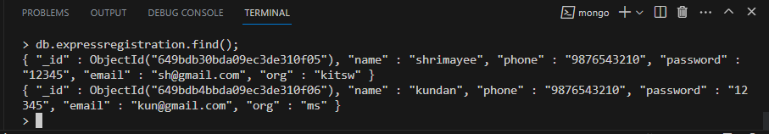

In this way we store the data in mongo db of new registrations