FULL STACK PART-4 ,ASSIGNMENT-1

Create Navigation Bar using React and Styled Components

Install the react drivers using the command----npx create-react-app reactproject

And create a folder on desktop using the command ---npc create-react-app fenotesmanager and the folder is created on desktop

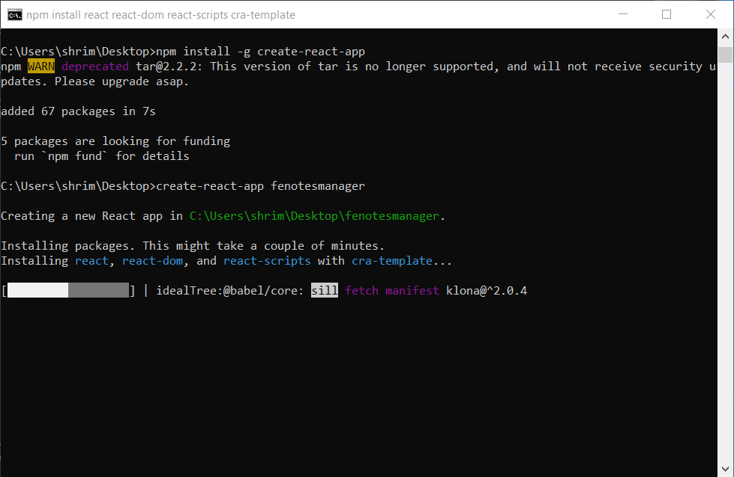

Remove the default code in app.css and create a folder components and folder pages in src folder

Now cerate a file in components named navbar.js and navbarelements.js for navigation bar

Now install bootstrap framework in the library using command---npm install react-bootstrap

Install simple react snippets extension in vs code

Npm install react-icons in the folder and install npm install [styled-components@5.3.10](mailto:styled-components@5.3.10)

Now write the code in navbarelements.js and into navbar.js

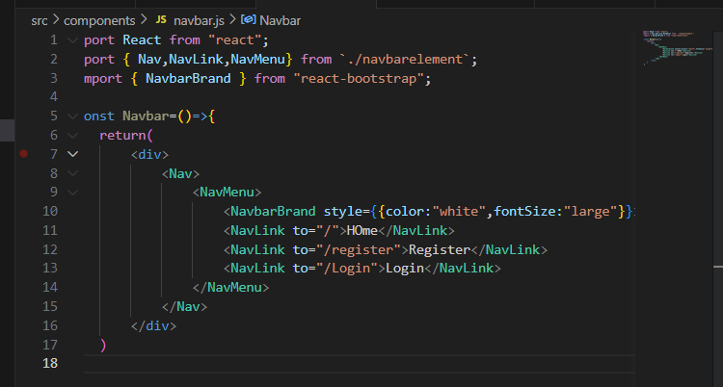

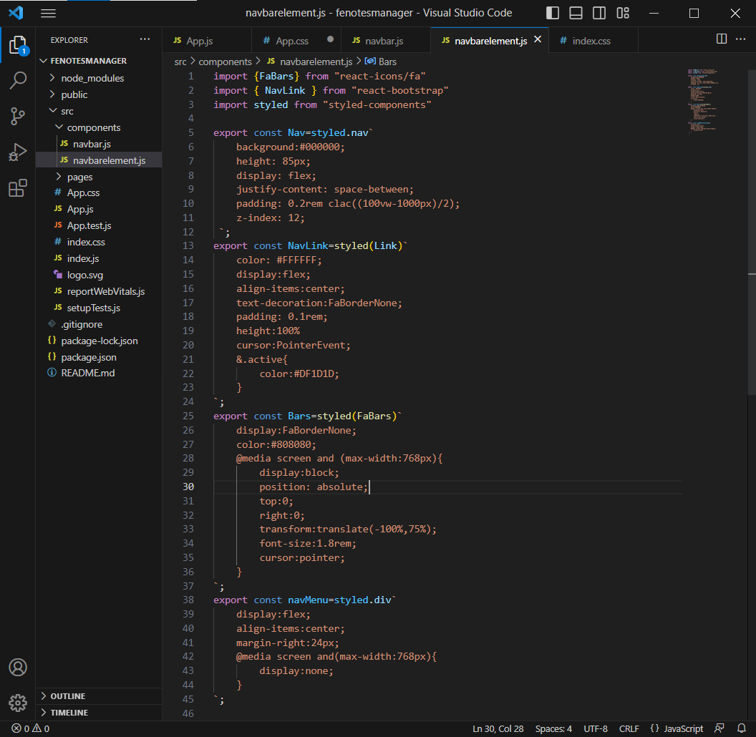

Now create a new file in pages folder as index.js,login.js and register.js.