FULL STACK PART-4 ,ASSIGNMENT-4

Connect Register Page with BackEnd API

Run the backend server that we created in full stack part 3

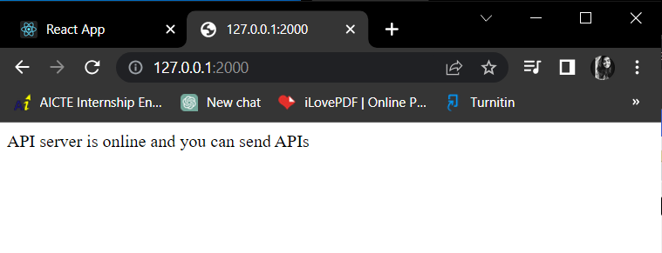

Connecting the backend server

