FULL STACK PART-4 ,ASSIGNMENT-5

Create Login Page Front End

Write the code in login.js to create a front-end for login page

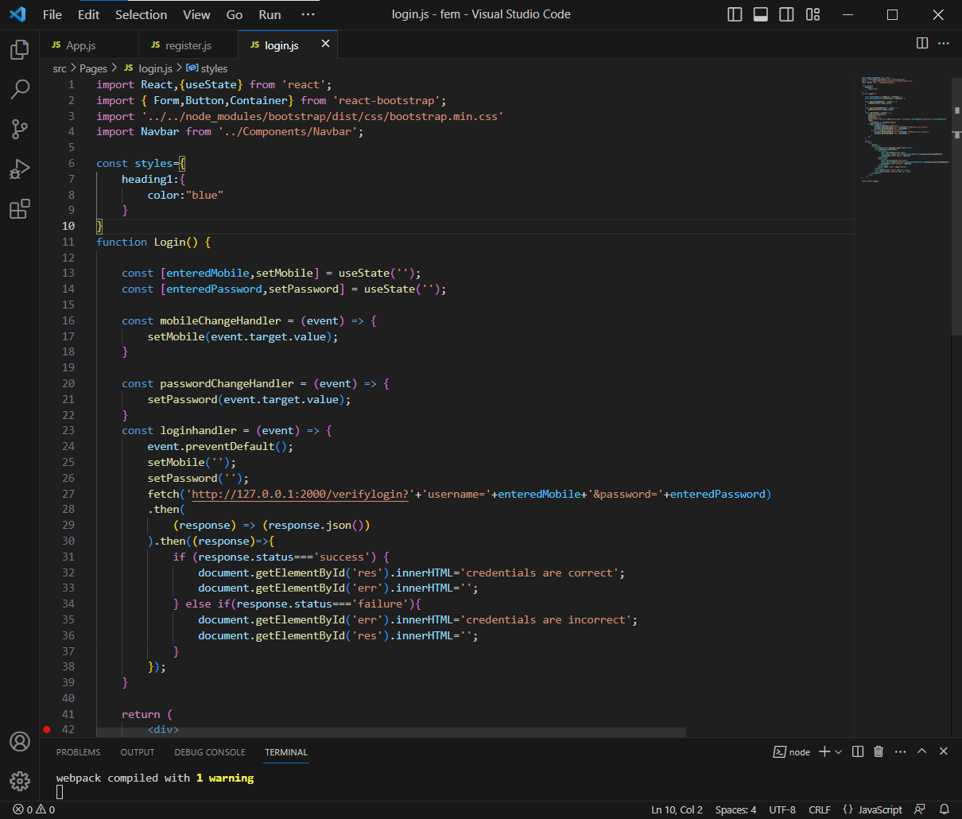

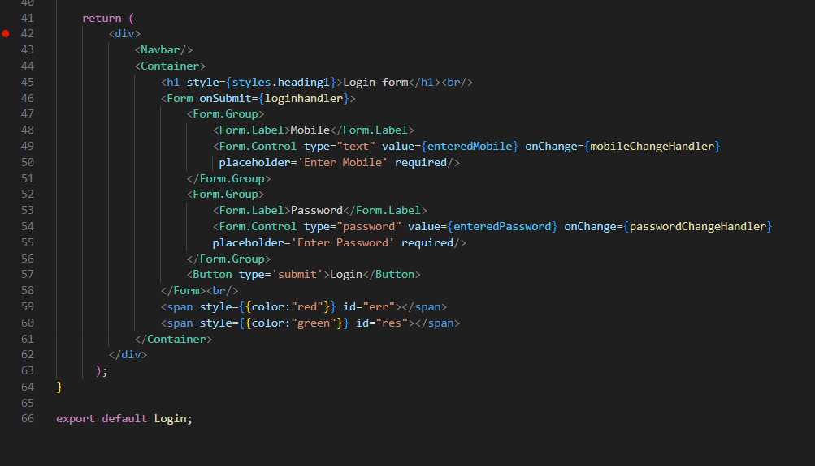

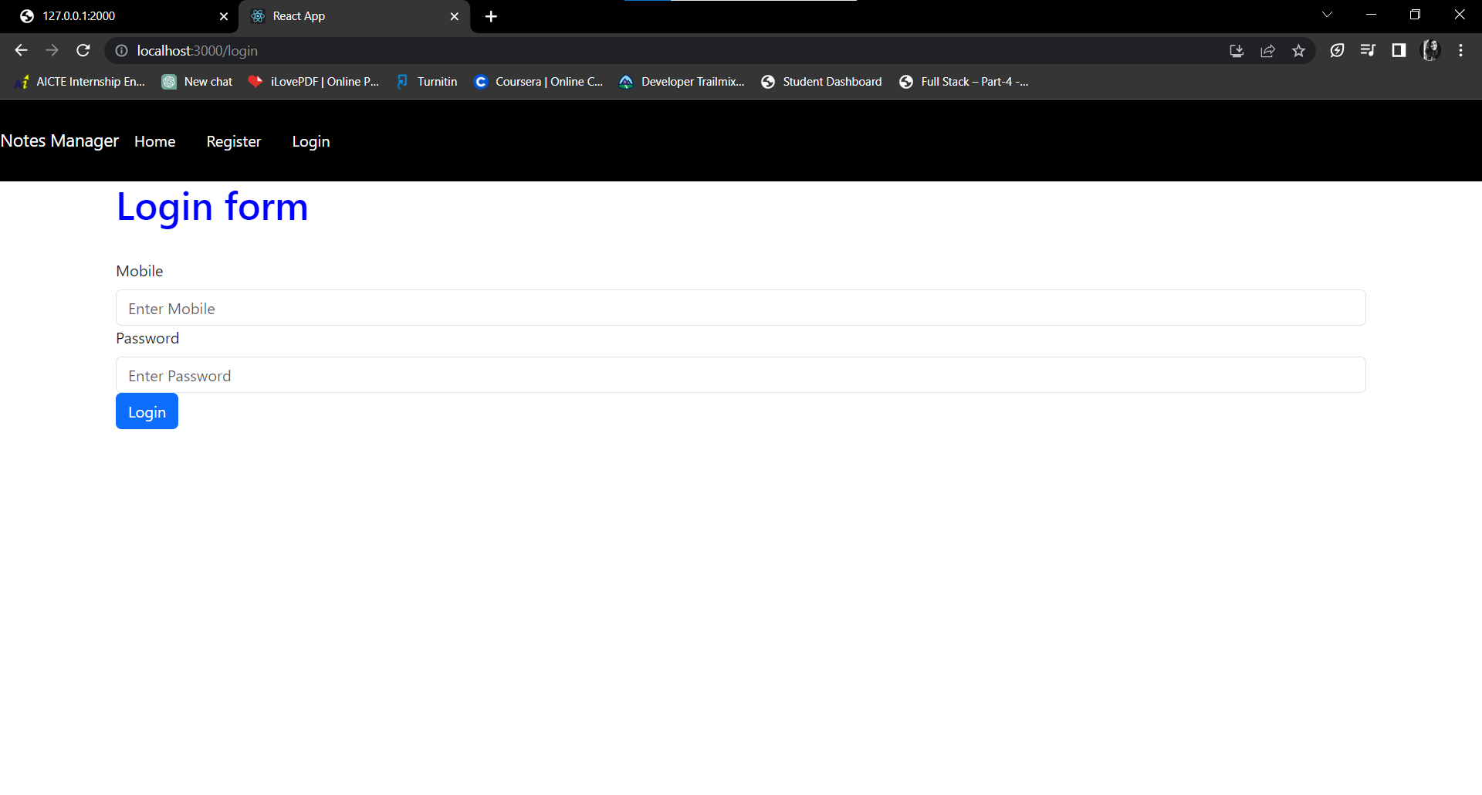

Login page front-end