FULL STACK -4 ASSIGNMENT-7

Create Dashboard Page

Create a file in the pages folder and name it as dashboard.js and write the code into it

Add the route to app.js and connection to dashboard.js as we log in with valid credentials.

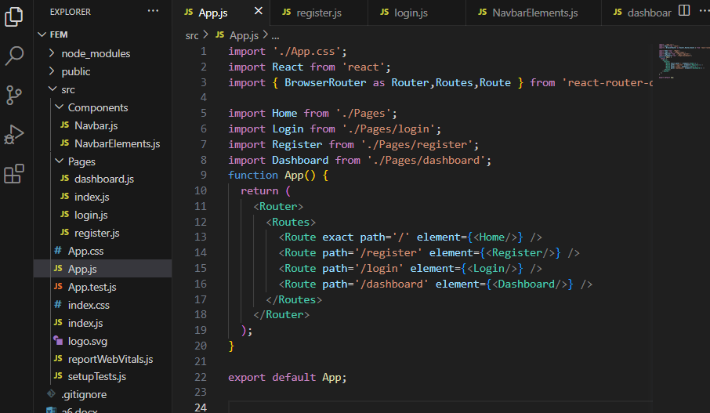

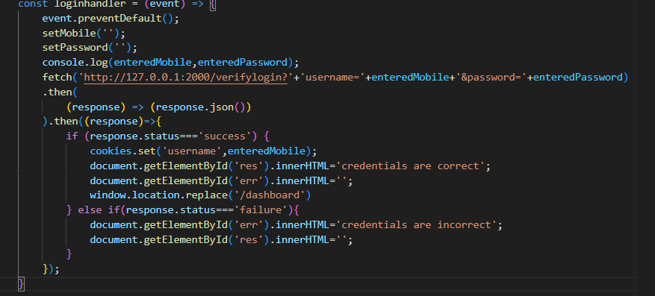

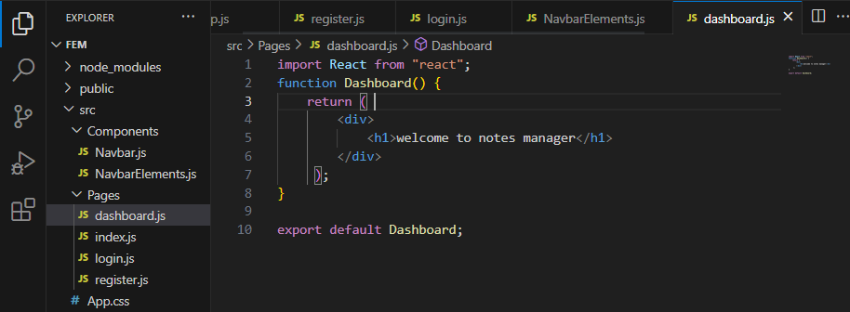

The output seems like..

