FULL STACK PART-4 ASSIGNMENT-8

Create Insert Notes Page Front End

Create a file named insertnotes.js in pages folder and write the code into it

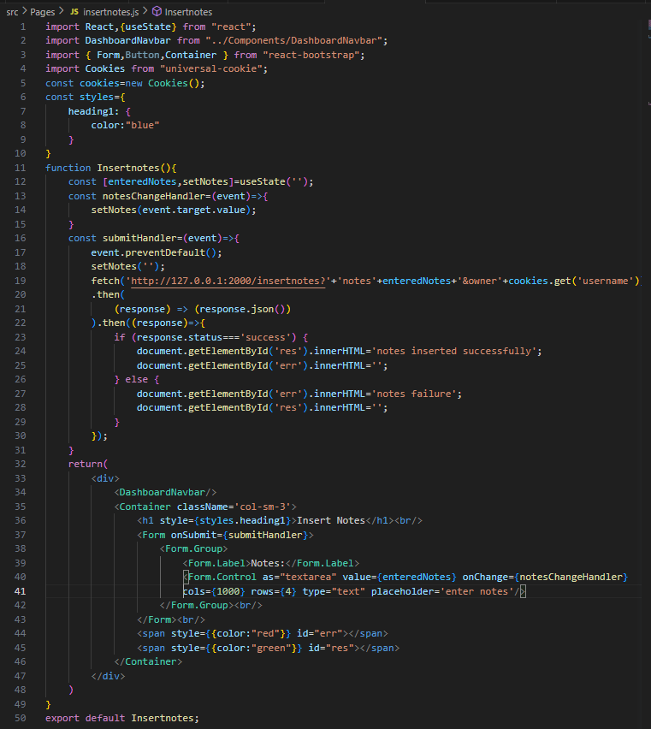

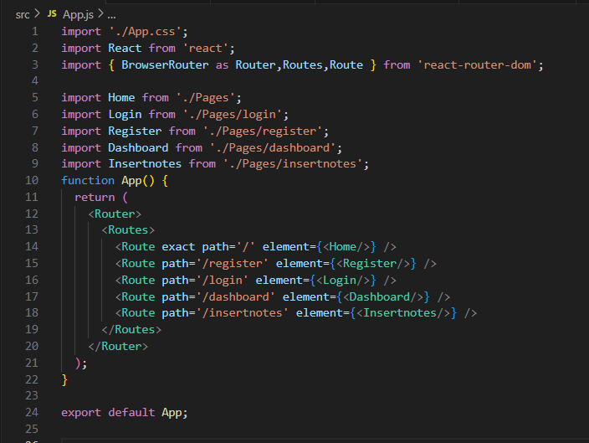

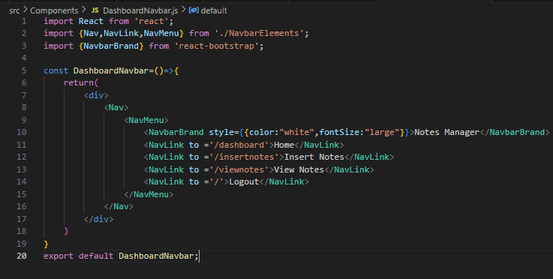

And the output is

