FULL STACK PART -1 ASSIGNMENT-1

Create a Register Page (HTML) and bind it with Python API

1. Create a folder on desktop with name A1 and open it in the vs code
2. Now create another folder within the folder as ‘templates’ which holds all the html files
3. Create a new file named ‘index.html’ in the templates folder and write the code for index page
4. Using “getbootstrap.com” for the front end application as it customizes the components we need ,have snippets and to build and extend in real-time with CSS Variables.
5. Linking it with css and javscript links in the head ,

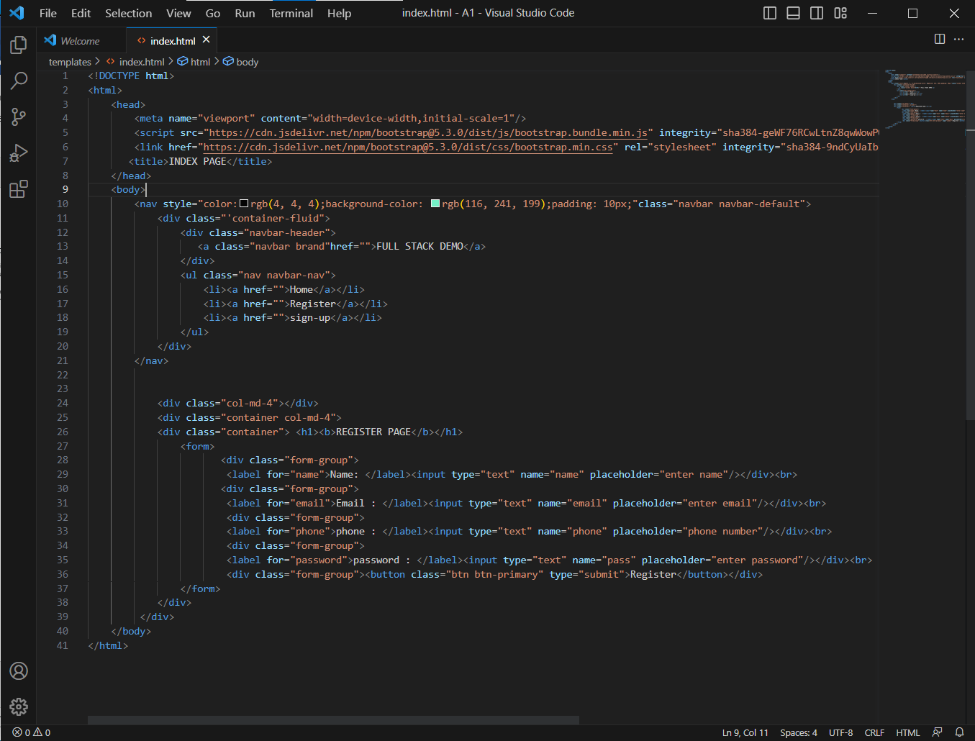

1. Create a file app.py in the a1 folder outside the templates and write the code to import flask and attributes

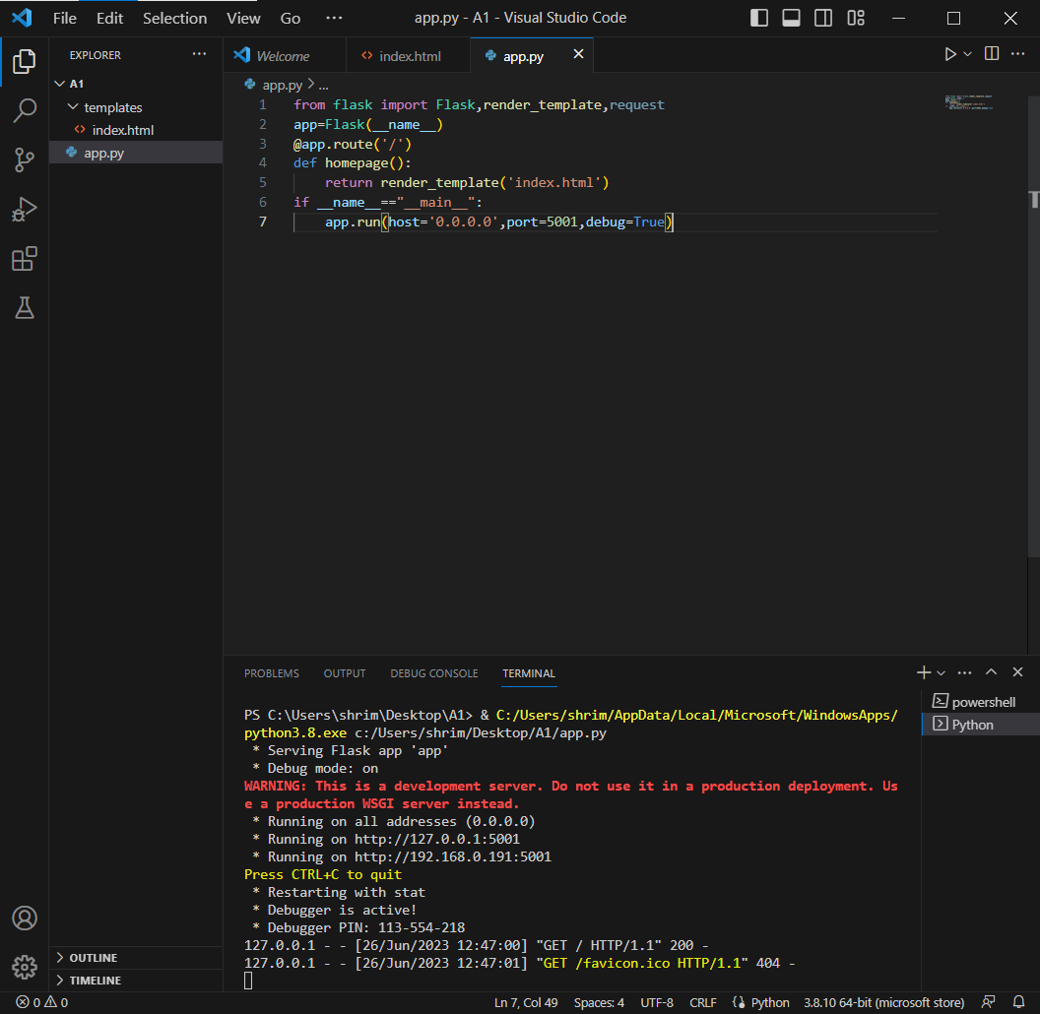

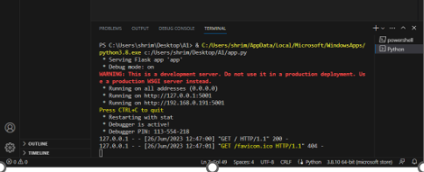

1. When you follow the link running on http you will be followed to the web page we just created.

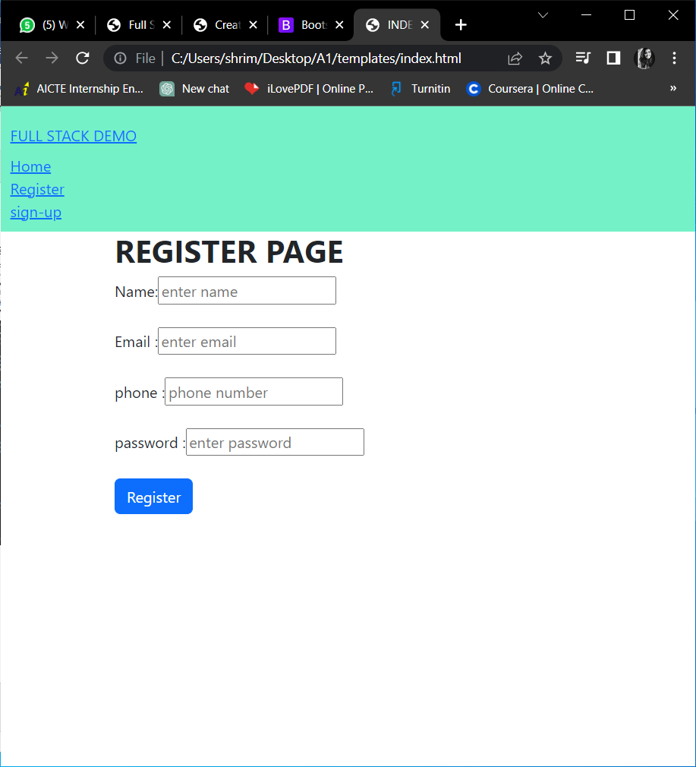

1. Now for the form to take the inputs using the method post and defining form data

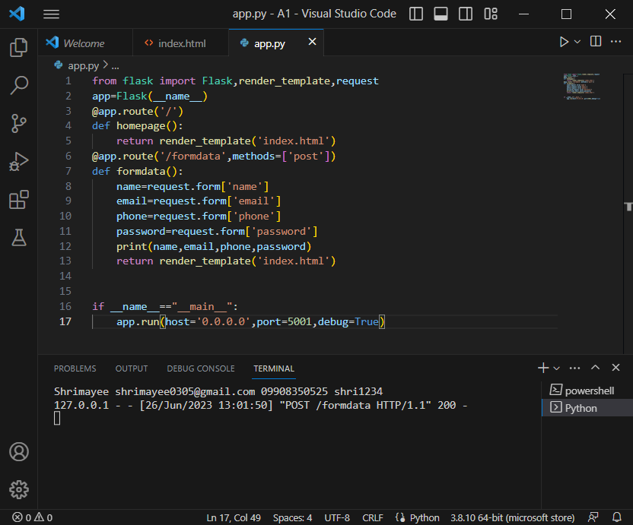

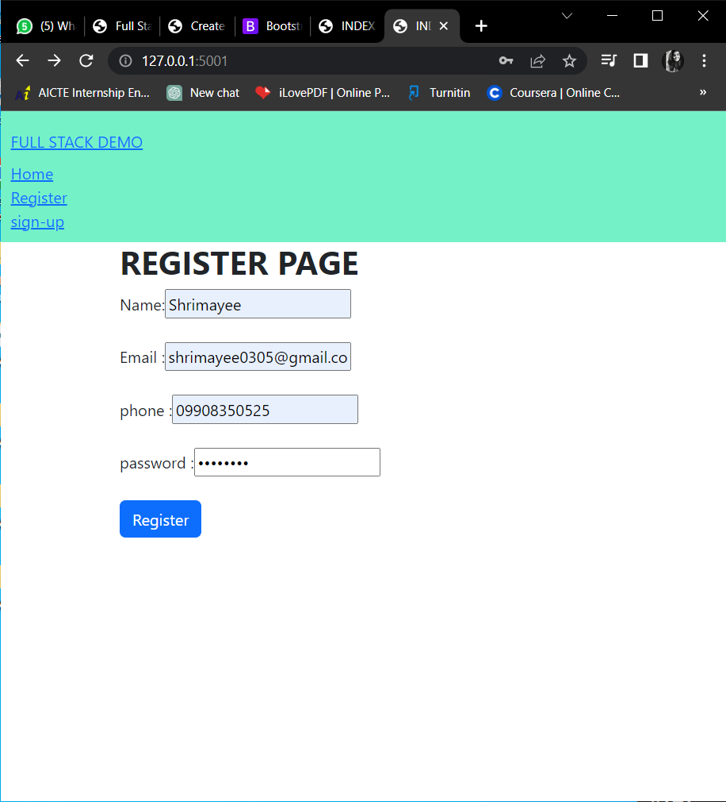

Here, we created a register page if html and bonded it with python in this assignment.