FULL STACK PART-1 ,ASSIGNMENT-4

Test the BackEnd using the Postman

Send the address in postman and append the values and test the backend using postman.

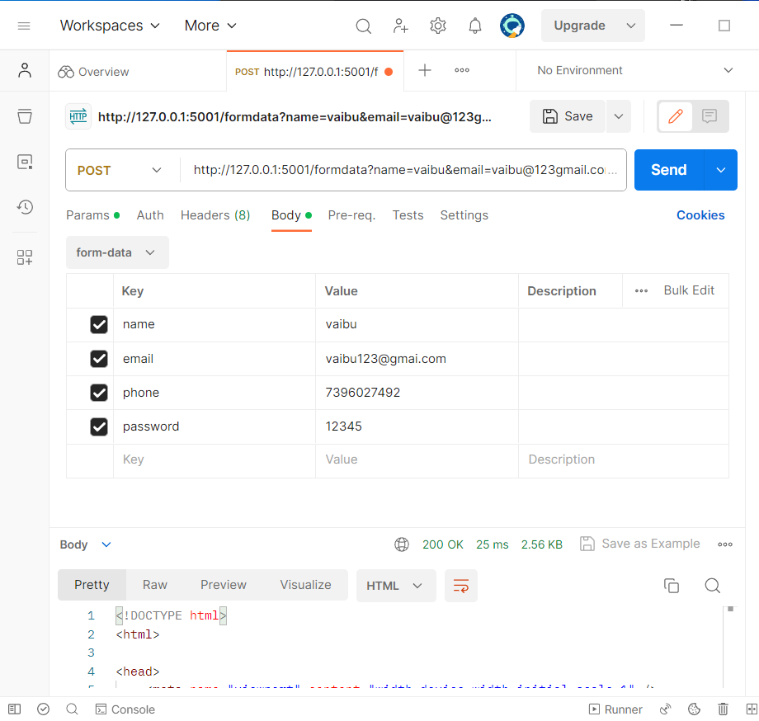



Now give the same values in webpage and you can see that you are already registered.

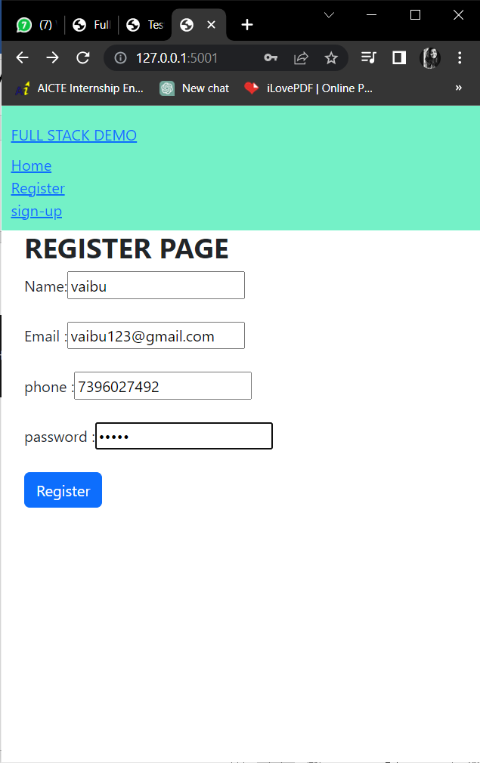

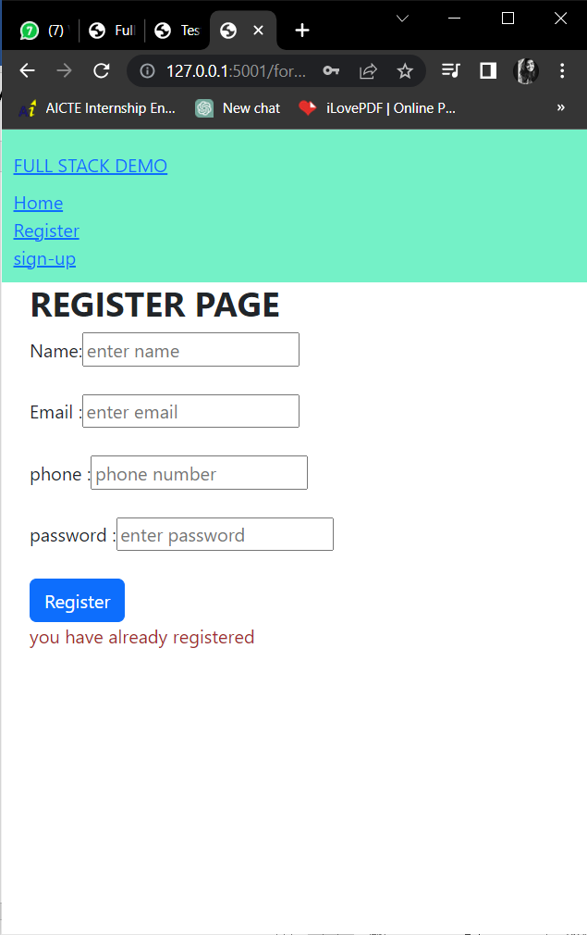

In this way we can test the backend using python.