Full stack part-2,assignment-2

Verify the Login, and display the status

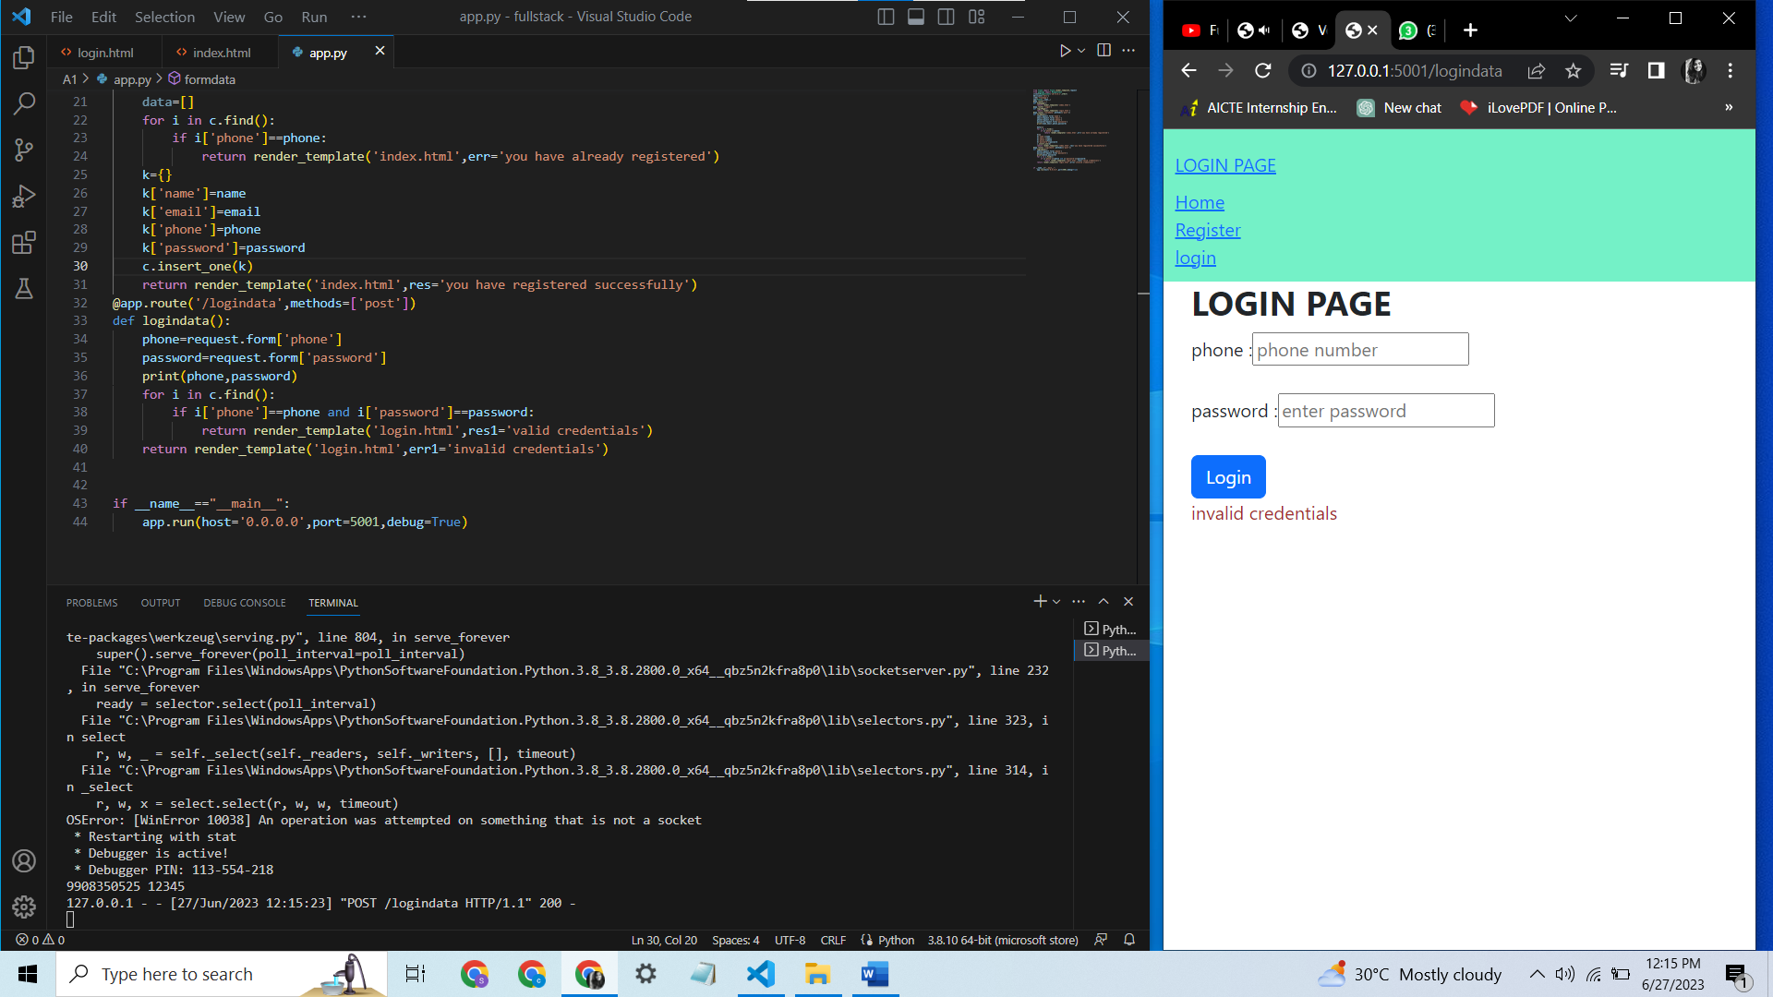

If the mobile number and password are not in the database it shows the invalid credentials

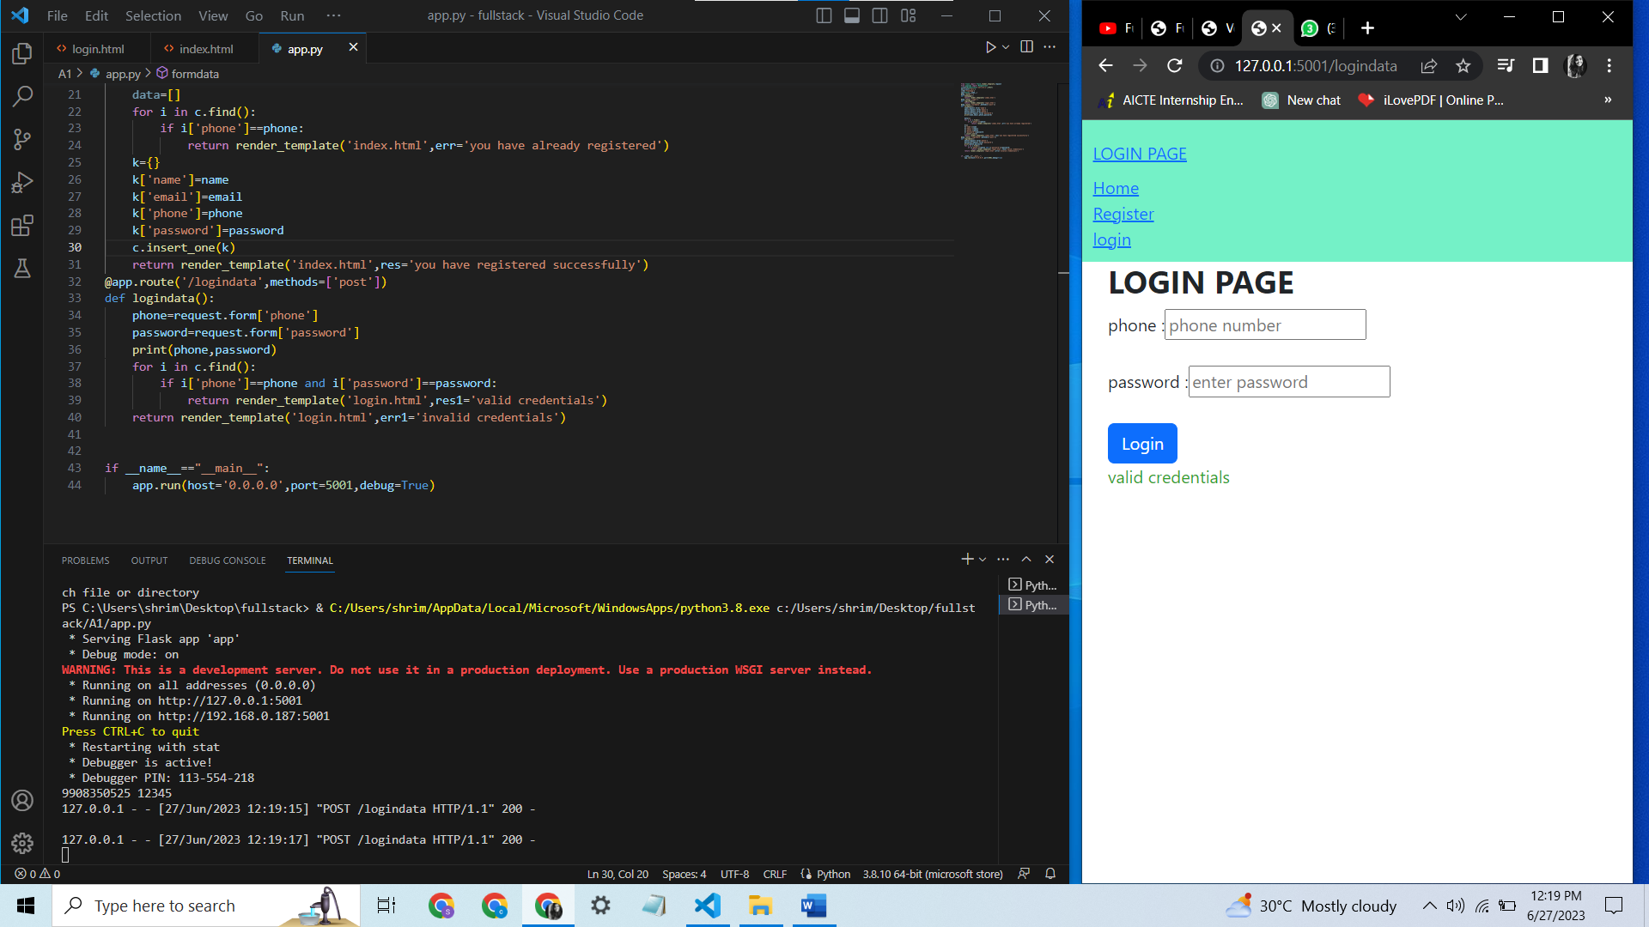

If valid credentials from database are given then it shows valid credentials