FULL STACK PART-2,ASSIGNMENT-3

Verify the Login through postman

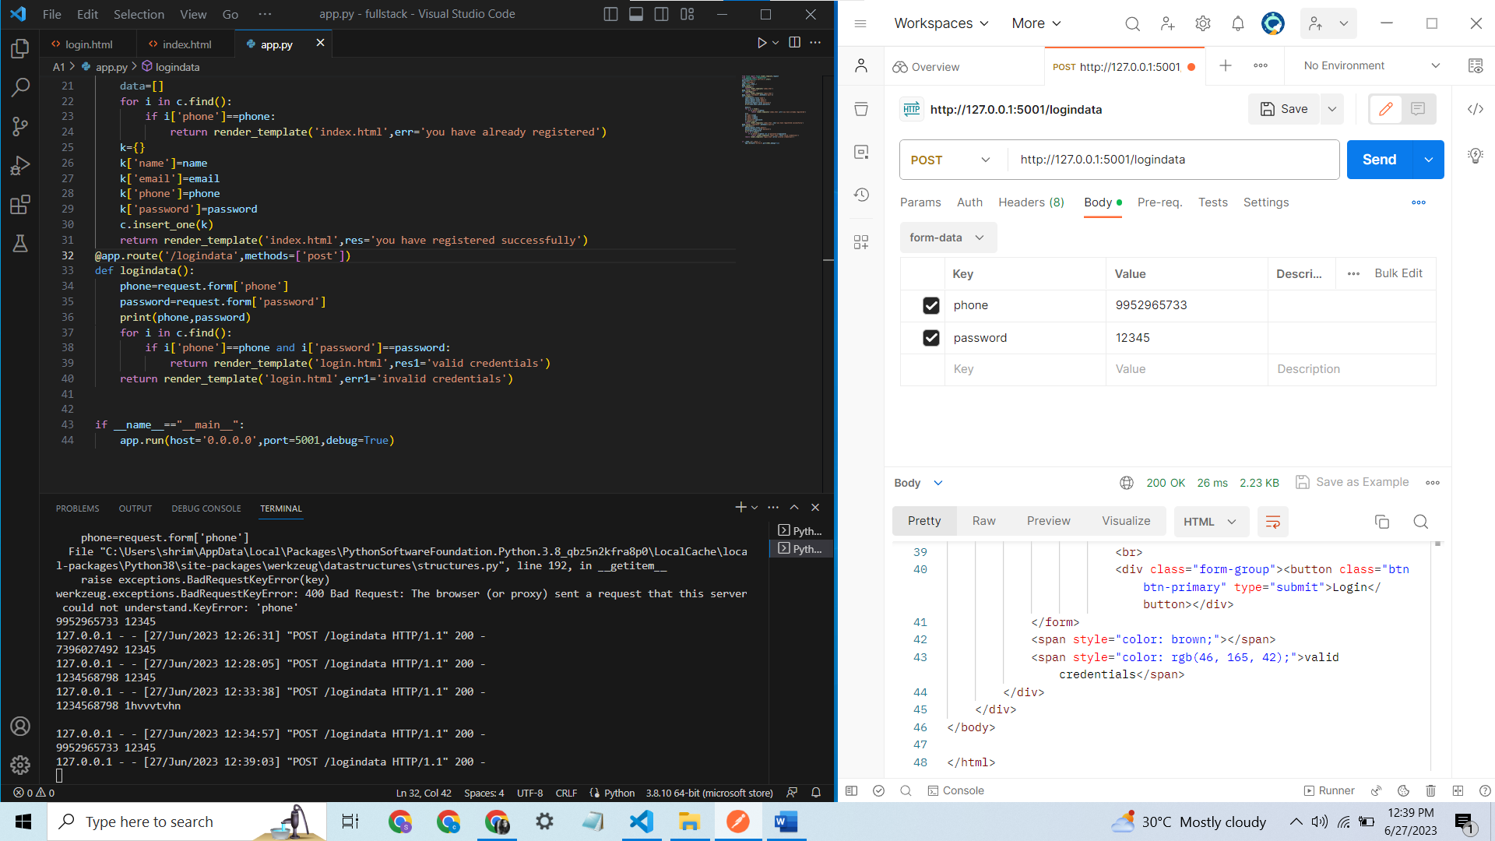

Verifying the valid login credentials through post man

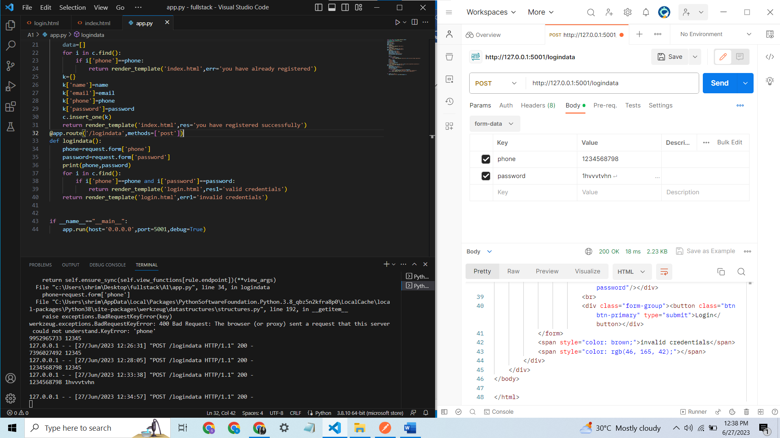

Verifying the invalid login credentials through postman