FULL STACK PART-2 ASSIGNMENT-4

Create a Dashboard Page upon a successful login

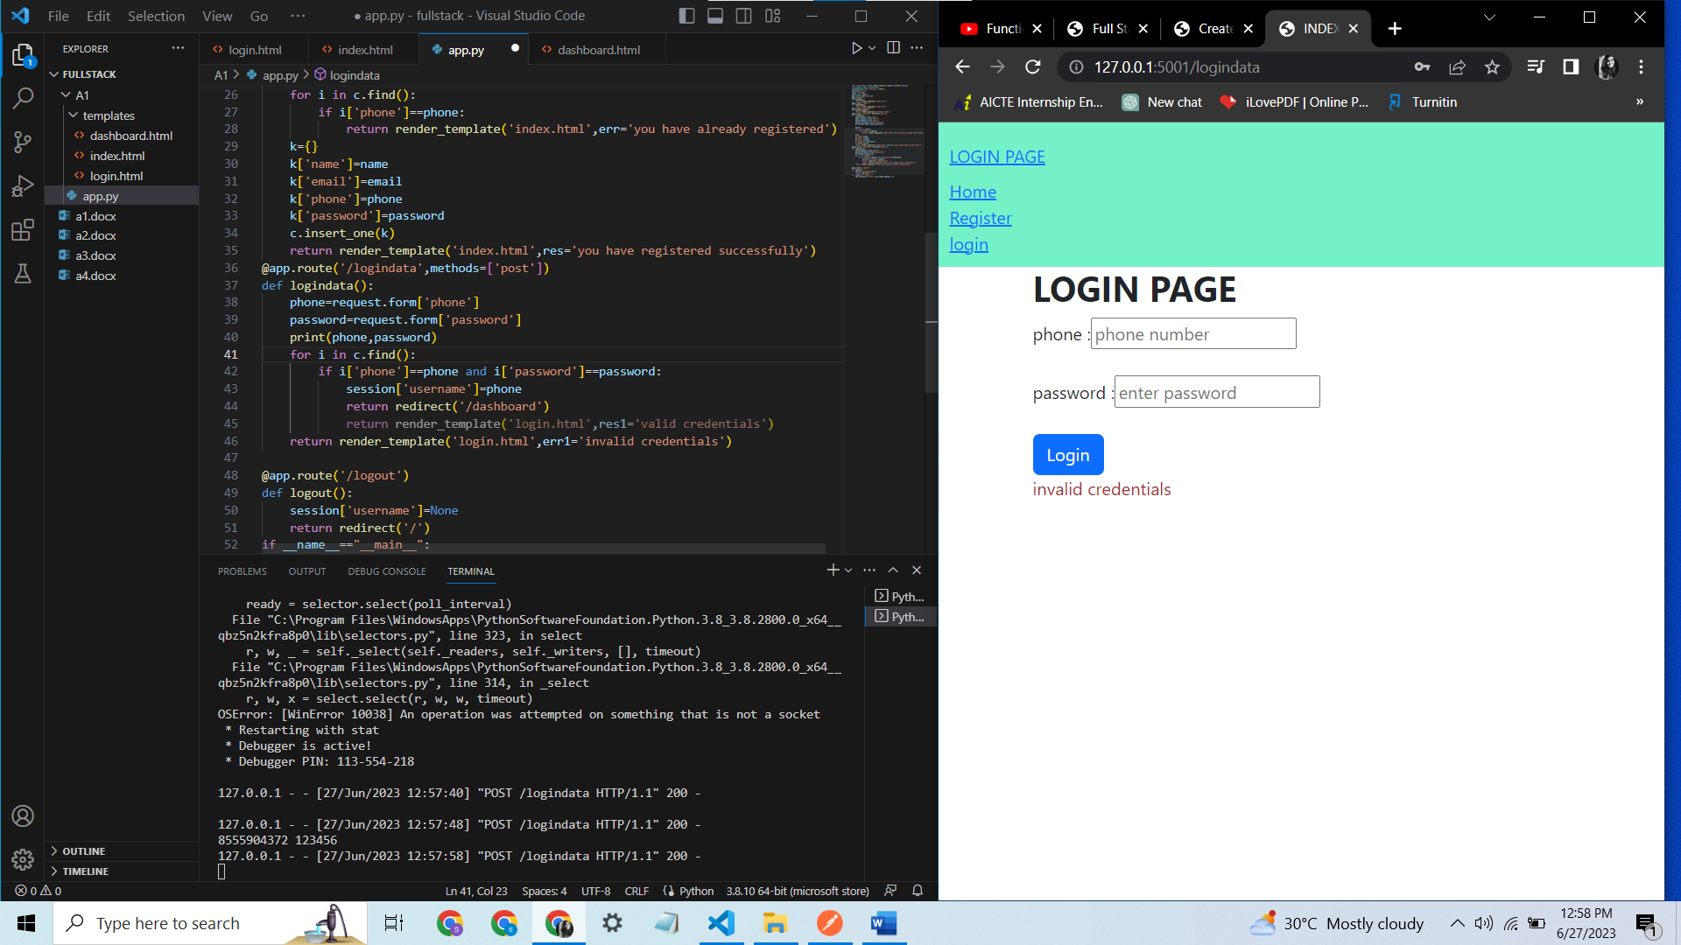

For invalid credentials

And for valid credentials

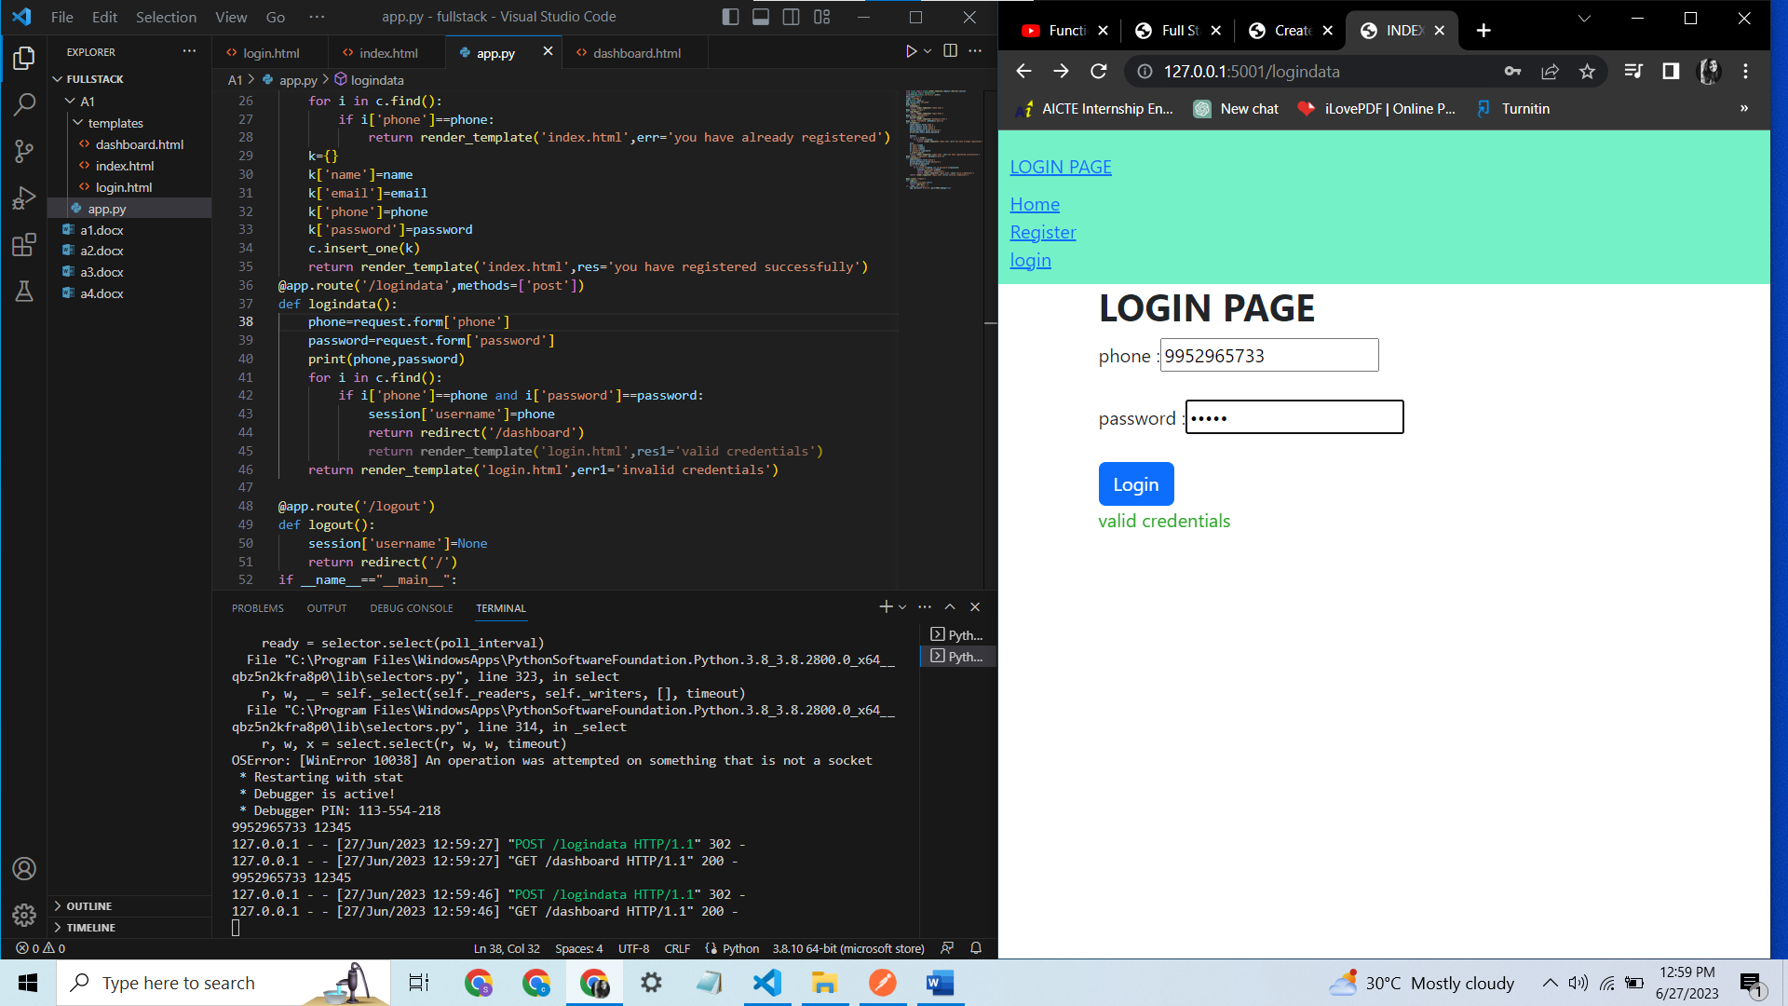

On successful login we are redirected to dashboard page.

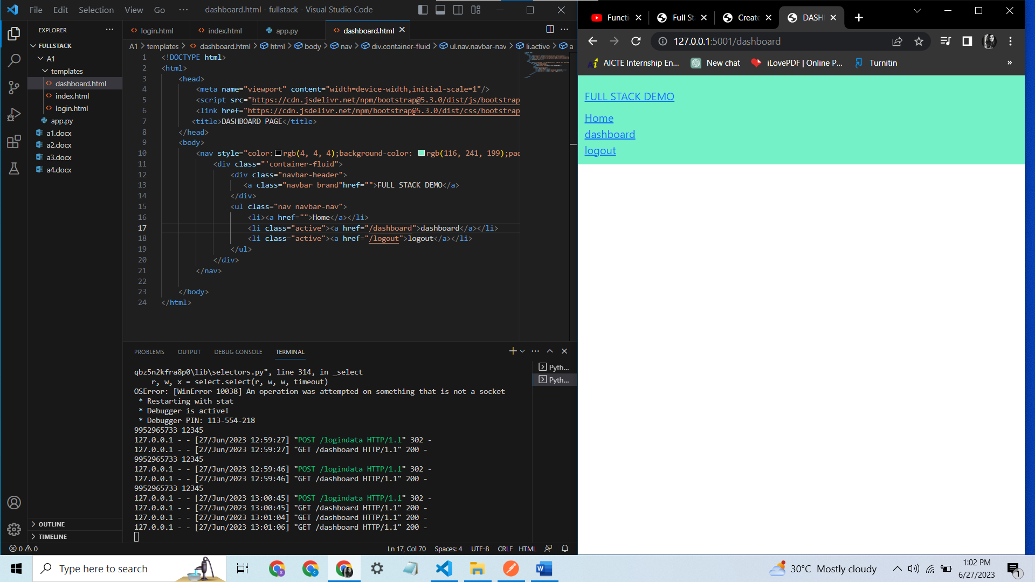

And when we click on log-out, the session is destroyed

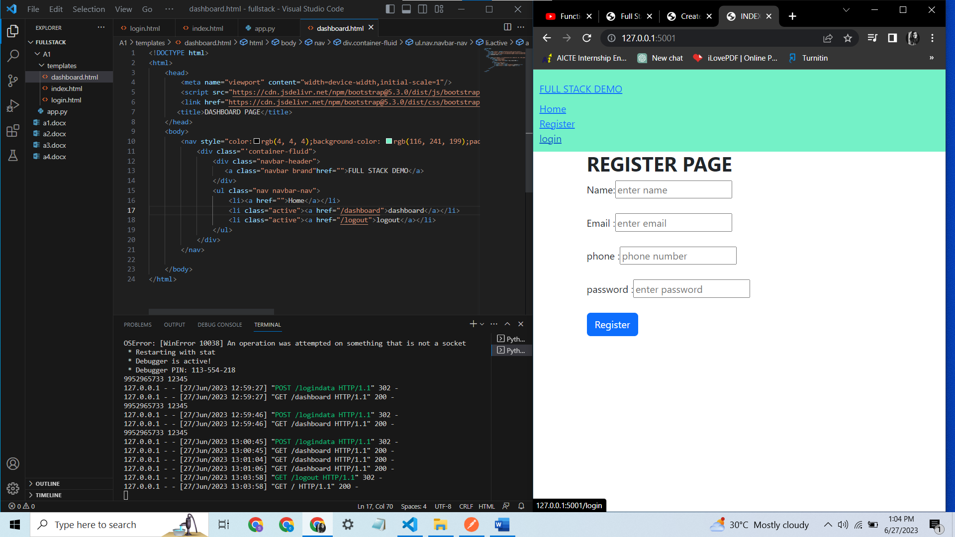

Adding insert-notes and view notes in dashboard.html

