FULL STACK PART-1,ASSIGNMENT-5

Create Insert Notes Page Front End

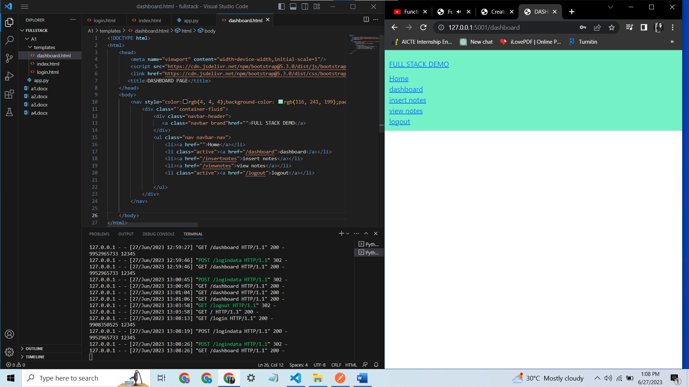

Now that the insert notes and view notes are added to the dashboard,

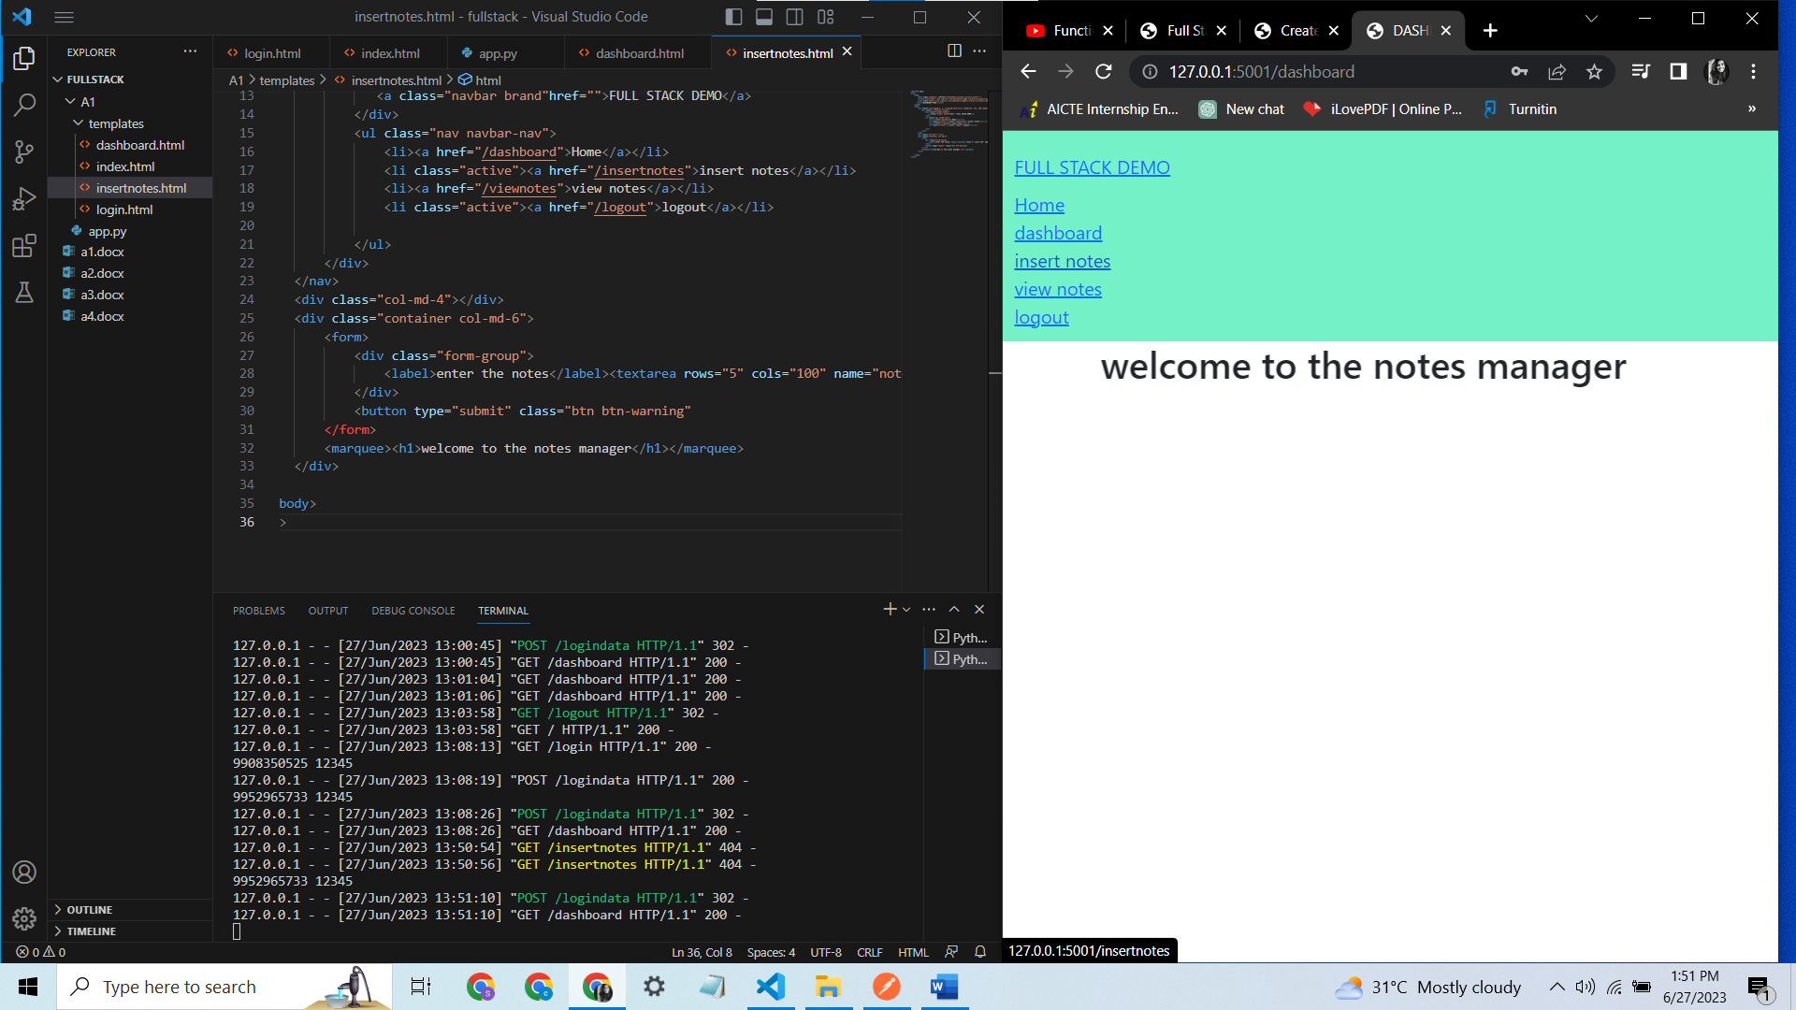

And in the insert-notes page you can insert the text

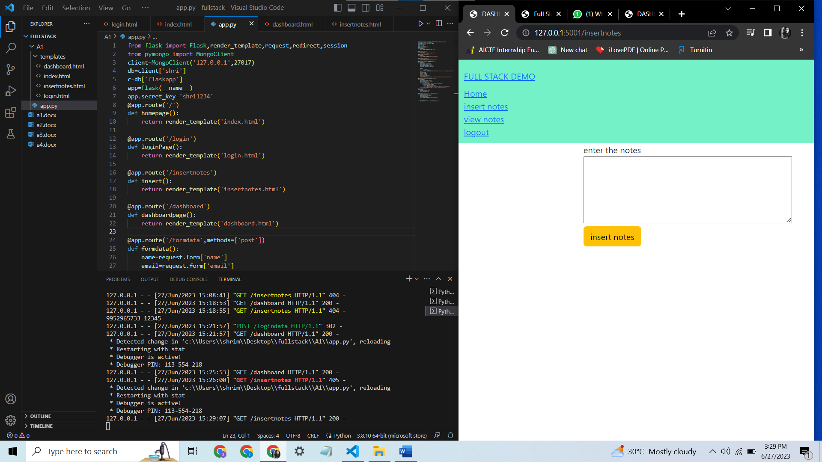

Insertnotes.html page code

