FULL STACK PART-2 ASSIGNMENT-6

Store Notes in MongoDB from Front-End

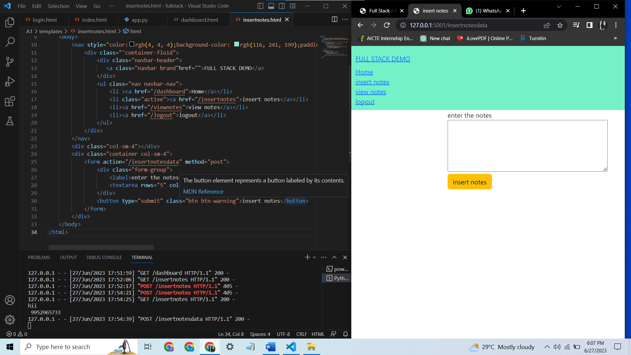

Insernotes.html code

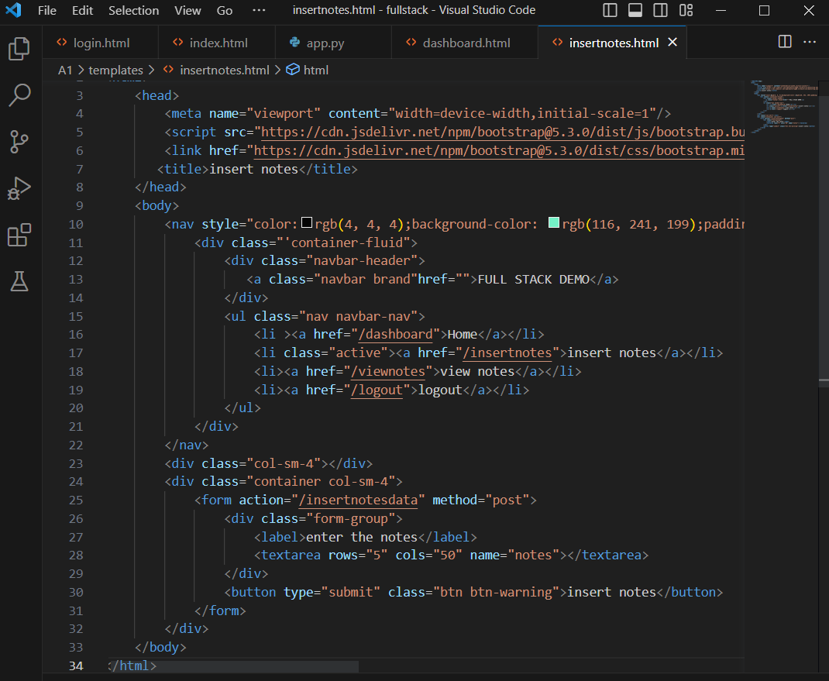

In app.py this code is added

