FULL STACK PART-2 ASSIGNMENT-8

Storing and Viewing through postman

Logging in through postman

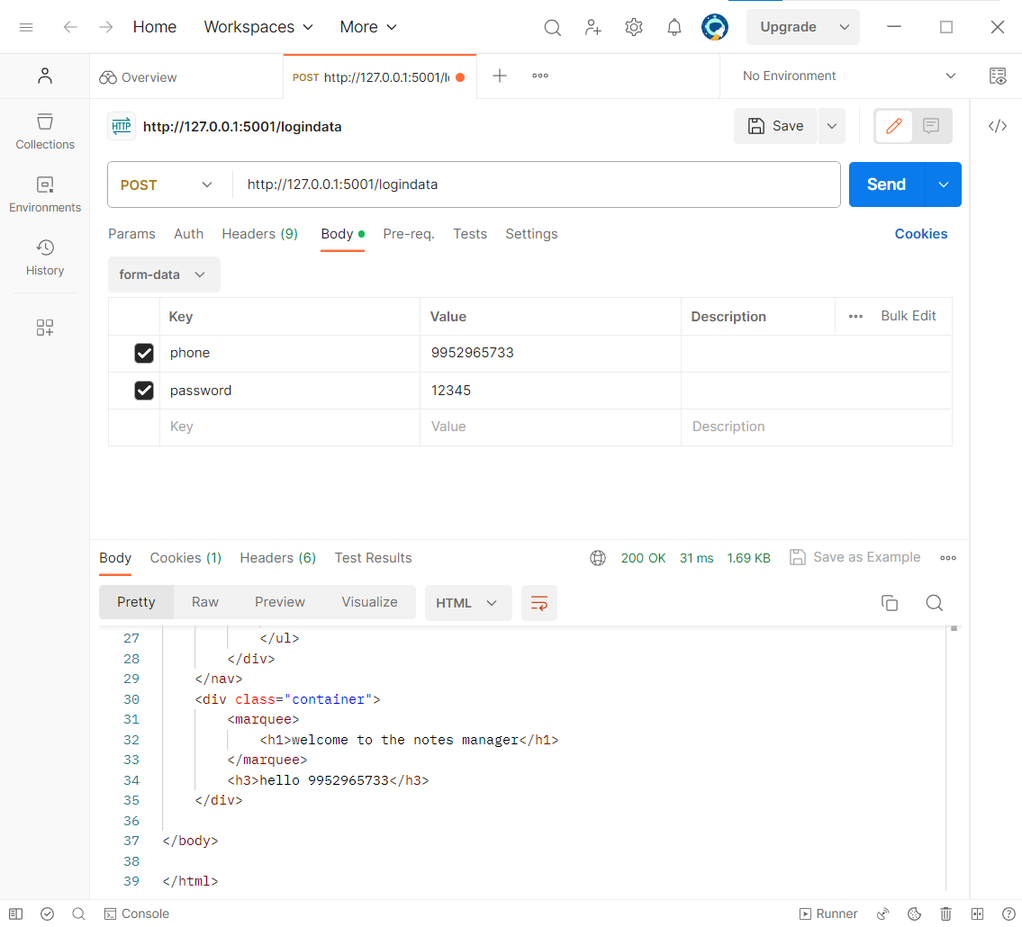

Inserting notes through postman

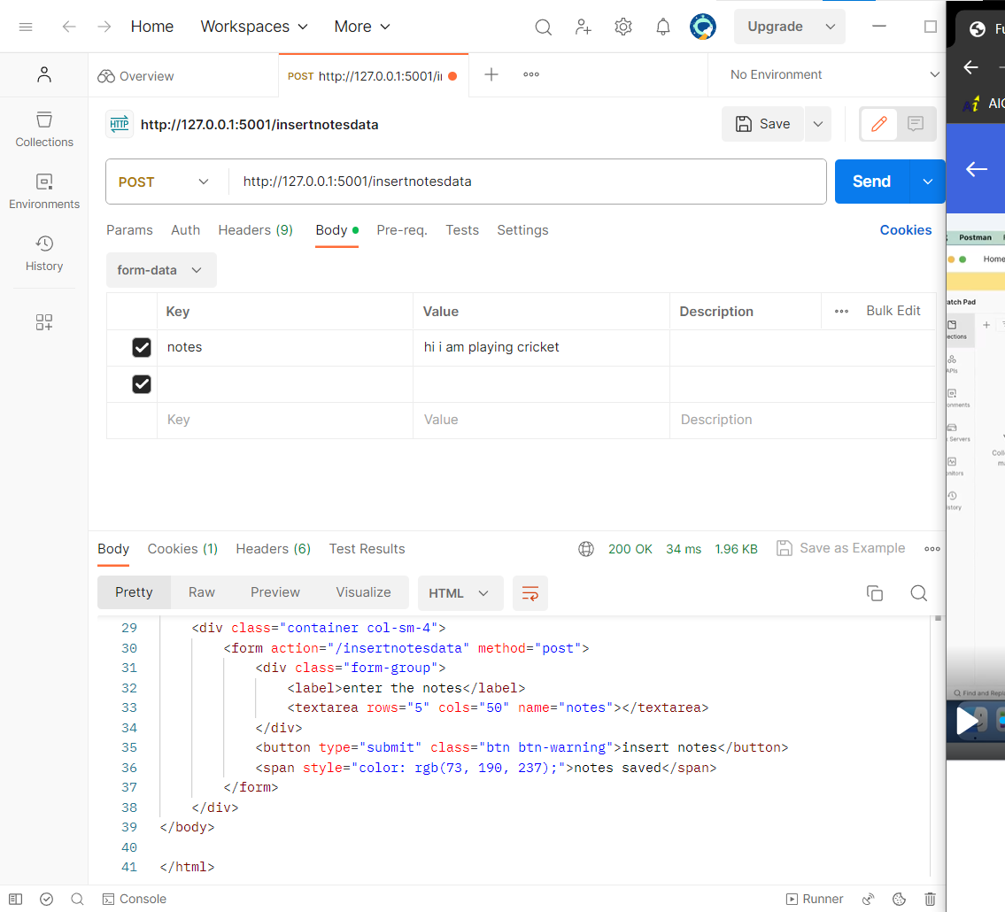

Viewing data from postman

