**Git Setting -up a Git on Laptop**

1. Go to the official Git website  of git-scm.
2. Download the appropriate setup file based on your system: "64-bit Git for Windows Setup" for Windows Setup."
3. Once the download is complete, locate the setup file and double-click on it to start the installation.
4. Leave the default options selected as they should work for most users, or choose alternative options if desired.
5. On the "Adjusting your PATH environment" screen, choose the option "Git from the command line and also from 3rd-party software."
6. Continue with the installation by clicking "Next" and "Finish."
7. To verify the successful installation, open the command prompt or Git Bash  and type git . This command will display the installed Git software if the installation was successful.

**Process of creating git repository**

1. Initialize the repository

This repository created is the empty repository and is initialized (local)

1. Write code for the given task in visual studio
2. Add the file to the local repository

Tells you what you have added

1. Commit this change in the repository

Tells who made the changes

1. Push the local repository to the remote repository

**ASSIGNMENT -1**

1. Open the command prompt from the start menu.
2. Change the directory to the desktop using the command --- ***cd <directory name>***

Here: cd desktop

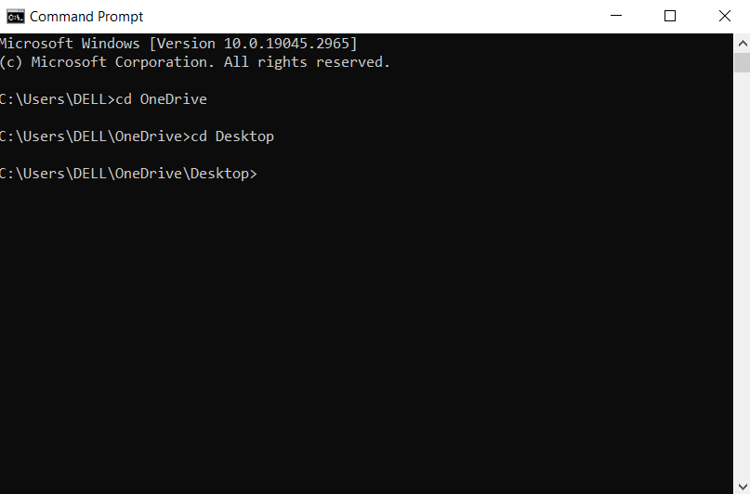

1. Now the directory is changed to desktop.
2. Create a directory with name of the file using the command ***--- mkdir<filename>***

Here: mkdir exprog

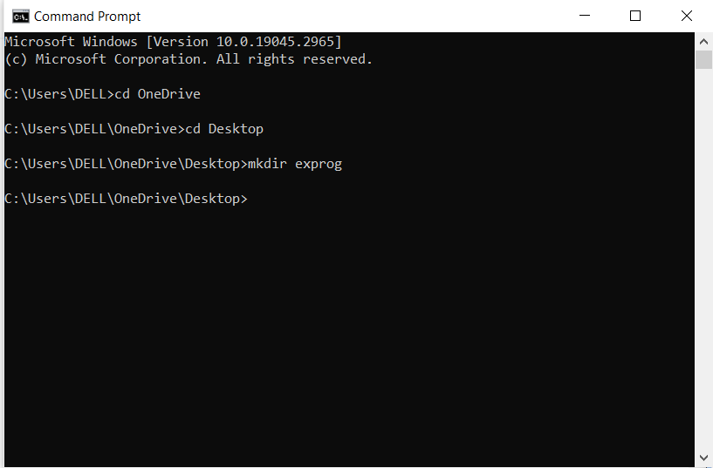

1. Now again change the directory to the created using the cd command .

Here: cd exprog

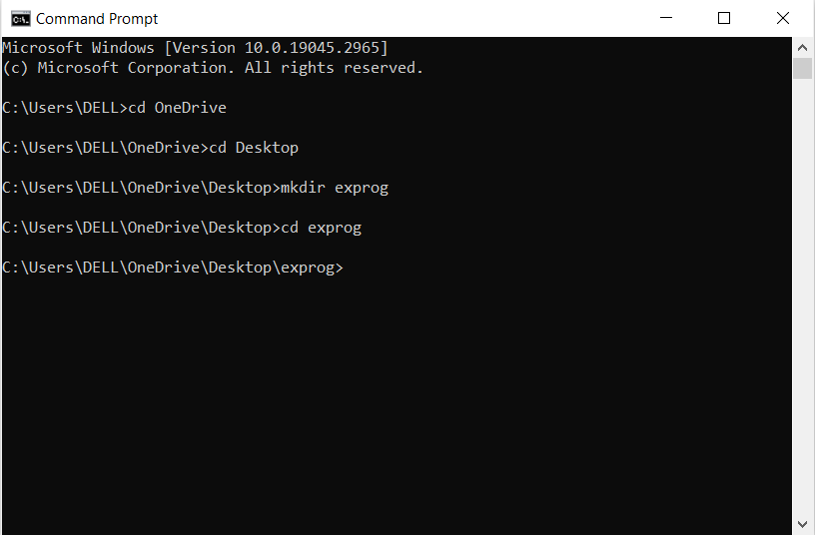

1. Initialize the repository using the command***--- git init***

Now an empty repository is created.

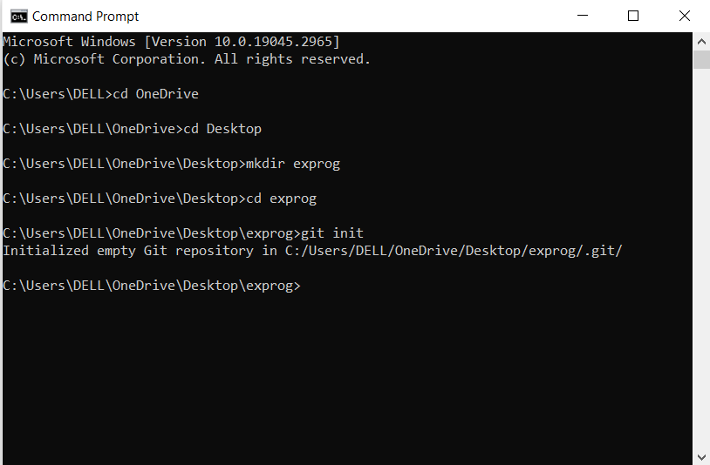

1. Open the visual studio code and in the left top corner click on the files on it and select open folder.

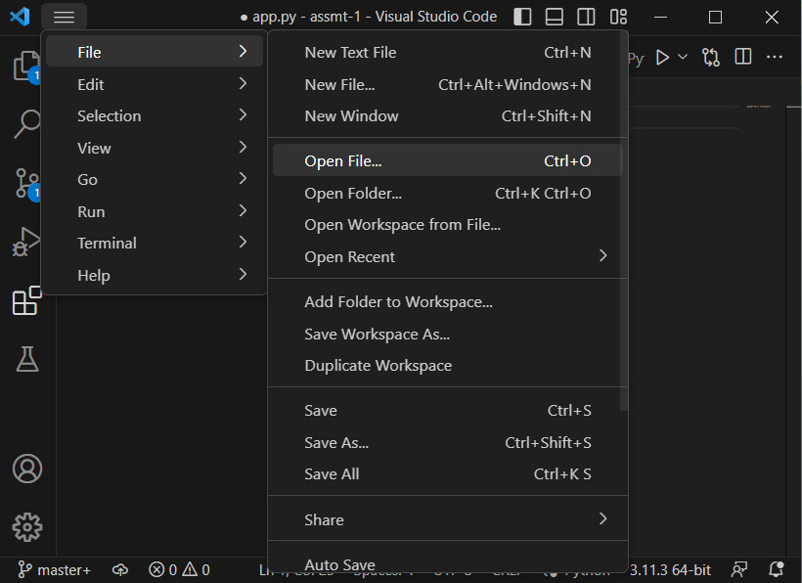

1. Now write a program in python using visual code studio and give name as <program>.py inside the directory you created

Here: ex.py

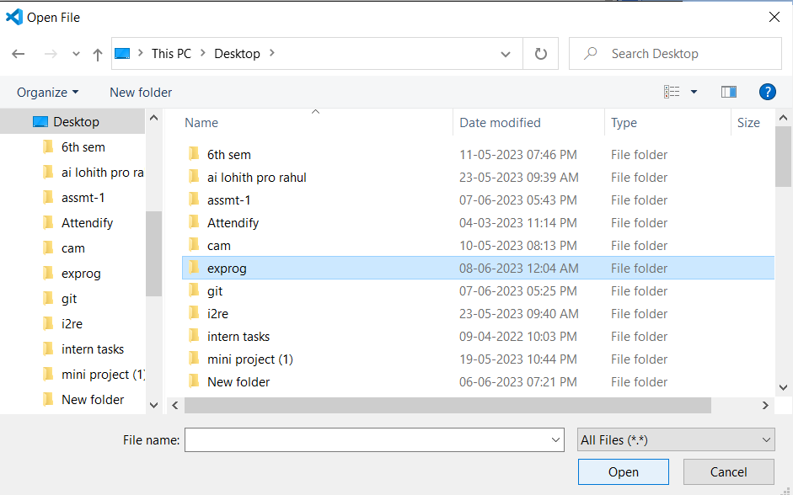

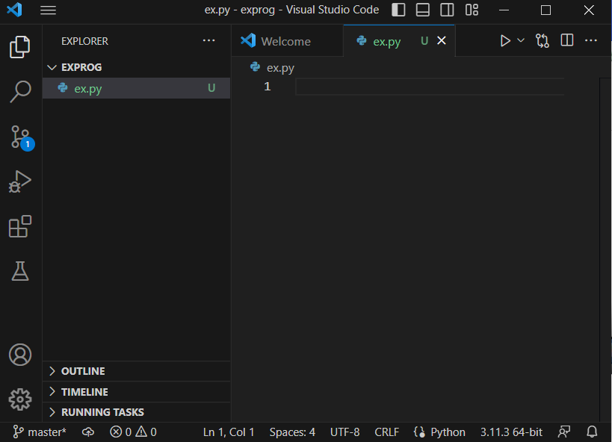

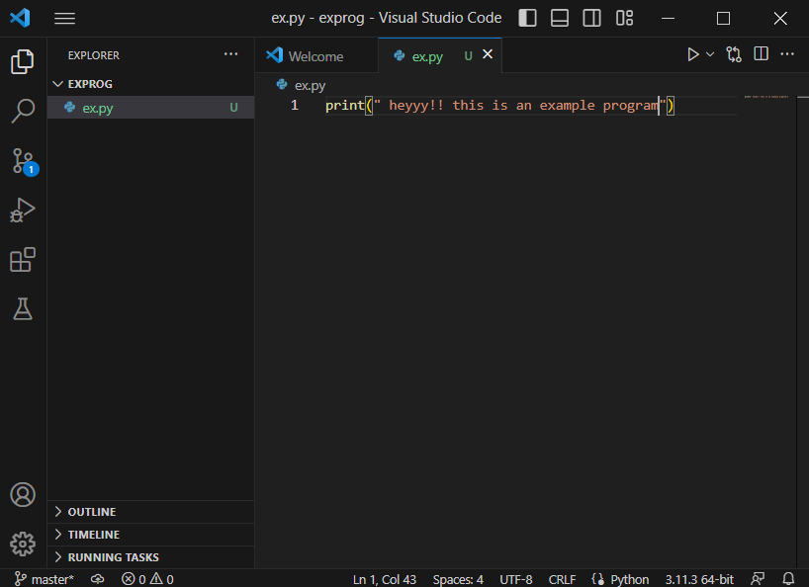

1. Now with the command ***--- git status*** ,you can see if the if the present file is being tracked or not. it shows the status of the file.

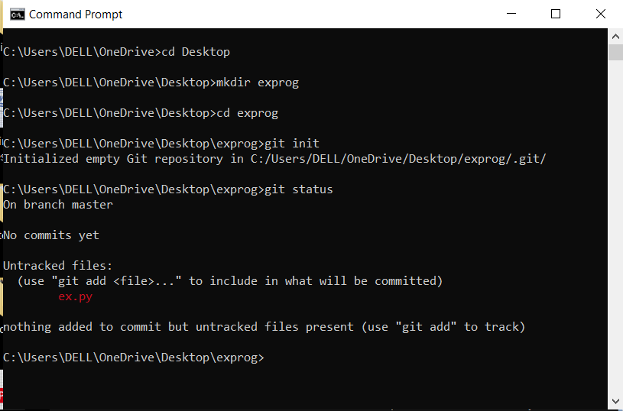

Here on git status command the ex.py is untracked because it is not added in the repository.

Note: Only if the repositories are added to the git they can be tracked.

1. Now we add the program to the repository by the command ---***git add <program-name>.py***

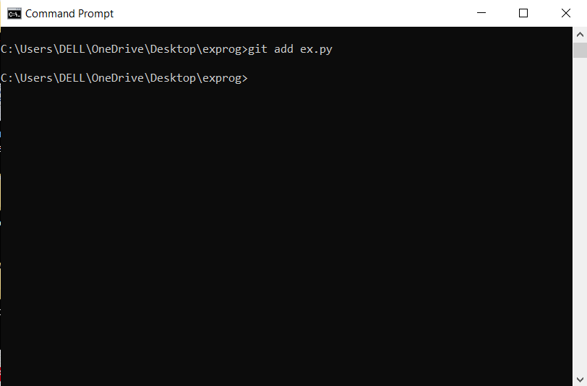

Here: git add ex.py

We can also run the program using git command***---python3 <program name>.py***

1. Now again check the status of the folder and with command ***---git status***, you can see that there is a new file named (here) ex.py . here it is moved from un-stacked to stacked branch.

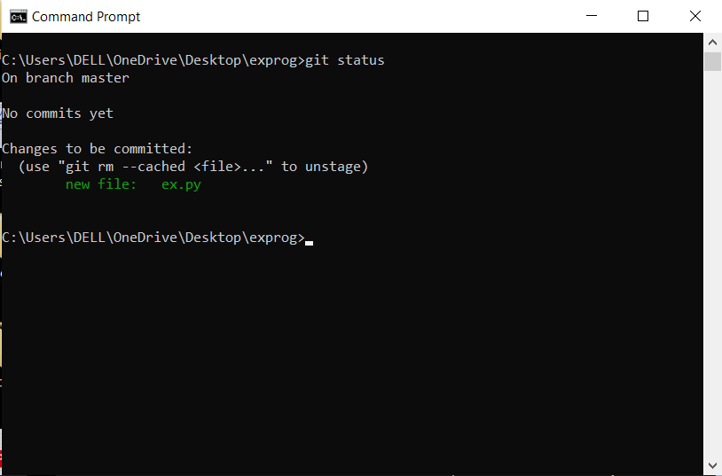

1. Now we commit the file to the repository using the command ***---git commit –m “program”.***

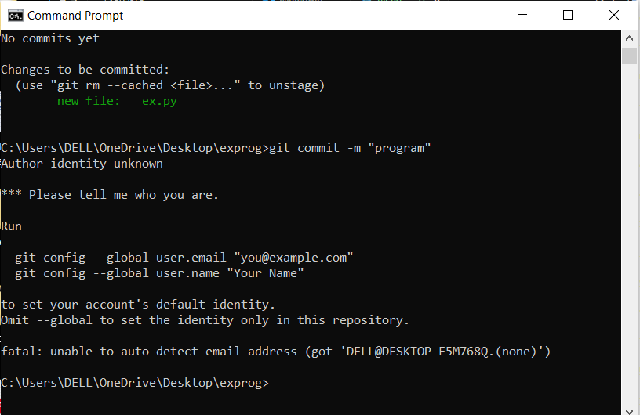

1. Now if we check the git status we can see that there is nothing to commit as we did not change anything in the program.
2. If we modify the program code then the git status is shown as changes are not committed .

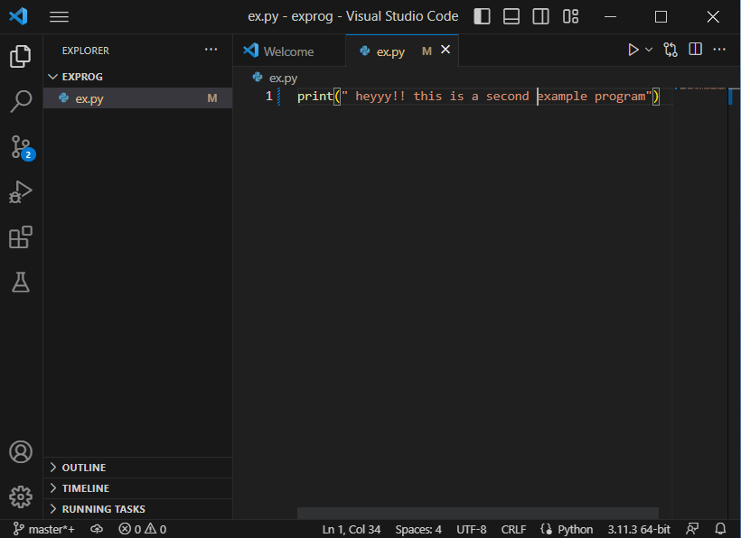

Here we modified the program and did not commit

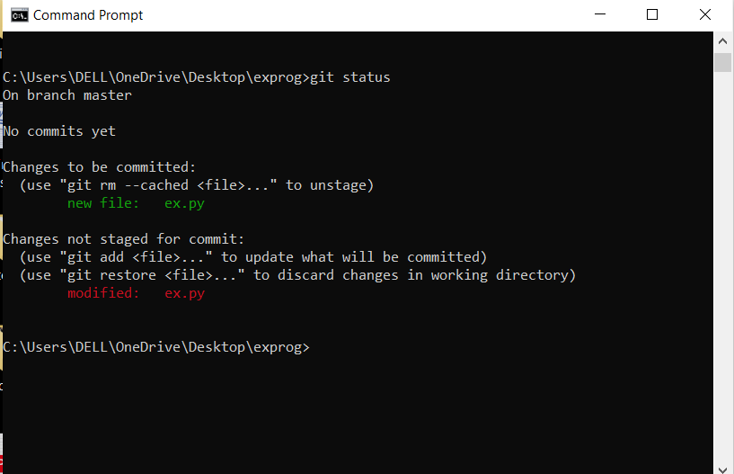we can see that it shows the ex.py is modified and changes are not staged for commit.