**Git push origingit push origin b4ASSIGNMENT-2**

1. Login into remote repository hub

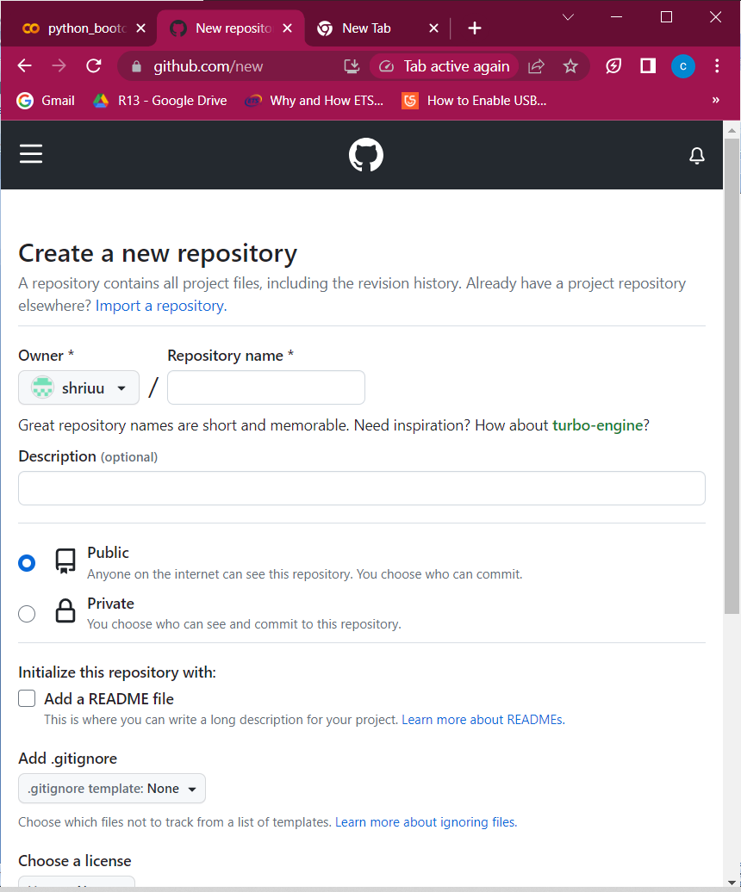

1. Create a new remote repository with repository name and add the description(optional)
2. Opt the repository to be public or private depending on the essentials.

Public: everyone on the internet can access the repository.

Private: you can choose who can see and commit to the repository.

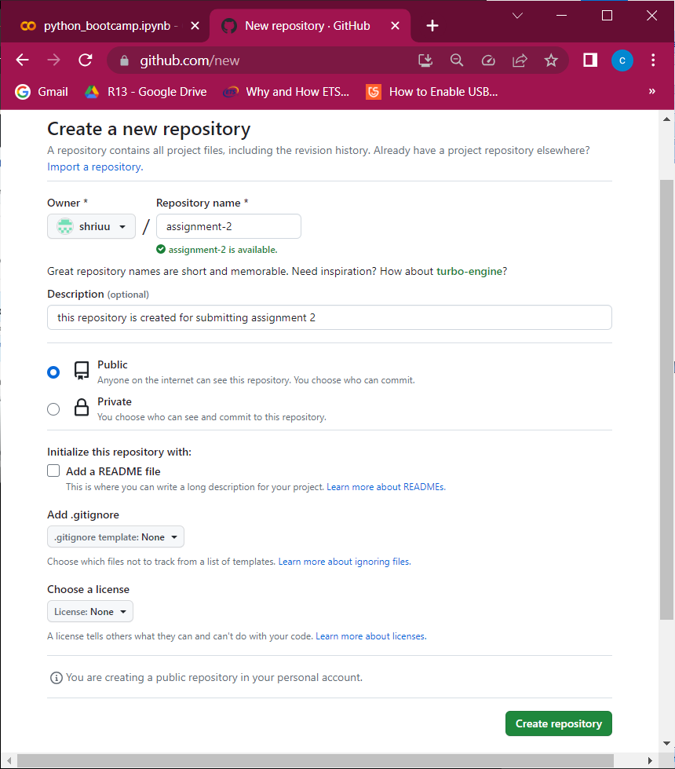

1. Click on create repository.

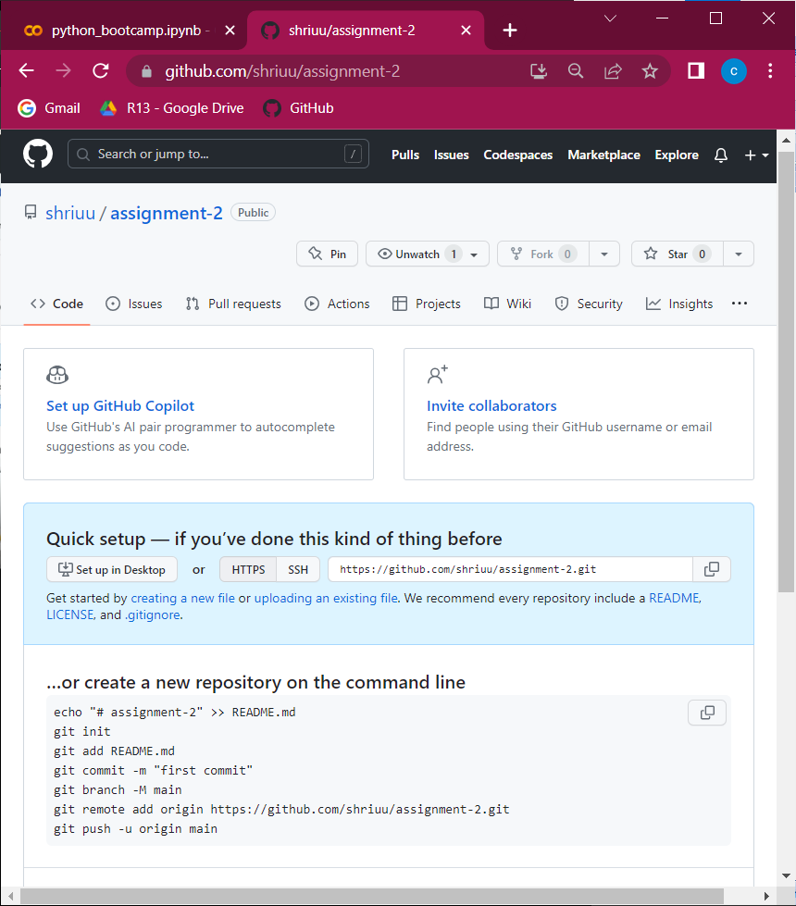

1. Connect local repository with remote repository in command prompt using the command –git remote add origin remoterepolink.

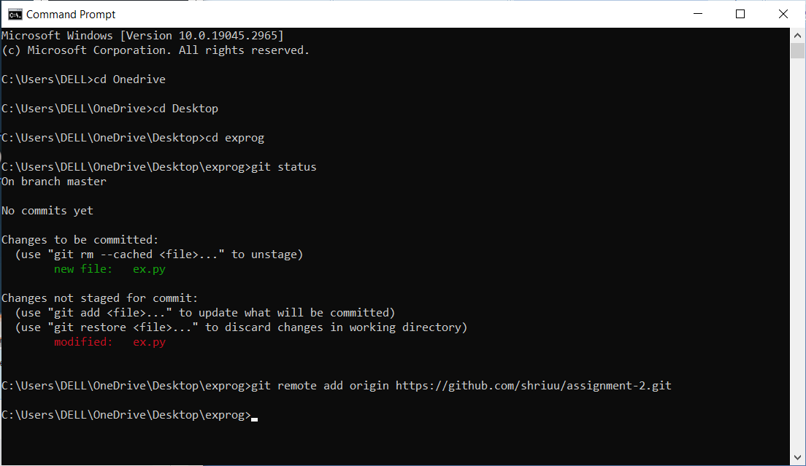

1. Now you need to create a branch in repository using the command ---git branch –m “name of branch”

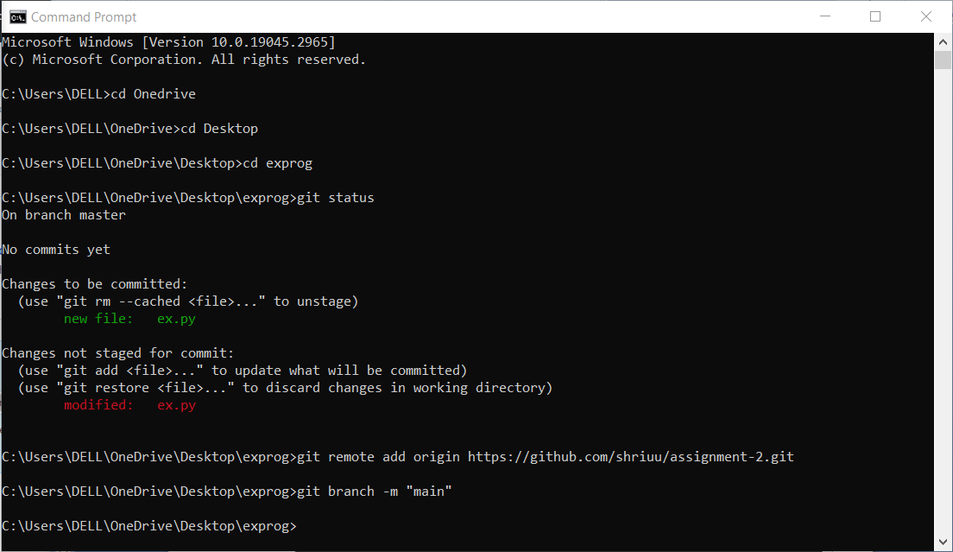

Now a branch is created with name “main”.

1. now push the main branch to remote repository on main branch with the command--- git push origin main.

Every developer has branch and team leader has main branch access.

Here you are the developer and team leader as well, you can push the branch to main branch.

1. The default branch is named as “main” and with the command ---git branch –m “main” for pushing the local repository to remote repository on main branch.

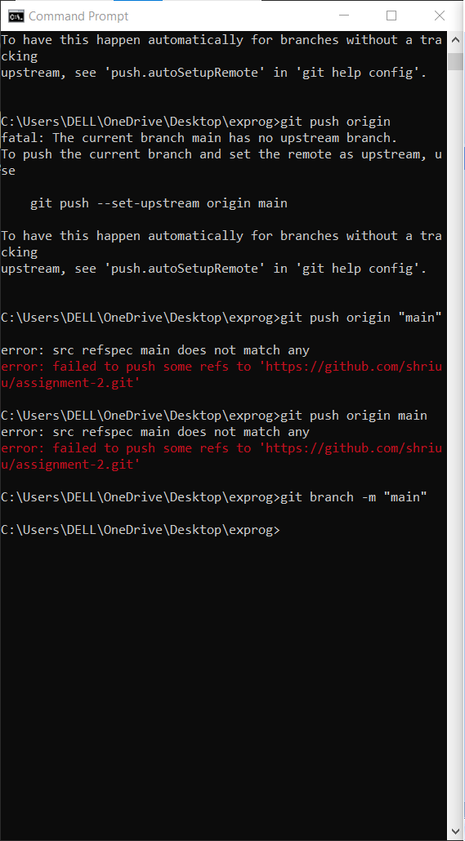

1. Command--- git push origin main is used to upload the code into remote repository push origin main

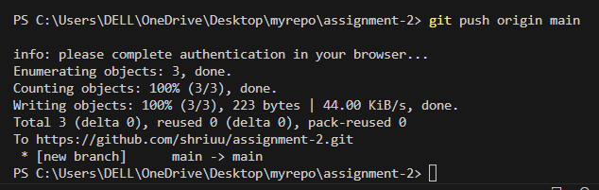

To update the code,

1. Adding the file to staged directory using command --- git add app.py
2. Commit the changes
3. Push it to repository

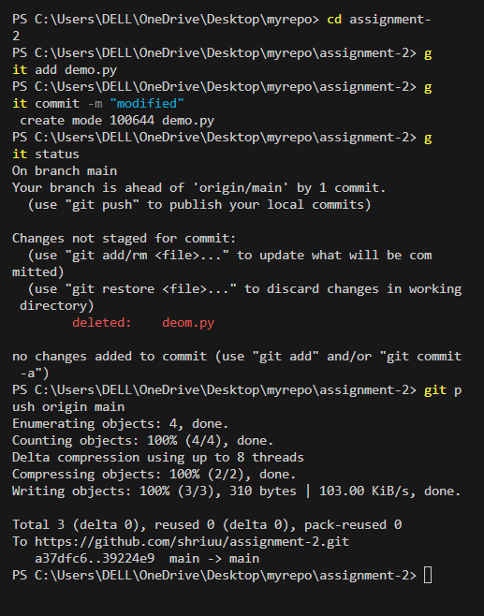

The modified changes can be seen in github

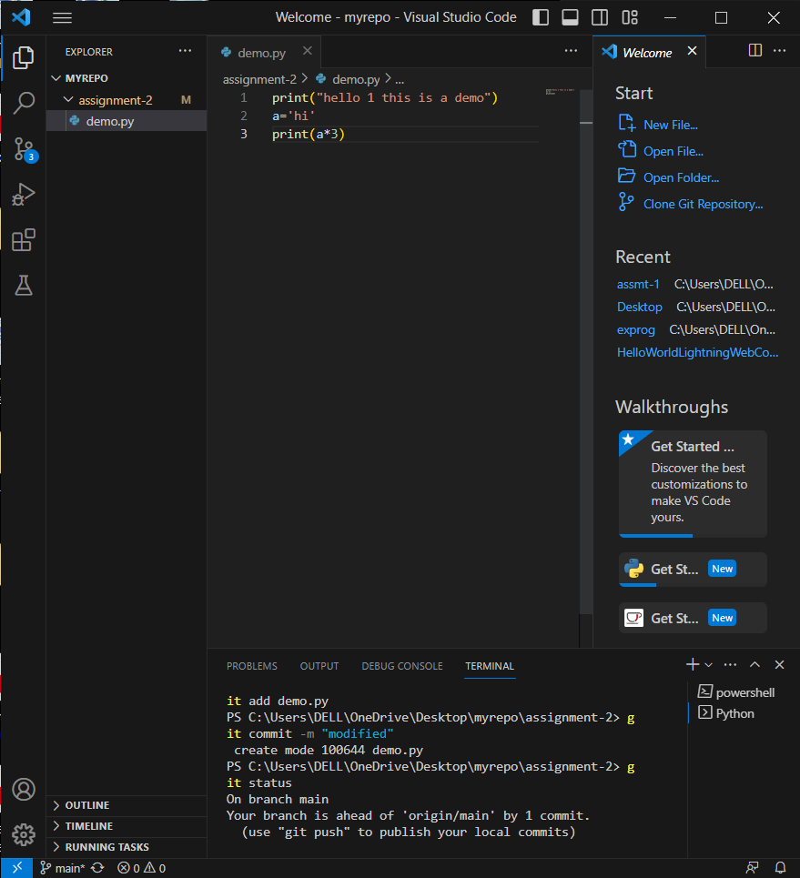

Here we modified the code and renamed it

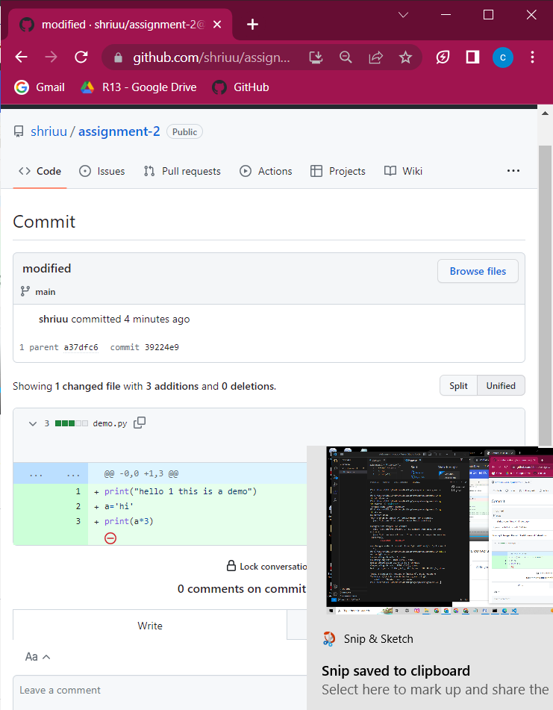

­­­­now we are creating a own branch and modify the code with command---git branch –m “a2”

Add the file to the stagged directory using command ---git add demo.py

Commit the changes with command --- git add asmt-3.pygit add shri.py “

Push the local repository into remote repository

Command--- git push origin a2

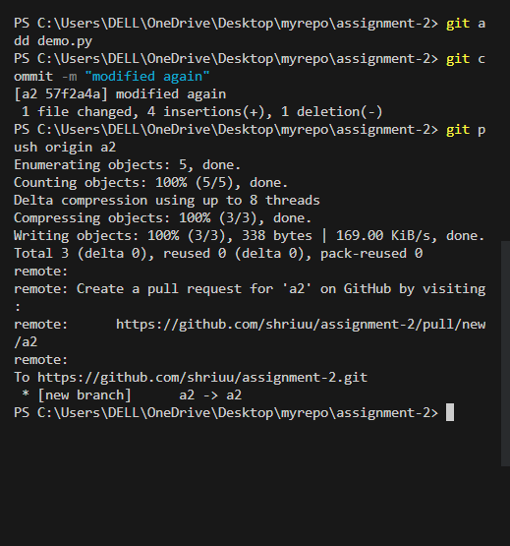

You can see that a branch is created

