**ASSIGNMENT-1**

**Scenario-5**

The team leader git has already created a remote repository and if asked to get the project from remote repository and make it available

1. You should not re-initialize the repo
2. You should not push until the team leader ask you to push

Cloning is a process of getting a remote repo on the developer’s repo as it is.

Command is--- git clone<repository-url> is used to clone git

After cloning open the folder and create a branch and push it to your own branch using the main branch

Use command git branch –m “b3” to create the branch and write a program and add it using the command---- git add app.py

And commit the changes and check the status

Push it to branch using command-------git push origin b3

**Scenario-6**

Team member has X+Y code and other team numbers have only X+Z code and team leader has X+Y+Z code

Here the other teams have to pull the code----git pull origin b3…. from remote repository and new team has to clone the repo------git clone remote<repo-url>

These code conflicts are solved once pulling is done

**a-1**

**clone**

**create a new branch**

**update some python code**

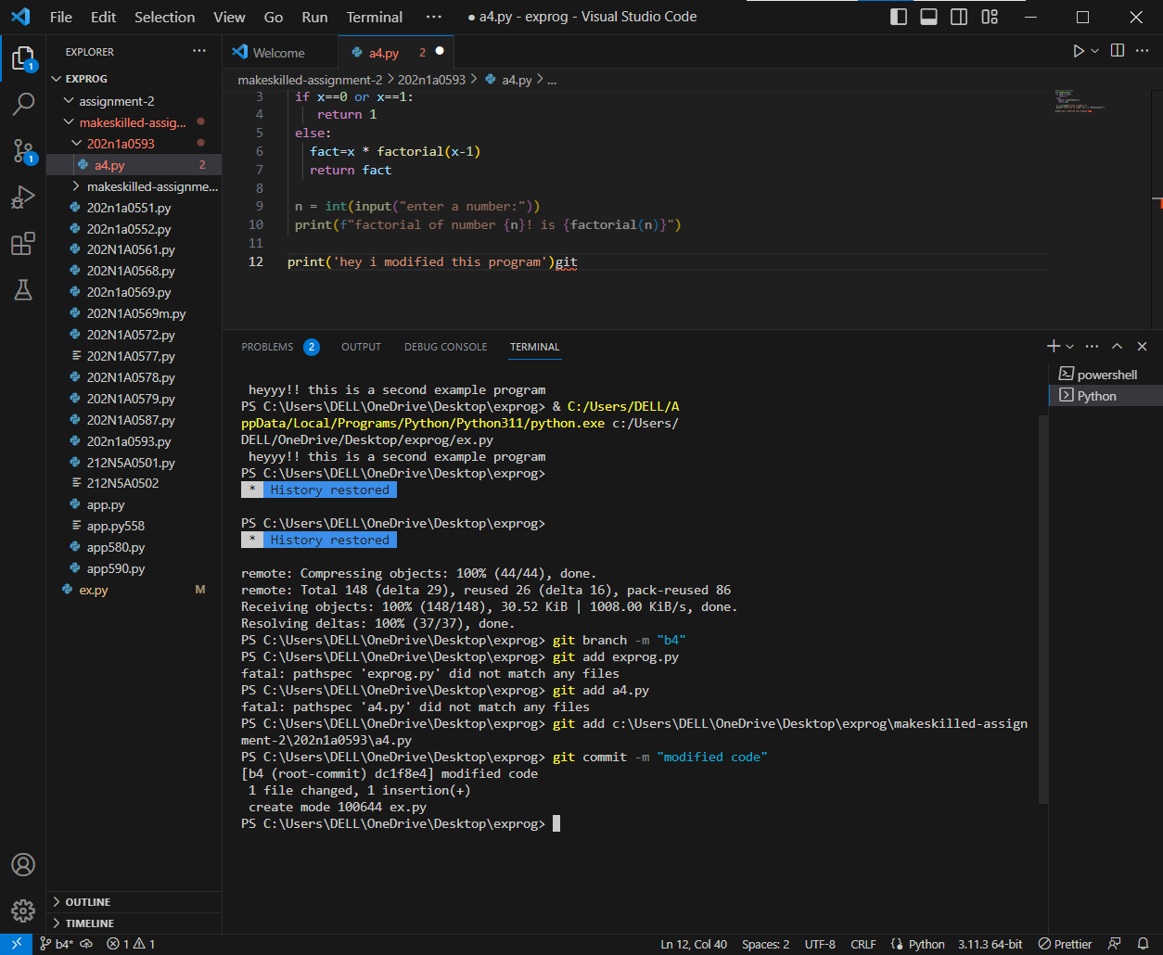

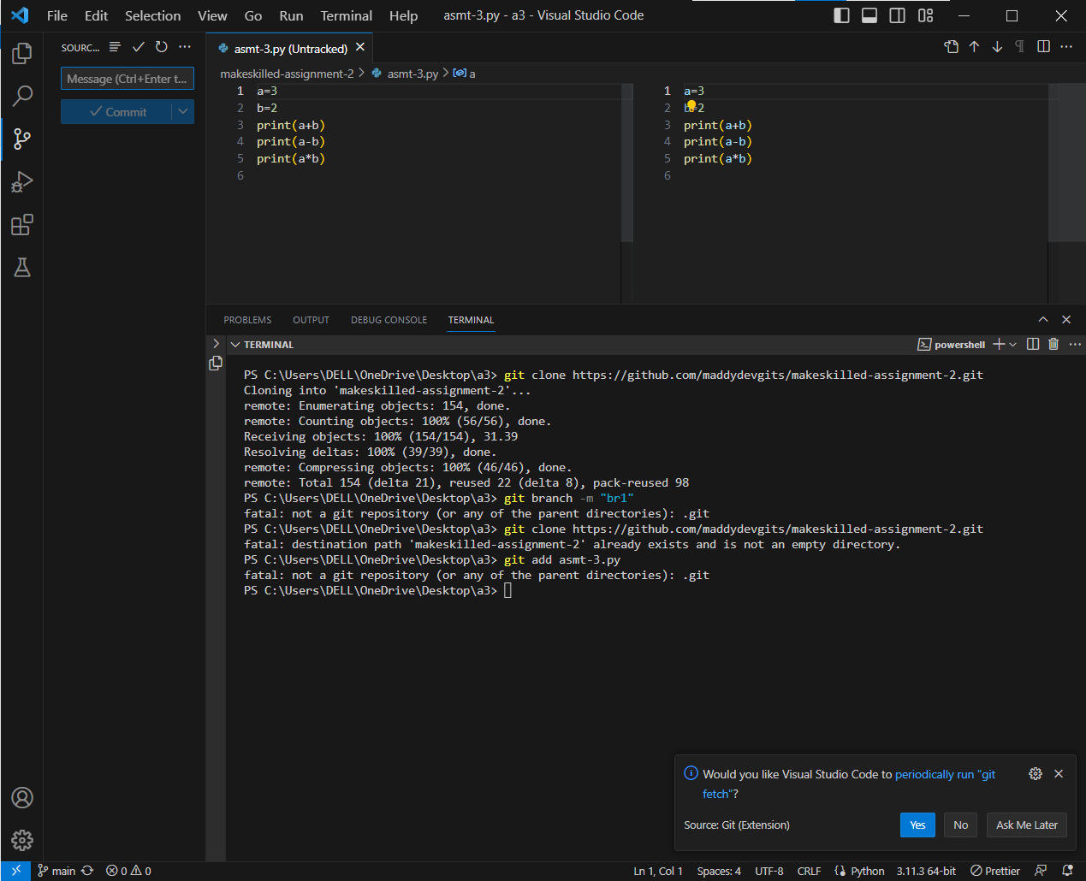

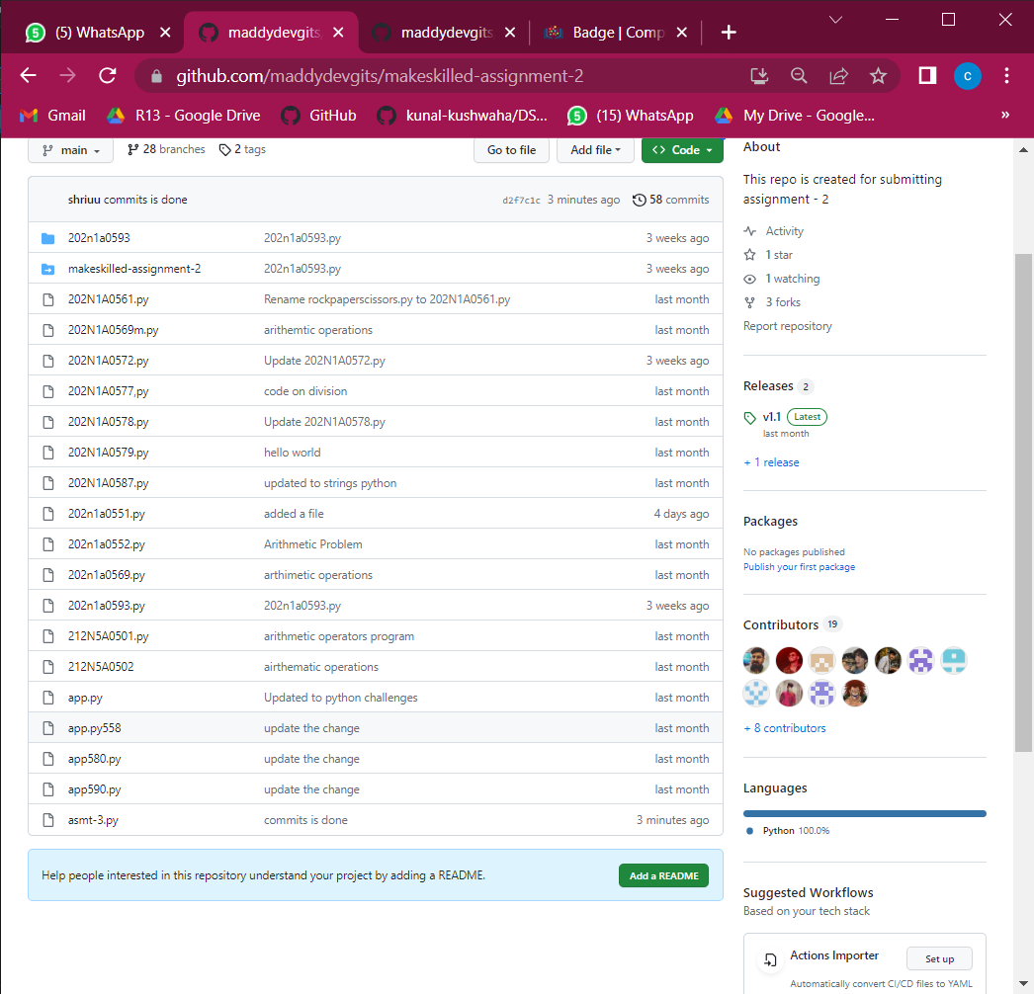

**a-2**

**push code to master branch**

**code conflicts-same branch**

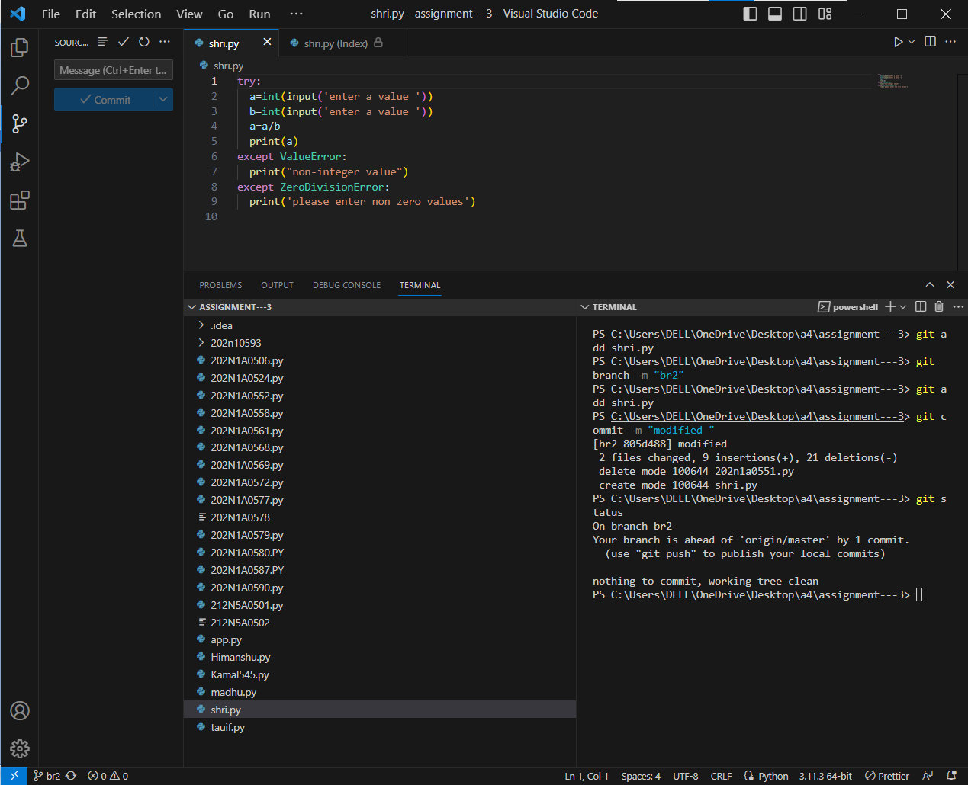

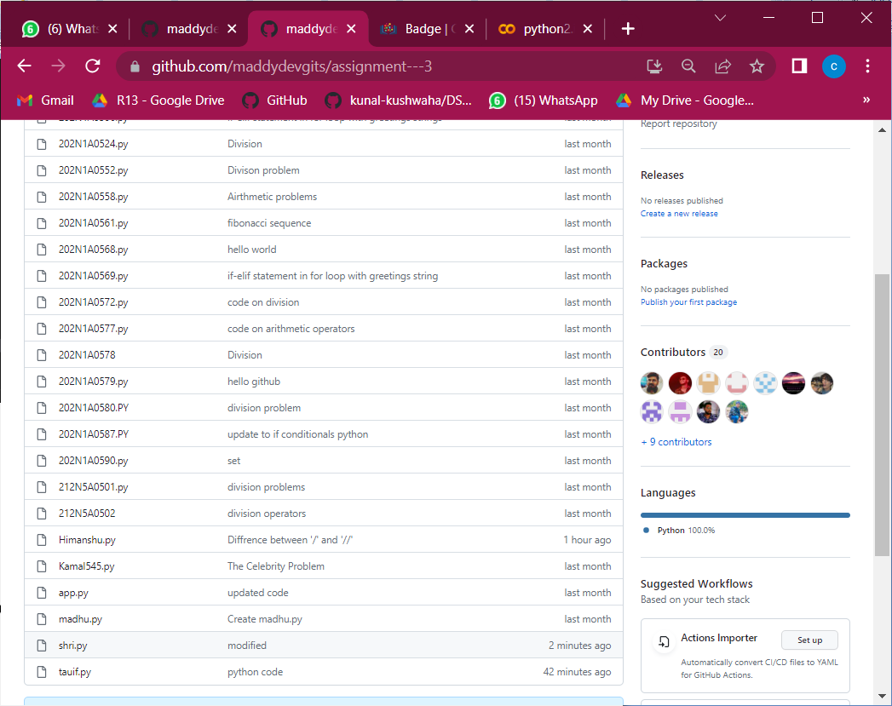

**a-3**

**publish a new repo from dev folder using vs code**

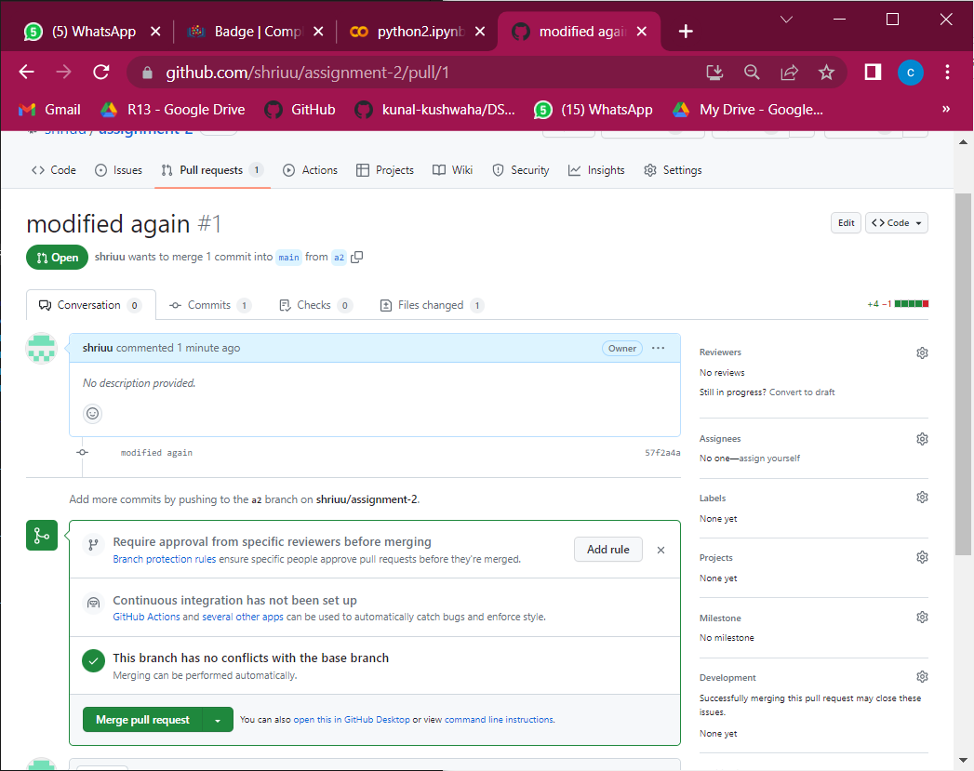

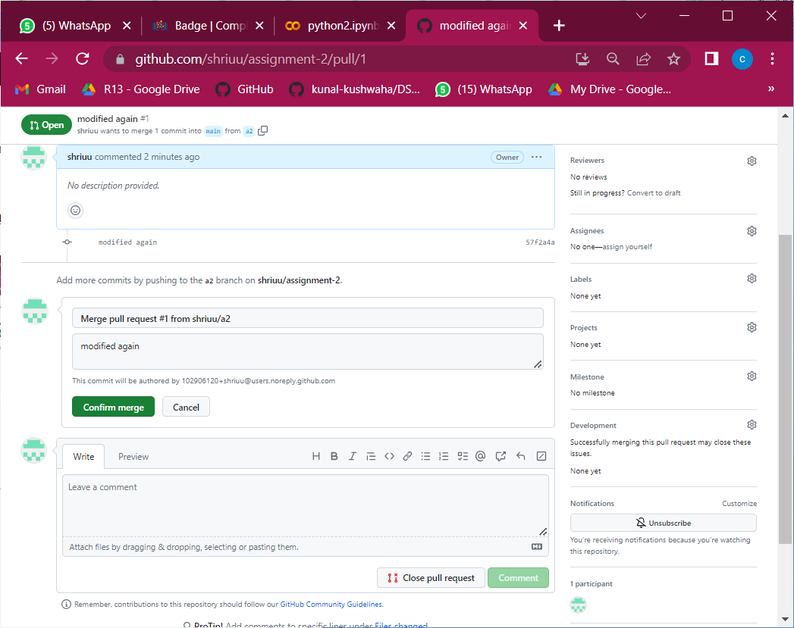

A4