**ASSIGNMENT -4**

**Scenario 9**

Swithching between branches

Command---git checkout <branchname>

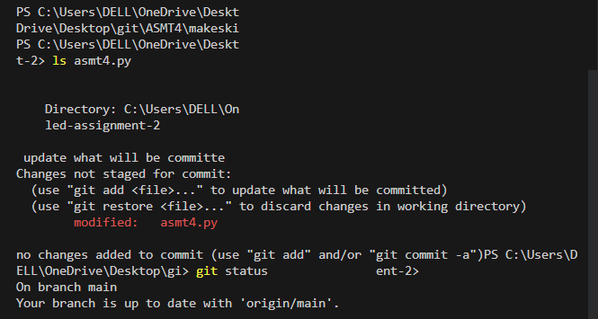

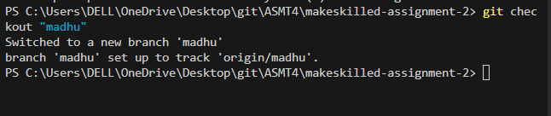

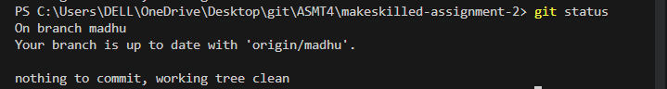

**Scenario 10: commit log of remote repo**

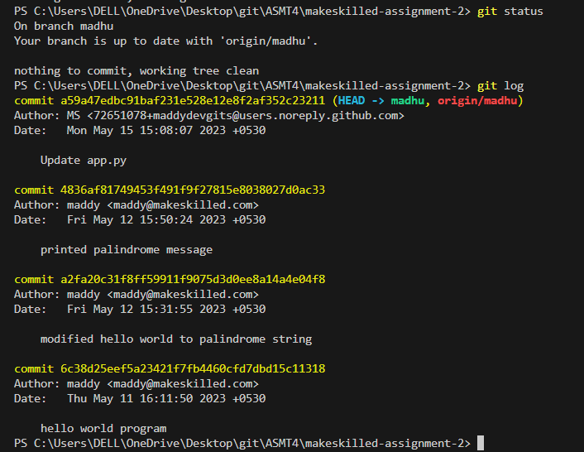

**Scenario-11: forking of a repository**

If you want to contribute to a repository forking is needed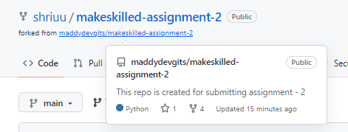

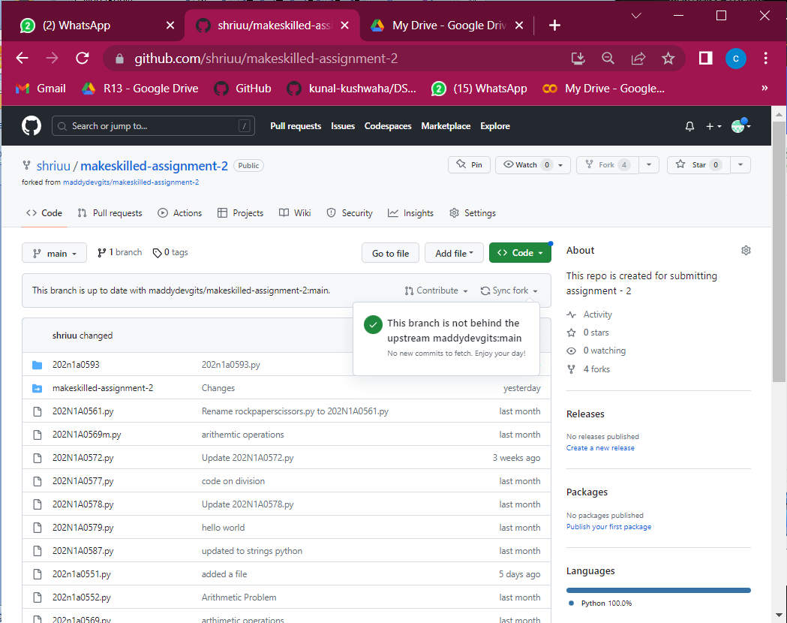

Scenario-12

Pull request

Merges your branch with main branch

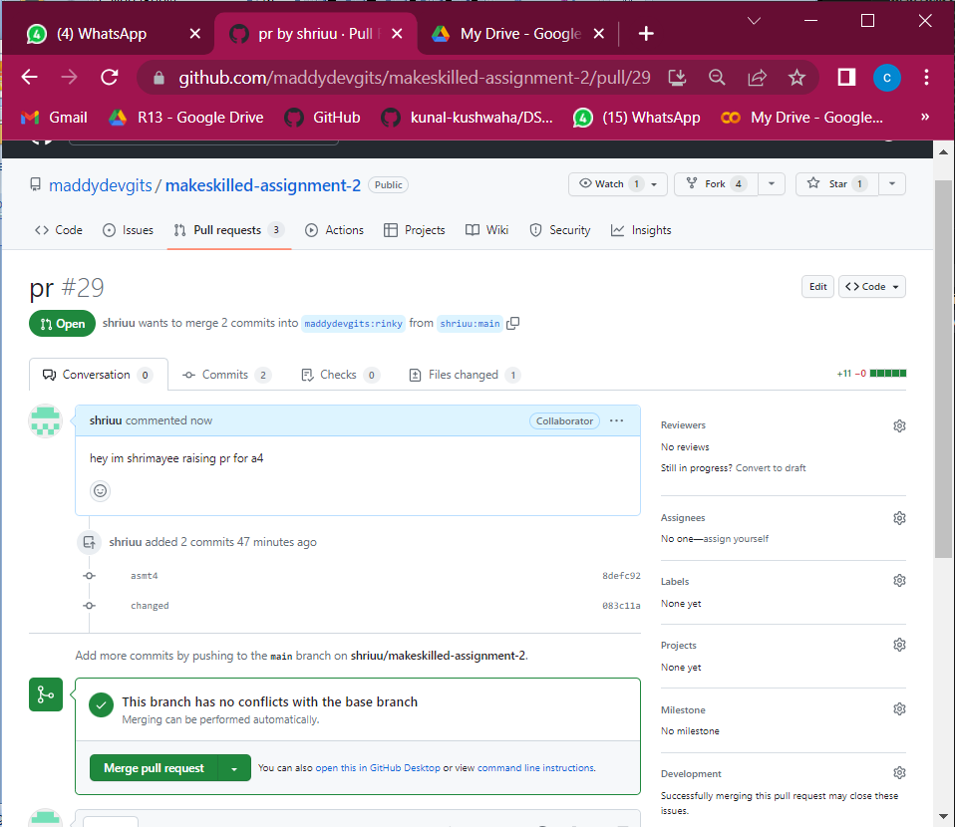

Version control systems

Git is a distributed version control system that allows multiple people to collaborate on a project while keeping track of changes to the codebase.

