NODEJS EXPRESS PART-1 ASSIGNMENT-5

Create a Web Server using Node and Express, render your Name

Express is a framework in javascript

Create a desktop folder and install the xpress drivers using the command--- npm install express ---save

Create a file named app.js in the folder and write the java script to create a web server using node ,express ,render your name

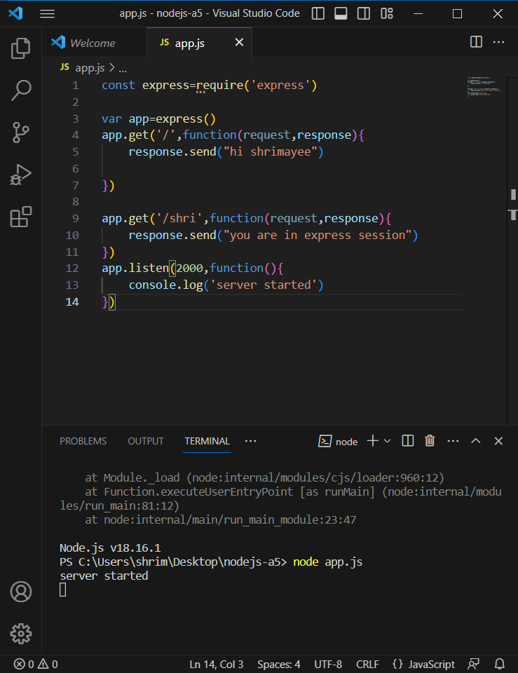

Now enter the server port number as 12.0.0.1:2000 and you you can see the web page

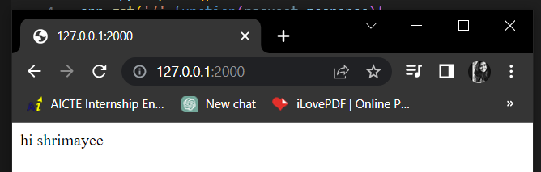

If you append /database name you can see the web page as

