PART-1 ASSIGNMNET-1

Create a Node Script to read all data from collection in MongoDB

1. Open cmd and create a new directory on desktop and change directory to it.

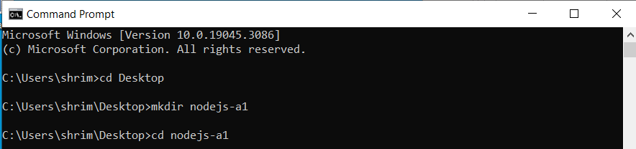

1. Use the command to install packages ----->npm install mongodb –save

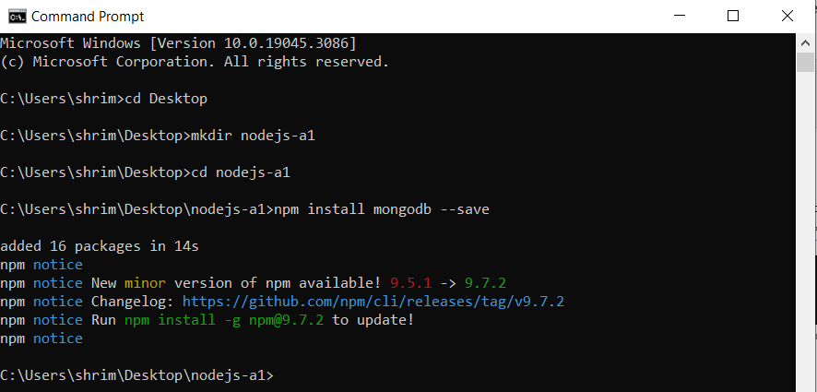

And you can see the files are installed in your folder and see them in vs code—

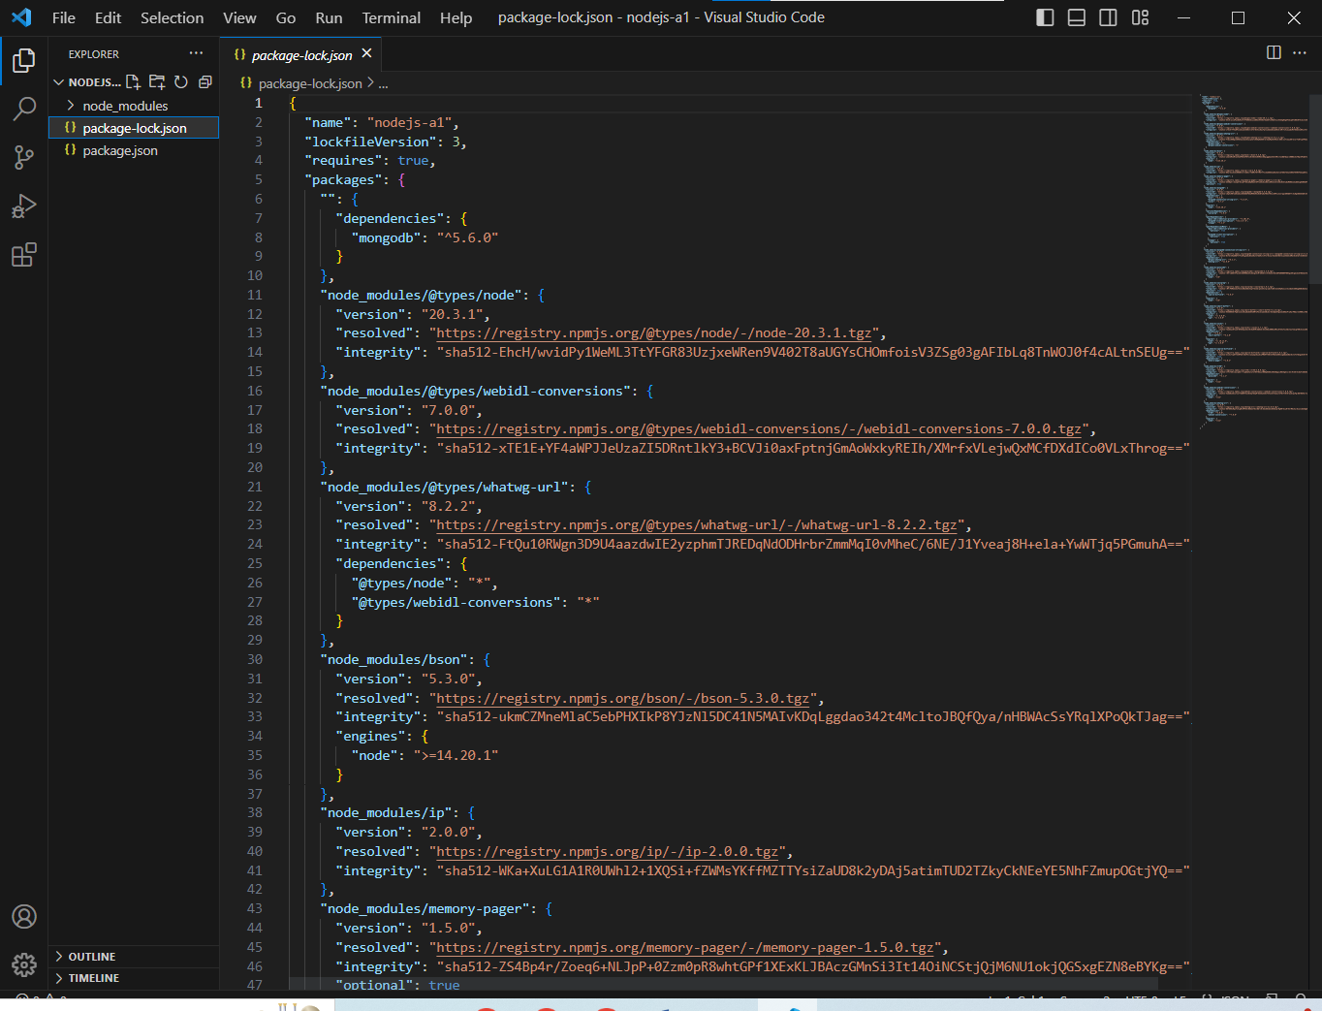

1. Now create a file named “app.js” in the folder

And add the code to the file to read all the data in the collections

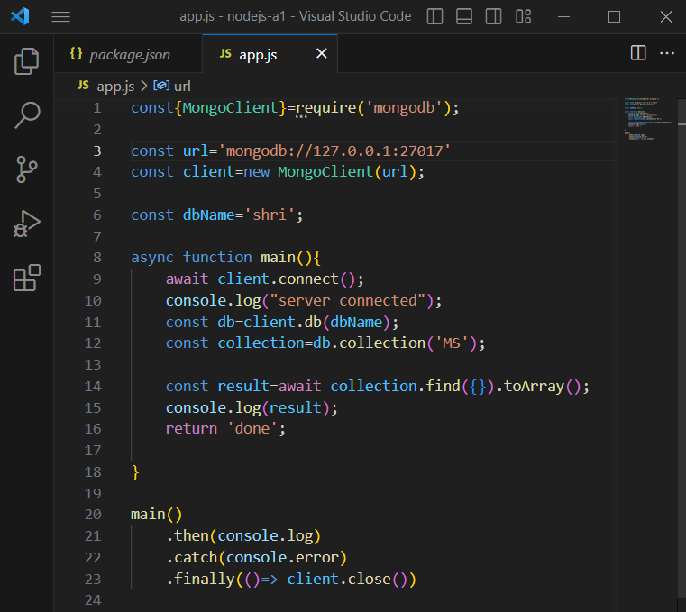

1. syntax used to connect with database

await client.connect();

console.log("server connected");

1. syntax used to select database

const db=client.db(dbName);

1. syntax used to select the collection

const collection=db.collection('MS');

1. Syntax used to read all the data

const result=await collection.find({}).toArray();

