NODE JS PART-1 ASSIGNMENT 2

Create a Node Script to insert a document into the collection of MongoDB

1. Create a desktop folder nodejs a-s and install the mongo db drivers in the folder

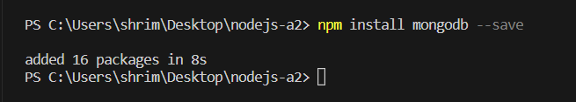

Create a file named app.js to insert documents into the collection of mongo db

