NODEJS PART1- ASSIGNMENT-3

Create a Node Script to update a document in the collection of MongoDB

1. Create a desktop folder nodejs a-s and install the mongo db drivers in the folder

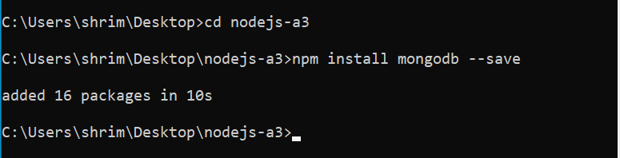

1. Now write the code into app.js to update the documents in the collection of mongodb

