NODE JS EXPRESS PART-1 ASSIGNMENT-6

Create a Web Server using Node and Express, render HTML Page

Create a desktop folder and install the express drivers and create a new file app.js to create a web server using node and express and render the html page

We do not need any templates folder in nodejs as in python

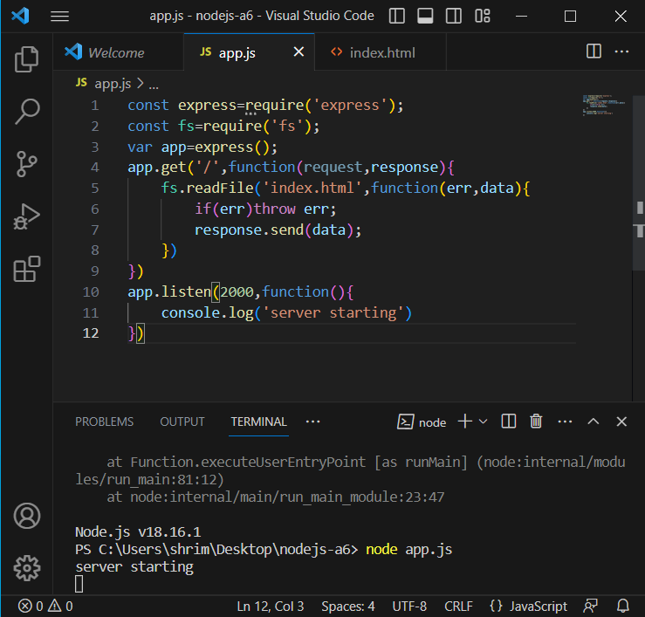

The html code is as follows

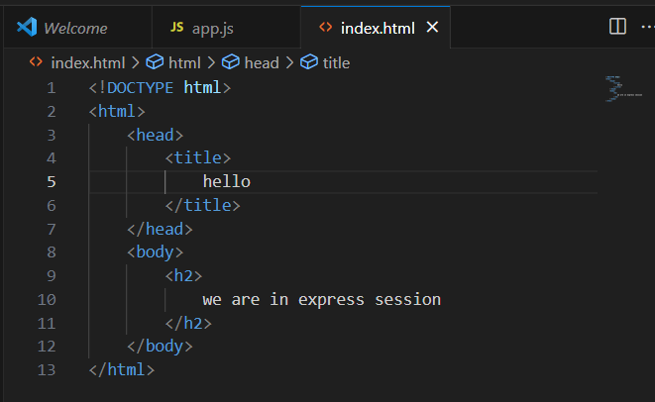

Now copy the port number and if we search we can see 