NODE JS,EXPRESS PART-2,ASSIGNMENT-3

Create an API to read data from MongoDB using Node and Express

Create a desktop folder and install express and mongodb drivers in it

Create a new file app.js and write the code to create an API to read data

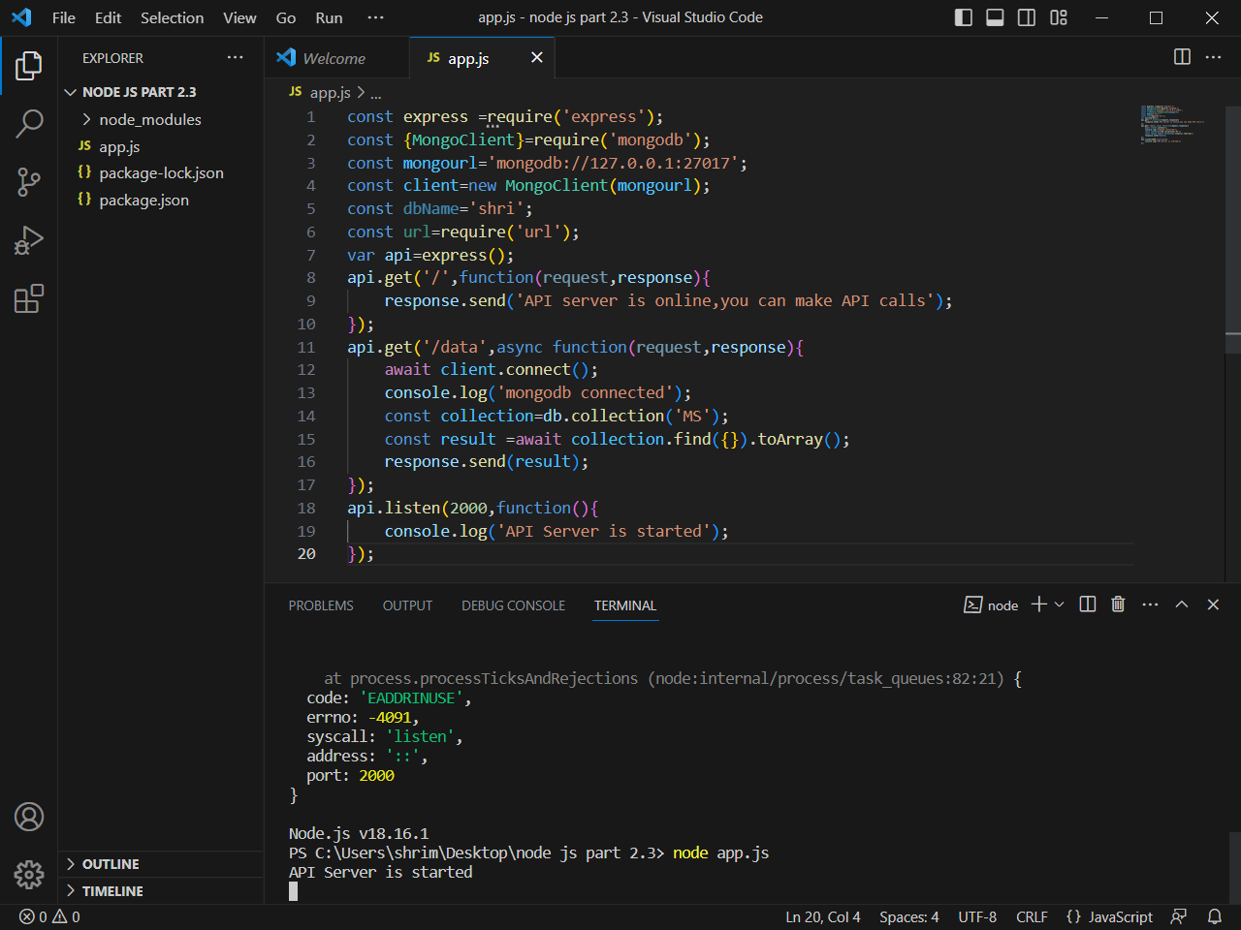

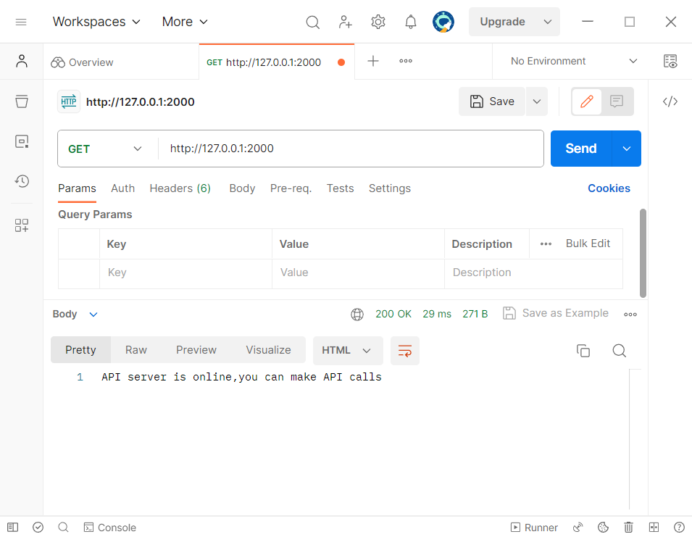

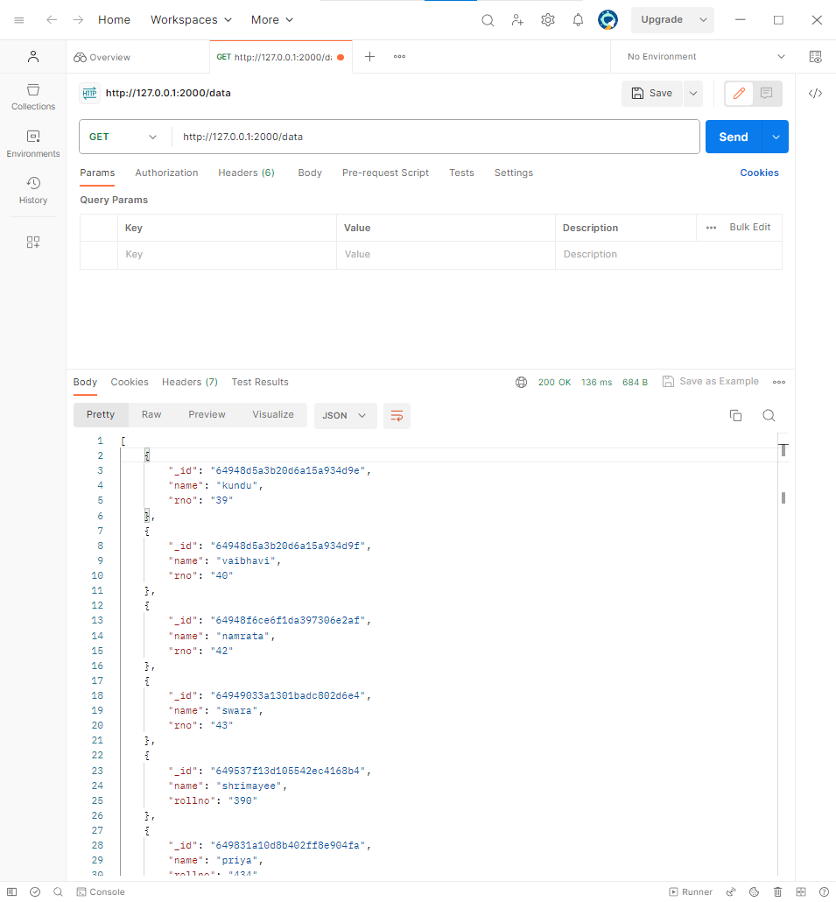

In this way we Create an API to read data from MongoDB using Node and Express