App.java

package com.example;

import java.util.Random;

public class App {

private String generatedOTP;

// Generate OTP
public String generateOTP() {
Random rand = new Random();
int otp = 1000 + rand.nextInt(9000); // 4-digit OTP
generatedOTP = String.valueOf(otp);
return generatedOTP;
}

// Validate OTP
public boolean validateOTP(String inputOTP) {
return generatedOTP != null && generatedOTP.equals(inputOTP);
}

// Reset password
public boolean resetPassword(String inputOTP, String newPassword) {

// Password rule: at least 6 characters
if (newPassword == null || newPassword.length() < 6) {
return false;
}

// OTP must be valid
if (!validateOTP(inputOTP)) {
return false;
}

return true; // reset success
}

public static void main(String[] args) {
App app = new App();

String otp = app.generateOTP();
System.out.println("Generated OTP: " + otp);

boolean result = app.resetPassword(otp, "newpass123");

if (result) {
System.out.println("Password Reset Successful");
} else {
System.out.println("Password Reset Failed");
}
}
}

AppTest.java

package com.example;

import org.junit.Test;
import static org.junit.Assert.*;

public class AppTest {

@Test
public void testSuccessfulReset() {
App app = new App();
String otp = app.generateOTP();

assertTrue(app.resetPassword(otp, "secure123"));
}

@Test
public void testInvalidOTP() {
App app = new App();
app.generateOTP();

assertFalse(app.resetPassword("0000", "secure123"));
}

@Test
public void testWeakPassword() {
App app = new App();
String otp = app.generateOTP();

assertFalse(app.resetPassword(otp, "123"));
}
}

pom.xml

<project xmlns="http://maven.apache.org/POM/4.0.0">
<modelVersion>4.0.0</modelVersion>

<groupId>com.example</groupId>
<artifactId>password-reset-app</artifactId>
<version>1.0</version>

<dependencies>
<dependency>
<groupId>junit</groupId>
<artifactId>junit</artifactId>
<version>4.13.2</version>
<scope>test</scope>
</dependency>
</dependencies>

<build>
<plugins>

<plugin>
<groupId>org.apache.maven.plugins</groupId>
<artifactId>maven-compiler-plugin</artifactId>
<version>3.10.1</version>
<configuration>
<source>17</source>
<target>17</target>
</configuration>
</plugin>

<plugin>
<groupId>org.apache.maven.plugins</groupId>
<artifactId>maven-jar-plugin</artifactId>
<version>3.2.2</version>
<configuration>
<archive>
<manifest>
<mainClass>com.example.App</mainClass>
</manifest>
</archive>
</configuration>
</plugin>

</plugins>
</build>
</project>

Pipeline

pipeline {
agent any

tools {
maven 'M3'
}

stages {

stage('Checkout Git') {
steps {
git branch: 'main',
url: 'https://github.com/aishwaryasuresh020-source/agile.git'
}
}

stage('Build and Test') {
steps {
sh 'mvn clean test'
}
}

}
}

Dockerfile

FROM eclipse-temurin:17-jdk

WORKDIR /app

COPY target/password-reset-app-1.0.jar app.jar

CMD ["java", "-jar", "app.jar"]

deployment.yaml

apiVersion: apps/v1
kind: Deployment
metadata:
name: password-reset-app

spec:
replicas: 2

selector:
matchLabels:
app: password-reset

template:
metadata:
labels:
app: password-reset

spec:
containers:
- name: password-reset-container
image: yourdockerhubusername/password-reset-app:latest
---
apiVersion: v1
kind: Service
metadata:
name: password-reset-service

spec:
type: NodePort

selector:
app: password-reset

ports:
- port: 80
targetPort: 8080
nodePort: 30011

Screenshots:

Git:
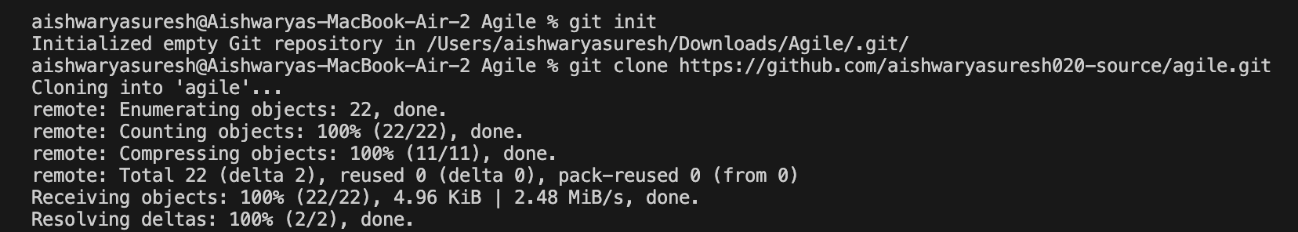
JUnit Test:
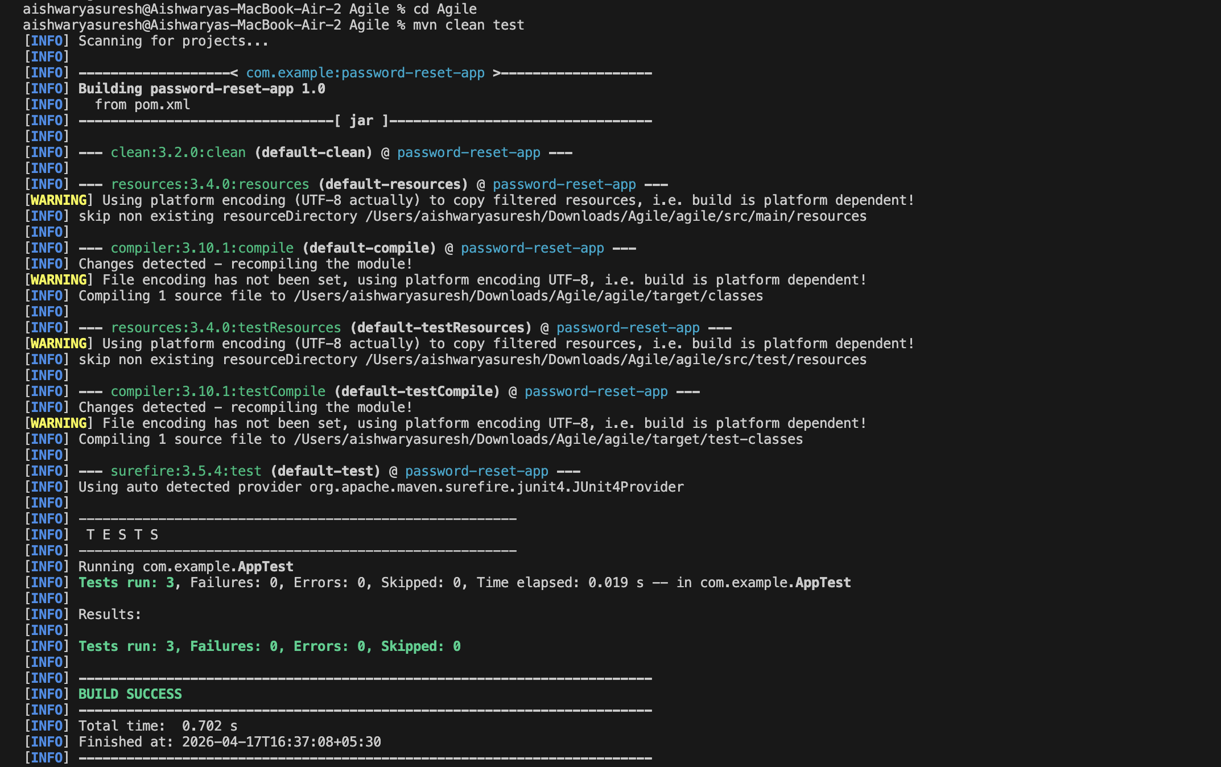
Building Pipeline in Jenkins:
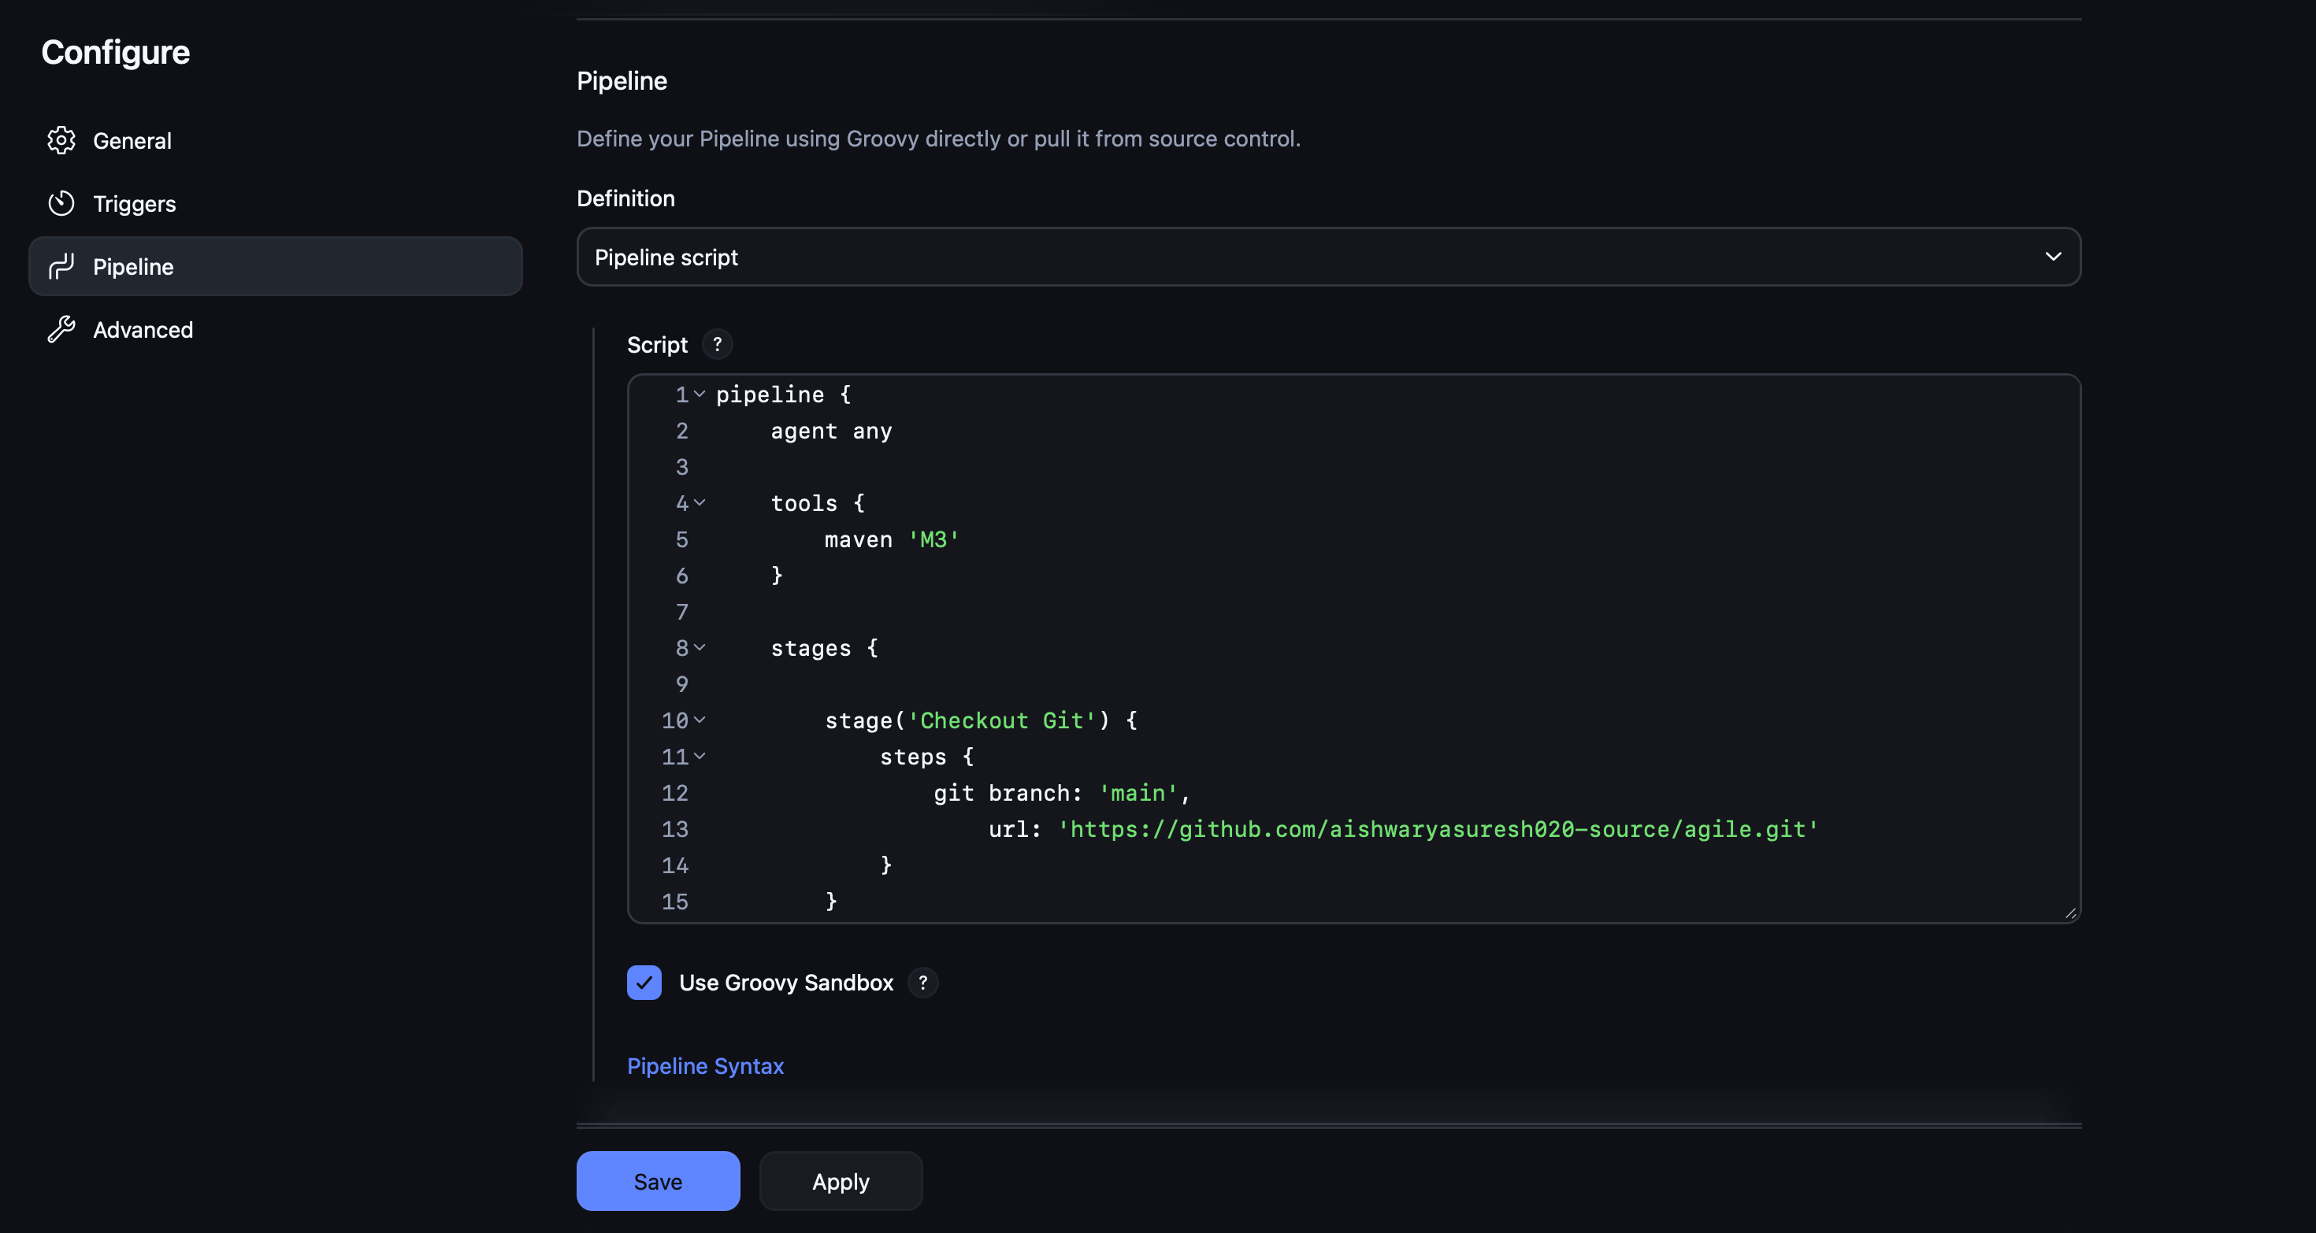

Jenkins Pipeline Output:
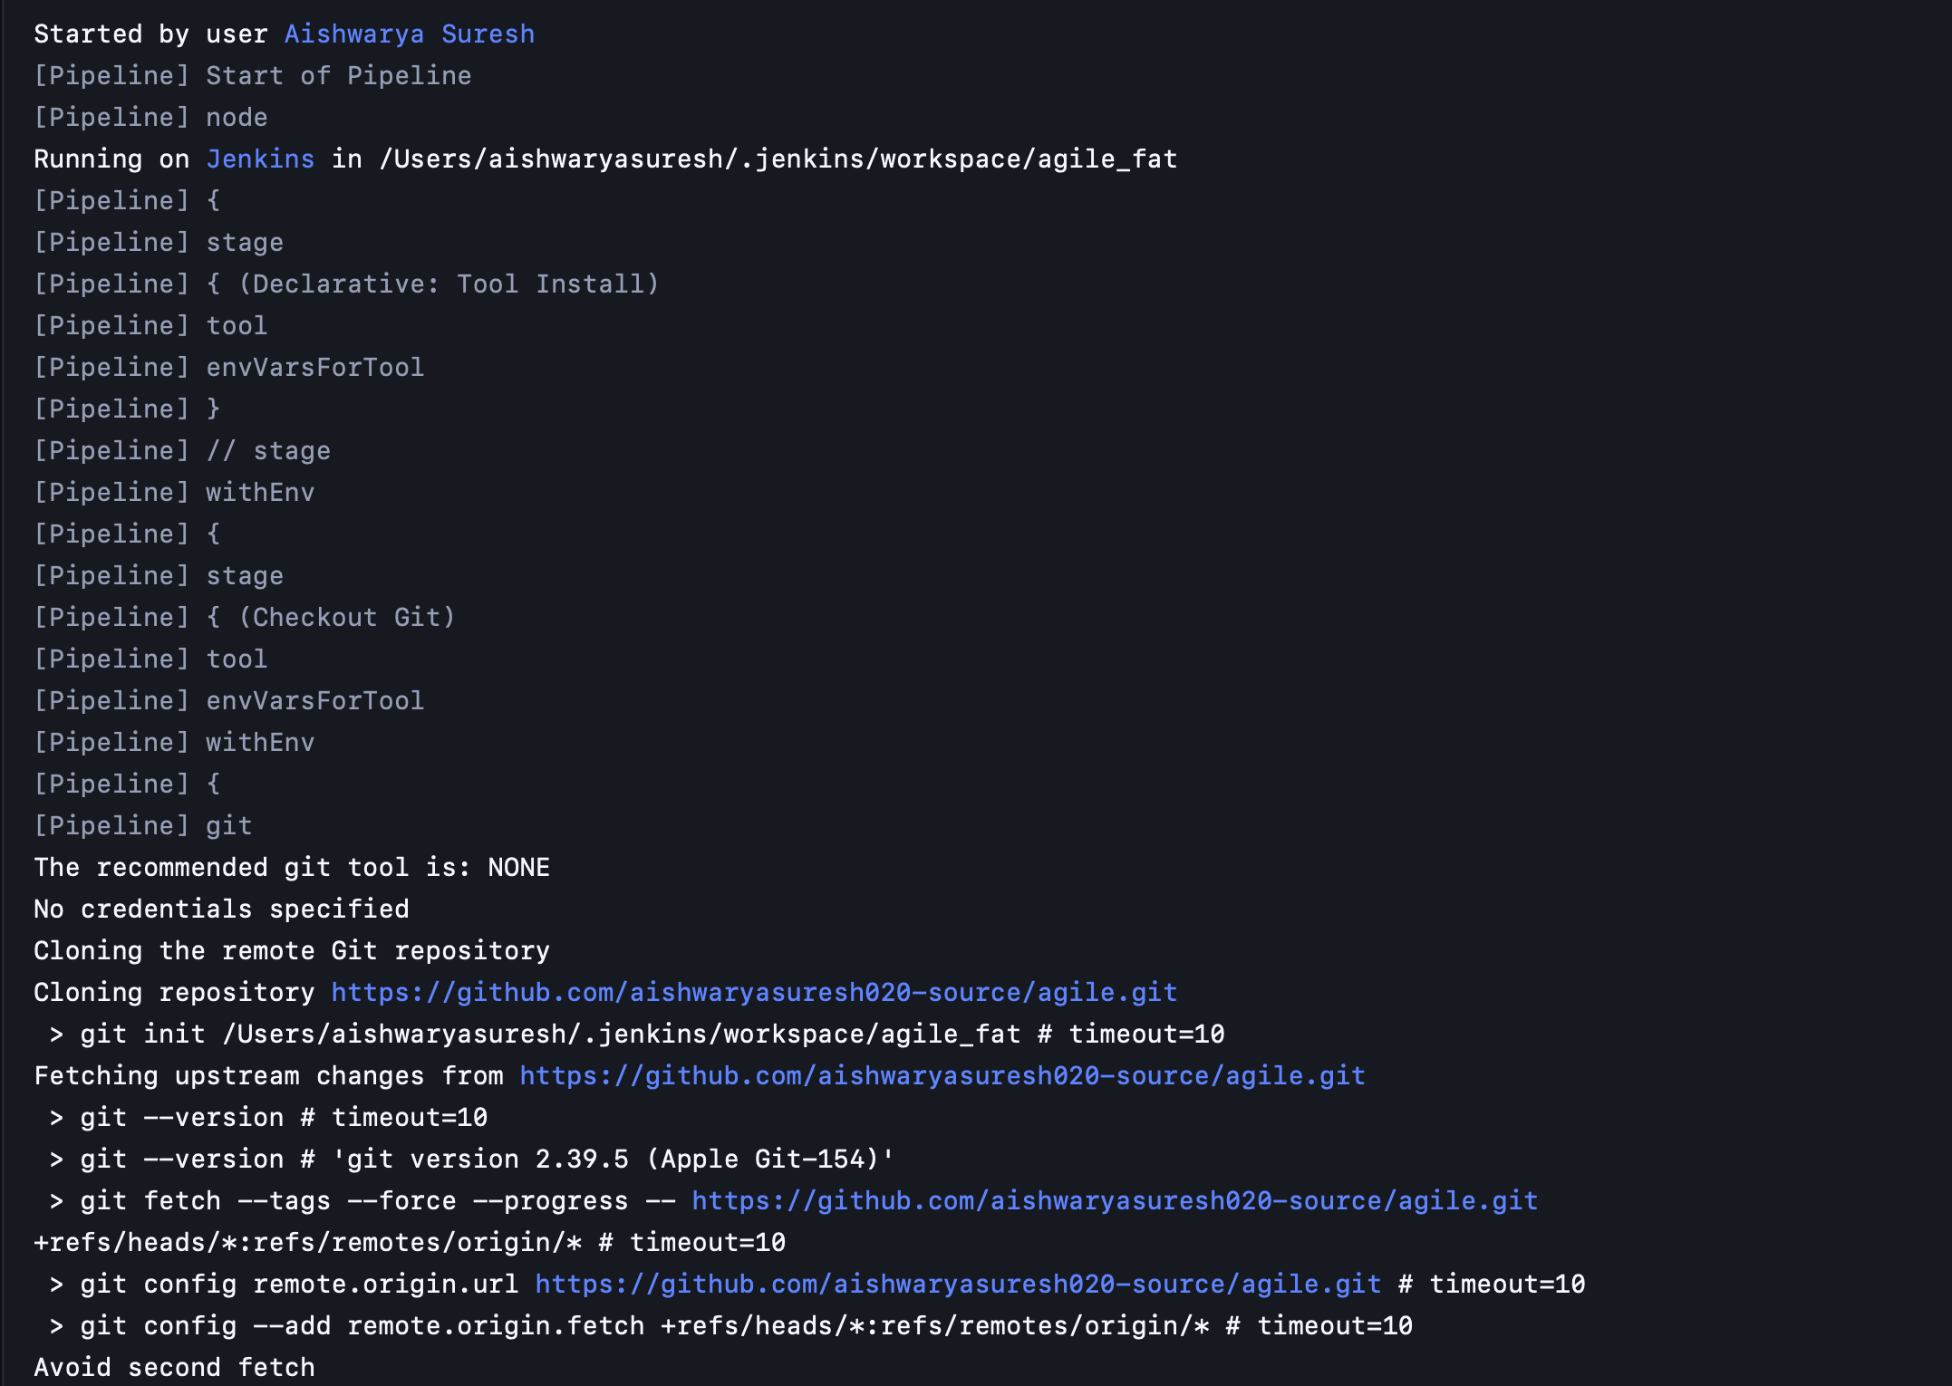
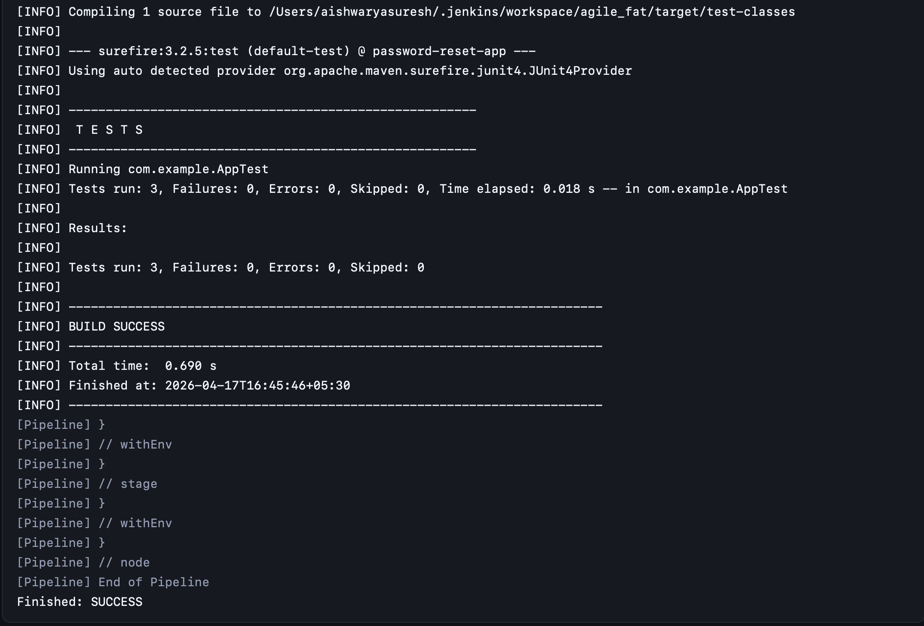
Building Dockerfile and deployment.yaml
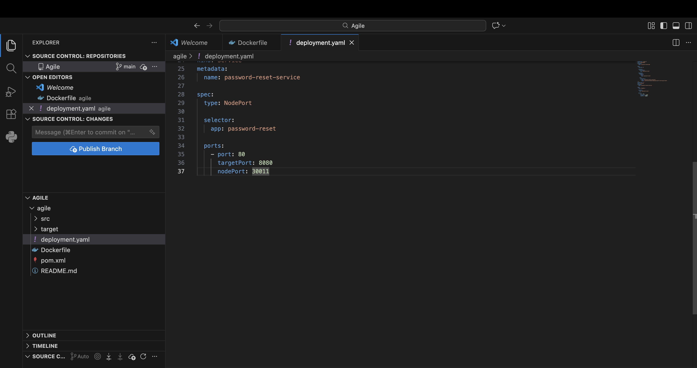
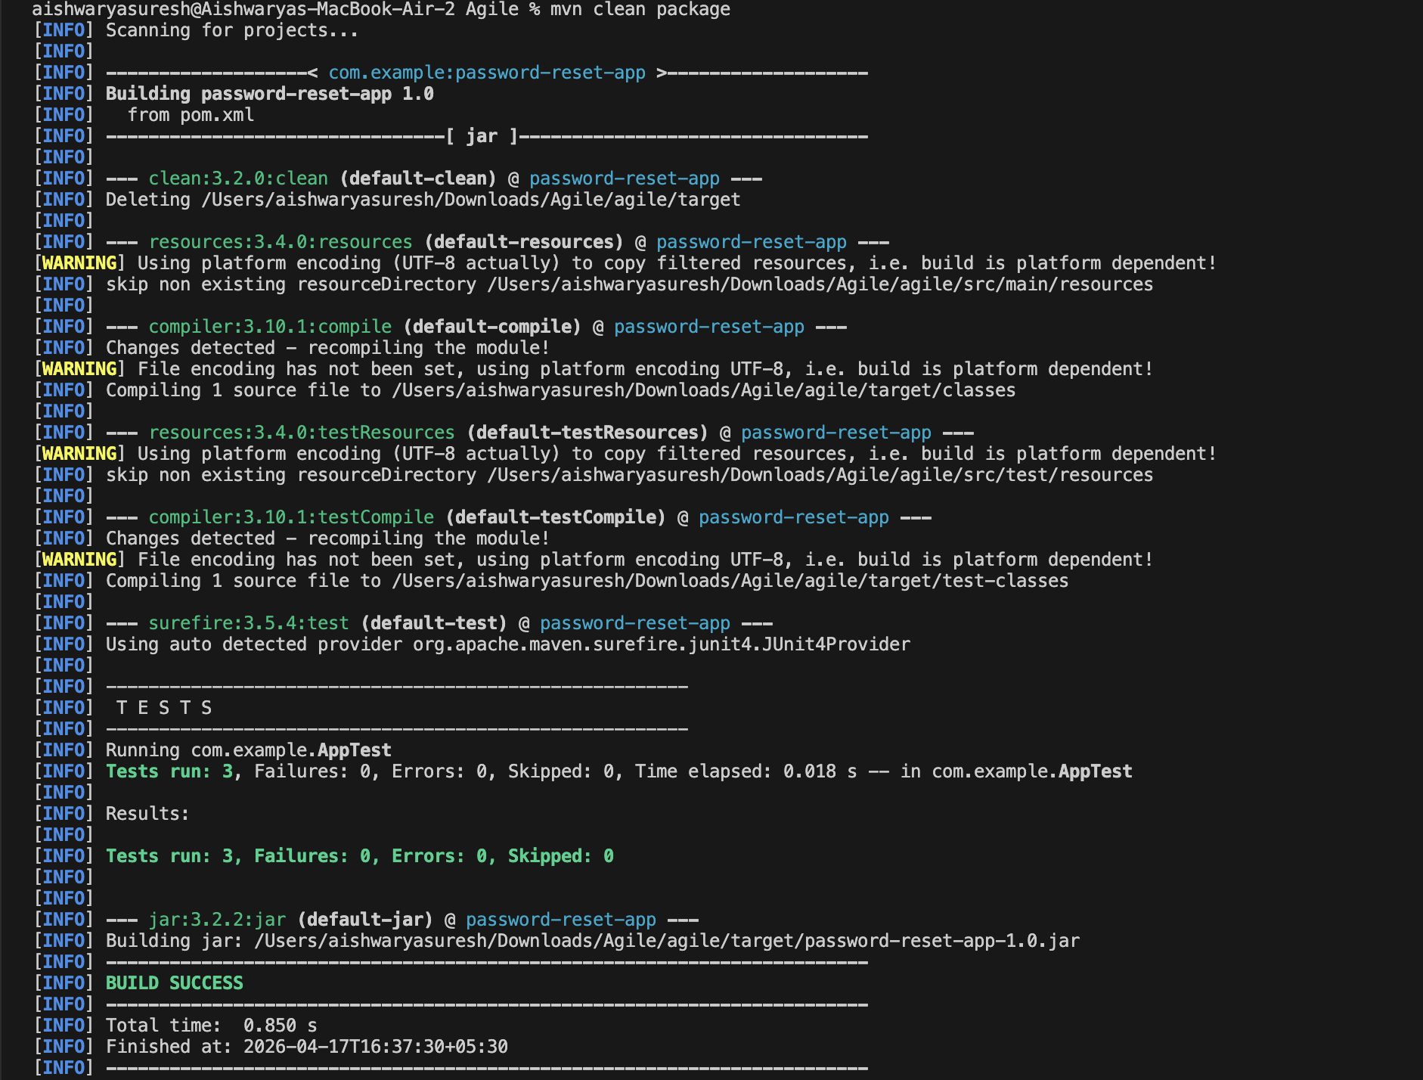

Man clean package:

Implementing Dockerfile:

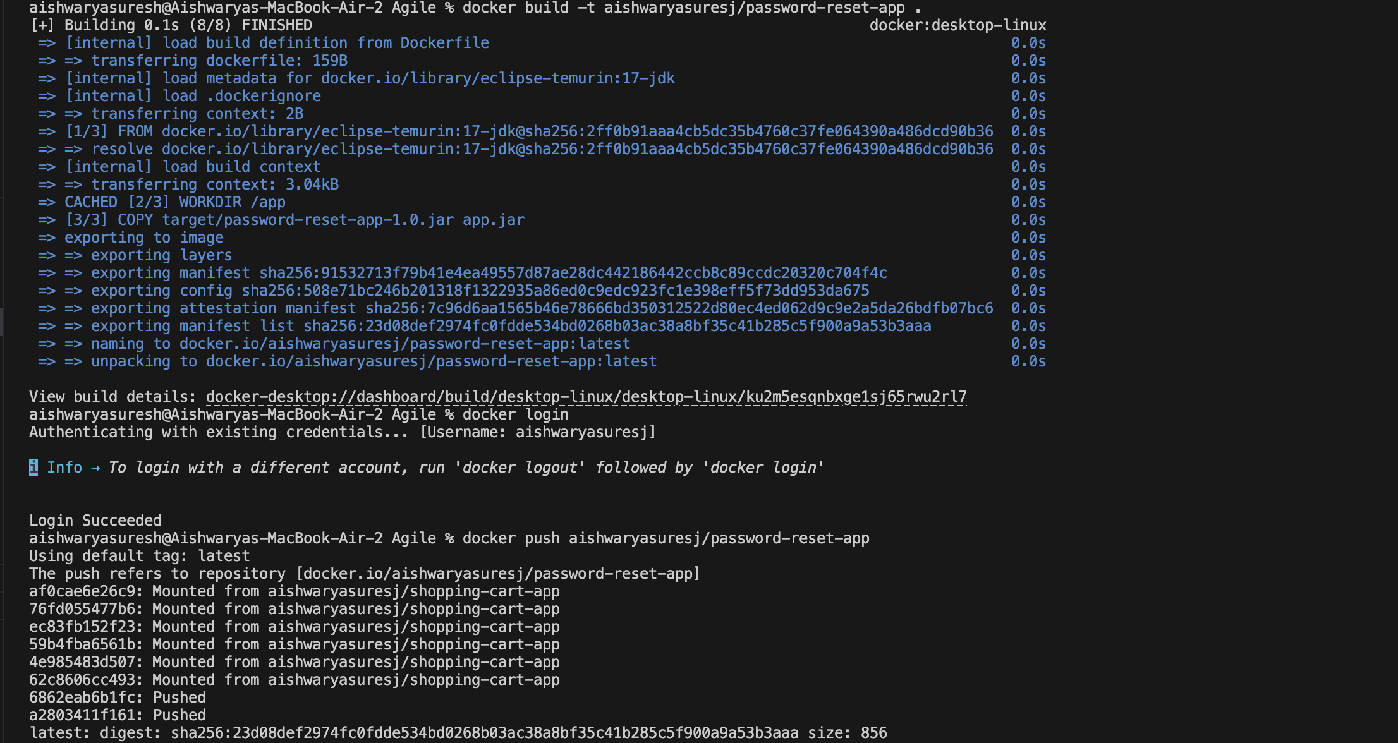
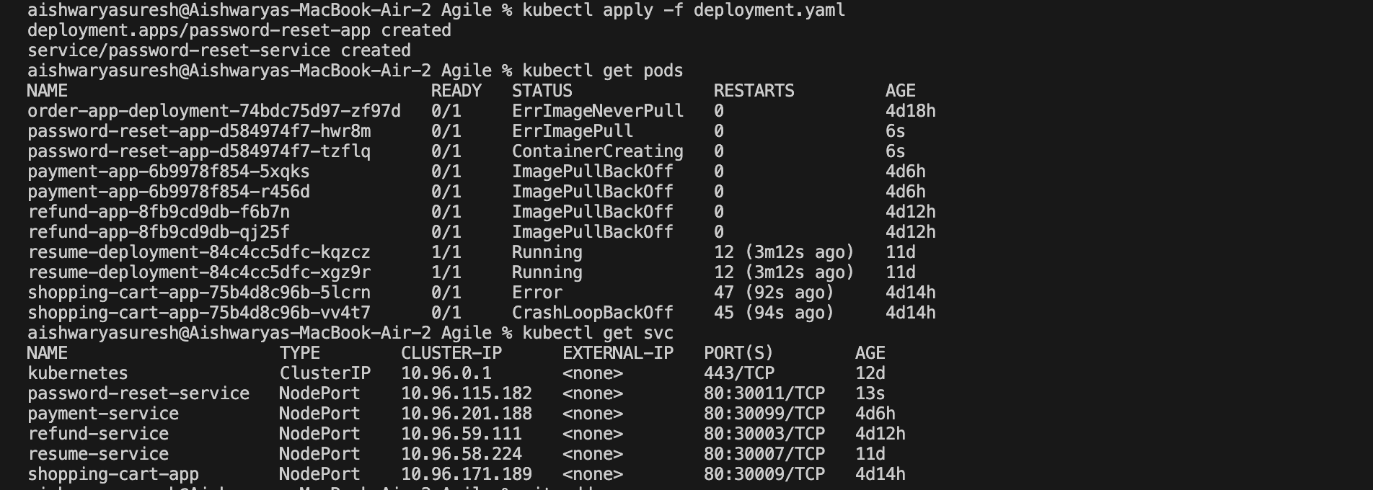
Kubernetes deployment and service YAML files:

Docker Image:

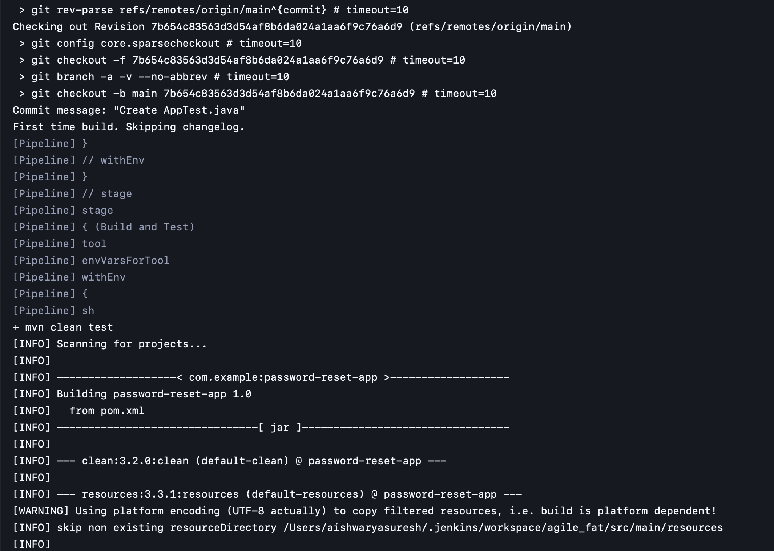

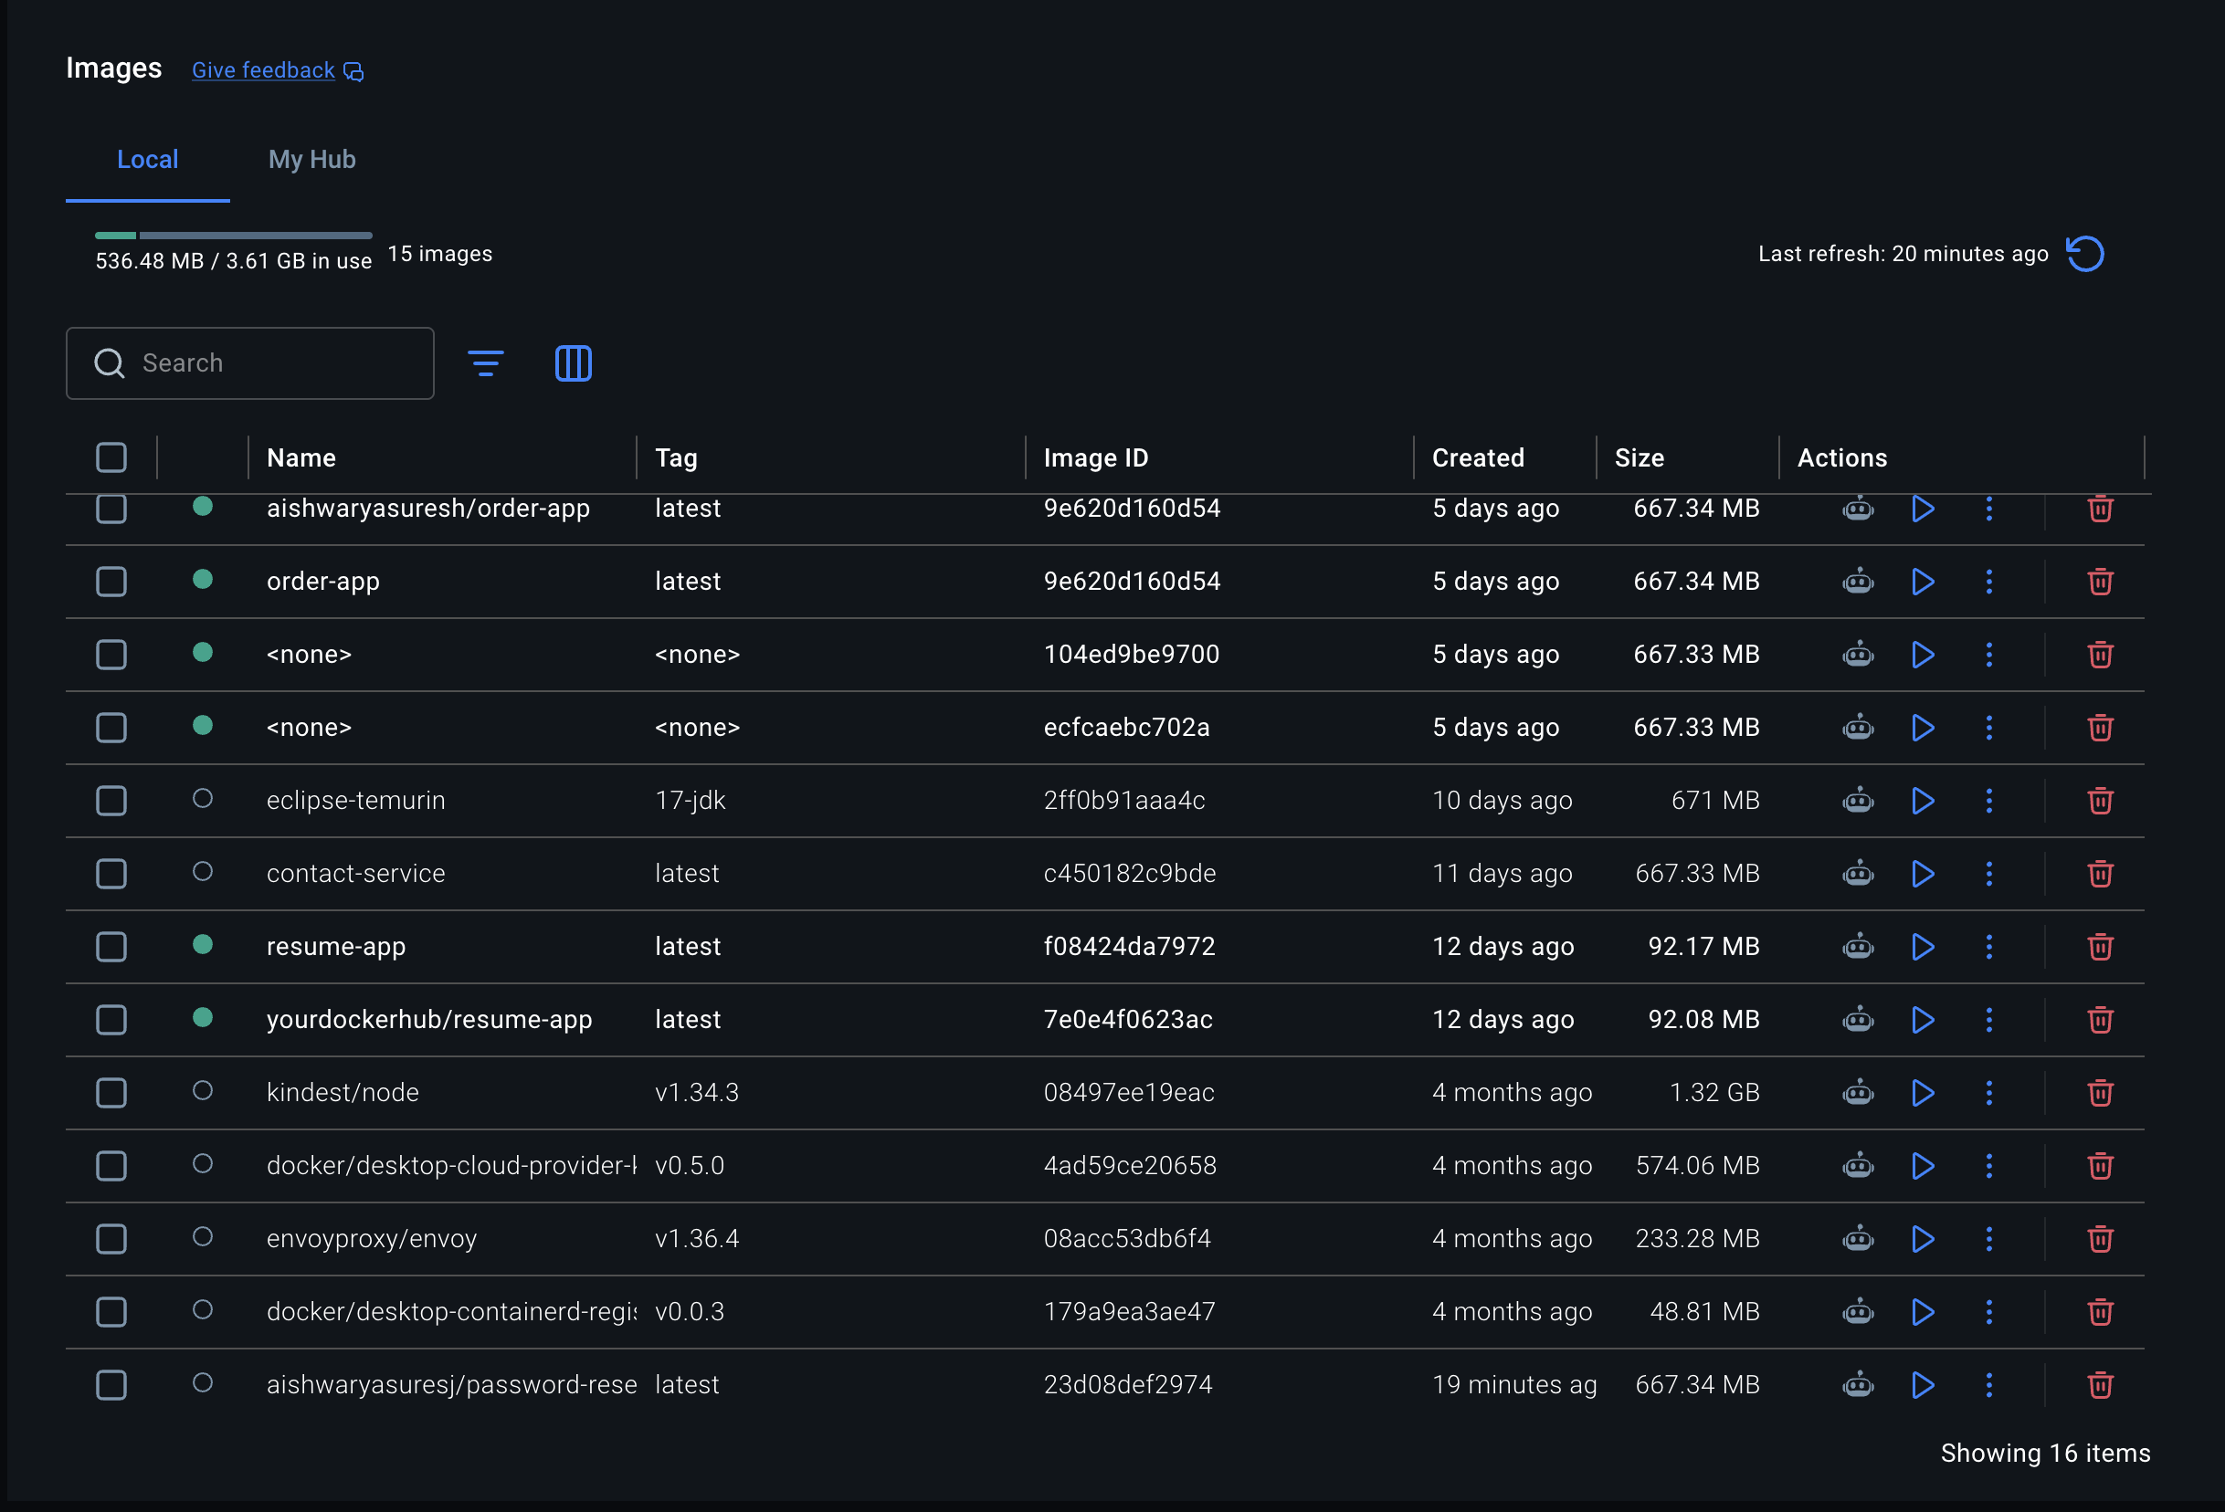
Kubernete:
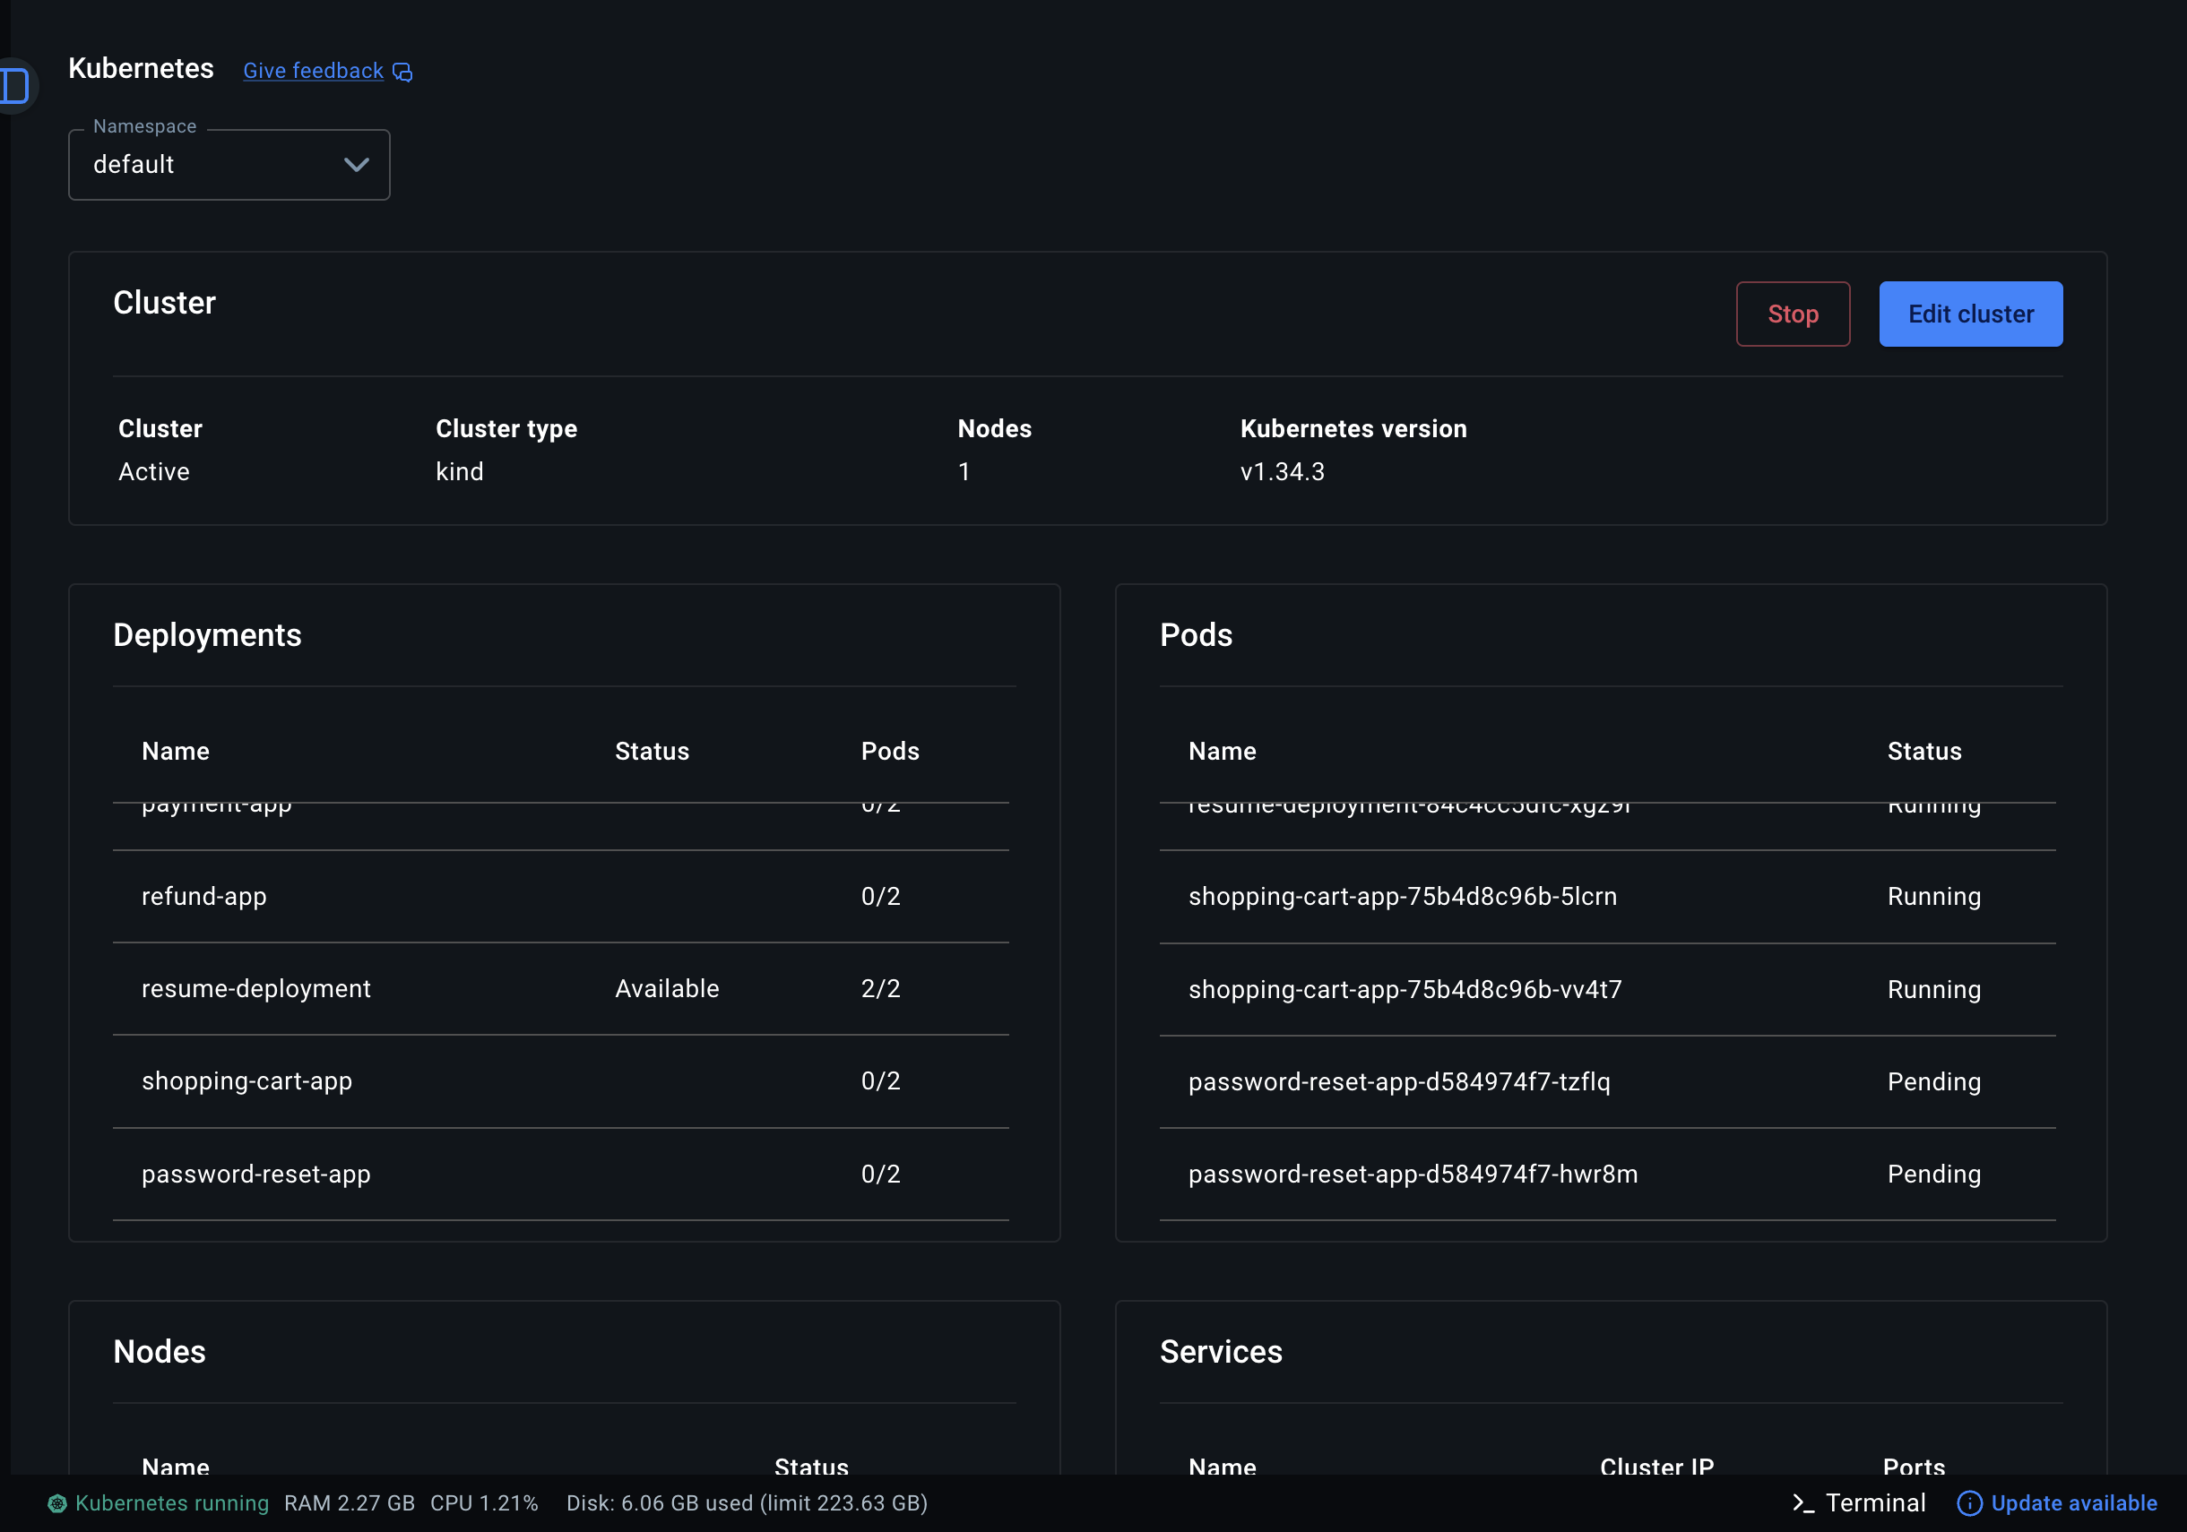
Git structure:
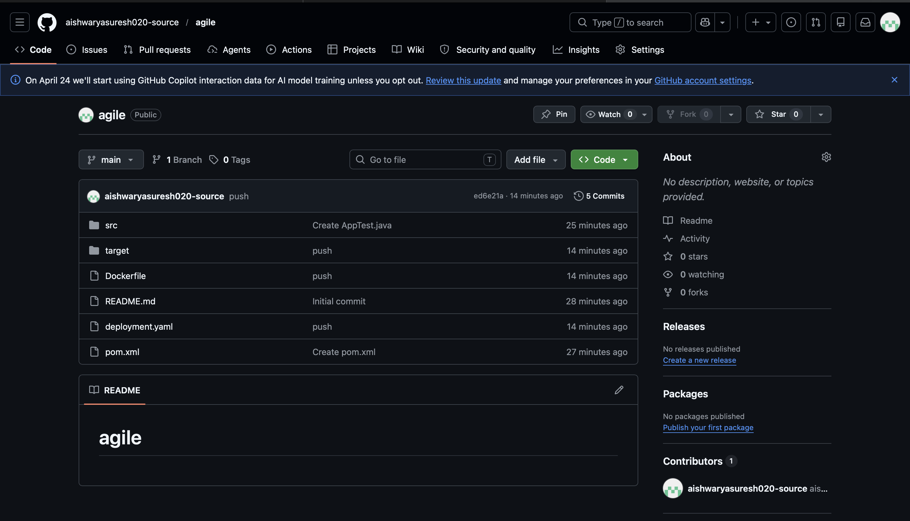

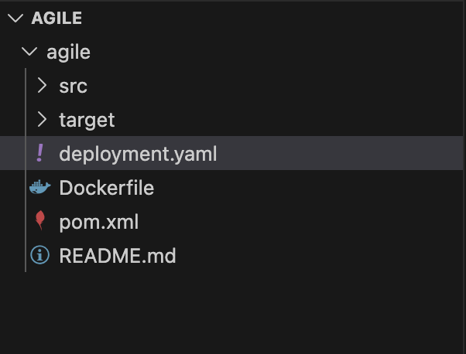
Folder structure:

Build:
