Detection of Diabetic Patients using ECG signals

Shrivas Sudharsan
Cambridge Center for International Research

Corresponding author: Shrivas Sudharsan
Email: sudharsan.shrivas@gmail.com

Abstract—We applied machine learning algorithms to detect diabetes in patients based on ECG signals. Through machine learning processes, like Random Forest Classifier, Logistic Regression, and Gaussian Naïve Bayes, we were able to predict if a patient was diabetic. This prediction metric came from a confusion matrix, where the data could test if the machine learning algorithm detected a false positive, false negative, true positive, and true negative. Before applying machine learning, we preprocessed the data through normalization and down sampling. This process involved concepts from calculus and algebra to extrapolate the optimal range for data analysis. Filtering the data eliminated noise or unwanted “fuzz”, making feature extraction a more efficient. To do this, we used a filtering formula to preserve the necessary data points for analysis. With these data points, we calculated the mean, standard deviation, average time domain, and other features of the electrical signals. Through this, we gathered the necessary features that would be used in the machine learning algorithm. Through the Random Forest Classifier, we found a precision of 87.5%. This metric comes from the ability of the machine learning program to correctly predict the patient as being diabetic or healthy which in this case, the algorithm was able to predict most of the diabetic patients correctly. This experiment highlights how machine learning is an important factor in not only the detection of diseases in the medical field, but also for a wide variety of applications. The influence behind the research was past medical experiences, serving as an influence to find future solutions to ongoing problems involving artificial intelligence.

Author summary
Ever since I was little, I wanted to learn more about the world around me, and the real-world applications of computer science. One specific field I was interested in is medicine. With my family background, I conducted research to understand the causes of diabetes as well as how to predict these patients early on. Keeping this goal in mind, I used multiple machine learning techniques to see their effects on classifying patients with diabetes. The results gathered show that the Random Forest classifier was the most precise measure in an imbalanced dataset (more patients in one class vs another). This highlights both the differences in algorithms as well as the limitations included with smaller and imbalanced data. Doing research that might not be as optimal is essential to producing potential drawbacks in future experiments, mitigating the cause for error.

Introduction

What is Diabetes Mellitus?
Diabetes mellitus is a medical condition affecting over 37.3 million Americans. This chronic health condition results in many complications and even risk of death when left untreated [1]. Given its significant threat, it’s imperative to develop an understanding of Diabetes. Diabetes relates to the process in which the body converts food into energy. Specifically in type 2 diabetes mellitus, this targets the amount of insulin in the bloodstream. In the human body, there are two types of endocrine cells: insulin-producing beta cells and glucagon secreting alpha cells. Both cells are essential for the balance of glucose or sugar in the blood stream [2]. With diabetes mellitus, insulin is either impaired or absent resulting in an imbalance in insulin to glucagon ratio, causing hyperglycemia––high blood glucose —to develop.

Factors of Diabetes Mellitus
Diabetes forms from multiple factors such as obesity, aging, genetics and poor lifestyle choices. Some variations of the disease include Maturity Onset diabetes of the young––Diabetes developed at a young age––and Gestational diabetes––through pregnancy. Regardless of the type, diabetes deals with the flow of blood being prevented by fatty deposits [3]. Obesity in adolescence has caused an exponential increase in diabetic patients recently. Globally, 1 in 11 adults have DM, 90% being type 2. With diabetes mellitus, the brain faces risk of stroke; the eyes face risk of blindness; the heart faces risk of heart attack; the kidneys face risk of chronic kidney disease; and many lose sensation in their feet and legs [4].
Since diabetes can form as a result of poor lifestyle choices, there are a lot of measures the diagnosed patient can take to improve overall health. Overweight people who lose as little as 7 percent of their body weight (by walking for at least 30 minutes a day) can decrease the risk of developing Diabetes Mellitus by over 50% [5]. Metformin is a medication that treats diabetes by absorbing glucose from the liver and food. Fingerstick glucose testing, continuous glucose monitoring, fructosamine, and urine glucose are all methods that monitor the levels of sugar in the body [6]. Since glucose levels can vary throughout the day, it is important that patients are constantly monitored to prevent levels from reaching deadly extremes. Insulin tablets and injections are prescribed based on the abundance of glucose to help regulate a normal sugar level in the body.

Nowadays, there are standards and methods used to diagnose patients based on their glucose count. Typically when diabetes is active, there is not enough insulin to break down the sugar in the blood, resulting in an apparent increase in glucose [7]. Fasting glucose levels and HBA1C testing are used to diagnose prediabetic patients (typically involving oral serum tests), allocating for preventative measures rather than treatment. According to the American Diabetes Association (ADA), diabetic patients contain HbA1c levels of 6.5% or higher, fasting plasma glucose level of 126 mg/dL (7.0 mmol/L) or higher (no caloric intake for at least 8 hours); a two-hour plasma glucose level of 11.1 mmol/L or 200 mg/dL or higher during a 75-g OGTT; a random plasma glucose of 11.1 mmol/L or 200 mg/dL or higher in a patient with symptoms of hyperglycemia (polyuria, polydipsia, polyphagia, weight loss) or hyperglycemic crisis [8]. These results can determine the right treatment plan for each specific patient. Other methods like serum lipid monitoring are used with active diabetic patients (DM) to prevent problems from spreading to other parts of the body, such as chronic kidney disease and nerve damage.

Effects of Diabetes Mellitus

By monitoring frequently and early, doctors can protect patients from alternative impacts. Diabetes, being a metabolic disease, causes high blood sugar over time, damaging blood vessels in the brain (responsible for carrying oxygen rich blood) [9]. Oxygen is an element necessary for the human body to perform cellular respiration and create energy. Diabetes mellitus inhibits rich oxygen from being transported to the brain, decreasing function of cells (due to a lack of production of energy) also known as Hypoglycemia [10]. Effects of oxygen deficiency are dizziness, trouble walking, difficulty talking, and decreased focus. Other studies show that big drops in blood sugar are also responsible for depression (21 million people per year) or even lead to a coma in severe cases.

The Role of ECG Signals

ECG signals (electrocardiogram) are electrical currents that are recorded from the heart’s rhythm. These signals can tell us a variety of information, from a patient’s average beats per second to abnormalities in the blood flow [11]. Since diabetic patients have an increased level of glucose in their blood, ECG signals can provide intrinsic information to visualize those discrepancies. Thus, ECG signals provide the foundation to understanding factors that affect the human body and serve as the fundmental diagnostic tool for cardiology [12].
To understand the importance of ECG signals, we can look at how it’s used through computer science. Computer science incorporates artificial intelligence (AI) and visualization techniques through code to depict discrepancies in patients’ signals. While each ECG signal is unique for each human, there are certain abnormal trends that can be observed to help identify problems. In this way, ECG signals pave way for predicting and diagnosing diseases before symptoms arrive. While employing algorithms capable of analyzing hundreds of signals per second, doctors can swiftly detect arrhythmias, irregularities, and other cardiac conditions far more efficiently [13]. While ECG signals can be difficult for humans to discern manually, the use of computer science has the capability to eliminate noise, or unwanted data from these signals, leaving the most critical values for analysis.
This experiment will better visualize the importance of computer science, specifically machine learning, in the medical field. This paper also presents an in-depth analysis of the usefulness of feature engineering and modeling of various signals [14]. The application of machine learning highlights the potential for automated processing to expedite the interpretation of physiological signals such as ECG and EEG. Through machine learning techniques such as binary classification, we can understand patterns and analyze features that are unique to patients with and without diabetes – in their own respective groups.

Machine Learning in the Status Quo

Machine learning is a type of artificial intelligence which relies on data and algorithms to imitate how humans behave. Almost any business or enterprise relies on the advantages of machine learning to enhance and market their product. Regarding medicine, there are multiple examples that can underscore the extent to which artificial intelligence is used [15]. Convolution Neural Network (with more than 100 layers) is a machine learning algorithm used in clinics to perform diagnoses. While these AI tools can be more powerful than diagnosticians, people are still required to monitor these machines. This demonstrates how machine learning is currently being used to assist with challenging medical procedures. [16]. Additionally, AI works alongside a multitude of imaging softwares to render medical diagnosis. One algorithm includes decision trees: a node-based algorithm that connects branches from their “roots” until a Boolean parameter is achieved [17]. By branching out to different roots, this algorithm identifies the best combination of features to classify a group of data. Another example of machine learning is K-Nearest-Neighbors (KNN), which is used for the classification and prediction of data. This supervised machine learning algorithm (datasets with x and y labels) calculates distances between points on a graph to form conclusions based on visual patterns [18]. After initializing a value of k to the data, a value correlating to the distance between each data point is ordered on an index. Then, the algorithm selects k number of data and labels to calculate the mode (for classification) or mean (for linear regression) [19]. Recently a test by UCI has been done with KNN, to optimize a classification tool [19]. With this algorithm, k is the value used for accurate predictions of data and varies based on the input provided. Through multiple trials, the students at UCI tested different values of k to classify data with the highest accuracy and fewest data points provided. This example is one of many that highlights how the use of AI in the medical field makes clinical tasks quicker and more self-sufficient [20]. While this paper focuses on the use of machine learning in the detection of diseases, Artificial Intelligence can make life easier in any field, making it a versatile and essential tool.

Currently, AI is being used in diagnosis of intercranial hemorrhage, drug detection, and outbreak prediction [21]. Many monitoring applications require specific signals to visualize discrepancies and produce predictive models of the spread of diseases. Thus, physiological signals such as EEG, ECG, and PPG are all gathered to diagnose patients with a multitude of diseases such as diabetes, stroke, and myocardial infraction. With the improving technology in laboratories, data acquisition has become exponentially easier and more precise. For example, studies have used machine learning to predict hypertension and blood pressure through the sweat from workers in a construction field [22]. The continual application of Machine Learning opens numerous possibilities for its improvement in medical analysis.

The use of AI in the medical field continues to improve as wearable devices become more prevalent. As technology improves, companies can produce cost-efficient devices that implement various machine learning techniques. For example, Atlas Wearables uses machine learning algorithms to decipher if a person is performing a cardio or aerobic activity. These wearable devices have the potential to provide a large amount of data, as they are constantly recording the features of organs in the human body. Wearable devices have become increasingly popular leading to the increased potential of data gathering. Since more data is available to the technology industry, companies are pushing towards the analysis of this data through machine learning. Wearable devices serve as an integral tool to early diagnosis of diseases, gathering information from heart rate, sweat levels, skin temperature, and blood pressure of patients [23]. One of the most common features of wearable devices is the detection of heart arrythmias through ECG signals. To mimic this feature of wearable devices, our project will focus on the binary classification of patients from ECG signals through advanced machine learning techniques.

Related Works
Another implementation of machine learning, one that is used extensively in this experiment, is neural networking. A study done at the 40th International Conference of IEEE in Medicine and Biology Society used PPG signals to detect hypertension [24]. Based on socio-demographic data (age, education, religion, employment, marital status, income levels, migration background, race, and ethnicity) and clinical tests, Artificial Neural Networking is used to classify the level of hypertension each patient has. The unique aspect of this experiment is that it uses both raw signals and clinical data to form a conclusion [24]. Clinical data involves age, gender, and body mass index while raw signals are relevant features extracted from PPG and ECG signals. Similarly, our experiment includes both clinical data of the patient’s history alongside the features extracted from ECG signals. While machine learning is heavily used on the signals from ECG, having clinical data is important to select a variety of patients for the code to analyze.

Another study has used deep learning algorithms, such as a convolution neural network (CNN) with a support vector machine for classification of diabetes [25]. For binary classification, 20 groups were taken from each class, being the diabetic and control patient. A unique aspect about their experiment was that they used a Pan Tompkins algorithm with ECG signals to gather their data. This dataset had a sampling frequency of 500 hertz while the data gathered in our experiment has double of that frequency. Regardless of the difference in the datasets, this research used similar tools, such as a recurrent neural network—with long short-term memory—a convolutional neural network, and support vector machine to plot data as a point in space [25]. This aspect of processing the data allows binary classification to analyze the gaps in each data point. These algorithms analyzed morphological features such as slope, amplitude, and width after a band pass filtering algorithm processed the data. With these features and a combination of neural networks, binary classification was used to get an accurate prediction of the classes. While many research papers focus on the use of morphological features, our experiment highlights multiple aspects of the data. We present a feature model that highlights the mean and standard deviation of various peaks in the data and presents the difference in accuracy between multiple types of machine learning systems.

Machine learning studies like these use a variety of algorithms to yield similar results. Feature Subset Selection is used for binary classification in Deniz’s study [26]. This study focuses on how the medical field has shown increased importance to binary classification through its implementation in diagnostics. This experiment extracts the number of features necessary to predict the status of patients through feature subset selection (to prevent overfitting and underfitting of data). This machine learning algorithm uses a variety of data and techniques to find the point where there is the highest accuracy and the minimum number of features. This unique addition to the project allows them to yield a high accuracy with its results in binary classification, emphasizing future improvements in the healthcare field [26]. Aside from feature selection, this study (like ours) uses machine learning techniques such as Logistic Regression and Support Vector Machines from the previous study. A new tool is the Extreme Learning Machine, a feed of neural networks. Aside from supervised algorithms, the study also highlights K-means and Affinity Propagation. All studies here use some sort of numerical data for machine learning to study the data easily [27]. By feeding the program values as opposed to images, machine learning algorithms can optimize the data for the highest output.

Innovation
As opposed to other projects, we highlight how various machine learning applications result in different levels of accuracy (while feeding the same features coming from specific amplitudes, means, standard deviations, as well as average time intervals). With the combination of multiple types of features, our experiment presents a unique way of implementing machine learning in binary classification. As explained later in the paper, there will be a table recording f1 score, precision, accuracy, and recall score [28]. Other studies focus on finding the most accurate machine learning implementation but fail to encapsulate how data can be interpreted differently based on different machine learning algorithms. Other papers used a multitude of neural networks while this project focuses on a wide array of machine learning algorithms and its impact on the specific data gathered from each wave of the electrical signals (P wave, S wave, Q wave, T wave, as well as the onsets) This data is then converted into a variety of features such as mean, standard deviation, and time. A combination of a variety of signals makes these features very accurate and unique from other papers. To prevent an over fitting or underfitting of data, this study aims to gather details from various machine learning strategies, to find the best number of features suited for the most precise results. Many of these papers don’t focus on how data leakage and overfitting can cause extremely high, but inaccurate predictions for machine learning [29]. With the errors discussed in the analysis section, we can show how there still needs to be more optimization for machine learning to get the most accurate results. With binary classification, there are many methods that need to be tested before developing conclusions, such as an imbalanced dataset, something that this project highlights.

The Wang IEEE experiment focuses on a combination of clinical and raw data to perform machine learning, this is different from the goal of my project [24]. Here we focus on the different types of machine learning and its impact on the same features. The Vinayakumar study uses multiple neural networks to analyze morphological signals, but doesn’t focus on the time domain, something that my experiment does by calculating the average seconds when the amplitude is zero [30]. The Deniz study focuses on minimizing the number of features while trying to find the highest accuracy [26]. Our experiment on the other hand tries to find how different machine learning algorithms respond to a certain number of features to not only find the most accurate model but also highlight the differences between algorithms. To my knowledge, ours is the first experiment to try and find the most accurate machine learning algorithm for binary classification while highlighting the individual differences between f1, recall, precision, and accuracy through a variety of features such as morphological, temporal, and statistical data. In addition, our data comes from the analysis of cerebral blood flow from 3 Tesla MRI, the fastest diagnostic magnetic resonance technology available.

Methods

Database Information

In this experiment, we used a database from PhysioNet, a large database with physiological data. Their data contained a total of 140 patients who went through the laboratory test, 70 with type two diabetes mellitus and 70 constants who were between 50-85 years of age [31].

At the Beth Israel Deaconess Medical Center, Day 1 procedures were performed (vital signs, glucose measurements, physical exam, cognitive test, walking test, Holter monitor). On day 2, subjects checked into the SAFE laboratory and had a TCD ultrasonography (CO2 rebreathing, Valsalva maneuver, head-up tilt, sit-to-stand) simultaneously recorded with respiratory variables [31]. At the SAFE laboratory, each patient had a Doppler ultrasound (in the anterior and middle cerebral arteries) to monitor the blood flow velocity (BFV) of each patient. To gather the ECG signals, a 3 Tesla MRI evaluated the regional distribution of cerebral blood flow. This MRI assesses the three-dimensional spatial activity of ECG signals [32]. In a heartbeat, there is electrical activity that causes the heart to pump blood. Advanced technology like the Doppler ultrasound and MRI can pick up those electrical signals and plot them for the computer to analyze them. This diagram shown on the computer is known as ECG signals. The ECG signals were recorded at a sampling frequency of 1000 Hz [31]. This means that there are 1000 samples of ECG signals per second of time recorded. Sampling frequency is an important factor to take into consideration when preprocessing the data and making it more effective for analysis.

Cerebral Blood flow (rate of delivery of arterial blood to a capillary bed in the brain tissue) also known as CBF was assessed through ECG signals recorded from the middle cerebral arteries (with transcranial Doppler ultrasound). Cerebral vasoregulation (the ability of blood vessels to maintain CPP - the net pressure gradient driving oxygen to the brain) was calculated by comparing blood flow velocity responses in the brain (hypocapnia and hypercapnia) [31]. This data was recorded with patients sitting in a head-up-tilt position, to get the most accurate data.

From that database, we used 10 patients as controls (who don’t have the disease) and 6 patients with Diabetes Mellitus. These patients were put in a laboratory (head-up-tilt) to monitor blood flow velocity (BFV) in the anterior cerebral artery (ACA) and middle cerebral artery (MCA). ECG signals were gathered and recorded alongside cardiovascular and respiratory variables. These signals were then plotted on a 30-second timeframe.

Materials
In this experiment, I used a python software called VsCode, with an application called Neurokit and matplotlib features. This was used in the analysis of the data gathered from the Beth Israel Medical Center.

Analyzing ECG Signals

ECG signals are graphical representations of the heart’s signals, recorded through the electric impulses of the human body. These signals follow a certain trend, with hundreds of different variations that are unique to everyone. An ECG signal displays four different peaks, representing one heartbeat. Each one of these heartbeats follows a pattern. This pattern is consistent throughout the diverse combination of electrical signals.

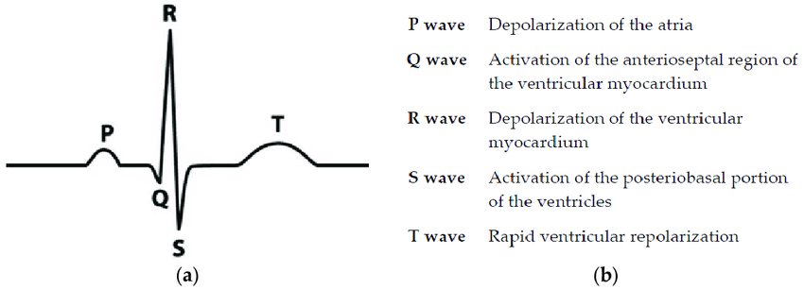
Figure 1: The extrapolated data above is a representation of each of these waves for a duration of 30 seconds. The P, Q, R, and S waves all deal with the contraction of the blood vessels, while the T wave is responsible for the release, marking the end of one heartbeat.

Techniques

With these ECG signals being recorded, the extracted data is then preprocessed to be analyzed further. This typically involves normalizing the data by putting the features of the data on a similar scale [34].

Normalization of data using standard deviation
- $σ= \sqrt{\frac{Σ{\left(x- μ\right)}^{2}}{N}}$

Where $σ$ is the standard deviation
Where x is each feature
Where $μ$ is the mean of each feature
Where N is the number of data points in the signal

Normalization of data using mean [35]
- $X=\frac{∑x}{n}$

Where $X$is the mean
Where x is each feature
Where n is the number data points in the signal$.$

Normalization involves both the mean and standard deviation of each data point. To eliminate variation, one takes the mean of the data and subtracts each value from it. By taking the mean from each value, data points become more closely connected and there is less variance [34]. To further lower the variance in datasets, standard deviation is used to normalize the data, subtracting the mean from every value and finding the square root of the average of those values. Standard deviation essentially models the spread of the data, or how far the data points are spread out. By normalizing the data, the range automatically decreases, allowing the dataset to yield itself for analysis.

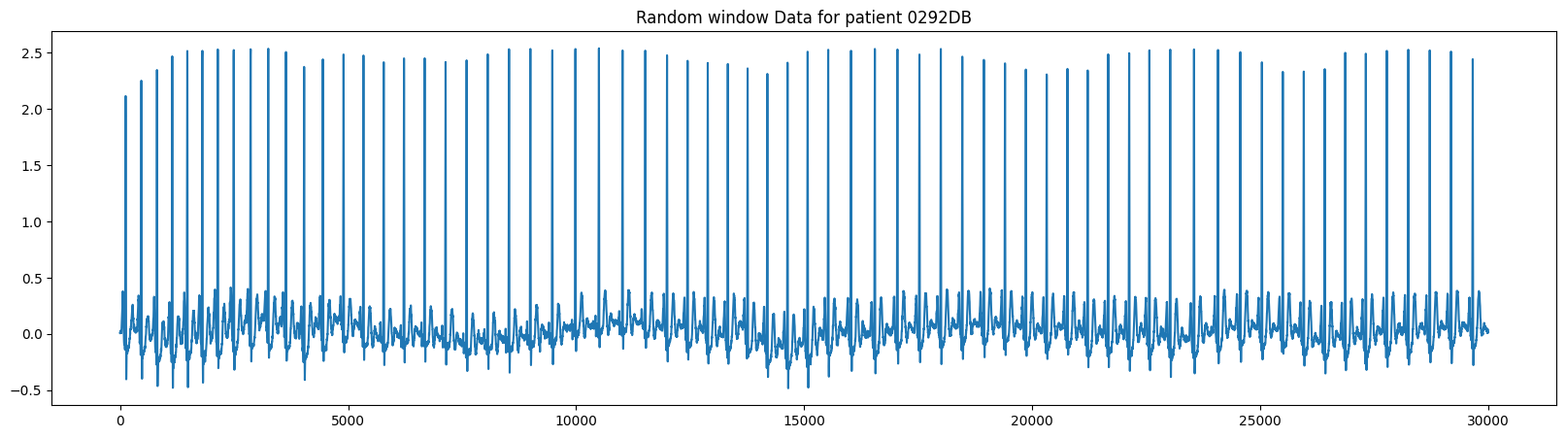

Figure 2: The above figure represents the electrocardiogram signal for a female diagnosed with Diabetes Mellitus. This represents the rhythm in the heart.
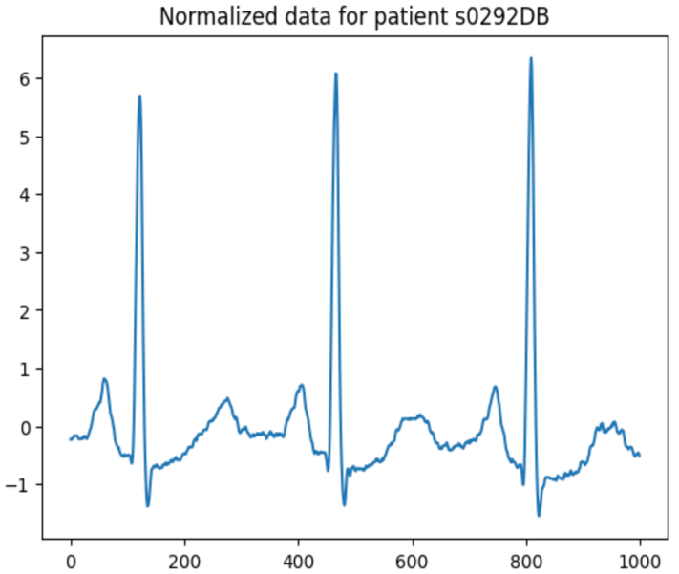

Figure 3: The figure above contains the same data as the previous patient, but the graph is normalized to be easier to read and processed to analyze features.

Before completing feature extraction, the data needs to be filtered. Data typically has a lot of noise, so we use filtering methods to retain the relevant values in the data (while preserving the overall model) [40]. To get as much data as possible, there are various visualization tools that graph the ECG signals in different forms. For example, ECG signals are usually graphed with the x-axis of time, and the y-axis of amplitude. We change the plot of the data into the x-axis of frequency, and the y-axis of amplitude, also known as a periodogram.

$$\left(3\right) x\left[k\right]=\left(Σ[ k = 0 to N-1 ] \right)*x\left[n\right]e^{-\frac{j2πkn}{N}}$$

Where x[k] is the frequency
Where k are the possible frequencies for the signal between 0 and N-1
Where N is the number of data points in the signal
Where x[n] is the strength of a signal’s component at a particular frequency
Where j is the imaginary unit
Where n is the time index ranging from 0 to n-1

This frequency equation is used to convert the ECG signals into periodogram form. To return the possible frequencies of the table, this equation applies Discrete Fourier Transform to take the input of the time data and convert it to the frequency signal. This is the formation of the x-axis for the periodogram; with these values, the highest magnitude is calculated for the domain of the periodogram. The coefficients of the results calculated for the frequency correspond to k. With this equation, data values are then plugged into the frequency equation to find the resulting amplitudes [34]. By multiplying each value calculated by k, the frequency is then calculated from the time components.

Since random error can occur with the machine recording ECG signals, it is important to remove all unnecessary data that will change the values of your results. To decipher whether data is unnecessary, normalizing, downsampling, and filtering are done through mathematical formulas. While these formulas analytically get rid of unnecessary data, visually the data will appear to have a lot of noise [35]. Referring to figure 2, the lines in the q s and t peak are very thick, leading to a fuzz of data values. Instead, we normalized our data to appear like figure 3, showing that the lines are more easily visualized without any fuzzy marks making it unclear.

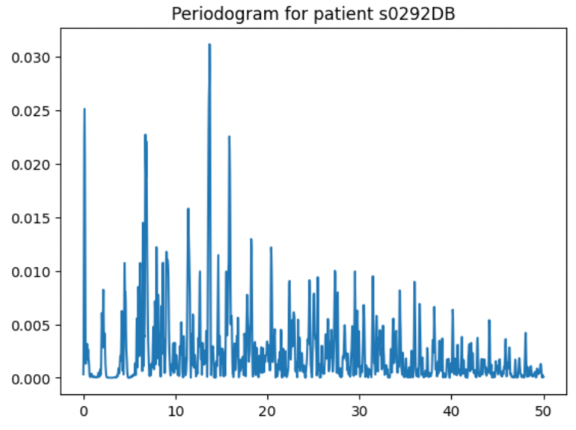

Figure 4: The above diagram converted ECG signals for patient s0292DB (x: time, y: amplitude) to periodogram format (x: frequency, y: amplitude). This is a unique way to visualize plots and extract more features to prep for machine learning

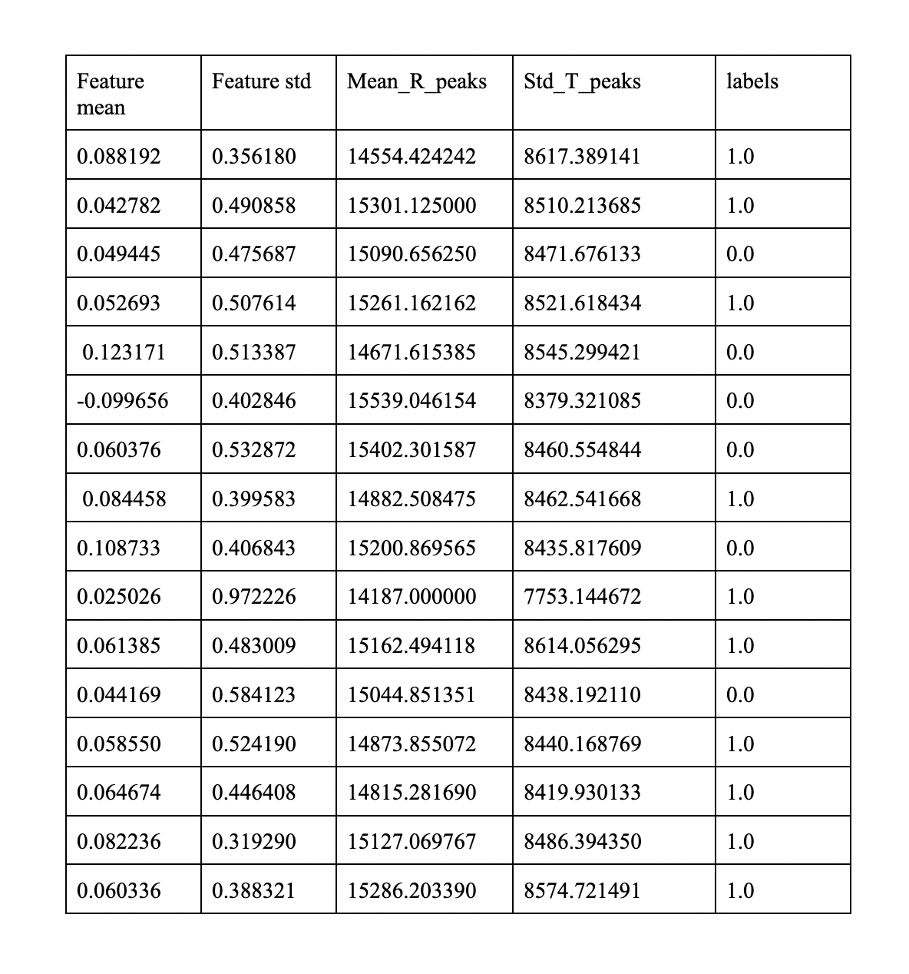
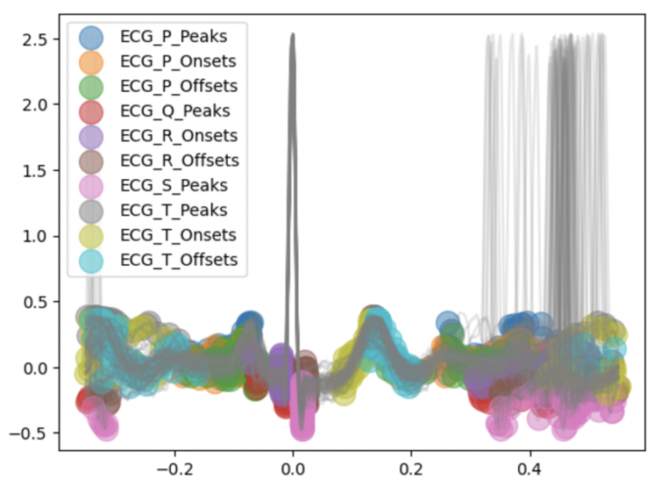
Figure 5: The above graph is plot of P, Q, R, S, and T peaks alongside onsets to show the different aspects of ECG signals.
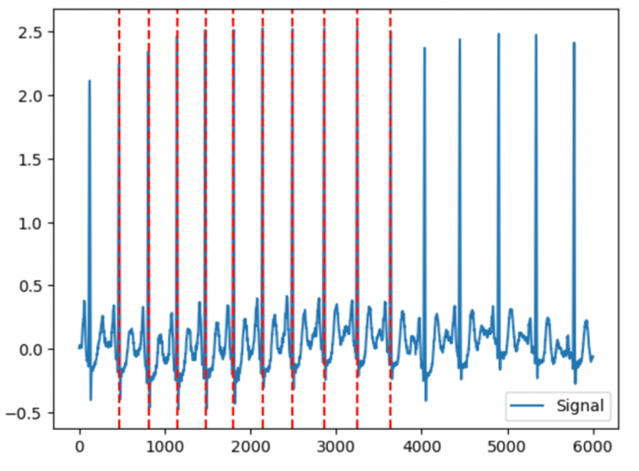

Figure 6: The graph above shows the R peaks and their locations in ECG signals when visualized on the graph. Each red line represents one r peak; since there are 10 red lines, it displays the location of 10 heartbeats for a diabetic patient. Visualizing data in contrasting views prepares the data for feature extraction.

Statistical Techniques

After visualizing the graph, feature extraction is used to extrapolate the necessary data from the plots. An application called NeuroKit is used to extract features from the ECG signals to further analyze the numerical values of the data: features such as the mean of T Peaks, standard deviation of P Peaks, or the average seconds that the amplitude of ECG is zero [36]. Alongside visualizing the patterns, extracting features is essential for prepping machine learning applications.

By extracting multiple features, machine learning algorithms can formulate patterns from all these values to find commonalities and differences between diabetic patients and the control. To prevent an overfitting of data (when too many features are extracted causing ultra-specific trends), we extract less than the number of patients in the data (which is 16). By extracting 13 features, we can prevent an underfitting of data, while making sure our patterns aren’t too specific (making it impossible to classify patients) [37]. Feature extraction allows for a diverse set of data to be gathered and is the basis for creating accurate algorithms. Thus, feature extracting is one of the most essential steps prior to performing binary classification.

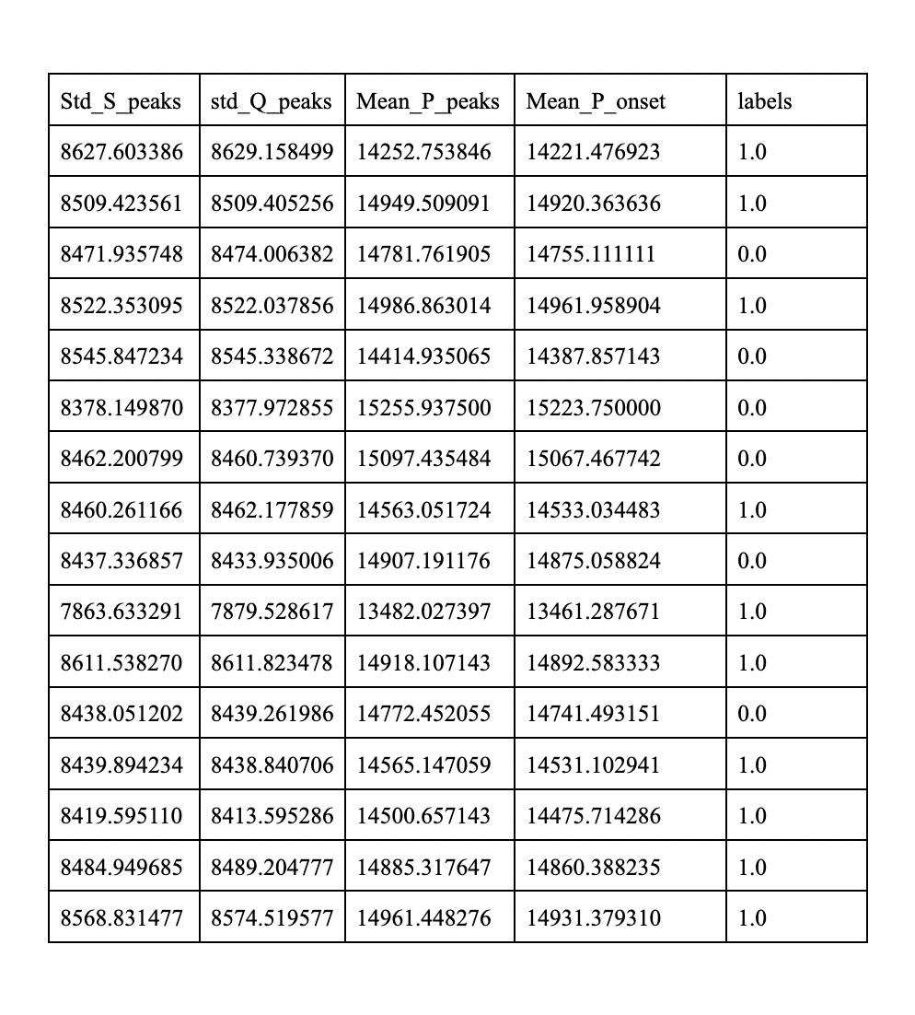

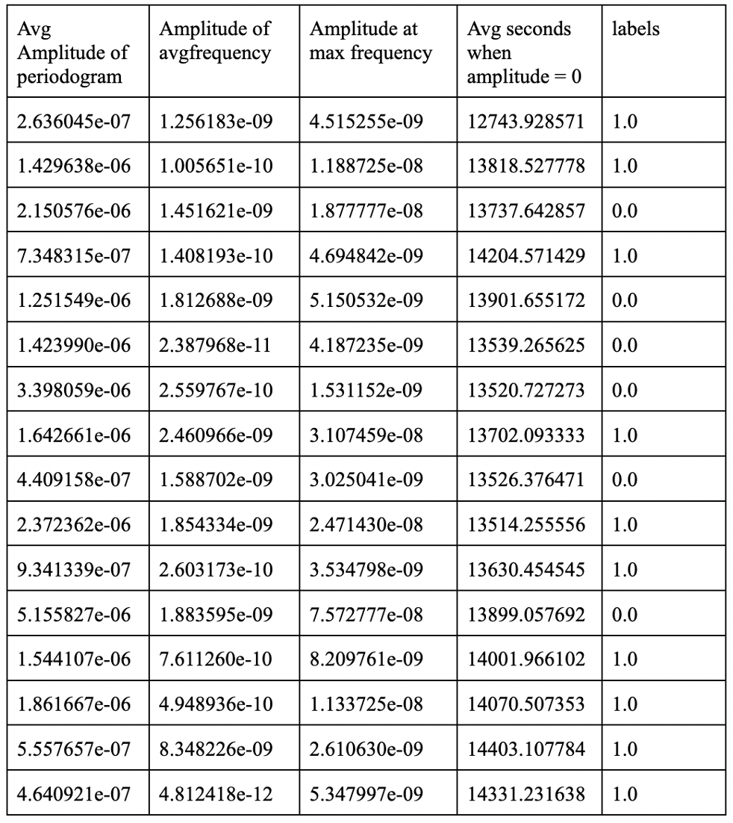

Figure 7-9: The tables above represent the features extracted from the ECG signals. By putting it in table format, we can see the data of each of the 16 patients. These diagrams represent the features extracted from the ECG signals. Each column represents one feature and has 16 rows for the value of each patient. The labels column
determines whether each patient has diabetes or is a control (1.0 – diabetic patient, 0.0 – control patient).

Machine Learning

In this experiment, we used binary classification to determine if a patient has Type 2 diabetes mellitus or not. Binary classification involves categories that are predefined, that way new observations can be classified into one of these definitions.

To visualize the differences between the control and diabetic groups, we use a variety of plotting methods such as boxplots, histograms, and scatterplots [38]. By plotting the features extracted earlier, visual analysis of the two groups becomes apparent as certain patterns of the control and diabetic groups remain consistent.
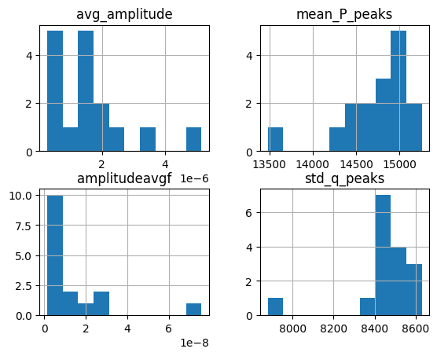

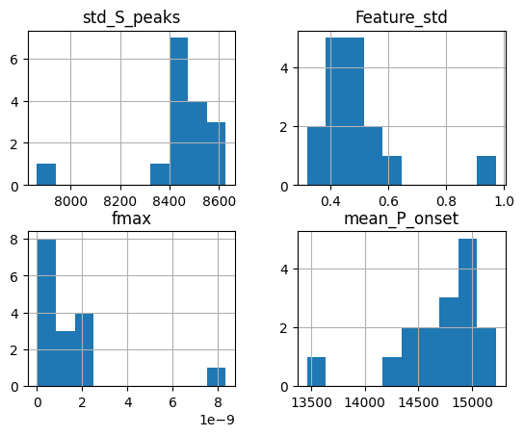

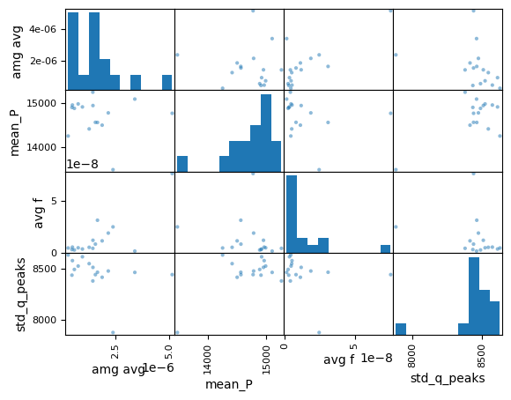

Fig 10-12: The above diagrams show a simple way of extracting twelve relevant features and plotting them on a histogram. Similarly, many other diagrams are created such as the scatter plot below. Here we can see the distribution of r peaks is a lot different from the distribution of T peaks. With variation in the data, machine learning can perform analysis to find patterns between different groups.
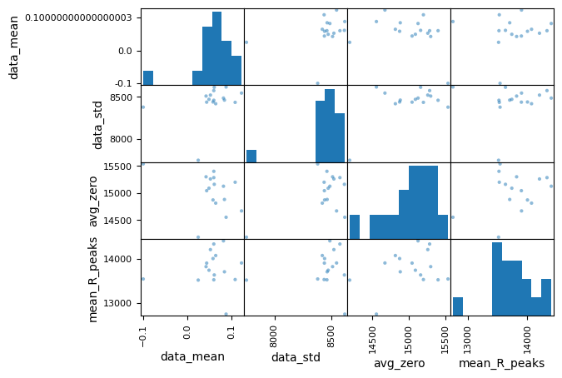

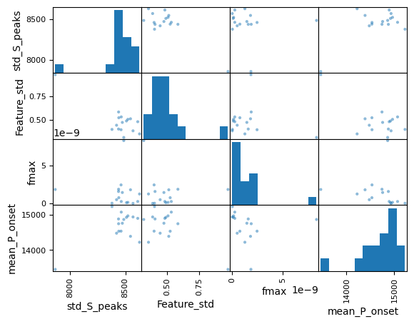

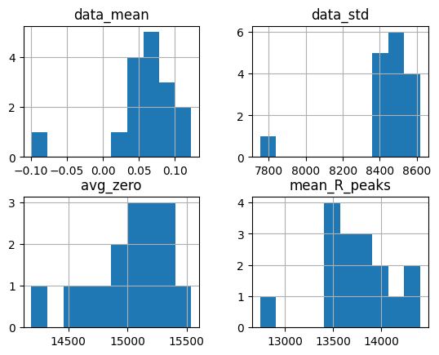

Figure 13-15: Many other diagrams are created such as the scatter plots above. Visualizing differences between features makes it easier to decipher if the features gathered previously were optimal. Here we can see both the histogram and scatterplots in one, to see the correlation between features gathered. The less correlated, the better features that were gathered.

For machine learning to accurately predict the classes based on the features, the scatter plots should be less linear. Essentially, if features are linear, there is a lot of correlation to one another—like a line of best fit. With a line of best fit, that means the data between the control group and diabetic group are too alike resulting in a lack of distinction. Distinction between the two classes is the most important step regarding accurate machine learning implementation [46]. Using binary classification, machine learning should accurately define which data belongs to which class. If there isn’t a large enough distinction, binary classification won’t work. All these visualization techniques are used to ensure that the features gathered are ready for machine learning.

This experiment focuses on a variety of machine learning algorithms to show how different algorithms yield different results while having the same features. Some algorithms used are Logistic Regression, Linear Discriminant Analysis, K-Nearest Neighbors, Decision Tree Classifier, Random Forest Classifier, Ada Boost Classifier, Gradient Boosting Classifier, Extra Trees, Bagging, MLP Classifier, Perceptron, NuSVC, Isolation Forest, Support Vector Machine, Gaussian Naïve Bayes, Voting Classifier, SGD Classifier, and Artificial Neural Networks [39]. While each one of these applications was created similarly, they all have different methods. Logistic Regression incorporates numerical values and the ideals of mathematics into machine learning [40]. By finding the relationship between two points, logistic regression makes a prediction of one of the points based on a common factor between multiple types of datasets. Linear Discriminant Analysis computes the mean of values in the dataset, the scatter matrices, and the eigenvalues to correctly predict the class [41]. It also reduces the number of features before classifying the data. Meanwhile, K-Nearest Neighbors is a supervised machine learning algorithm that calculates the distance of every value from a specific point k and finds the closest values to predict the outcome of a patient [18]. Decision Tree Classifier uses “branches” and nodes to determine the likely outcome of a patient [16]. For example, if you were to predict if a person had diabetes, you would have to make a conclusion that a certain ECG amplitude is likely to have diabetes. Based on that conclusion, you can create multiple different factors and if they answer yes to every class, then they eventually work down the tree till it reaches the “diabetes” label. While the previous algorithm has one tree to classify, Random Forest Classifier takes multiple trees and puts them in an overarching problem. Just like a decision tree, the algorithm has a variety of tests and, depending on the answer, go down a specific path on the branch [42]. Once they reach the bottom, each tree’s vote will either be a “yes” or a “no”. With this vote, the Random Forest classifier takes the votes with the highest majority to be the correct prediction. Ada Boost Classifier is an ensemble learning method that focuses on weak learning algorithms (such as decision trees) and combines them to create a strong output [43]. By assigning different weights to different trees, Ada Boost Classifier can give very accurate predictions regarding the proper classification of patients. Gradient Boosting Classifier is another ensemble machine learning algorithm that uses a series of weak learners to fix the errors that that other algorithms create [44]. Boosting Classifiers like such often learn and adapt from previous algorithms to construct an effective conclusion for the patient. Extra Trees operates similarly to the Random Forest Classifier, but it adds random thresholds to each feature of the decision tree, creating a more diverse featured algorithm [45]. While this may seem like a negative aspect, introducing more diverse algorithms can make the machine learning algorithm much more precise and account for an array of factors. Bagging, or Bootstrap Aggregating, is an ensemble learning algorithm that builds a predictive model based on different subsets of the data [46]. This data is created through bootstrapping, where the final model is based on the predictive analysis of other machine learning algorithms. The MLP (Multi-Layer-Perceptron) Classifier is a type of neural network used in classification problems [48]. Using backpropagation–– a method used to minimize the error of the stages with a neural network ––nodes, and nonlinear activation functions, this algorithm is one of many neural networks that can accurately perform binary classification tasks. Perceptron is a type of neural network, with a single layer of nodes [48]. This layer adjusts the weight of certain features based on the miscalculation of data, until it can formulate an accurate algorithm. Instead of using one perceptron, algorithms typically prefer MLP as multiple layers allow it to handle a large amount of data with visual depictions. NuSVC, or Nu-Support Vector Classification, is a form of the support vector machine that creates a variable nu, to control the number of support vectors and training errors [49]. Isolation Forest incorporates decision trees through an anomaly detection software [50]. This machine learning algorithm counts the number of trees needed to isolate each data point. The data that takes the fewest amount of trees is the anomaly, which stands out in the isolation process. This process repeats until the data is split into the two classes, which formulate its predictions. Support Vector Machine is a supervised learning algorithm that incorporates a hyperplane in classification tasks [51]. By creating multiple support vectors in this hyperplane, this algorithm maximizes the margin between classes and produces decision boundaries. Gaussian Naïve Bayes incorporates the Gaussian bell curve and treats each feature as independent to locate the distribution of classes [52]. Voting Classifier involves the combination of each individual machine learning algorithm, taking in one vote from each algorithm, and returning the majority prediction [53]. Soft voting results the average of the predictions while Hard voting results in the mode of the predictions, or the most common prediction. SGD Classifier, also known as Stochastic Gradient Descent, is a popular binary classification algorithm. SGD optimizes the model parameters iteratively by updating them based on the gradient of the loss function for each individual training example. This loss function calculates the disparity between predicted values and actual values. Through this approach, the algorithm is able to vary its implementation based on the ability to properly classify the patients. Its efficiency in handling large datasets and online learning, coupled with its simplicity, makes it a versatile choice for real-time and large-scale binary classification applications [54]. Finally, Artificial Neural Networks have individual nodes that have different weights throughout the implementation [55]. As the different layers (input, hidden, output) are being passed, the neural network captures complex relationships and patterns, and trains the data so that certain features have a greater weight to the classification task. Each one of these algorithms operates in different manners, yet they will still perform the same function: binary classification. Binary classification is the ability to take data and give it a class (1.0 for positive and 0.0 for negative), hence the name “binary.” Decision trees are one of the algorithms used throughout the most accurate methods: extra trees and random forest. Decision trees are algorithms that create branches with different categories and tests (these are known as nodes); each node splits the classes into subsets based on features leaving one class for the answer [52]. While both algorithms incorporate their diagram from decision trees, their methods are distinct. Extra trees focus on maximizing the randomness of the trees while the random forest focuses on picking the best splits. While extra trees operate more efficiently and quickly, Random Forest prevents the overfitting of data, by sticking to the most optimal splits and decision trees when formulating the answer [45]. This example shows how machine learning algorithms use different methods to get the greatest accuracy for the same data.

Random Forest
Random Forest is a unique algorithm that yielded the most precise predictions for the classes in this experiment. This algorithm stems from the decision trees: the process in which nodes are created to split the data into different classes. Through multiple decision trees, Random Forest can combine the usefulness of multiple algorithms to make the best predictions [56]. Like other ensemble algorithms, Random Forest is used for both regression and classification tasks. In this experiment, we highlight the use of classification to accurately predict the status of diabetes in a patient. Ensemble algorithms like random forest are very useful as they combine multiple algorithms to form the most robust result [57].

To create a random forest, the code must know how to create decision trees first. Decision trees are one of the fundamentals of machine learning algorithms: they provide the basis for extra trees, isolation forest, random forest, etc. In a decision tree, each node represents a decision based on a specific feature (done in feature extraction), each branch represents the outcome of that specific decision, and each leaf node determines the predicted class [52]. To find each node, the algorithm recursively partitions the data based on the most informative features. These features are based on Gini impurity or information gain. Gini impurity is a measure of how often a randomly chosen element in the dataset would be incorrectly classified. In the context of classification, it is the measure of the quality of each split of the decision tree [58]. This is calculated by measuring the sum of the probabilities of misclassifying the element and weighting it by the probability of selecting that element from the set.

Gini(S)= $1-Σ p(i)^2$ [58]

In this equation, p(i) is the probability that the node chooses class i from the set.
To illustrate, consider a binary classification problem with two classes (0 and 1). If a node contains a mixture of both the diabetic patient and the control patient, the Gini impurity will be higher. However, if the node contains instances of only one class, the Gini impurity is lower, indicating a “purer” node. Deciphering through multiple nodes, Gini impurity can find the most optimal nodes to create a decision tree that effectively separates and classifies the data [58].

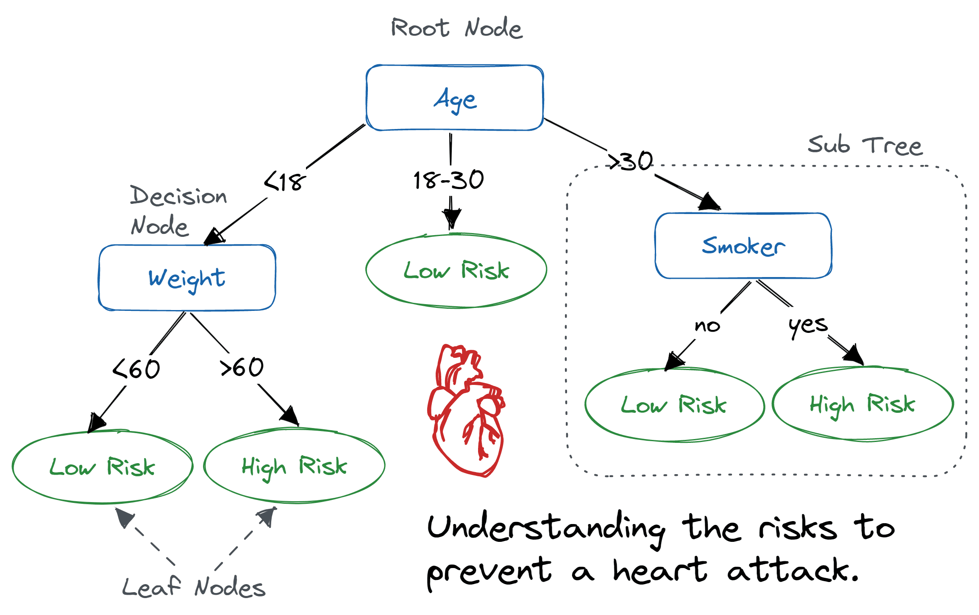

Figure 16: The above diagram is shown from a study done on machine learning through decision trees. This represents a medical approach to the way decision trees classify patients.

Here we can see how decision trees work. Nodes like “Age”, “Weight”, and “Smoker” can split the data until they can classify the person as having a low or high risk of heart attack [58]. Based on morphological features, the machine learning algorithm creates different nodes to split the data into diabetic or healthy patients. This relates to random forest because this same template is used multiple times to optimize the algorithm. Bootstrap Aggregation is another tool used in the Random Forest classifier [52]. This process selects a random number of instances from the dataset with replacement. With each copied dataset, the model is trained slightly differently with different decision trees, to ensure there is a randomness of sampling and focuses on different aspects of the data. These decision trees each have unique nodes and provide their own final classification of the data [58]. Through aggregation, the final predictions are then assessed through the majority vote from the decision trees.
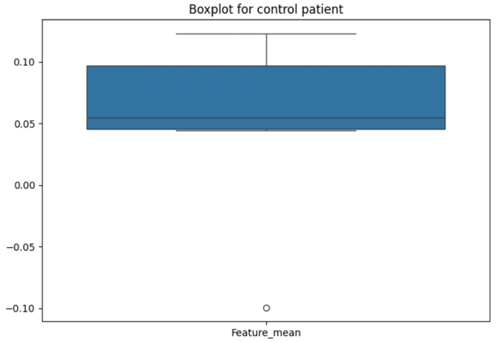
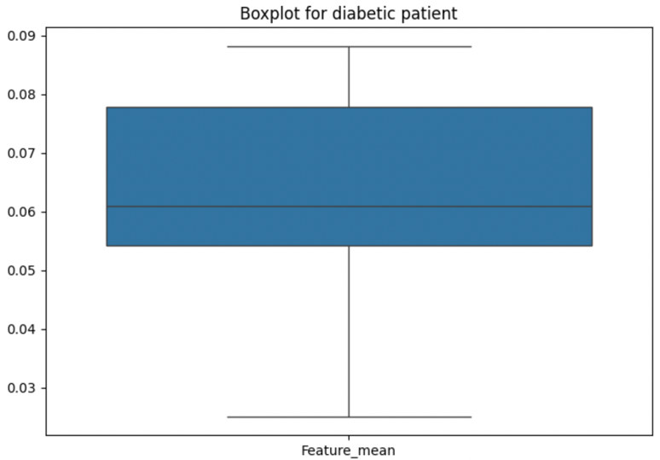

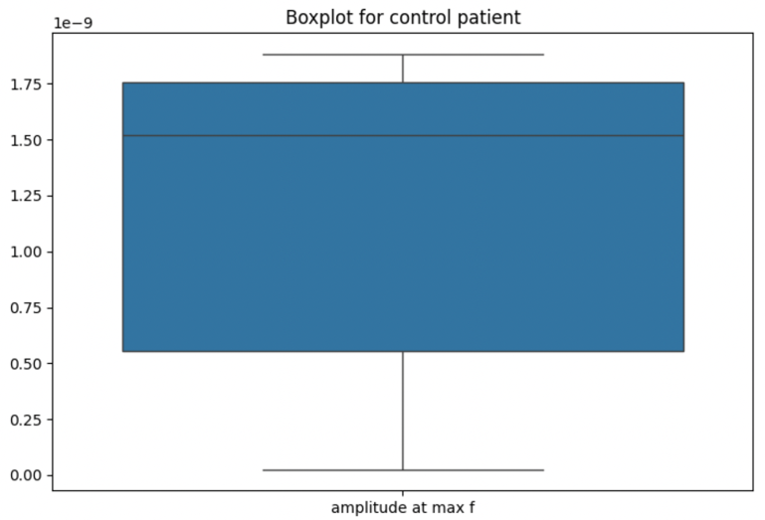

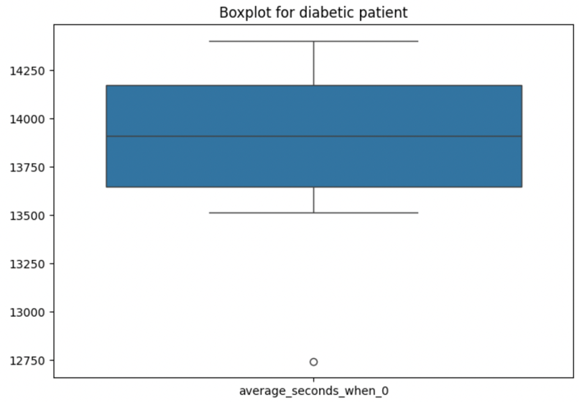

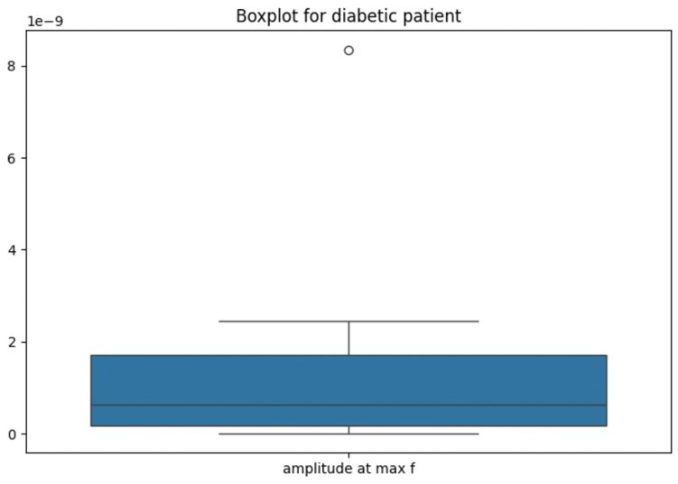

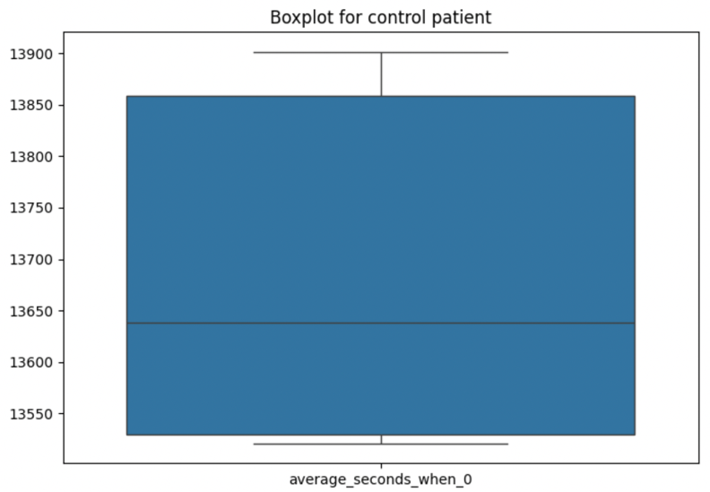

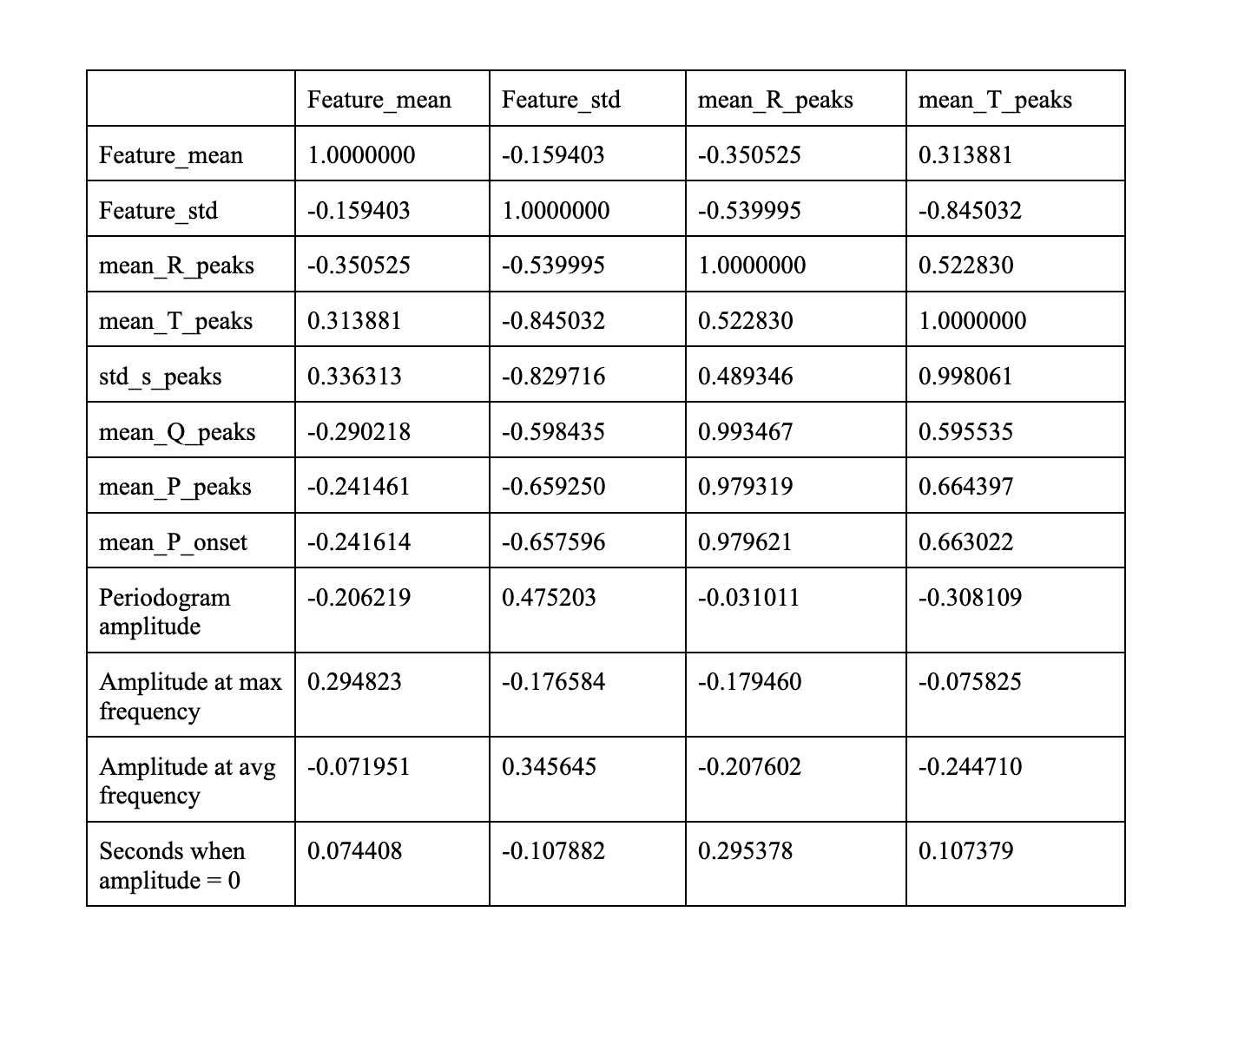
Figure 17-22: The above figures are diagrams of boxplots. Analyzing boxplots is a straightforward process that provides valuable insight into the distribution and central tendencies of a dataset. A boxplot consists of a rectangular box, which represents the
interquartile range (IQR) of the data, with a line inside denoting the median.

Longer boxes indicate a larger interquartile range and more spread in the data. The whiskers, lines extending from the box, illustrate the range of the data, and any points beyond the whiskers are considered outliers [58]. Boxplots are particularly useful for comparing multiple datasets or identifying any extreme values. Looking at the data above, we can see how each feature has a wide range of values. Looking at the feature mean, we can see most of the values corresponding to the first interquartile range. The feature mean is also a larger rectangle as the spread of its whiskers is a lot longer than the other
features. The more spread out the features, the better the data is for feature extraction [60].
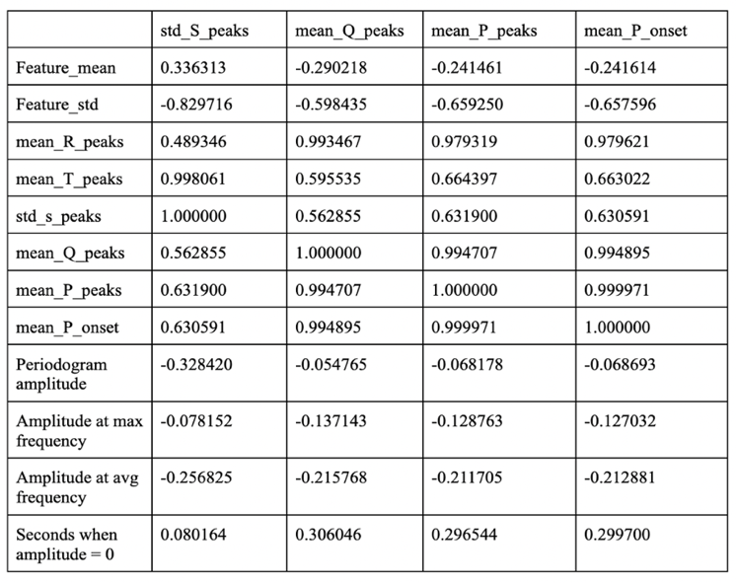

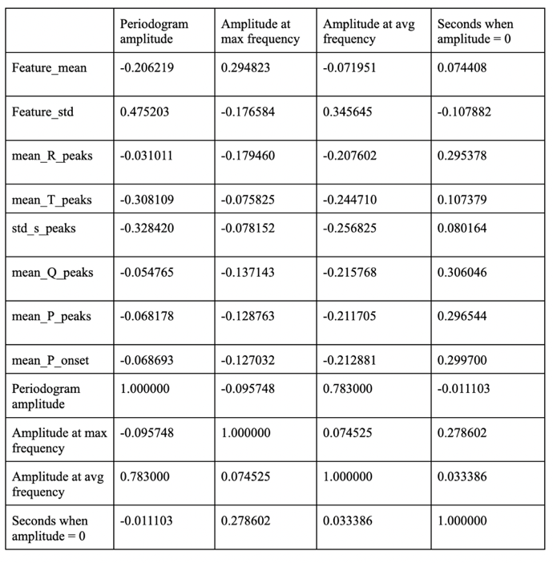

Figure 23-25: The above figure represents the correlations between features gathered during feature extraction. Here we can see that feature_mean has a 1.00000 correlation with feature_mean as they are the same values but feature_mean has a 0.313991 correlation with mean_T_peaks. Notice how the correlation matrix has the 1.00000 values going diagonally down. This represents an identity matrix, showing the correlation between each of the features to another feature. This chart is a visual diagram to represent how effectively the data can be used for machine learning.

With this dataset, it is important to understand the correlation between the features extracted. Correlation refers to the similarity between data gathered for the class with diabetes and without. If there is a high correlation between those classes, the data will not have a high distinction, which will make it difficult for the machine learning algorithm to decipher between the classes. Therefore, we plot a correlation matrix to see if the features are extremely similar or optimal for machine learning. Through understanding the similarities and differences, the data can be altered and prepared before the application of algorithms. Correlation is measured in terms of numbers [60]; if the number is 1.0 it has a high correlation. If the number is closer to 0.0, the data is less correlated. Because the “seconds when amplitude = 0” is a 0.033386 correlation with the amplitude at the average frequency, it has very distinct values making it a useful feature for machine leaning.

Although correlation matrices are usually observed after
the feature extraction of data, this step is typically referred to throughout the coding process. By learning that certain features are more correlated than others, researchers can alter their data to be the most effective prior to formulating their predictions.

Results/Discussion
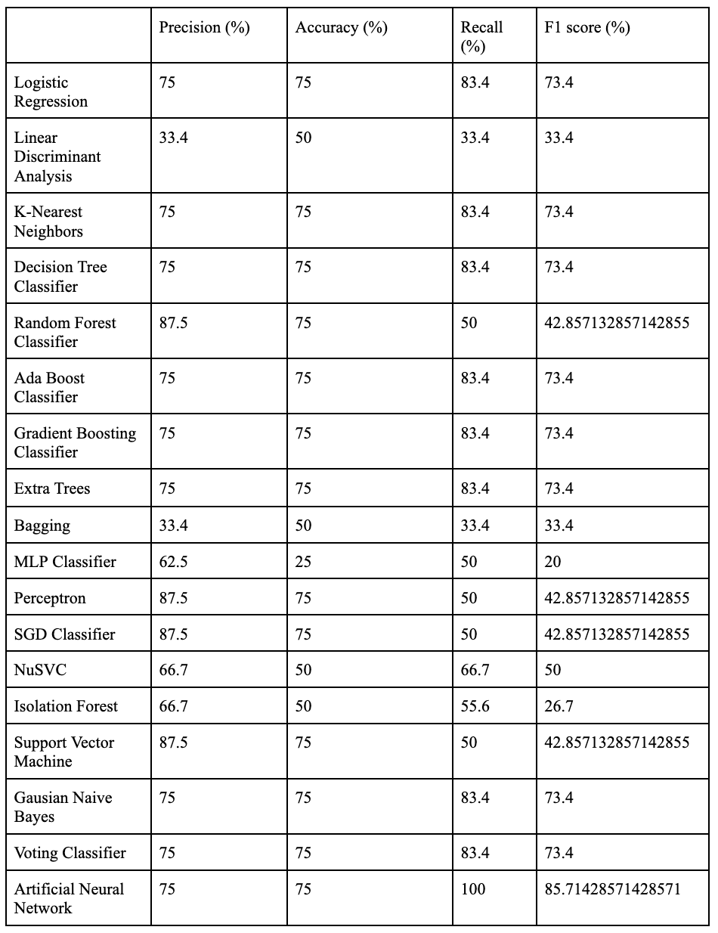

Figure 26: The figure represents the precision, accuracy, recall, and f1 score for different machine learning algorithms on the same features. With this data, we can see how different algorithms respond
differently to the same features, while some have much smaller precision, and some have much higher accuracies.

In this research, we leveraged machine learning to classify patients with diabetes using ECG signals, with a focus on precision, recall, and F1-score as key performance metrics. The results provided valuable insights into the potential utility of ECG-based models for diabetes diagnosis and highlighted broader implications for healthcare.

To incorporate more information on the effectiveness of machine learning, we can look at its confusion matrix or the visual representation as to the ability to correctly classify patients. By understanding the relationships between true and false positives, machine learning systems can adapt to create the most efficient processes.
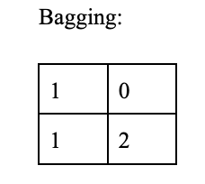
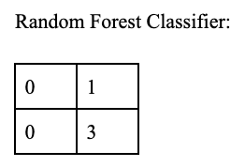

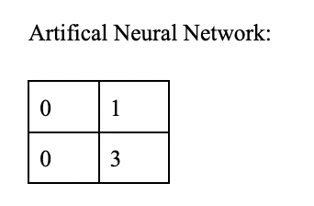
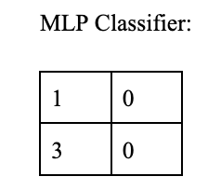

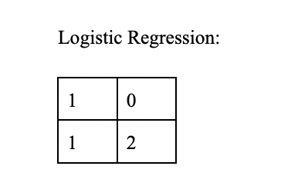

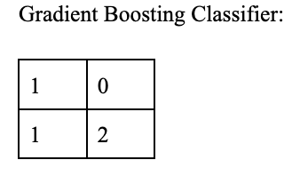

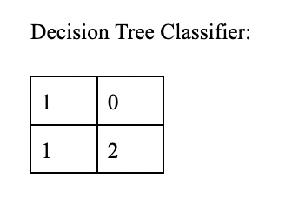
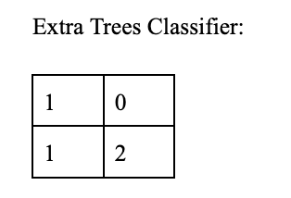

Figure 27-34: The above tables represent the cross validation scores for each of the machine learning algorithms. This represents how many classes the algorithm accurately predicted. The top left represents the number of true positives the class can predict, the top right represents the false negatives, the bottom left represents the false positives, the bottom right represents the true positives. Through these cross validation scores, we can understand how the machine learning’s accuracy, f1, recall, and precision scores were calculated.

Based on the table and confusion matrices, we find that the code recorded a precision score of 87.5%, a recall score of 50%, a f1 score of 42.8%, and an accuracy score of 75%.

These results were calculated through the Random Forest Classifier. In machine learning, there are multiple variations that can produce an accurate result, but the random forest was the most efficient method when compared to linear discriminant analysis with a precision score of 33.4%.

Discussion

A precision score of 87.5 indicates that our model has a remarkable ability to minimize false positive predictions. In the context of diabetes classification, this translates to a reduced likelihood of wrongly identifying individuals as diabetic when they are not [61]. This precision-oriented approach is pivotal, as it reflects the model's cautious stance in confirming diabetes cases, which is crucial for patient safety and treatment decisions.

A recall score of 0.5 demonstrates that our model successfully identifies half of the patients who genuinely
have diabetes. Essentially a recall score is the value signifying the number of positive cases identified. This value is especially important in determining the reliability of healthcare machines and their use to diagnose patients [62].

With an F1-score of 0.428, our model shows promise, and further optimization can significantly enhance its predictive capabilities. This represents a combination of both precision and recall, to show the model’s overall performance [62]. The F1-score emphasizes the need for a balanced approach in managing both false positives and false negatives, which is crucial in healthcare applications to avoid unnecessary stress and expenses for patients.

An accuracy score of 0.75 means our model was able to correctly predict the cases of diabetes and control patients. This represents the model’s performance in the real world, being able to provide accurate details based on the patient’s electron signals. The accuracy emphasizes the need for machine learning algorithms to be able to correctly classify patients, to understand the true longevity of machine learning in practical medical applications.

This experiment's broader scope extends beyond its immediate results. The research opens the door to the development of non-invasive, data-driven tools for early diabetes diagnosis. Such tools have the potential to revolutionize healthcare, offering an accessible and efficient means of identifying at-risk individuals.

As this model continues to evolve, the integration of ECG-based diabetes prediction into routine medical assessments could lead to earlier interventions, improved patient outcomes, and a reduced burden on healthcare systems [63]. Furthermore, this research can encourage the collection of more extensive and diverse ECG data, potentially leading to a significant shift in how diabetes is diagnosed and managed on a global scale. It is observed that the Random Forest Classifer, Support Vector Machine, SGD classifier, and Perceptron were the best algorithms as they had the best precision scores.
The presented results indicate a promising start for using ECG signals and machine learning to classify patients with diabetes. While there is room for refinement, the broader implications of this research are immense, hinting at a future where technology and healthcare converge to enhance early diagnosis and treatment, ultimately improving the quality of life for individuals at risk of diabetes [14]. This study underscores the transformative potential of machine learning in healthcare and the path towards more accessible and effective healthcare solutions.
While machine learning has various positive effects in the healthcare industry, there is still a long way to go before machine learning can fully replace the jobs of physicians. Data can be poorly labeled, there could be too many instances of a single class, and factors that supervised learning cannot account for can leave machine learning not entirely self-sufficient [64]. Since there are so many instances that machine learning must account for, there are lots of training and procedures that need to be done to innovate this tool for large scale operations. Despite the drawbacks, machine learning has proven useful for many corporations, making life far more automated and efficient. In the coming years, with more machine learning implementation, the detection of diseases alongside other operations can become self-sufficient and more accurate.

References
- Zou, Q., Qu, K., Luo, Y., Yin, D., Ju, Y., & Tang, H. (2018). "Predicting diabetes mellitus with machine learning techniques." Frontiers in genetics, 9, 515.
- Goldberger, A. L., Amaral, L. A., Glass, L., Hausdorff, J. M., Ivanov, P. C., Mark, R. G., ... & Stanley, H. E. (2000). "PhysioBank, PhysioToolkit, and PhysioNet: components of a new research resource for complex physiologic signals." Circulation, 101(23), e215-e220.
- Buchanan, T. A., & Xiang, A. H. (2005). "Gestational diabetes mellitus." The Journal of clinical investigation, 115(3), 485-491.
- Rodrigues, M. L. C., & Motta, M. E. F. A. (2012). "Mechanisms and factors associated with gastrointestinal symptoms in patients with diabetes mellitus." Jornal de pediatria, 88, 17-24.
- Slentz, C. A., Duscha, B. D., Johnson, J. L., Ketchum, K., Aiken, L. B., Samsa, G. P., ... & Kraus, W. E. (2004). "Effects of the amount of exercise on body weight, body composition, and measures of central obesity: STRRIDE—a randomized controlled study." Archives of internal medicine, 164(1), 31-39.
- Rojas, L. B. A., & Gomes, M. B. (2013). "Metformin: an old but still the best treatment for type 2 diabetes." Diabetology & metabolic syndrome, 5(1), 1-15.
- Watkins, P. J. (2003). "ABC of Diabetes." London: BMJ publishing group.
- Jimeno, C. A. (2012). "Associate Professor, University of the Philippines College of Medicine, Department of Pharmacology Clinical Associate Professor, UPCM Philippine General Hospital, Department of Medicine, Section of Endocrinology, Diabetes and Metabolism Associate Professor, Ateneo School of Medicine and Public Health."
- Soumya, D., & Srilatha, B. (2011). "Late stage complications of diabetes and insulin resistance." J Diabetes Metab, 2(9), 1000167.
- McCall, A. L. (2004). "Cerebral glucose metabolism in diabetes mellitus." European journal of pharmacology, 490(1-3), 147-158.
- Jambukia, S. H., Dabhi, V. K., & Prajapati, H. B. (2015, March). "Classification of ECG signals using machine learning techniques: A survey." In 2015 International Conference on Advances in Computer Engineering and Applications (pp. 714-721). IEEE.
- Reisner, A. T., Clifford, G. D., & Mark, R. G. (2006). "The physiological basis of the electrocardiogram." Advanced methods and tools for ECG data analysis, 1, 25.
- Li, H., & Boulanger, P. (2020). "A survey of heart anomaly detection using ambulatory electrocardiogram (ECG)." Sensors, 20(5), 1461.
- Khatibi, T., & Rabinezhadsadatmahaleh, N. (2020). "Proposing feature engineering method based on deep learning and K-NNs for ECG beat classification and arrhythmia detection." Physical and Engineering Sciences in Medicine, 43(1), 49-68.
- Watson, J., Hutyra, C. A., Clancy, S. M., Chandiramani, A., Bedoya, A., Ilangovan, K., ... & Poon, E. G. (2020). "Overcoming barriers to the adoption and implementation of predictive modeling and machine learning in clinical care: what can we learn from US academic medical centers?." JAMIA open, 3(2), 167-172.
- Alex, S. A., Ponkamali, S., Andrew, T. R., Jhanjhi, N. Z., & Tayyab, M. (2022). "Machine Learning-Based Wearable Devices for Smart Healthcare Application With Risk Factor Monitoring." In Empowering Sustainable Industrial 4.0 Systems With Machine Intelligence (pp. 174-185). IGI Global.
- Zhou, Z. H., & Chen, Z. Q. (2002). "Hybrid decision tree." Knowledge-based systems, 15(8), 515-528.
- Yu, C., Ooi, B. C., Tan, K. L., & Jagadish, H. V. (2001, September). "Indexing the distance: An efficient method to knn processing." In Vldb (Vol. 1, pp. 421-430).
- Guo, G., Wang, H., Bell, D., Bi, Y., & Greer, K. (2003). "KNN model-based approach in classification." In On The Move to Meaningful Internet Systems 2003: CoopIS, DOA, and ODBASE: OTM Confederated International Conferences, CoopIS, DOA, and ODBASE 2003, Catania, Sicily, Italy, November 3-7, 2003. Proceedings (pp. 986-996). Springer Berlin Heidelberg.Wang
- Syed, F. I., AlShamsi, A., Dahaghi, A. K., & Neghabhan, S. (2022). "Application of ML & AI to model petrophysical and geomechanical properties of shale reservoirs–A systematic literature review." Petroleum, 8(2), 158-166.
- Siddique, S., & Chow, J. C. (2021). "Machine learning in healthcare communication." Encyclopedia, 1(1), 220-239.
- Lee, G., Choi, B., Jebelli, H., & Lee, S. (2021). "Assessment of construction workers’ perceived risk using physiological data from wearable sensors: A machine learning approach." Journal of Building Engineering, 42, 102824.
- Chowdhury, M. E., Khandakar, A., Qiblawey, Y., Reaz, M. B. I., Islam, M. T., & Touati, F. (2020). "Machine learning in wearable biomedical systems." In Sports Science and Human Health-Different Approaches. IntechOpen.
- Wang, D., Yang, X., Liu, X., Fang, S., Ma, L., & Li, L. (2020). "Photoplethysmography based stratification of blood pressure using multi-information fusion artificial neural network." In Proceedings of the IEEE/CVF Conference on Computer Vision and Pattern Recognition Workshops (pp. 276-277)...
- Thurner, T., Hintermueller, C., Blessberger, H., & Steinwender, C. (2021). "Complex-Pan-Tompkins-Wavelets: Cross-channel ECG beat detection and delineation." Biomedical Signal Processing and Control, 66, 102450.
- Deniz, A., Kiziloz, H. E., Dokeroglu, T., & Cosar, A. (2017). "Robust multiobjective evolutionary feature subset selection algorithm for binary classification using machine learning techniques." Neurocomputing, 241, 128-146.
- Goulon-Sigwalt-Abram, A., Duprat, A., & Dreyfus, G. (2005). "From hopfield nets to recursive networks to graph machines: numerical machine learning for structured data." Theoretical computer science, 344(2-3), 298-334.
- Nahavandi, D., Alizadehsani, R., Khosravi, A., & Acharya, U. R. (2022). "Application of artificial intelligence in wearable devices: Opportunities and challenges." Computer Methods and Programs in Biomedicine, 213, 106541.
- Cao, C., Chicco, D., & Hoffman, M. M. (2020). "The MCC-F1 curve: a performance evaluation technique for binary classification." arXiv preprint arXiv:2006.11278.
- Tušar, T., Gantar, K., Koblar, V., Ženko, B., & Filipič, B. (2017). "A study of overfitting in optimization of a manufacturing quality control procedure." Applied Soft Computing, 59, 77-87.
- Swapna, G., Vinayakumar, R., & Soman, K. P. (2018). "Diabetes detection using deep learning algorithms." ICT express, 4(4), 243-246.
- Novak, V., Quispe, R., & Saunders, C. (n.d.). "Cerebral perfusion and cognitive decline in type 2 diabetes."
- Martinek, R., Brablik, J., Kolarik, J., Ladrova, M., Nedoma, J. A. N., Jaros, R., ... & Krupa, P. (2019). "A low-cost system for seismocardiography-based cardiac triggering: A practical solution for cardiovascular magnetic resonance imaging at 3 tesla." IEEE Access, 7, 118608-118629.
- Lourenço, A., Silva, H., & Fred, A. (2011). "Unveiling the biometric potential of finger-based ECG signals." Computational intelligence and neuroscience, 2011, 1-8.
- Vafaei, N., Ribeiro, R. A., & Camarinha-Matos, L. M. (2022). "Assessing normalization techniques for simple additive weighting method." Procedia Computer Science, 199, 1229-1236.
- Chandrakar, C., & Kowar, M. K. (2012). "Denoising ECG signals using adaptive filter algorithm." International Journal of Soft Computing and Engineering (IJSCE), 2(1), 120-123.
- Makowski, D., Pham, T., Lau, Z. J., Brammer, J. C., Lespinasse, F., Pham, H., ... & Chen, S. A. (2021). "NeuroKit2: A Python toolbox for neurophysiological signal processing." Behavior research methods, 1-8.
- Bergfeldt, L., Bergqvist, G., Lingman, M., Lundahl, G., Bergström, G., & Gransberg, L. (2020). "Spatial peak and mean QRS-T angles: A comparison of similar but different emerging risk factors for cardiac death." Journal of Electrocardiology, 61, 112-120.
- Wainer, J. (2016). "Comparison of 14 different families of classification algorithms on 115 binary datasets." arXiv preprint arXiv:1606.00930.
- Subasi, A., & Ercelebi, E. (2005). "Classification of EEG signals using neural network and logistic regression." Computer methods and programs in biomedicine, 78(2), 87-99.
- Yeh, Y. C., Wang, W. J., & Chiou, C. W. (2009). "Cardiac arrhythmia diagnosis method using linear discriminant analysis on ECG signals." Measurement, 42(5), 778-789.
- Elola, A., Aramendi, E., Irusta, U., Del Ser, J., Alonso, E., & Daya, M. (2019). "ECG-based pulse detection during cardiac arrest using random forest classifier." Medical & biological engineering & computing, 57, 453-462.
- Liu, Q., Si, Y., Li, L., & Wang, D. (2019). "ECG identification based on PCA and AdaBoost algorithm." In Digital Human Modeling and Applications in Health, Safety, Ergonomics and Risk Management. Healthcare Applications: 10th International Conference, DHM 2019, Held as Part of the 21st HCI International Conference, HCII 2019, Orlando, FL, USA, July 26–31, 2019, Proceedings, Part II 21 (pp. 50-62). Springer International Publishing.
- Zaorálek, L., Platoš, J., & Snášel, V. (2018). "Patient-adapted and inter-patient ECG classification using neural network and gradient boosting." Neural Network World, 28(3), 241-254.
- Shafique, R., Mehmood, A., & Choi, G. S. (2019). "Cardiovascular disease prediction system using extra trees classifier."
- Kadam, V., Jadhav, S., & Yadav, S. (2020). "Bagging based ensemble of support vector machines with improved elitist GA-SVM features selection for cardiac arrhythmia classification." International Journal of Hybrid Intelligent Systems, 16(1), 25-33.
- Borghi, P. H., Borges, R. C., & Teixeira, J. P. (2021). "Atrial fibrillation classification based on MLP networks by extracting Jitter and Shimmer parameters." Procedia Computer Science, 181, 931-939.
- Savalia, S., & Emamian, V. (2018). "Cardiac arrhythmia classification by multi-layer perceptron and convolution neural networks." Bioengineering, 5(2), 35.
- Pławiak, P., & Abdar, M. (2020). "Novel methodology for cardiac arrhythmias classification based on long-duration ECG signal fragments analysis." Biomedical Signal Processing: Advances in Theory, Algorithms and Applications, 225-272.
- Rezaei, M. J., Woodward, J. R., & Munroe, P. (2021). "A novel two-stage heart arrhythmia ensemble classifier." Computers, 10(5), 60.
- Tripathy, R. K., Acharya, A., & Choudhary, S. K. (2012). "Gender classification from ECG signal analysis using least square support vector machine." American Journal of Signal Processing, 2(5), 145-149.
- Sushma, S. A., & TG, K. K. (2021). "Comparative Study of Naive Bayes, Gaussian Naive Bayes Classifier and Decision Tree Algorithms for Prediction of Heart Diseases."
- Rezaei, M. J., Woodward, J. R., Ramirez, J., & Munroe, P. (2022, June). "Combination of Isolation Forest, SMOTE and Ensemble Learning for the classification of Atrial Fibrillation and Ventricular Arrhythmia." In 2021 International Conference on Biomedical Innovations and Applications (BIA) (Vol...
- Nandi, A., Xhafa, F., Subirats, L., & Fort, S. (2021). "Real-time emotion classification using eeg data stream in e-learning contexts." Sensors, 21(5), 1589.
- Eftekhar, B., Mohammad, K., Ardebili, H. E., Ghodsi, M., & Ketabchi, E. (2005). "Comparison of artificial neural network and logistic regression models for prediction of mortality in head trauma based on initial clinical data." BMC medical informatics and decision making, 5(1), 1-8.
- Louppe, G. (2014). "Understanding random forests: From theory to practice." arXiv preprint arXiv:1407.7502.
- Polikar, R. (2012). "Ensemble learning." Ensemble machine learning: Methods and applications, 1-34.
- Disha, R. A., & Waheed, S. (2022). "Performance analysis of machine learning models for intrusion detection system using Gini Impurity-based Weighted Random Forest (GIWRF) feature selection technique." Cybersecurity, 5(1), 1.
- Franchi, G. C., Moraes, C. S., Toreti, V. C., Daugsch, A., Nowill, A. E., & Park, Y. K. (2012). "Comparison of effects of the ethanolic extracts of Brazilian propolis on human leukemic cells as assessed with the MTT assay." Evidence-based complementary and alternative medicine, 2012.
- Hall, M. A. (1999). "Correlation-based feature selection for machine learning" (Doctoral dissertation, The University of Waikato).
- Chipindu, L., Mupangwa, W., Mtsilizah, J., Nyagumbo, I., & Zaman-Allah, M. (2020). "Maize kernel abortion recognition and classification using binary classification machine learning algorithms and deep convolutional neural networks." Ai, 1(3), 361.
- Yacouby, R., & Axman, D. (2020, November). "Probabilistic extension of precision, recall, and f1 score for more thorough evaluation of classification models." In Proceedings of the first workshop on evaluation and comparison of NLP systems (pp. 79-91).
- Nacif, M. S., Zavodni, A., Kawel, N., Choi, E. Y., Lima, J. A., & Bluemke, D. A. (2012). "Cardiac magnetic resonance imaging and its electrocardiographs (ECG): tips and tricks." The international journal of cardiovascular imaging, 28, 1465-1475.
- Ghassemi, M., Naumann, T., Schulam, P., Beam, A. L., Chen, I. Y., & Ranganath, R. (2020). "A review of challenges and opportunities in machine learning for health." AMIA Summits on Translational Science Proceedings, 2020, 191.

