Smoke and Fire Detection using Smart Cameras

Shrivas Sudharsan
Pioneer Research
San Jose, California
sudharsan.shrivas@gmail.com

Abstract— As global warming continues to become a pressing issue in our world, so has the conservation of both wildfires and home fires. Being unpredictable in nature, fires can be caused by any small factor in the environment, and within minutes blaze to high temperatures and destroy land. With the recent development of technology there have been measures taken to combat the devastating effects of fires. Cameras and smoke sensors are two types of sensors that use either vision or “smell” to alert a presence of danger. Our project aims to introduce both the detection of fires and smoke visually through smart cameras. Through WIFI, these smart cameras developed will be able to detect dangers in images and contact local authorities, all through its micro processing. While smoke detectors have served important in-home settings, we want to create a camera that can be used in both indoor and outdoor settings, being versatile and avoiding marginal errors that smoke detectors have. Using the Internet of things, we implement the YOLO (You only Look Once) algorithm on a raspberry pi to detect images of fire and smoke. To start we gather datasets of fire and smoke images and train them on the roboflow software. By creating bounding boxes around each image, the algorithm becomes familiar with what appears to be a fire and smoke during the training phase. To test the capability of the algorithm, certain images (that the algorithm has not looked at yet) will be used in the validation phase to give a proper metric to the success of the algorithm. Once we change the parameters and are comfortable with the values in the validation phase we run machine learning on the testing set, recording the time, confidence, and accuracy for these values. We reported a 92.8% confidence level and 90.2% accuracy for detecting fires. For smoke we reported 85.1% confidence with an accuracy of 85.7%. The highest confidence level when detecting fire was between 17.9 to 31.9 seconds at 93.8%. This was done with a training of 180 epochs. Overall, this experiment highlights the versatility of machine learning (since the small parameters can drastically change the accuracy) while showing the capability of automation being done with raspberry pi, an IoT implementation.

Introduction
With the necessity of environmental conservation, it becomes essential that humans develop better technology to combat and mitigate disasters in the future. One such disaster that is very common is fires, (7,200 in 2023 alone) which require the use of immediate detection to contain the spread of its deadliness [1]. Hence, clear cutting-edge technologies with high power sensors are being introduced to actualize the true benefits of environmental protection. One such instance of that can be with the recent development of the smart cameras.

Countering fires is essential to safeguarding human and animal lives, as well as preserving the planet that we will continue to live on in the future. Fires pose a significant threat to our lives, destroying businesses, homes, and costing the US $893 billion a year alone [2]. Regarding the environment, forest fires decrease biodiversity, destroy the homes of millions of organisms, and even disrupt climate regulation. Even if a fire starts small, in less than 30 seconds this fire can turn into a large blaze, reaching over 600 degrees in heat. Smoke and toxic gasses are often more deadly to the flame itself and can spread over miles while the fire only has a 200-foot radius. In 2022, there was $10.5 billion in property damages, 10,000 civilian injuries, and 360,000 home structure fires in the United States alone [3].

Regardless of whether fires are indoor or outdoor, these fires make animals prone to respiratory diseases. To mitigate the radius of impact, technology needs to act fast and efficiently, which is only possible through early detection through smart cameras.

Smart cameras are a tool that implemented with machine learning for image detection. They rely on the ability for a sensor to capture images, then using a processor to analyze images to create an output. In correspondence to the environment, smart cameras play a pivotal role in the early detection of fire. By implementing these cameras, humans can identify false alarms, unusual activities, and potential hazards far faster than before.

Now to expand towards the use of cameras and machine learning, numerous experiments have been done in the fields of healthcare, smart cities, environment, and transportation. Visual inspection has played an important role in product shipment. Smart cameras have been especially prevalent with the protection of our homes, detecting any anomalies in the area [4]. To classify an anomaly or detect an object from a recording, these cameras need to include an aspect of machine learning.

Being able to quickly identify hazards are especially important when considering the effects of fire both on our environment and in home automation systems. Using image recognition software allows for innovation to help with prevention and potentially prediction of fires from even occurring.

While there are multiple ways to detect fires (smoke, heat, thermal rays, or human eye), smart cameras can see very high and far, meaning it has the capability to detect a fire before it has any serious detriment on our environment.

Furthermore, if we point to studies done on smoke detectors, they can be great in detecting fires in indoor settings but are much worse than smart cameras in outdoor settings. This is because smoke takes time to travel (especially if the fire is miles away) while a smart camera can visually detect this smoke over 10 miles away [5].

But how are these smart cameras able to detect and send information so fast? That’s where IoT Comes into play. The internet of things is an implementation of various tools and communication protocols that allow smart devices to work with one another to complete tasks with ease. The interconnected network of devices allows for seamless communication, improved efficiency and automation, advanced data analytics, better infrastructure, and so many more security benefits. With all these benefits, IoT can be seen as a versatile tool that can be applied to many fields. For example, Hongyan used data from urban sewage’s water quality to determine the proper treatment method through an IoT approach [6]. These systems calculate data from sensors that measure multiple aspects of the water in sewers; from that data, intelligence can be used to determine a solution to any existing barriers while better improving the network between urban systems. However, with regards to the environment, there are also ways in which IoT is already being used. A study by Jayachandran uses IoT soil sheets for real-time nutrient analysis [5]. As the use of fertilizer in excess becomes a major concern for many environmentalists, this study aims to use nitrate concentrations of the soil to optimize the use of fertilization. Thus, we can see that the environment has multiple ways in which the world of IoT can benefit it.

Now that we have established that IoT has the capability to communicate with devices, what makes it so accurate and impactful? This is where machine learning is implemented. Machine learning is a branch of artificial intelligence that allows for complex decision making with automation and ease. Processes that give recommendations, processes that predict outbreaks, or processes that estimate the value of the home all use a form of artificial intelligence, or complex decision making. Machine learning uses previous data and “learns” from it to complete a process that the user wants.

As artificial intelligence and IoT continue to develop, more products have relied on edge computing (where machine learning is done locally) as opposed to artificial intelligence being done in a server setting. This has led to an increased development of embedded processors (like the raspberry pi) which are self-sufficient and are extremely important with the development of smart cameras. By employing machine learning algorithms like YOLO (You only Look once), these processors have had the capability to do image segmentation, object detection, and early prediction. With the introduction of more than once camera, this IoT network can be furthered to have multiple devices monitoring a given area, then communicating with each other to improve the accuracy of detecting smoke and fire.

Overall, our project works on addressing the issues of fire and smoke while implementing an IoT based machine learning model. Since smart cameras have had a history of being used in home automation systems, we want to apply that in our unique perspective. By considering indoor and outdoor images, we want to use this idea of visual detection by making it versatile and flexible, leading to early prevention of the early detriments that come with fire. As we will see how other works have tried implementing this problem, we want to overall further that research and highlight how nuances of machine learning can have a large effect in the success of the algorithm.

Related works survey
There are several related works that have been done in smart cameras and the internet of things with regards to fire. First, let’s start with smart cameras in general.

One project that has been done in this field is the development of the Slug Cam, or a camera that is adaptable to the outdoors while limiting battery power through the internet of things [7]. This project has computer vision algorithms run locally on the device, has duty cycles which determine the quality of the video in terms of the battery life required, has a web-based interface to retrieve certain requested snippets of time, and has adaptability to other visual sensors. This communication between devices highlights the application of doing a project regarding visual analysis. By working to optimize the cost of devices used, we can not only improve the efficiency, but pave the way for machine learning processes to automate the quality of imaging and the response based on visual cues.

One study analyzes how smart cameras can incorporate multiple algorithms that are dependent on the type of camera used [8]. Factors such as field of view, thermal imaging, and energy of the camera are all important when considering what algorithms to implement. Ultimately this study highlights the variety that comes with machine learning and smart cameras, and how their capability is versatile. Like our project, this study goes into depth on multi-camera systems, specifically how there can be more actions done with less human interaction. With all these factors, there still comes the problem of energy, and how systems must conserve it, especially in the world of IoT.

More towards the detection of fires, some studies have been done using smart camera and machine learning specifically. One study like such uses a You Only Look Once learning algorithm to detect fires based on images. This YOLO algorithm is especially important because it does both classification and detection of fires in images. This means that the algorithm looks at an image, splits a certain portion of it to be analyzed and determines whether that specific portion should be analyzed. This study implements a similar algorithm that we use in our study except it expands on the data given to improve the accuracy [9]. There are many types of databases that can be used for machine learning: surveillance images, drone pictures, still images, and smoke pictures. While there is a vast number of datasets out there, this study incorporates more still images while changing the color augmentation of the dataset. This means that there are less features that the machine learning algorithm has to learn, but it can also improve its accuracy because there is more data for the algorithm to train itself. This is an important idea to consider when training machine learning algorithms because if we can give it less features to process while still maintaining its accuracy, we also can better the energy consumption of the IoT device at whole. This project also successfully detects these fires in sunny, cloudy, day, or night conditions, exemplifying the capability of the yolo algorithm.

Studies have used smoke sensors combined with machine learning to determine fires in smaller areas [10]. Like other projects, the machine learning algorithm denoising convolutional neural network (DNCNN) uses a set of smoke characteristics to classify smoke vs no smoke in certain images. This study also takes into consideration the significant energy cost that comes with computation, something that is essential to consider in the engineering of IoT devices. A study done by Krishnamoorthy also explains the scope of IoT within forest fires [11]. Their device uses an Arduino based system with 5 sensors: a temperature sensor, an ESP 32 cam, a PIR sensor, a gas sensor, and a vibration sensor. This experiment shows the multitude in ways that one can acquire data from a fire and perform machine learning on it. Furthermore, their study highlights how its data gets uplinked through a satellite. The earth’s station sends data to the satellite which transfers information to a local server (while the satellite can communicate to the local station); from there the server performs machine learning on the data and returns an output to the alert and monitoring system. In their proposed design, they also have water pumps and self-actuators to mitigate fire capabilities.

While the previous study used a Yolov4 algorithm, an earlier study used Yolov2’s convolutional neural network to detect fire in images [12]. These experiments are some of the older versions of the Yolo algorithm than what we will be using (Yolov5), but it serves the importance of demonstrating the effectiveness of machine learning. This neural network takes into features of texture, shapes, irregularity, flutter, or frequency to classify the image as a “fire” or “non-fire”. This study also goes in depth on how Yolo works. It first takes grids (like boxes) of the image, and then splits those boxes based on confidence level (how strongly the algorithm can associate it to a fire) then picks the most confident box to enclose on the fire. This is done through mathematical calculations which initiate scores for each box created. For this to be possible, thorough feature extraction and pre-processing of data was done to improve the accuracy of this project. As IoT stresses the importance of conserving energy when using machine learning, maintaining accuracy is very important, and that comes with proper normalization of data. This study not only performs Yolo on fire images, but videos as well; they also implement this machine learning in a Jetson Nano, an IoT AI computer. Like most machine learning studies, there is a confusion matrix that records the false and true positives and negatives to better record the accuracy of the algorithm. To maximize the true positives detected, this study recorded over 400 images to give the model the most amount of information to learn from. However, to improve this study, we incorporate both indoor and outdoor images from a dataset of over 700 images to get the most variety and accuracy possible.

Now if we were to introduce data of smoke into our classification of fire, we could better our accuracy of the overall IoT system. One study uses a fuzzy logic toolbox to record the readings of sensors for real-time actions [13]. By feeding both smoke and fire images to the central microprocessor can use multiple data sources to better support its decision in properly detecting a fire. However, this doesn’t include information from home smoke detection, which allows for increased automation at home. Furthermore, our experiment also highlights the overfitting and underfitting of models that can occur as we experiment with the use of different epochs to find the most optimal model.

Some commercial fire detection systems include SmokeD, a machine learning based camera used to detect forest fires in 10 minutes for up to 10 miles away from the location of the device; FLIR, a thermal imaging infrared cameras which is capable of detecting heat; and AVIOTEC, a Starlight 800 model which uses artificial intelligence and optical analyses to detect fire in warehouses and in dark areas with little to no light [14]. MoviTherm, the company that designs these tools use these cameras with machine learning to build an automated sprinkler in large scale warehouses. This furthers the opportunity that comes with smart cameras, as their detection can lead to automatic safety features that can mitigate the fire if need be. Smoked, FLIR, and AVIOTEC fire detection cameras are advanced technologies designed to enhance fire safety, prevention, as well as mitigation [15]. Smoked cameras are integrated with smoke detection capabilities, utilizing visual and thermal imaging to identify fire hazards early by detecting smoke particles. While some projects implement a G2 sensor to get smoke concentration, cameras like AVIOTEC use their vision features to manually detect smoke. FLIR (Forward-Looking Infrared) cameras rely on thermal imaging to sense heat signatures, enabling them to detect fires through the temperature variations in the monitored area. AVIOTEC fire detection cameras, developed by Bosch, combine optical and thermal imaging to identify flames and smoke with high confidence levels [16]. Each technology offers unique benefits, ensuring proper coverage and better safety in fire detection and prevention.

Innovation
As we are working with IoT, it is important to consider how smaller devices have lower processing powers, thus resulting in lower capabilities with machine learning.

While the previous experiments have tested IoT’s capabilities in a similar experiment, we want to shift our focus to more nuanced perspectives to get deeper into the research. Firstly, we are considering both fire and smoke in our detection of YOLO, making it unique from the experiments that have only considered using fire and only smoke. Furthermore, we draw a comparison with detecting fire and smoke versus only detecting fire, so we show key differences between datasets as part of our innovation. Finally, the other experiments that use IoT have developed their algorithm on YOLOv5 as YOLOv8 has been compatible on raspberry pi we have switched our focus to a newer YOLO model. Thus, while all the experiments have focused on using smart cameras and trying to get the highest accuracy we went for a variety of metrics: precision, recall, f1, accuracy, mean average precision, confidence level, computing time, and differences between smoke and fire. We not only test more metrics than any of the other experiments, but we also compare how using datasets with different test, train, and validation splits can lead to changes in these values in different stages of our experiment.

Background of IoT and Smart Cameras
Smart devices in a broad sense are devices that have the capability to perform more than just their basic functions—ideally programmed to communicate with other devices. In the context of the environment, the smart camera plays a pivotal role in surveillance of various weather anomalies. These cameras offer features from motion detection to facial recognition all with real-time alerts [17].

By using edge computing (processing done locally within the camera), smart cameras are typically engineering using the Internet of Things (IoT). Now IoT works by first collecting data from various sensors and then sending it out to either a central server or to the local device. With our implementation of a smart camera connected through a circuit, we can gather visual data and perform intelligence operations on it. This happens as the sensor is connected to a central processing unit (CPU) that performs the task of downlinking and up linking data.

An IoT device consists of many components that allow it to become a fully sustainable tool. To capture data from a sensor and perform machine learning algorithms, there needs to be a central processing unit, or in the case of our smart camera, a microprocessor.

Microprocessors are a portion of the system that perform commands and instructions required for processing (such as machine learning, sending and receiving data). In addition, these chips must be small due to the small micro processing systems. These run only 10’s of kilobytes in size [18]. Microprocessors must connect to the sensor via a motherboard or a system where all chips are interconnected. In an Arduino board, there are ethernet ports in which cables can be attached (or there can be wireless communication such as WIFI) as well as slots to connect sensors to the central processing. These pins in which sensors are placed on can have Analog to Digital Converters (ADC) to convert these analog signals (like images) into digital signals. Then, the code becomes binary so that the CPU can perform the necessary command. From this relationship, the CPU is constantly sent information which it can store and refer to later when it calls the machine learning algorithm [19].

With information from the CPU being sent to nearby servers, it is critical that the sensor sends data through what is known as an IoT gateway.

An IoT gateway acts as a bridge between sensors and the server in which it computes on. For data to be sent in the right place, IoT relies on communication protocols (ex: Zigbee, MQTT, HTTP/HTTPS, and AMQP) to know the correct path to send data. Each server has a router or a location (known as an address) it can refer to when being open to receive data. An IoT processor uses a protocol built into its program to determine which address it needs to send and receive data from [20]. With the use of WIFI, devices will be able to not only communicate with servers but to a network of households and smart cameras.

This forms a key distinction with IoT: edge computing vs cloud computing. With cloud computing, data needs to be aggregated and sent via a communication protocol, which takes both time and computation. If the microprocessors allow for it, some IoT devices use edge computing, where machine learning is done within the local motherboard, automating its actions.

Regarding edge computing, there are two steps that are involved in completing the classification: pre-processing and machine learning. For the preparation of data, multiple strategies have already been implemented through the Hough transform (feature extraction through a voting method of object candidates––now used to look for arbitrary shapes), ROI-based processing (region of interest: setting pixels as 0s and 1s to determine which portion of the image to focus on), and image identification [21]. Methods like these are important to combat the energy consumption issues that are present with large-scale IoT projects. Then comes the machine learning, where the pre-trained algorithm is run to detect on real-time collected images.

Once we have engineered the hardware to communicate with one another, there comes the next step: machine learning. By training the algorithm with a plethora of images, we allow for the system to “learn” what a fire and smoke is and from there be able to detect it with any image given. This repetitive process to increase the accuracy of the algorithm alongside the development of communication between devices is what we call a “smart camera.”

Problem statement
The problem that we are trying to address is the increased risk of fire that is present today and improving the status quo so that it can continue to detect these fires with ease. Smart cameras are where people can detect fires quickly and in versatile settings. Thus, we want to focus our experiment on comparing how smoke and fire detection can differ with plain fire detection to show how more variables for the machine learning to consider can lead to alternative effects. Furthermore, we want to connect this to our IoT based approach, where we show how computational differences with a smart camera does not tradeoff on its ability to detect danger. We also want to compare how datasets and various training parameters can alter the accuracy of machine learning to show overall how machine learning can help with the early detection of fire but also how it should constantly be optimized so it can be improved as time goes on. This will extend beyond one camera: by implementing a software that is adaptable to any lens connecting to a raspberry pi, we want to introduce the versatility and adaptability of this project. Finally, with an IoT based model, we aim to show how a network of cameras in a given area will be able to communicate with one another (via WIFI), leading to future developments of smart camera systems.

Proposed Approach
Datasets
In our design of this product, we will engineer a smart camera to detect both fire and smoke and compare that to the results of simply detecting a fire.

First, we need to gather images of fire. We use a variety of images to train this mode: there are smaller fires like candles, large forest fires (to model outside fires), and indoor fires (kitchen and furniture fires). To make this project unique, we propose a camera that can detect a wide variety of fires, modeling a camera that can be used in all types of settings. For this we can look to sources of previous studies or online images. Once we gather this image, we split the data into three sections: training, validation, and testing.

The training set is used to help the model learn to detect these fires, repeating its machine learning over a set number of epochs. In the training phase, the parameters used to classify and detect a fire get adjusted based on the data it's being fed.

To evaluate the effectiveness of the model we use the validation dataset, to provide unbalanced data to the model after the training has been completed.

Finally, we run the last portion of the images (interference/training dataset) with the algorithm and record the time it takes to process as well as its ability to properly detect a fire/smoke.

Preparing the images

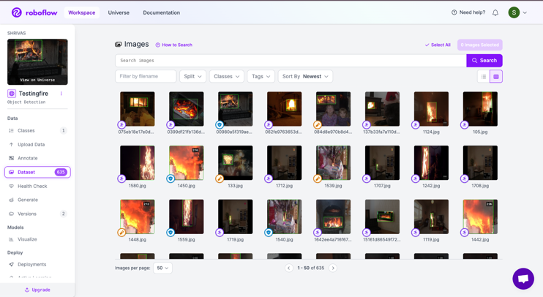

Figure 1: This is the overall hub we use to annotate images and split the datasets. This is an app called roboflow and here we can see how the dataset has different icons for test/train/validation sets.

This is what each annotation for an image looks like.

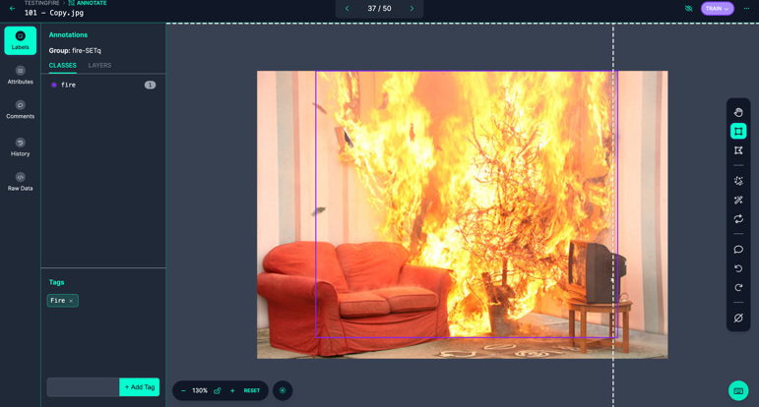

Figure 2: Here we can see that the purple box is labeled as a “fire” and surrounds the region which is seen to be a fire. This is the software used to annotate the image, telling the algorithm what appears to be a fire (or smoke).

Training the Dataset
On Roboflow we first upload the data that we gathered in our local computer and then annotate each image. In this process we make it easy for the website to process these images. With YOLO specifically, we train the dataset for a certain number of epochs. Starting at 10 and going up to 230 we try to find the most optimal number to prevent overfitting of data. Adjusting this metric changes both the time taken to learn the model as well as how many iterations it takes for the model to properly learn how to detect the fire.

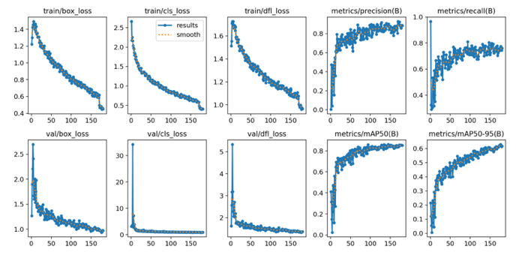

Figure 3: In this image, we can see the different values of loss, precision, and recall scores for training YOLOv8 on the dataset.

Yolov8
There are many two main types of machine learning algorithms, supervised and unsupervised. Supervised machine learning algorithms use classified data, learns from it, and can therefore analyze new data and predict its class [6]. For these supervised algorithms to work, we need to give the class a metric to learn from, in our case fire and smoke [22]. Yolo is an algorithm that is fed with images and breaks it down into bounding boxes, with regions that potentially include fire or smoke. After learning which boxes appear to be a fire, Yolov8 is ready for deployment. This model is trained with annotated images, ones that have bounding boxes to help the algorithm recognize these fires in the training stage.

Post deployment
After training the model using our local server, we test out our implementation on sample images. From there we run our code, and it saves an image with a bounding box around it is indicating its confidence level from running the neural network.

Due to another study, we will set our confidence threshold to 0.6, as that is what is typically the level in which danger can still be accurately detected [23].

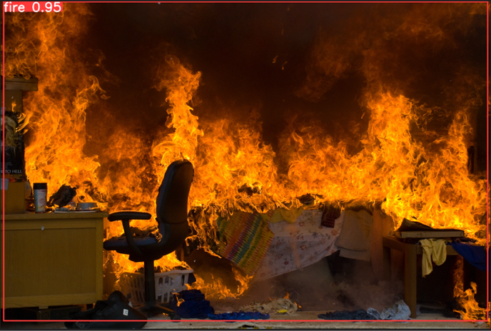
Figure 4: In this image we see that the YOLO algorithm has run its detection and classification while drawing a bounding box. After analyzing this image, it reports a fire within that square with a confidence level of 0.95 (the maximum being 1.0)

Once we find the most optimal epoch level, we then test out its implementation on a raspberry pi (modeling an edge computing as opposed to the servers). For this we take our file where we created the training and export it in Tensorlite format so that it can be processed a run-on raspberry pi (a significantly smaller microprocessor). From there we can report the same results and gather its information. One thing to note however is that the algorithm will run significantly slower since it has less computational speed. Here we record the speed to learn about the limits that come with IoT’s computation capability. However, we should also recall that there are a lot of positives that come with IoT being able to operate self-sufficiently.

Gathering Results
Once we gather some data with the raspberry pi, we also run a few more tests to get a better understanding of how machine learning is dependent on the data. We use the two sets of algorithms we created, one that detects fire and one that can detect both smoke and fire. From there we test out the confidence level for each. Each dataset is trained on the same images of fire, while the algorithm that can detect smoke uses images from smoke to train as well. We have 55 set of fire images to test the algorithm’s capabilities on by running the classification and detection by YOLO. From there we record its confidence level for each image.

There are also other metrics used to determine whether algorithms are properly optimized: precision, accuracy, f1, and recall score. Each one of these scores all work to create a confusion matrix which is better used to show how many positives and negatives (both false and true) the algorithm truly can detect. This gives research a proper metric to base their study off, working until they can optimize these values. As one study indicates: “The basic theorems of statistical learning establish the number of examples needed to estimate the accuracy of a classifier as a function of its complexity” [24].

Precision is the metric of true positives created out of the total positives possibly made. It is a measure of how many instances or images can true be predicted as positive. High prediction scores indicate that the model has a low rate of false positives [24]. To counter a low precision score, we would also have to go back to the training phase, either by adding more data for the algorithm to learn or by adjusting the number of epochs so that the algorithm gets more familiar with the preexisting dataset.

The formula is given as:

Precision= $\frac{True Positives}{True Positives+False Positives}$

[24]

Another metric is recall, which is called sensitivity or true positive rate. Rather than measuring how the algorithm can detect fire even when there isn’t a “true fire”, it focuses on the algorithm to properly detect every instance of fire it is fed [24]. A high recall score indicates that the algorithm has a low chance of detecting false negatives. If there is a low recall score, we tend to increase the number of epochs, so the algorithm is familiarized with what a fire looks like and develops a better accuracy.

The formula is given as

Recall =$\frac{True Positives}{True Positives+False Negatives}$

[25]

The third metric is f1 score which is also known as the harmonic mean between precision and recall. This is a great way to get a balance between understanding false positives and true negatives. This gives a more overall look at the algorithm which can be great for seeing the problems in the large picture. To understand why these things, occur from a closer perspective, we refer to the precision and recall scores listed above [25]. F1 is also a great metric to use when you have an uneven class distribution (when datasets don’t have an equal number of positives and negatives for the algorithm to be tested on). A high f1 score can indicate that the algorithm does a great job between balancing precision and recall scores. For accuracy the study indicates that you can “derive our main technical bounds relating precision and recall to accuracy”, giving us yet another way to base our answers [24].

The fourth metric is about measuring the correct instances for each class. Rather than taking into consideration how the algorithm can fail to detect certain images, it focuses on how much of the total class is it able to detect. This is great for understanding if there is any bias within the class as it can detect those true positives and negatives more than the other [25]. This is a great way for coders to learn how their algorithm deals with detecting multiple objects and in our case, we can use it to compare its effectiveness with smoke versus fire.

The Mean Average Precision is useful to understanding confidence-based ranking in machine learning. It averages the precision within each instance, while averaging precision and recall into a similar metric, just like the f1 score. Average precision and mean average precision work with collecting the precision at points based on their rank and importance [26]. This rank and importance in the context of the YOLO algorithm is based on the confidence metric (between 0 and 1), or how “sure” the algorithm can be that it detected a fire or smoke. It gives another detailed view at how the algorithm can balance its precision and recall score and is robust in its ability to consider both lower and higher confidence levels.

Once we get the final product running, we rely on edge computing for the smart camera to detect the fire/smoke. Using a communication protocol (WIFI), we send an alert to local homes owners and authorities through an IoT gateway. This is the mode for one camera. If we were to create a network of cameras in each area (10 cameras in 1 mile), then we set a threshold of at least 4 cameras to contact local authorities. If it detects a fire it can connect to a server locally and send an image of the danger present. With this communication between cameras, we also allow for IoT to have smart decision-making systems to determine the intensity of the fire.

Since the raspberry pi doesn’t need to constantly run, we will send an image to the processing once every 5 minutes. If a danger is detected it will then check for images once every 2 seconds (maximum speed).

Experiment
Experimental Setup
To start our experiment, we first use a raspberry pi and connect it to our monitor. This allows us to have an IoT based machine learning system. Then we take images from cameras and upload them to our raspberry pi. This represents the setup of smart cameras in indoor and outdoor systems to be able to see and retrieve images. From there we train images on a server (like a laptop) to be able to get the most optimal algorithm based on the number of epochs. Thus, our setup consists of cameras recording images, uploading them to an IoT micro processing unit that can perform machine learning.

To help you understand the design, refer to this model.

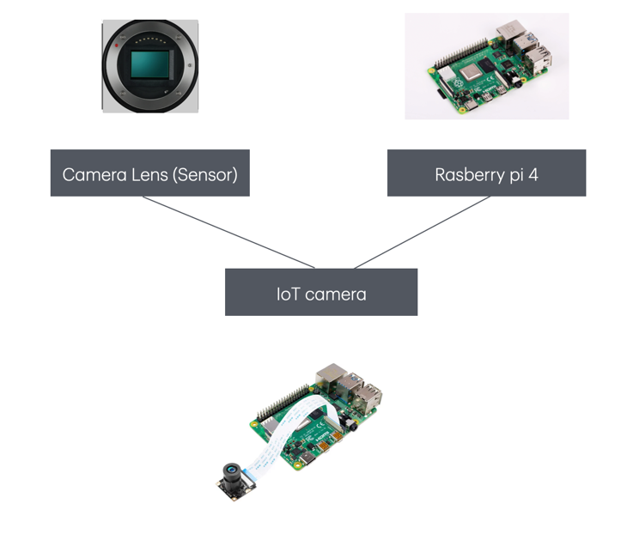
Figure 5: This image contains a flow chart of the initial setup of the IoT camera. It gives the initial component and how they can come together to create our proposed model.

By using a case to protect the hardware, we can see the full product design of the smart camera. This is the camera we use when we complete the entire setup and training of the raspberry pi. However, during testing phase, instead of putting the camera in a case we connect a micro-HDMI cable and a keyboard and mouse to operate the raspberry pi through a monitor. From there we can test images and code until we have the finalized product.

From this we can see that our IoT camera can be created by connecting a lens and pi using a raspberry pi CSI connector and a 15-pin connector. Once we have this connection, we can have the camera lens constantly connect images in its surrounding and upload them to the operating system stored in the raspberry pi (Raspberry pi OS). Regarding the specific camera lens, if it meets the specifications for the cable connection, it can be used. Some examples are Omnivision OV08B10 and Supertek IMX179. After we connect the IoT camera together we can power it based on the various settings we will use it in. For outdoor settings, it is not feasible to use a cable so we can install small solar panels to harvest energy then connect it through a usb type C converter to the raspberry pi 4 as its power source. In indoor settings, we can use a simple outlet which connects to the wall to power the raspberry pi. Finally, once we have the power connected and the raspberry pi built, we need a case to protect the hardware from getting damaged. For this we could use any silver-plated body that fits our specified lens for the camera.

Gathering the Dataset
Our dataset comes from a variety of indoor images from Google, previous studies on roboflow, and online datasets available from Kaggle. With a total of 635 images, we used 444 images to train the model (with annotated boxes), 127 for the validation set, and 64 images for the testing phase [27] [28] [29] [30] [31].

Results
After conducting our experiment, we report 3 types of results
- Precision, Recall, f1, and mean average precision scores: we will use these as basic metrics to show the importance of the algorithm
- Processing type on raspberry pi: We will record the time it takes for the raspberry pi to process our code and output it, ultimately highlighting the real-life implications of using IoT with machine learning.
- Confidence levels: This will be our main metric to show the success of our algorithm. It essentially tells us how sure the algorithm can detect a fire in each image.
- Comparison between smoke and fire YOLO algorithms. Since we had run a code that initially detected fire in images, we want to compare that with the new algorithm we created that can detect both smoke and fire. We will discuss those implications as well.
- What these results mean and what factors could have caused them. This is important for us to understand what further research could have been done to improve the capability of our algorithm.

Now when testing the algorithms capabilities on the validation set, we used one specific dataset version (with specific images). With different sizes for the validation set, we can observe key differences within each YOLO algorithm.

Validation Set Size  (# of images) | Precision | Recall | MAP
185 | 0.738 | 0.722 | 0.77
301 | 0.778 | 0.746 | 0.81
485 | 0.856 | 0.826 | 0.893

Figure 6: This data table shows the precision, recall, and mean accuracy precision recorded in the validation data set with various image sizes. This is for the fire portion of the smoke-fire code. These metrics are the decimal version of percentages and apply to the rest of the tables. (Ex: 0.738 Precision = 73.8% precision score)

Now that contained the results for just the fire. When we incorporate smoke, we get these results with the same algorithm.

Validation Set Size  (# of images) | Precision | Recall | MAP
185 | 0.785 | 0.661 | 0.77
301 | 0.821 | 0.677 | 0.758
485 | 0.878 | 0.758 | 0.838

Figure 7: This table is the smoke’s precision, recall, and validation score for various datasets with the smoke-fire code.

And this is their overall score together.

Validation Set Size  (# of images) | Precision | Recall | MAP
185 | 0.762 | 0.692 | 0.747
301 | 0.799 | 0.712 | 0.784
485 | 0.867 | 0.79 | 0.865

Figure 8: Combining the previous two tables, we. Get these values for the overall precision, recall, and mean accuracy precision.

From these images it becomes clear how certain metrics can improve as we include more images within the dataset. This could occur either because there are more images to get an accurate measure or simply because different images work different with the algorithm. This ultimately highlights how the algorithm can change drastically with the split between test, train, and validation sets, making it crucial for coders to run multiple tests before completing the testing phase. In previous research we typically observe that “Oversampling improve[s] both precision and recall,” however with finding one specific epoch numbers, these values are found solely by the random sampling of images [26].

Now here are some images to represent these scores visually on a graph.

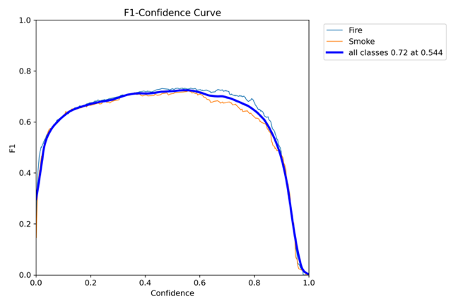

Figure 9: This image represents f1-confidence curve. This can help visualize the differences between smoke and fire to better understand the algorithm. Some people look at the manual numbers, but visualization can see the difference between classes. The reason why we don’t want a huge difference in classes is because the algorithm should both be able to detect fire and smoke in an accurate manner. Here we can see the lines between smoke and fire are not drastically different which means that we have a somewhat well-trained algorithm considering the specific epoch number used. Especially with the f1 confidence curve, we see minimal differences.

To visualize the differences within the algorithm, we can also look at the manual predictions the algorithm created as opposed to what we annotated manually in the validation set.

As we tweak the parameters of our YOLO algorithm in this validation phase, we found that between 170-190 epochs were the most optimal (in this experiment we used 180 epochs). The range was discovered as the algorithm started to look very similar after 190 epochs onwards. It displays a message that notifies the user that further epochs will result in overfitting of data as the loss of the algorithm is not decreasing by a significant amount. To ensure that we save computational power while preventing an over specified algorithm, we used epoch 180 for both the fire training and the fire and smoke training algorithm.

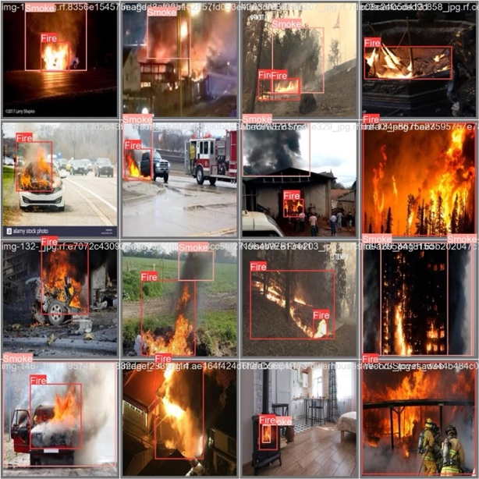

Figure 13: This image above are annotations of images done on the website roboflow, where we collect images of fire and show the algorithm where the detected fire is.

Here the labels above are manually done so that when the algorithm makes predictions it can give these metrics we see above. This validation set is crucial to report for researchers to be able to adjust and visualize the values in the dataset.

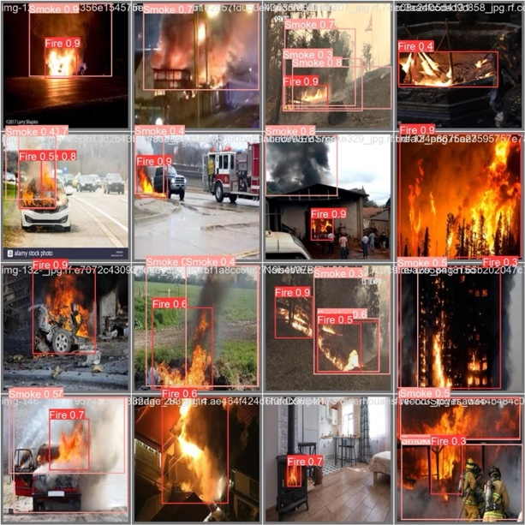
Figure 14: This image set is used in contrast with the annotated images in Figure 13. We can visualize the differences in the algorithm’s prediction of the fire.

Now these are the values we see when the algorithm is fed these images. This is still relatively in the early stages of the training process but is what we can test our algorithm with.

Finally, there is the confusion matrix. This is responsible for showing the precision and recall scores visually in a box. It labels itself with true positives and negatives. The top row is responsible for showing first the true positive rate, the false negative rate, and the false positive rate. This is then seen in the next columns for smoke and background images.

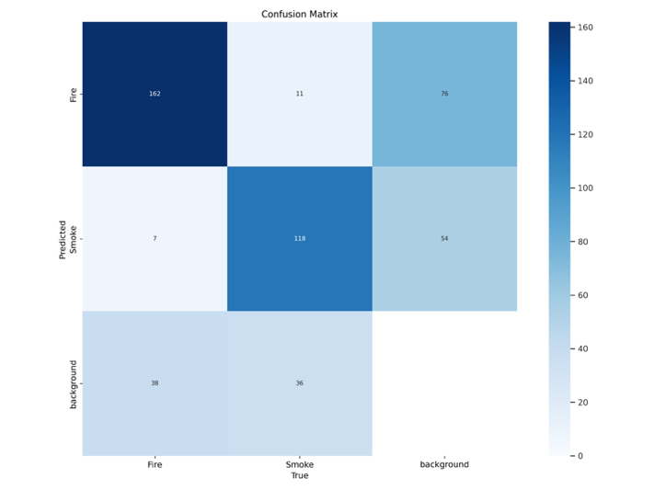
Figure 15: This is a confusion matrix that shows the false/true positives and negatives.

The normalized version of the confusion matrix gives these values in percentages while the regular confusion matrix gives these in the raw number for each category.
Now to take our confidence level we tested the algorithm on multiple images and reported those confidence levels.

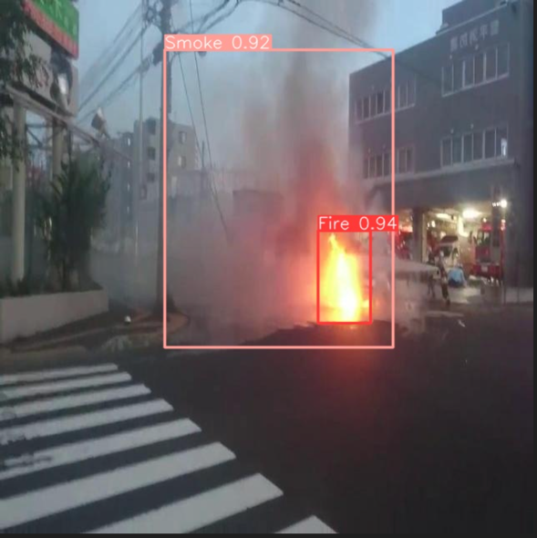
Figure 16: This image is the result coming from the machine learning algorithm detecting smoke and fire from images.

From this we report the values of the boxes surrounding the smoke and fire images and average them out.

When testing these values, we took a dataset of 100 images used for testing.

When we took the trained yolo algorithm for just fire, we reported an average confidence level of 85.1% with an accuracy of 85.7%.

When we took the trained yolo algorithm for both fire and smoke, we found an average confidence level of 90.2% and 92.8% accuracy for fire alone.

With images that did not contain fire or smoke, it correctly displayed no sign of danger in its result.

Another thing to consider is that in certain time intervals, the smoke’s confidence was much higher. Between 17.9 seconds to 31.9 seconds, there was an average confidence of 93.8%. With fire, there was more distribution. This could have to do with the order of images placed and the quality of the images. When considering interference with recorded videos there wouldn’t be a large difference in confidence with similar times as each image will only differ to the previous by 2 seconds in a continuous recording.

We found that the average confidence level for smoke was 85.02% and the accuracy was 76.1%.
When we applied these calculations to our IoT device, we found that the raspberry pi would take 1.9994 seconds per image, causing an increase in time taken for calculation. This allows us to send 1 image every 2 seconds for the raspberry pi to process.

Conclusion and future directions
With our results, we can observe a few key conclusions. When analyzing our raspberry pi, we see that the time it takes for it to process an image is around 2 seconds. Considering that most of the recordings that come from a camera are a series of videos, we can see that 2 seconds still results in real-time analysis. This also means that in real-time interference, we can upload an image every 2 seconds through the lens of the camera and have machine learning be constantly running and detecting fire. While implementing machine learning on a server-based implementation can decrease the time to less than a second, having a portable IoT based model saves time in sending data to the server. Thus, while IoT has some limitations in its power of computation, it can perform to the same capability with the scope of this experiment.

When we look at the confidence and accuracy levels we can point its results to multiple things. Starting off with the datasets, the quality of the image, the number of iterations, and the types of image selection, the datasets could have a huge effect on the accuracy of the algorithm.

With plain fire images, we have a variety of indoor and outdoor fires that make the algorithm versatile. However, when we create an algorithm that reads both smoke and fire, we expose our YOLO classification to also detect fires with images that heavily are clouded in smoke. This may result in an increased ability for the algorithm to detect fires in the fire and smoke algorithm. We can see this with the highest accuracy and confidence score coming from the fire detection algorithm which was trained on both fire and smoke with 90.2% confidence and 92.8% accuracy, highlighting how there was no compromise in accuracy when introducing the merged datasets. The broader implication of this is that images can either be extremely covered in smoke or extremely covered in fire. Being able to create an algorithm that accurately detects both minimizes the risk of missing out on potential danger.

Moving on from the difference between fire and smoke, we can see how the different metrics in the validation state have been caused by our datasets. Regarding precision we can see that the algorithm was able to get a lot of the fire images correct. However, to improve its score, we could have tried more epochs within the dataset and retraining it on the tested dataset. By retraining and retesting on more images, we could train the algorithm to approach the highest mark possible. With recall score we can see that there were some false negatives. With images containing smaller fires, we could have provided a balanced split of the dataset or include better quality images for the fire to detect. As f1 and mean accuracy precision are a combination of the other metrics, they can be affected by retraining the dataset with more images and maybe even false instances to widen the depth of the algorithm.

When we look at the confusion matrices, we can clearly see the false positives and false negatives rate. This gives us another way to view the precision scores. By seeing the number of images that were not properly detected we can try to lower than number and percentage closer to 0 or 1 depending on the category.
With all these metrics it can be difficult to get an understanding of the effectiveness of an algorithm. To solve that problem, we introduce the prediction and labeling image comparison we see in the validation phase. With those confidence levels we saw how the algorithm can be good at detecting images of fire that were trained on the smoke and fire, however. Another thing to note is that the smoke validation was slightly worse off than the fires when we compare the predictions to the original annotations. This makes sense as when we look at our results, we achieved the best accuracy with the fire.

With this validation phase we also observed how the change in dataset affected the metrics we gathered. Starting off with only 185 images, we achieved precision scores in the high 70s. However, introducing 485 images in the validation phase increased our precision by 10 percent. With such a small number of tests run initially, we might not have gotten a fair estimate of our algorithms capability because the images we selected could have been poor quality or different from the ones used from tested. This occurs because the images are selected from a random split (as in the test, train, and validation images are randomly classified from the overall dataset).

One parameter that played such role was the number of epochs and the iterations from the algorithm. We learned that with epoch levels lower than 150, the algorithm is poor at detecting fires (with both low accuracy and low confidence levels). However, increasing the epoch count to 300 overfit the data as the algorithm said there was not much difference in value after epoch count 170. Finding the optimal epoch count at 180 we also found another example of machine learning’s susceptibility to different parameters.

While our experiment successfully detected smoke and fire with high accuracy, we could try to further this experiment by opening it to low light settings or thermal imaging. From there we could try to improve our accuracy by focusing on indoor settings specifically and outdoor settings for a future study. Finally, one more study we could do is implement a location-based tracking system with the IoT. While we have a device that can notify users that a fire is present in the image, their only metric of knowing where the fire exists is by looking at the depth of the image. If we built a tracking system these smart cameras could also implement a location-based system to automatically locate, removing fires, and notifying nearby homes.

After completing this experiment, we can see how “smart fire detection system (SFDS) leverages the strengths of deep learning to detect fire-specific features in real time” and can “improve the accuracy of fire detection, reduce false alarms, and be cost-effective compared to traditional fire detection methods.” [31]. We can see that YOLOv8, one of the later models developed for YOLO, has had significant improvements in speed and accuracy meaning that the system we have created can be implemented in all sorts of cameras. By connecting a micro processing system to a sensor that gathers images, we can attach this software to drones, security cameras, and in our ordinary phones. This software can also be used with a network of cameras, furthering communication within IoT. By using more cameras, this experiment can highlight how intensity and location of fire can be determined. Through communication we can establish a geolocation of the various signals while getting an understanding of the size of the fire. This could lead to decision-based processing to determine whether the fire is large enough to contact local authorities or simply homeowners.

While this project highlights the capabilities of IoT there are some limitations. Due to smaller microprocessing system, an overloading of data can crowd out these systems, leading to even slower communication. Another thing to consider in outdoor settings is the constant power source needed to keep the smart camera constantly running. With machine learning there can also be constant improvements developing accuracy and making the levels with smoke and fire become more equal. Another step in this study can focus on differentiating between “danger” and a simple fire. If someone were to hold up a picture of a fire in front of the camera, there is a possibility of it detecting danger. Thus, future experiments could combine temperature and humidity detectors to reduce the chance of false positives. Finally, one other limitation is getting proper lens to detect thermal imaging and low light settings.

Smart cameras have been used to detect a variety of images and anomalies within the smart home system. By implementing an IoT based model, we have successfully created a camera that detects fire and smoke hazards, alerting nearby homes that could be present in this danger.

References
[1]: “Our Impact | CAL FIRE.” n.d. Www.fire.ca.gov. https://www.fire.ca.gov/our-impact#:~:text=In%20addition%20to%20the%20more.

‌[2]: Jones, Ben. “Wildfires in the US: Alarming Statistics and Trends.” Dryad (blog), May 13, 2024. https://www.dryad.net/post/wildfires-usa-statistics#:~:text=In%202023%2C%20there%20were%2056%2C580,to%20%24893%20billion%20each%20year

[3]: “Fire Loss in the United States | NFPA Research,” n.d. https://www.nfpa.org/education-and-research/research/nfpa-research/fire-statistical-reports/fire-loss-in-the-united-states.

[4]: Shallari I, O'Nils M. From the Sensor to the Cloud: Intelligence Partitioning for Smart Camera Applications. Sensors (Basel). 2019 Nov 25;19(23):5162. doi: 10.3390/s19235162. PMID: 31775371; PMCID: PMC6929032.

[5]: The SmokeD wildfire detectors. “The SmokeD Wildfire Detectors | LinkedIn,” n.d. https://www.linkedin.com/company/smokedsystem/.

[6]: Dui, Hongyan, Yawen Zhu, and Junyong Tao. 2024. "Multi-Phased Resilience Methodology of Urban Sewage Treatment Network Based on the Phase and Node Recovery Importance in IoT." Reliability Engineering & System Safety 247.

[7]: Abas, Kevin, Katia Obraczka, and Leland Miller. "Solar-powered, wireless smart camera network: An IoT solution for outdoor video monitoring." Computer Communications 118 (2018): 217-233.

[8]: Dharan, Anandu M. and Debarka Mukhopadhyay. 2023. "A Comprehensive Survey on Machine Learning Techniques to Mobilize Multi-Camera Network for Smart Surveillance." Innovations in Systems and Software Engineering.

[9]: Avazov, Kuldoshbay, Mukhriddin Mukhiddinov, Fazliddin Makhmudov, and Young Im Cho. 2022. "Fire Detection Method in Smart City Environments using a Deep-Learning-Based Approach." Electronics (Basel) 11 (1): 73.

[10]: Kaabi, Rabeb, Moez Bouchouicha, Aymen Mouelhi, Mounir Sayadi, and Eric Moreau. 2020. "An Efficient Smoke Detection Algorithm Based on Deep Belief Network Classifier Using Energy and Intensity Features" Electronics 9, no. 9: 1390. https://doi.org/10.3390/electronics9091390

[11]: Krishnamoorthy, Murugaperumal, Md Asif, Polamarasetty P. Kumar, Ramakrishna S. S. Nuvvula, Baseem Khan, and Ilhami Colak. 2023. "A Design and Development of the Smart Forest Alert Monitoring System using IoT." Journal of Sensors 2023: 1-12.

[12]: Saponara, Sergio, Abdussalam Elhanashi, and Alessio Gagliardi. 2021. "Real-Time Video fire/smoke Detection Based on CNN in Antifire Surveillance Systems." Journal of Real-Time Image Processing 18 (3): 889-900.

[13]: Garg, Sushil, Balaji Sharma, Kelly Cohen, and Manish Kumar. "A fuzzy logic based image processing method for automated fire and smoke detection." In 51st AIAA Aerospace Sciences Meeting including the New Horizons Forum and Aerospace Exposition, p. 879. 2013.

[14]: Sarwar, Barera, Imran Sarwar Bajwa, Shabana Ramzan, Bushra Ramzan, and Mubeen Kausar. 2018. "Design and Application of Fuzzy Logic Based Fire Monitoring and Warning Systems for Smart Buildings" Symmetry 10, no. 11: 615. https://doi.org/10.3390/sym10110615

[15]: Global, Bosch, Bosch Global, Bosch Global, Bosch Global, Bosch Global, Bosch Global, Bosch Global, and Bosch Global. “AVIOTEC Fire-and-smoke-detection-camera.” Bosch Security and Safety Systems I Nordics, n.d. https://www.boschsecurity.com/xn/en/solutions/fire-alarm-systems/fire-and-smoke-detection-camera/.

[16]: “Shop the FLIR Store | Teledyne FLIR,” n.d. https://www.flir.com/store/?utm_source=google&utm_medium=cpc&utm_campaign=americas.us.solutions.cm-vol.e.cpc-

[17]: The SmokeD wildfire detectors. “The SmokeD Wildfire Detectors | LinkedIn,” n.d. https://www.linkedin.com/company/smokedsystem/.

[18]: Rašić, Ivana Majić. 2023. “Embedded AI Demystified: A Deep Dive into Applications and Benefits.” Byte Lab • IoT Development & Production. September 11, 2023. https://www.byte-lab.com/embedded-ai-demystified-a-deep-dive-into-applications-and-benefits/#:~:text=Embedded%20AI%20is%20the%20application

[19]: Arduino Official Store. “Nicla Vision,” n.d. https://store.arduino.cc/products/nicla-vision. (8)

[20]: Dong, Mo, Haiye Yu, Zhipeng Sun, Mingzhi Wu, Lei Zhang, Yuanyuan Sui, Guanghao Yu, Ting Han, and Ruohan Zhao. 2022. "Design of IoT Gateway for Crop Growth Environmental Monitoring Based on Edge-Computing Technology." Computational Intelligence and Neuroscience 2022: 8327006-13. (9)

[21]: Aloi, G., G. Caliciuri, G. Fortino, R. Gravina, P. Pace, W. Russo, and C. Savaglio. 2017. "Enabling IoT Interoperability through Opportunistic Smartphone-Based Mobile Gateways." Journal of Network and Computer Applications 81: 74-84. (10)
[22]: "Working and Usage of Arduino as a Tool for Study and Research." International Journal of Research Publication and Reviews.
[23]: Computational, Intelligence, and, Neuroscience. (2023). Retracted: Yolo-Based Traffic Sign Recognition Algorithm. Computational Intelligence and Neuroscience, 2023 doi: 10.1155/2023/9831917

[24]: Juba, Brendan, and Hai S. Le. "Precision-recall versus accuracy and the role of large data sets." In Proceedings of the AAAI conference on artificial intelligence, vol. 33, no. 01, pp. 4039-4048. 2019.

[25]: Li, Kehuang, Zhen Huang, You-Chi Cheng, and Chin-Hui
Lee. "A maximal figure-of-merit learning approach to maximizing mean average precision with deep neural network based classifiers."
In 2014 IEEE International Conference on Acoustics,

[26]: Krishnamoorthy, Murugaperumal, Md Asif, Polamarasetty P. Kumar, Ramakrishna S. S. Nuvvula, Baseem Khan, and Ilhami Colak. 2023. "A Design and Development of the Smart Forest Alert Monitoring System using IoT." Journal of Sensors 2023: 1-12.

[27]: Roboflow. “Fire Dataset and Pre-Trained Model by XY Z,” n.d. https://universe.roboflow.com/xy-z/fire-0lzg9/dataset/2%20%20https://www.kaggle.com/datasets/ritupande/fire-detection-from-cctv/data%20%20https://www.kaggle.com/datasets/phylake1337/fire-dataset%20%20https://github.com/gaiasd/DFireDataset?tab=readme-ov-file%20%20https://universe.roboflow.com/fire-iak32/indoor-fire-ttiec.
[28]: Kaggle. “Fire Detection From CCTV,” May 25, 2019. https://www.kaggle.com/datasets/ritupande/fire-detection-from-cctv/data.

[29]: Kaggle. “FIRE Dataset,” February 25, 2020. https://www.kaggle.com/datasets/phylake1337/fire-dataset.

[30]: Gaiasd. “GitHub - Gaiasd/DFireDataset: D-Fire: An Image Data Set for Fire and Smoke Detection.” GitHub, n.d. https://github.com/gaiasd/DFireDataset?tab=readme-ov-file.

[31]: Fire. 99.jpg. n.d. Roboflow. https://universe.roboflow.com/fire-iak32/indoor-fire-ttiec.

[32]: Talaat, F.M., ZainEldin, H. An improved fire
detection approach based on YOLO-v8 for smart
cities. Neural Comput & Applic 35, 20939–20954
(2023). https://doi.org/10.1007/s00521-023-08809-1

Appendix
Code for Training Dataset
from IPython.display import Image
!pip install ultralytics==8.0.196
!pip install roboflow
import ultralytics
from roboflow import Roboflow
from ultralytics import YOLO
from IPython.display import Image
rf = Roboflow(api_key=” (Custom key) ”)


project = rf.workspace(("fire-and-smoke-
alkqh").project("fire-and-smoke-dgvbp")
version = project.version(3)
dataset = version.download("yolov8")
!yolo task=detect mode=train model=yolov8n.pt data=/content/Fire-and-smoke-3/data.yaml epochs=1 imgsz=640 plots=True
Image(filename=f'/content/runs/detect/train/results.png', width=600)
!yolo task=detect mode=val model=/content/runs/detect/train/weights/best.pt data=/content/Fire-and-smoke-3/data.yaml

Code for Testing Dataset
from ultralytics import YOLO
import os
model = YOLO('final2.pt')

all_data = os.listdir('/Users/shrivassudharsan/Desktop/datasets/data/test/test/images')
list_data = []
for i in range(len(all_data)):
list_data.append(all_data[i])
print(list_data)
for i in range(len(list_data)):
model.predict(source = list_data[i], imgsz= 640, conf = 0.6, save = True)

