***User Defined sign language interpreter***

**Graphical User Interface of *User Defined sign language Interpreter***

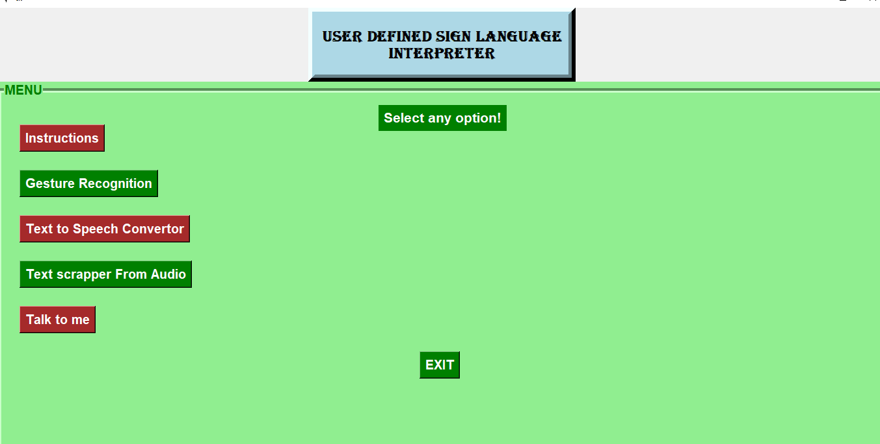

**Defining Hand Gestures:**

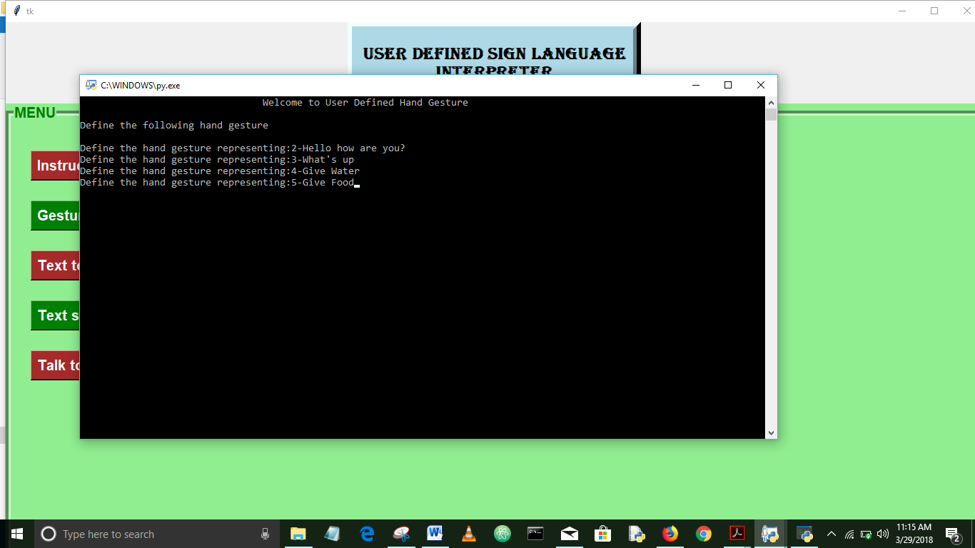

Face Recognition Using UDSLI:

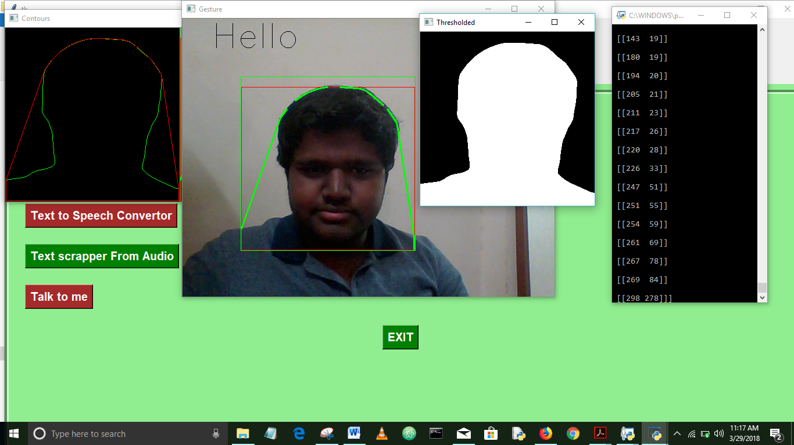

**Gesture representing 2:Hello how are you?**

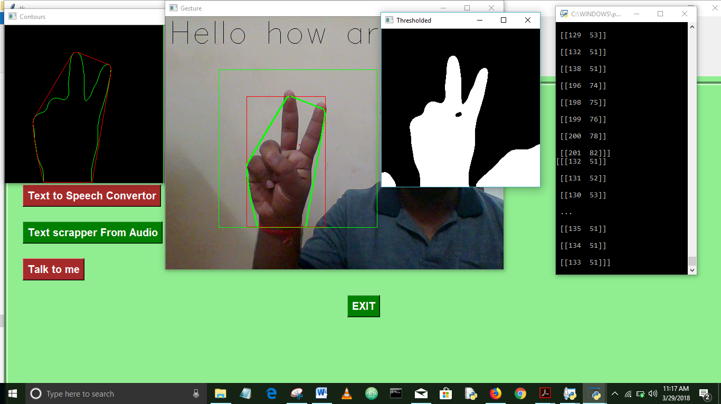

**Gesture Representing 3: What’s up**

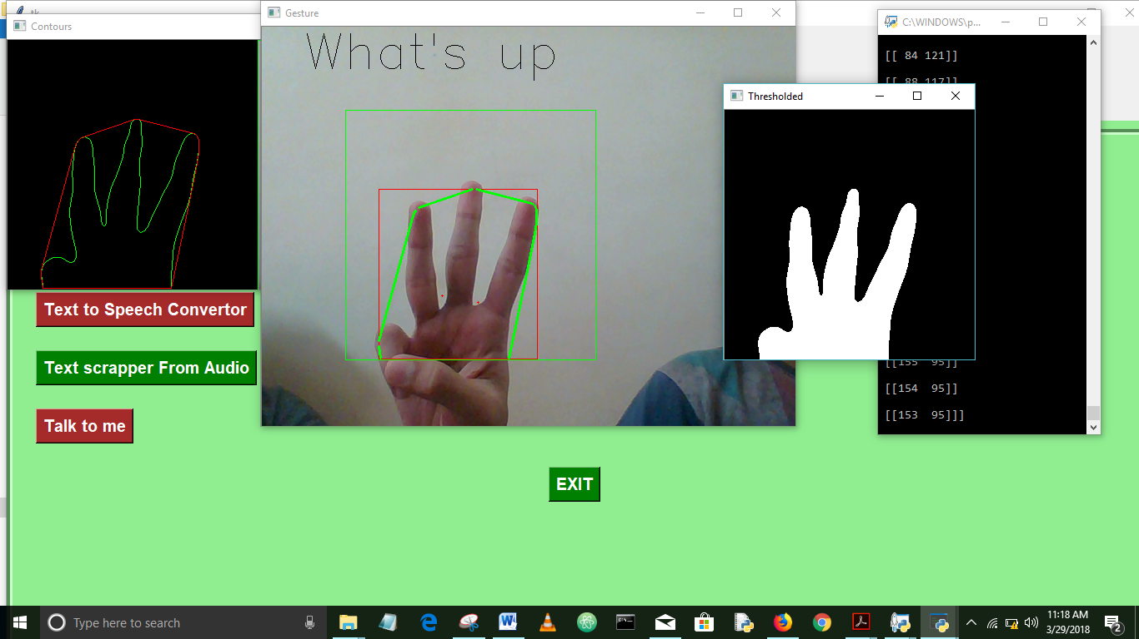

**Gesture Representing 4:Give Water**

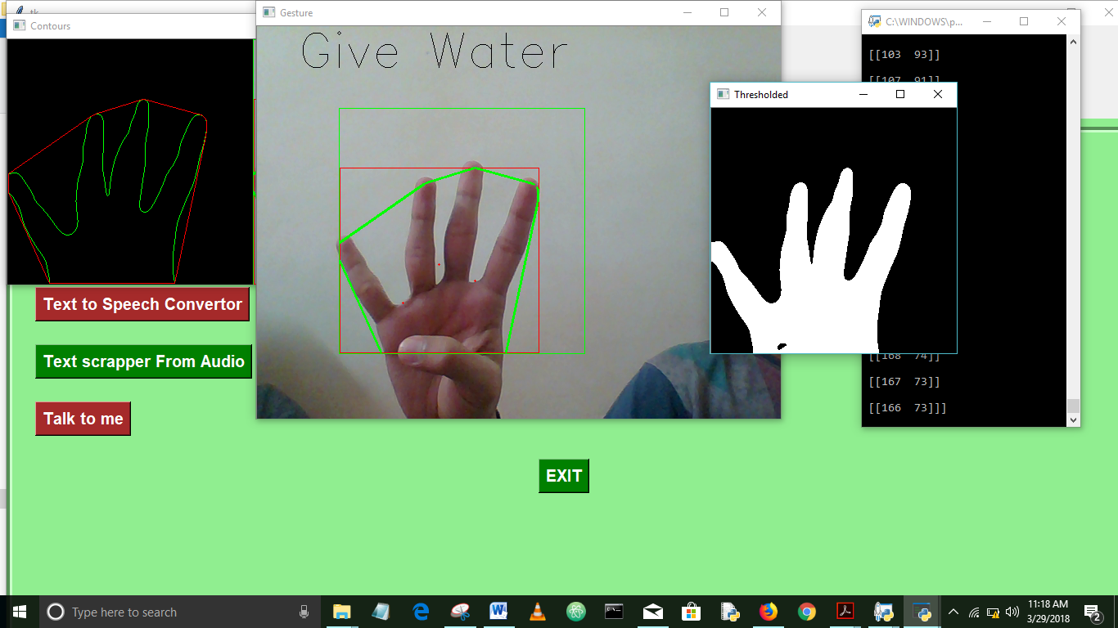

**Gesture Representing 5: Give Food**

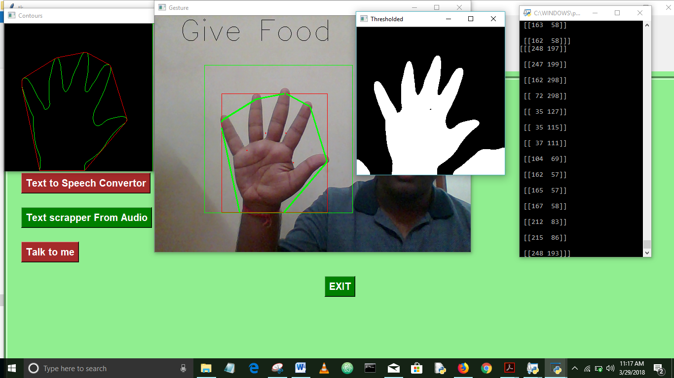

**Common Gestures:**

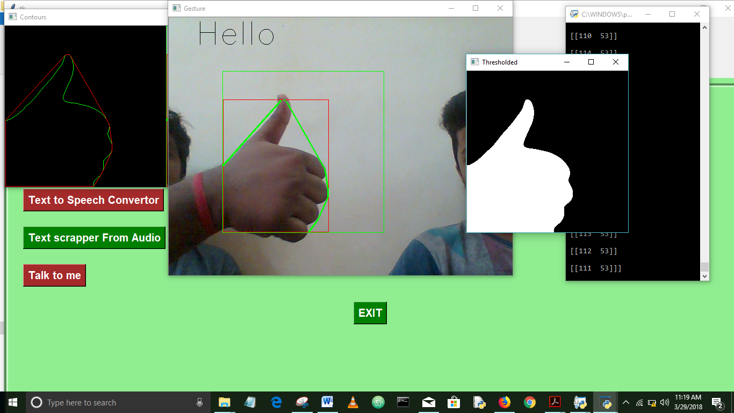

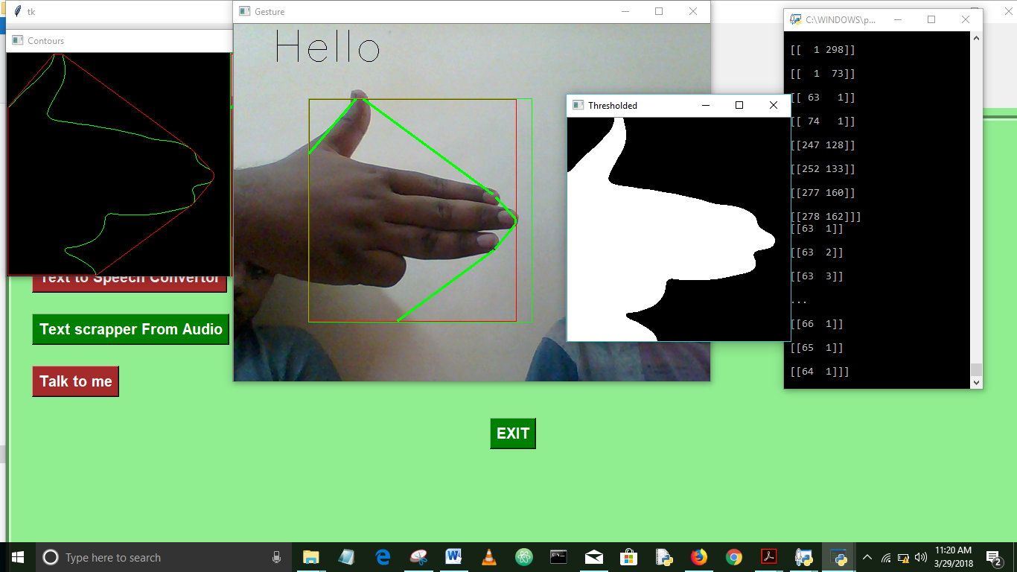

**TEXT To SPEECH**

**This module will convert text to human understandable language, here English, so that a deaf or a dumb person can type whatever he wants to speak to a normal person and the rest of the work of speaking to the person will be done by the software UDSLI provided by us.**

**Sample Output:-**

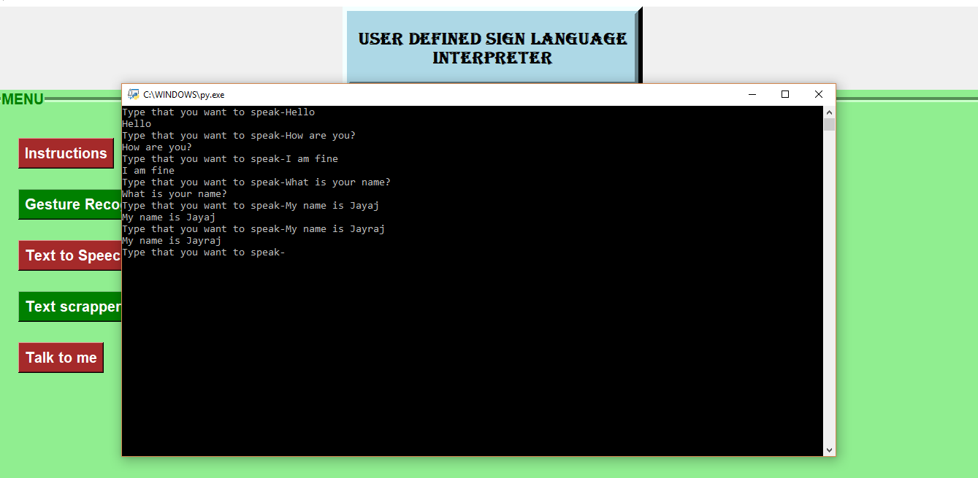

**TEXT Scrapping**

**This module is divided into two parts i.e., 1. Interpreting voice from the user and converting it to text so that a deaf person can read whatever a normal person is speaking, 2. Interpreting from a audio file to text so that a deaf person can read whatever is spoken in a recorded audio file.**

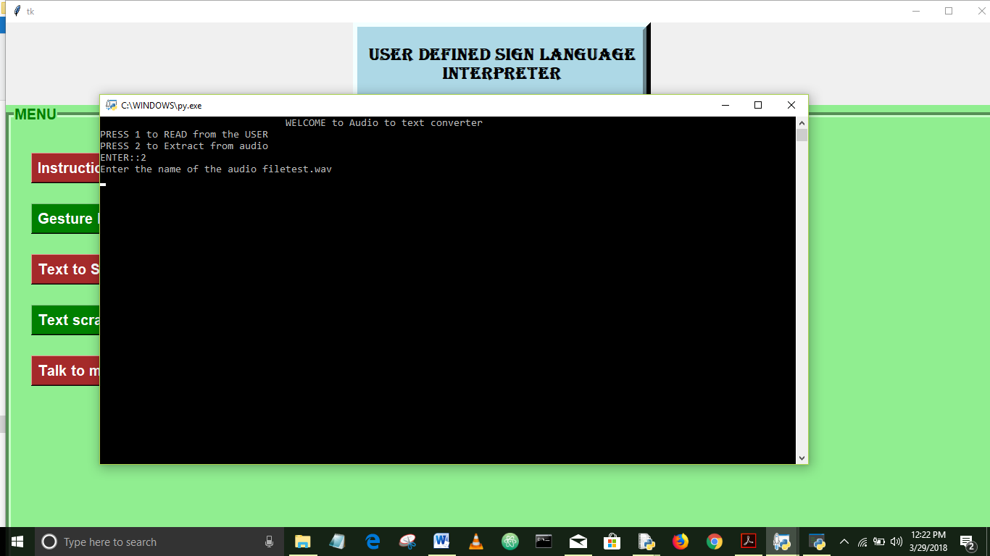**1:-**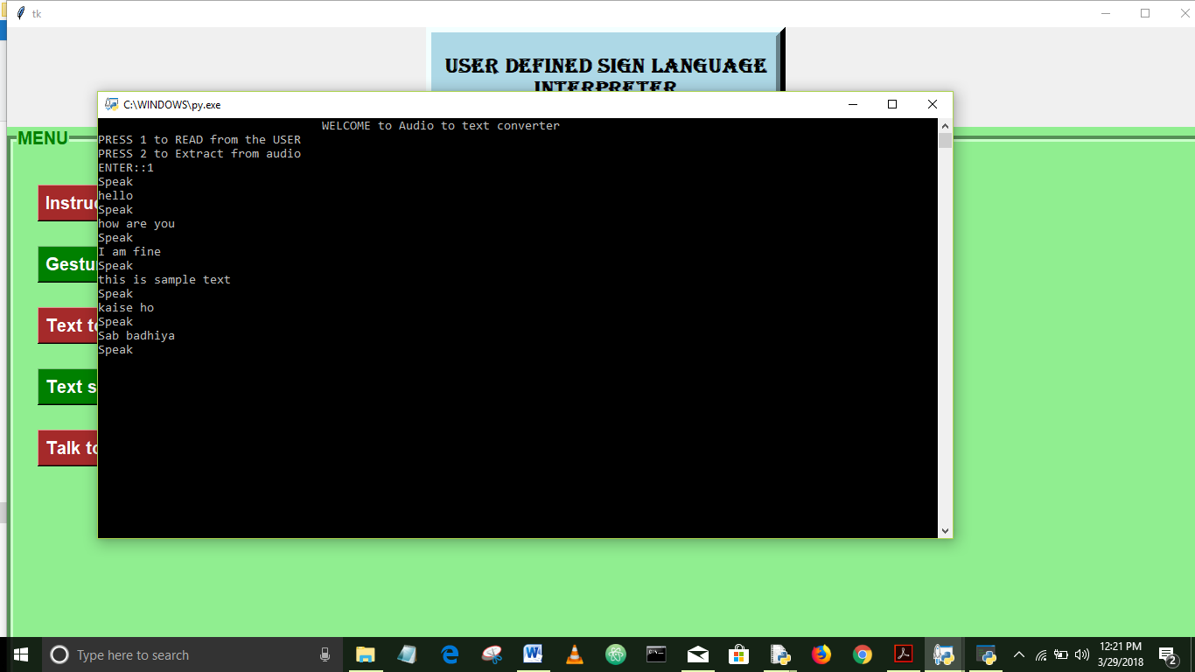

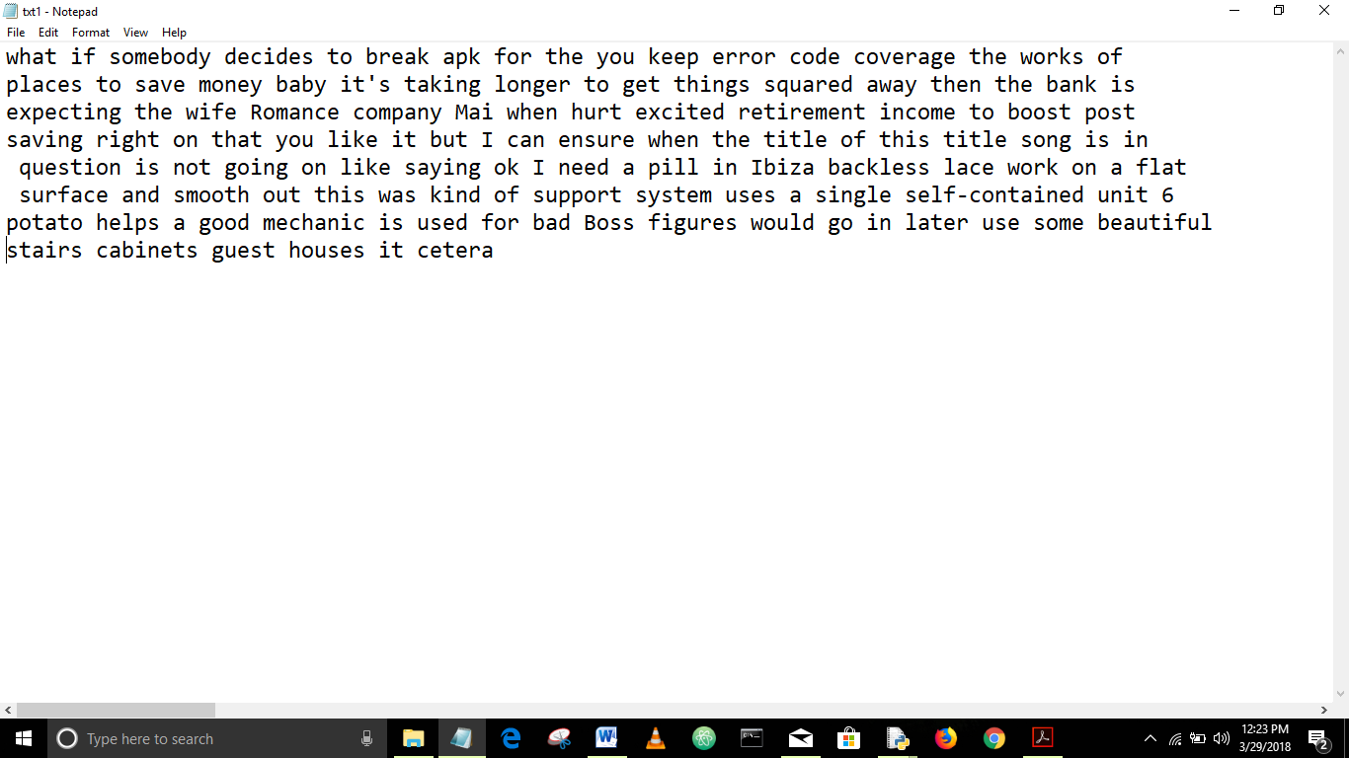

**Above is a screenshot of the interpreted text file of the given audio file sample.**