- 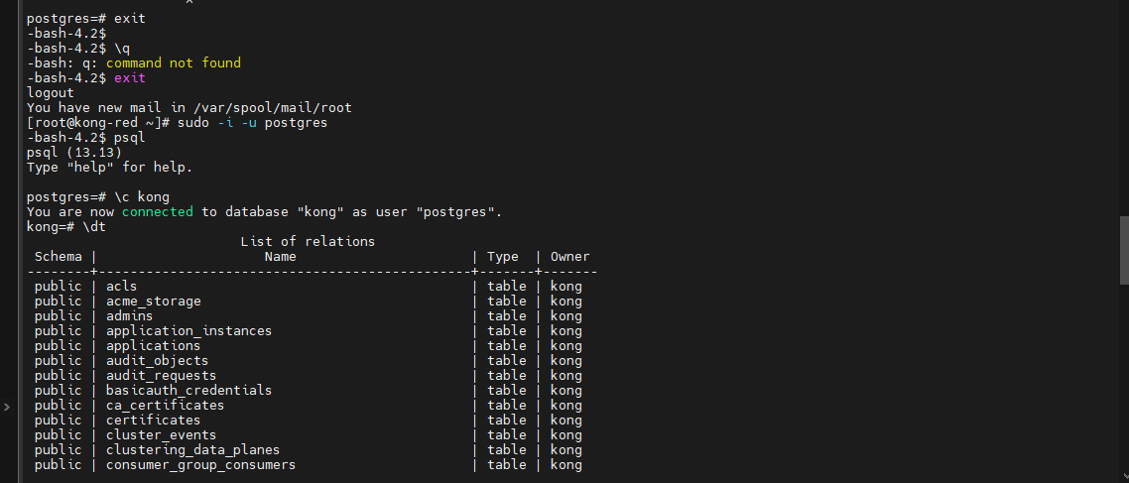
- 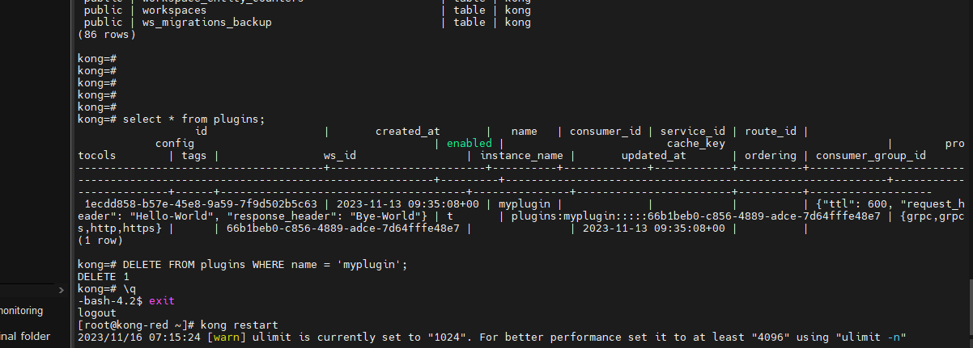
- First you need to come inside postgress as sudo -i -i postgres
- Then do psql
- Then type as “\c kong”
- Then to get tables types as “\dt”
- After that to get the plugins use the query as “select * from plugins;”
- Then do the another command as “DELETE FROM plugins WHERE name = 'myplugin';”
- Then to come out put “\q”
- Then u can type as “exit”.
- U will face the error
- as Error: /usr/local/share/lua/5.1/kong/cmd/start.lua:183: nginx: [error] init_by_lua error: /usr/local/share/lua/5.1/kong/init.lua:732: error building initial plugins: myplugin plugin is in use but not enabled
stack traceback:
[C]: in function 'error'
/usr/local/share/lua/5.1/kong/init.lua:732: in function 'init'
init_by_lua:3: in main chunk
- This will come when u delete the plugin directly from plugins folders and u will remove from kong.conf file.
- But your not remove the plugin from kong manager then this error will be facing
- To remove custom plugin first step is u need to remove from kong manager, you need to delete from kong manager and then you need to remove from kong.conf file and you need to remove the folder from plugins directory.

