**In Kong:**

* In CP and DP we need to add some annotations or codes we need to add in the cp and dp planes
* This docx mainly helpful to create prometheus but please include some codes in CP and DP plane
* In data plane
* 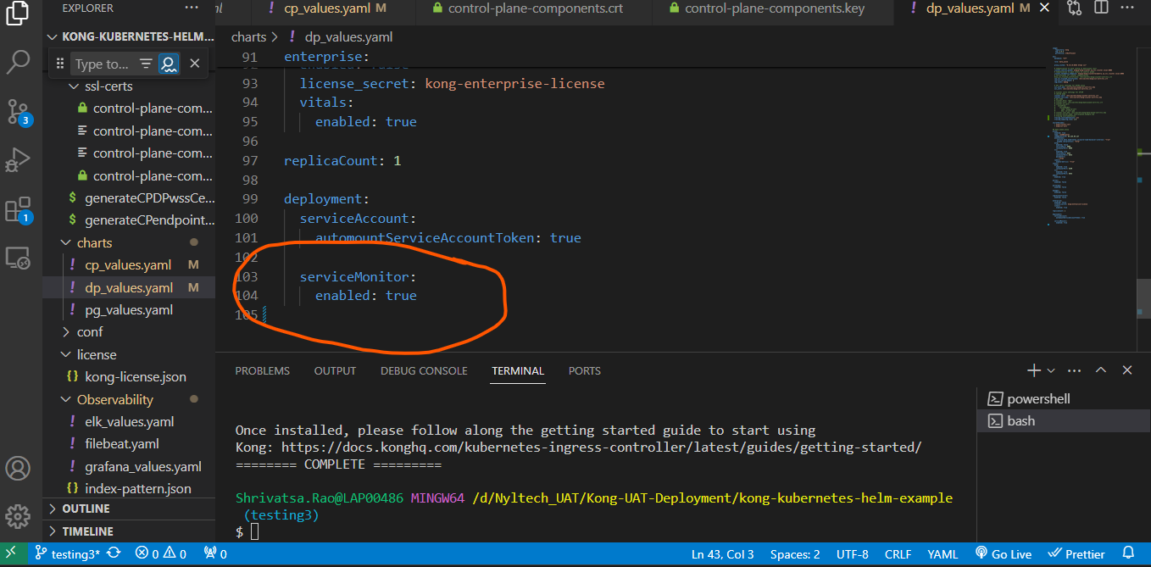
* In control plane
* 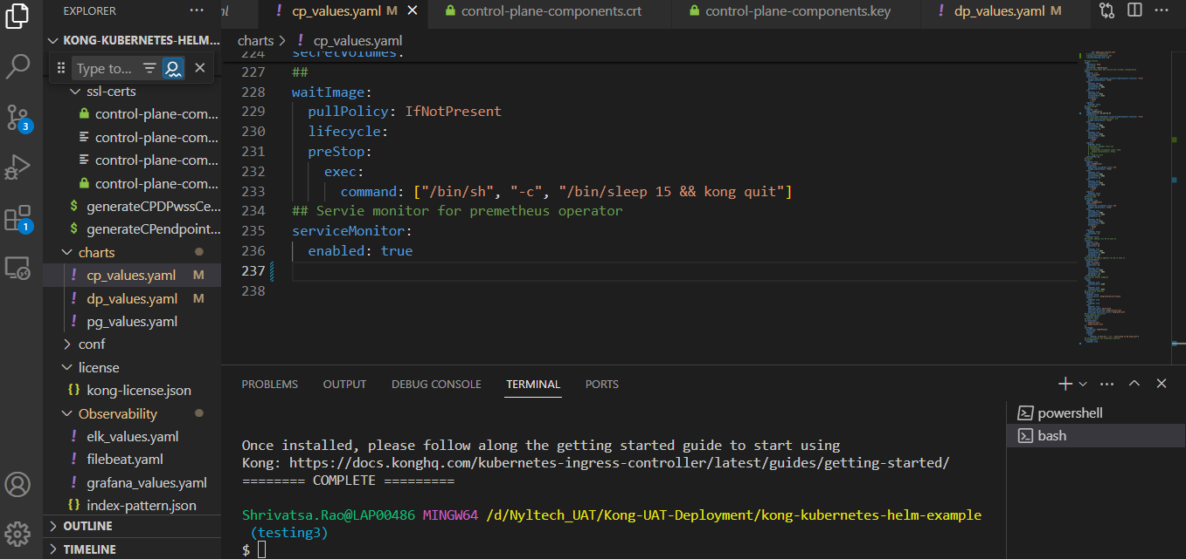
* In grafana docx we include some important url which is mentioned below
* 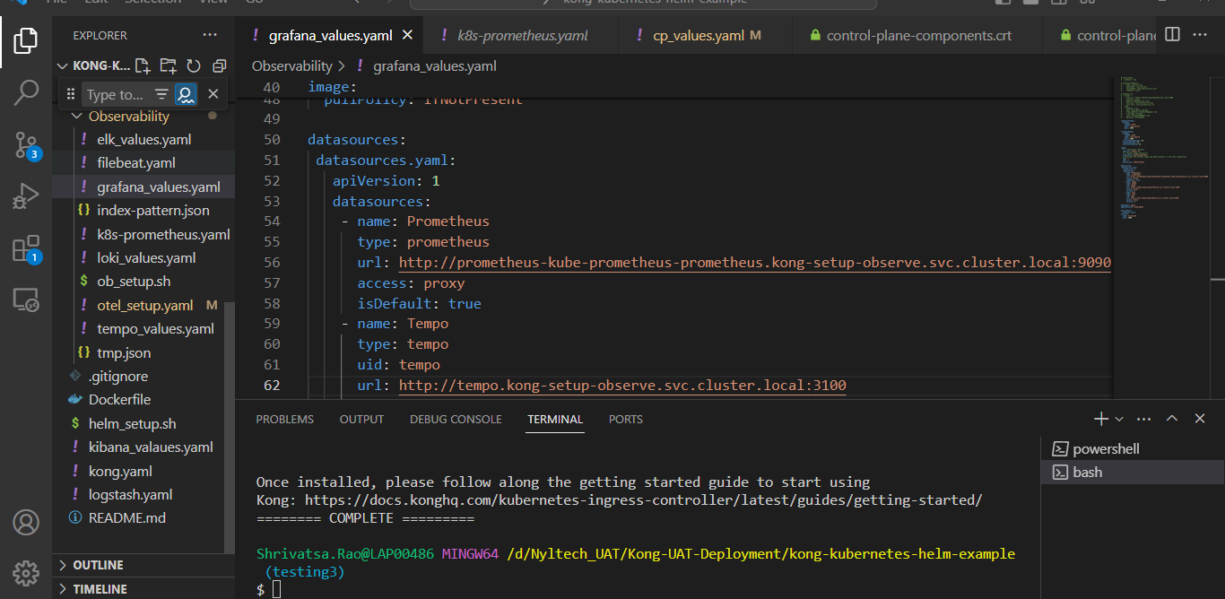
* In the url u need to add service name and then u need place those values and all where servicename.namespace.svc.cluster.local:9090
* Then in prometheus.yaml file u need to do required changes as mentioned below
* 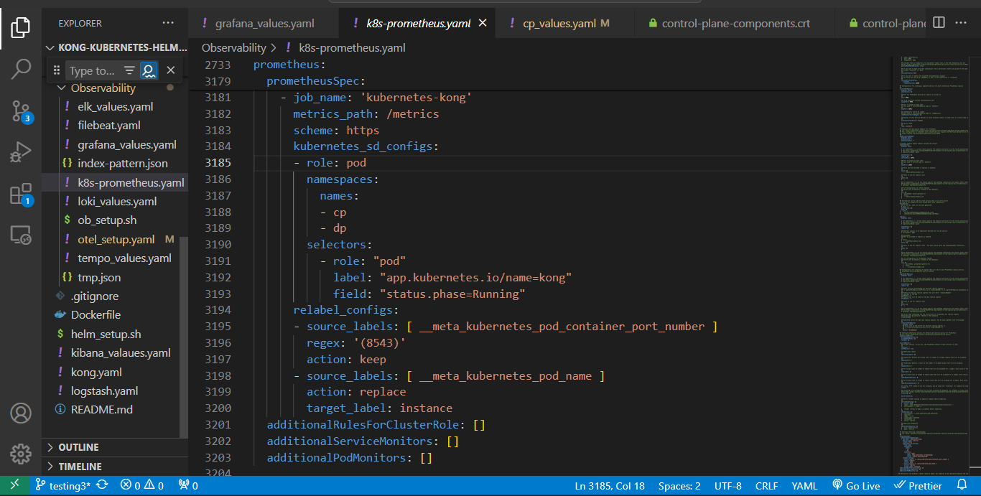
* prometheusSpec: This section contains the configuration for Prometheus.
* additionalScrapeConfigs: Specifies additional scrape configurations for Prometheus. In this case, it defines a new job named "kubernetes-kong" to scrape metrics from Kong pods.
  + job_name: The name of the job.
  + metrics_path: The path where Prometheus should scrape metrics from.
  + scheme: The protocol scheme to use for scraping metrics (in this case, HTTPS).
  + kubernetes_sd_configs: Configuration for Kubernetes service discovery, specifying which pods to scrape metrics from based on their labels and status.
  + relabel_configs: Specifies how labels should be modified before metrics are stored in Prometheus. For example, it keeps metrics only from pods with container port number 8543 and replaces the instance label with the pod name.
* cleanPrometheusOperatorObjectNames: This setting controls whether Prometheus object names should be cleaned to produce cleaner resource names. If set to true, it may require a data migration because the name of the persistent volume changes.
* extraManifests: Allows you to provide additional Kubernetes manifests to deploy alongside the Prometheus operator. This can include additional resources like ConfigMaps, Secrets, or CustomResourceDefinitions.

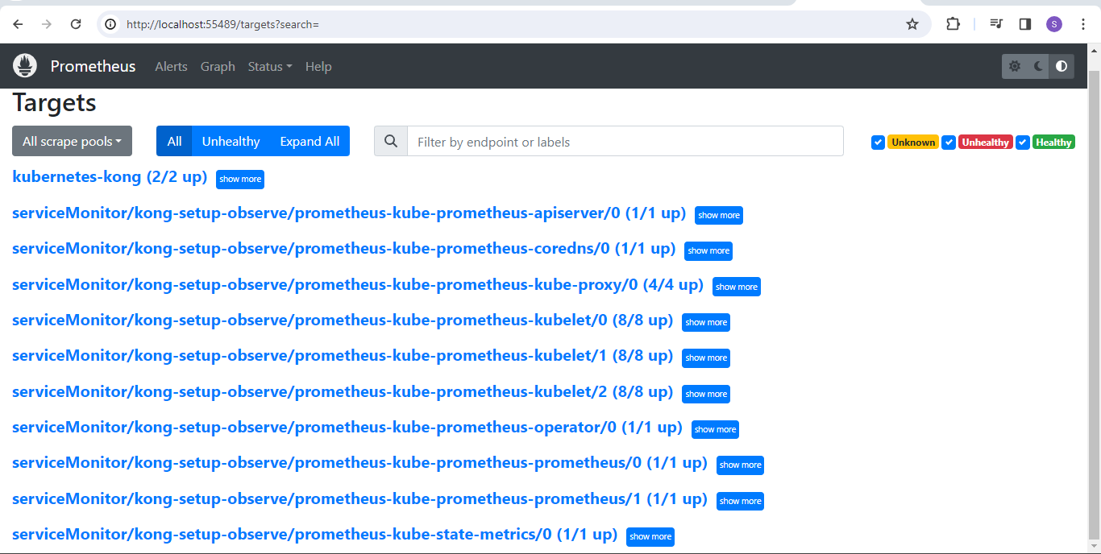

* This kubernates kong has to be visible when u run prometheus pod in the localhost
* This as to be visible then only we can say that we can achieve preomthus monitoring.

These are the some things which we need to keep in mind for premothus setup in the kong.