This setup based on the helm values and hence you need to have to run below commands first

* helm repo add grafana https://grafana.github.io/helm-charts
* helm repo update

Run the above commands and then you need to include below file in your repo

imagePullSecrets:

- name: "acr-creds"

filebeat:

enabled: false

image: filebeat

imageTag: 8.5.1

filebeatConfig:

filebeat.yml: |

logging.level: debug

filebeat.inputs:

- type: http_endpoint

# Change to true to enable this input configuration.

enabled: true

listen_address: 0.0.0.0

listen_port: 9010

prefix: "kong"

- type: container

paths:

- /var/log/containers/*.log

processors:

- drop_event.when:

or:

- equals:

kubernetes.namespace: "kube-system"

- equals:

kubernetes.namespace: "calico-system"

- add_kubernetes_metadata:

host: ${NODE_NAME}

matchers:

- logs_path:

logs_path: "/var/log/containers/"

output.logstash:

hosts: ["loki-logstash-headless:5044"]

fluent-bit:

enabled: false

grafana:

enabled: false

logstash:

enabled: false

image: logstash

imageTag: 1.0.1

inputs: |-

beats {

port => 5044

}

filters:

main: |-

filter {

if [kubernetes] {

mutate {

add_field => {

"container_name" => "%{[kubernetes][container][name]}"

"namespace" => "%{[kubernetes][namespace]}"

"pod" => "%{[kubernetes][pod][name]}"

}

replace => { "host" => "%{[kubernetes][node][name]}"}

}

}

mutate {

remove_field => ["tags"]

}

}

outputs:

main: |-

output {

loki {

url => "http://loki.kong-setup-observe.svc.cluster.local:3100/loki/api/v1/push"

#username => "test"

#password => "test"

}

# stdout { codec => rubydebug }

}

prometheus:

enabled: false

loki:

config:

memberlist:

bind_addr:

- ${MY_POD_IP}

compactor:

compaction_interval: 10m

retention_delete_delay: 2h

retention_delete_worker_count: 150

retention_enabled: true

working_directory: /data/retention

limits_config:

retention_period: 72h

enabled: true

isDefault: false

persistence:

enabled: false

size: 5Gi

storageClassName: gp2

env:

- name: MY_POD_IP

valueFrom:

fieldRef:

fieldPath: status.podIP

extraArgs:

config.expand-env: true

promtail:

config:

lokiAddress: http://loki.kong-setup-observe.svc.cluster.local:3100/loki/api/v1/push

enabled: true

* This is code for loki and here mainly when you install newly then u need to change the below url
* 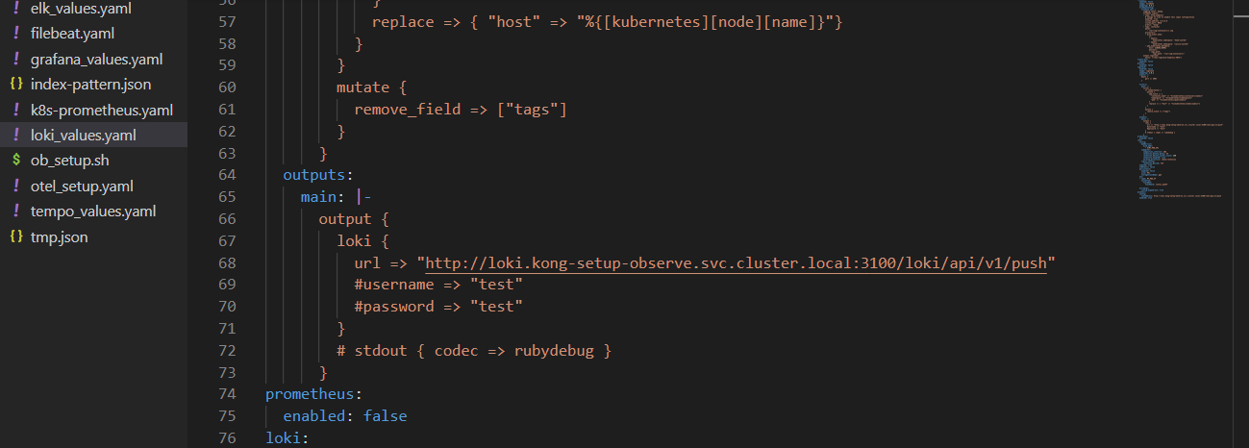
* Then also you need to change one more in the code
* 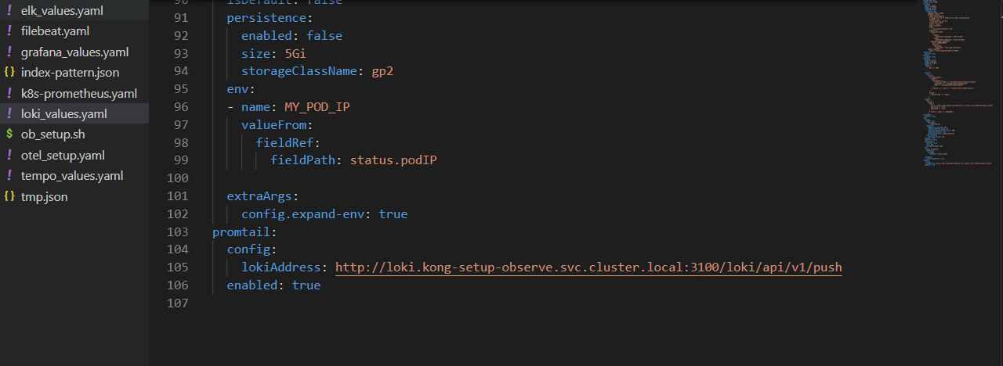
* These changes u need to do
* Then in kong setup in cp and dp you need to keep the log level as notice
* 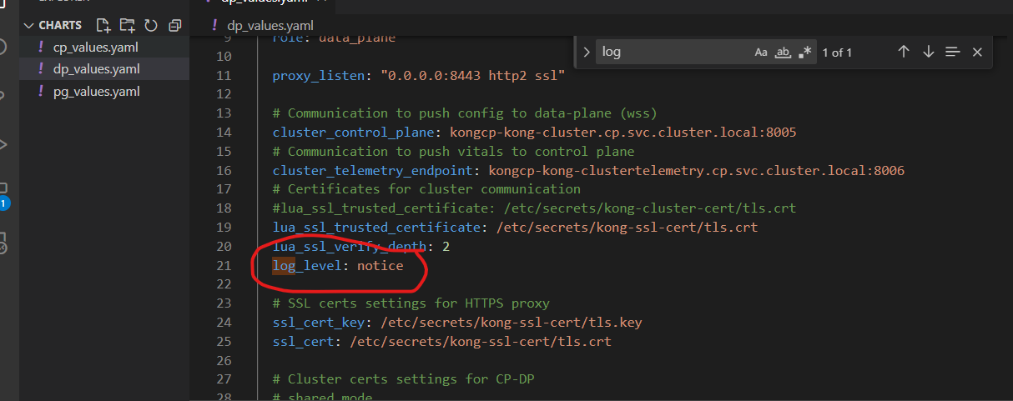
* In cp also you need to do same.
* Then you can do upgrade
* Next step is to install a plugin for a service that is file log plugin
* 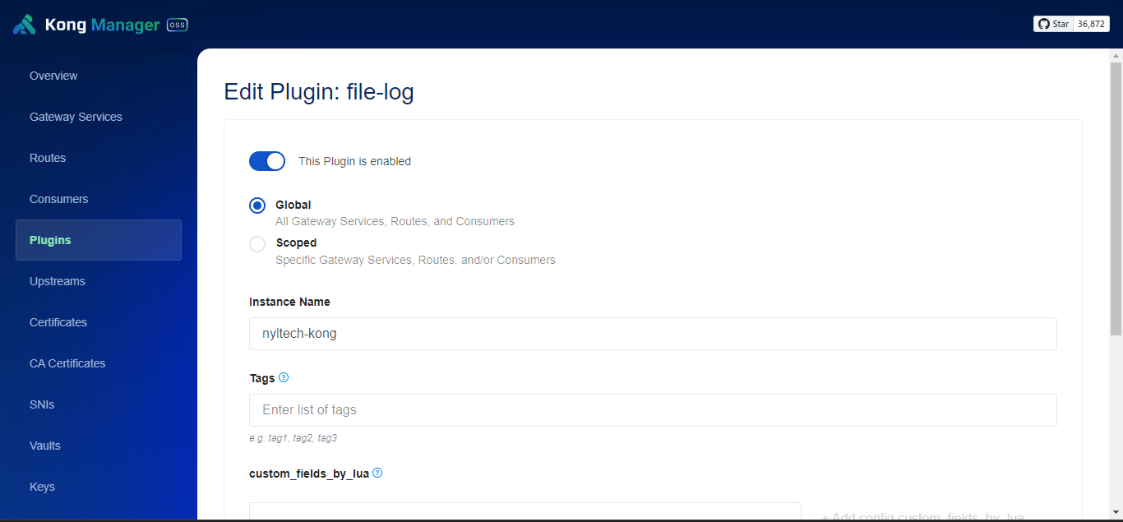
* 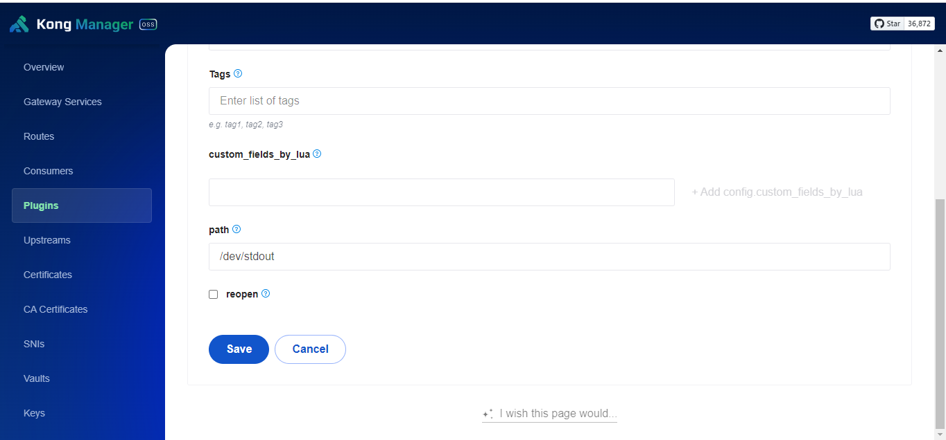
* Now u can send requests from postman but you need to small setup in grafana as well
* Also you need tp include this loki ka url in the grafana setup
* 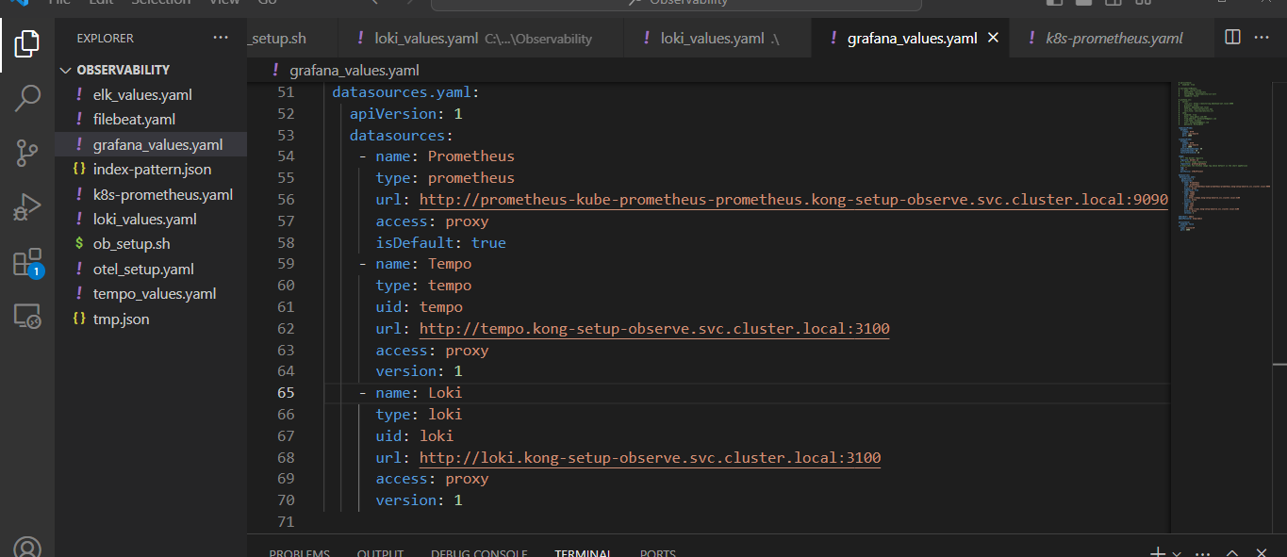
* Then you can see in the grafana
* 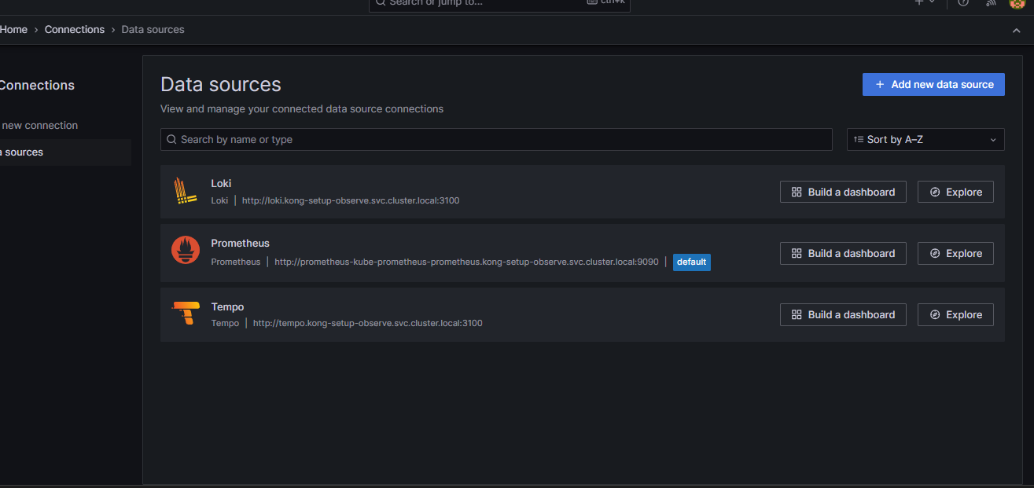
* In data sources just add loki no need to do any changes in the loki configuration which is visible in the grafana
* Then go for explore and select loki
* 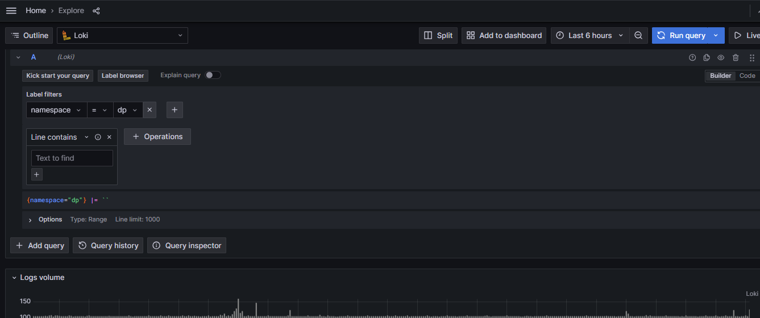
* Then in label select for namespace and then in values u can select dp and then you need to click on run query option.
* But before this you need to run some apis in postman.