Kong-installation in redhat OS(in aws)
- First install https://mobaxterm.mobatek.net/download.html click this one and then go for free edition and then go for portable edition.
- You will get zip file extract that one and then click on session then you need to add the public ip and later you need to add .pem file into your session screen.
- 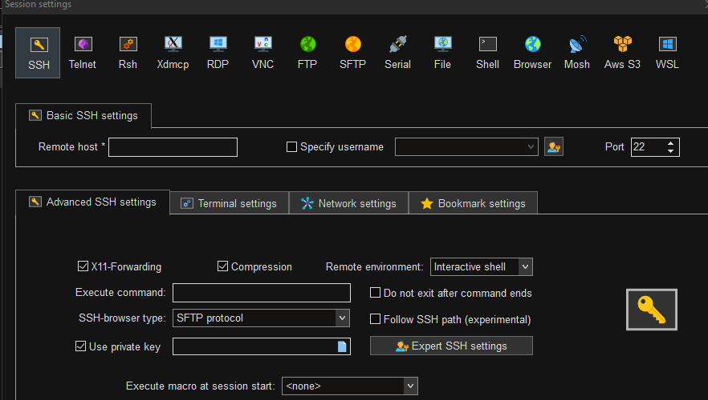
- In the private key you need to give ur .pem file and later u need give username as
- 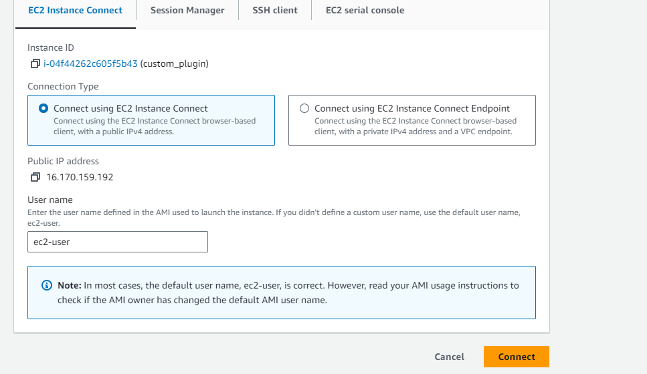
- U will find the username here add to the CLI.
- Now start installing kong.

- Before installation run this two commands
- Sudo yum upgrade
- Sudo yum update
- Sudo yum install wget
- To install kong https://docs.konghq.com/gateway/latest/install/linux/rhel/ this docx can be used.
- Then alfter that u need to run two commands which is given in docx curl -Lo kong-enterprise-edition-3.4.1.1.rpm $(rpm --eval https://packages.konghq.com/public/gateway-34/rpm/el/%{rhel}/x86_64/kong-enterprise-edition-3.4.1.1.el%{rhel}.x86_64.rpm) and also this command sudo yum install -y kong-enterprise-edition-3.4.1.1.rpm
- Next install postgress database using the commands from website PostgreSQL: Linux downloads (Red Hat family) you can choose
- 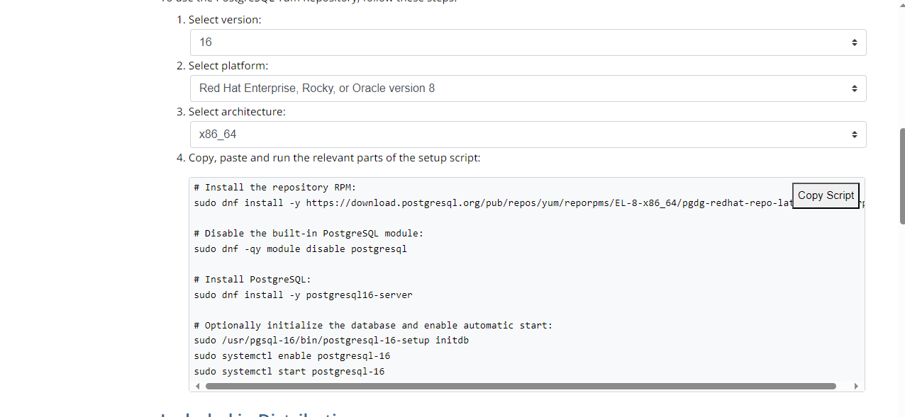
- Select this things and copy one by one command and postgress will be installed
- Then to go inside postgress use this command as sudo -i -u postgres

- Then to become root user type a command as psql
- Then rum the commands given below
- CREATE USER kong;
- CREATE DATABASE kong OWNER kong;;
- ALTER USER kong WITH password 'password';
- Then to come out from root user type “\q”.
- Then to come out from postgress type “exit”
- Then fron outside if you want to become super user type the command as sudo su -
- Then u need to run this command as cp kong.conf.default kong.conf when you run this command, it will effectively duplicate the kong.conf.default file and create a new file named kong.conf with the same content. You can then edit the kong.conf file to configure settings for a specific application or service, while preserving the original configuration in the kong.conf.default file as a reference or backup.
- After that do vi kong.conf
- 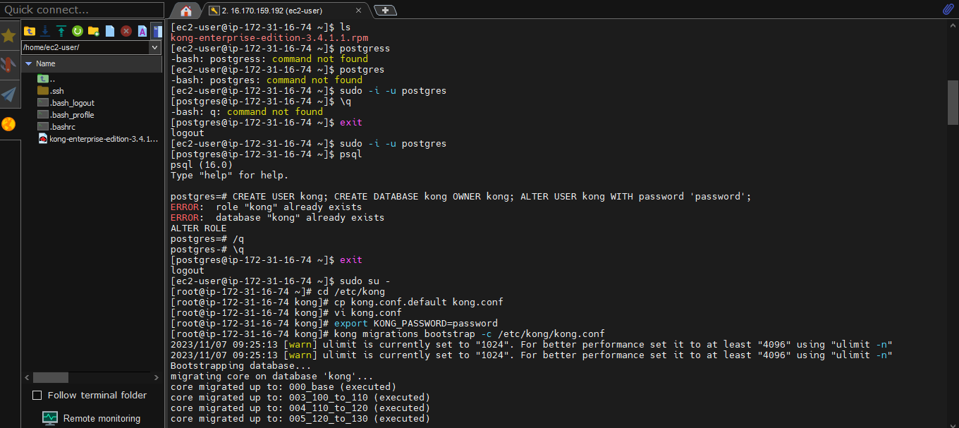
- Then in vi editor search for postgress using command “/postgress” and remove the “#” from some important details of postgress and then add the password as password. Please do as shown below
- 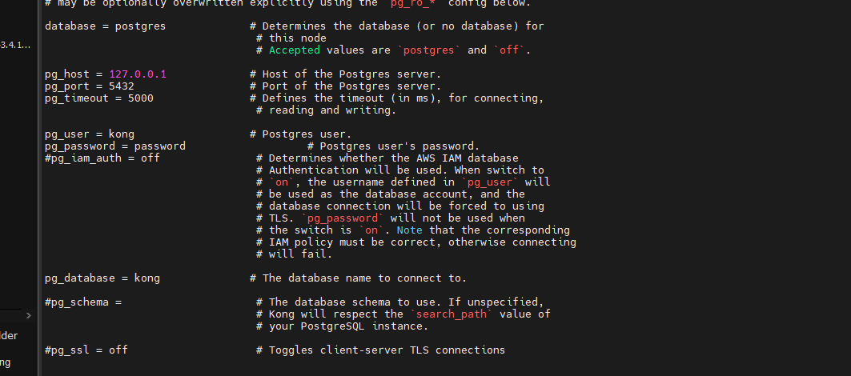

- Then do use “i” to insert and then press “esc” to search “/8001” remove “#” from admin listen and then make 127.0.0.1:8001 to 0.0.0.0.:8001 and then make 127.0.0.1:8444 to 0.0.0.0:8444 then press :wq! And come out.
- Then run some commands given below
- Just check ur a root user if not run the below command.
- Don’t forget that u should be root user as sudo su -. and u should not be in any direcotry. You should be under home.
- 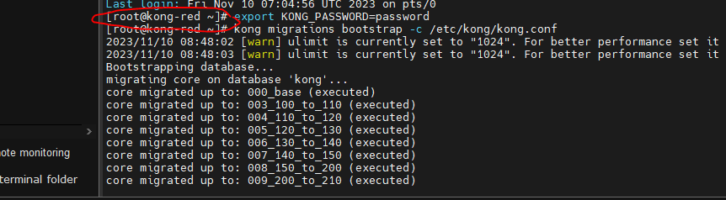
- Then follow below commands.
- export KONG_PASSWORD=password
- kong migrations bootstrap -c /etc/kong/kong.conf
- kong start -c /etc/kong/kong.conf
- curl -i -X GET --url http://localhost:8001/status
- curl -i -X GET --url http://localhost:8002
- Then u can check in browser.
- In aws you need to give port access as shown below
- Click on launch-wizard and
- 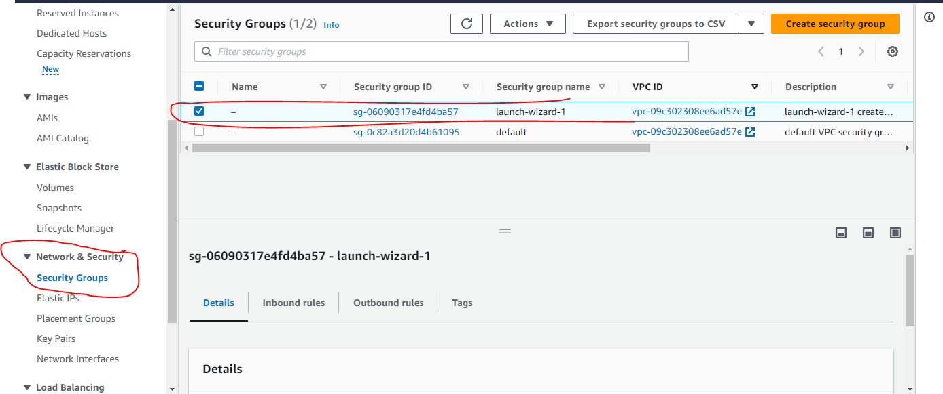
- Then click on inbound rules
- 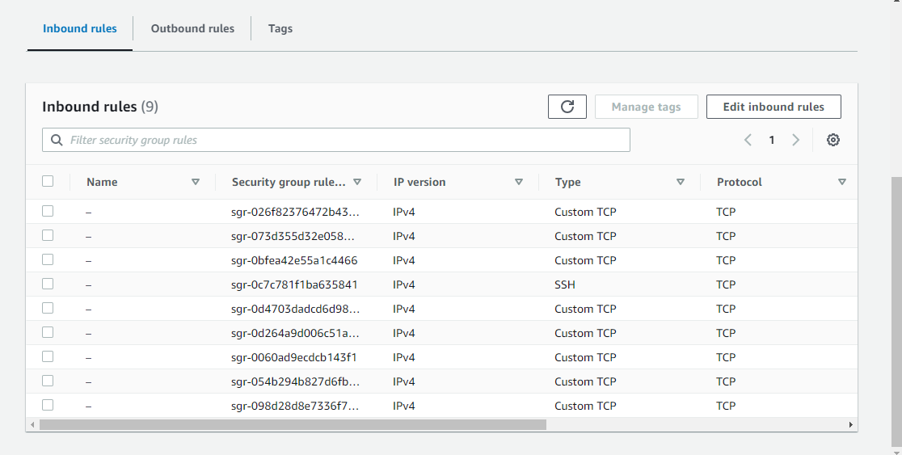
- Then edit inbound rules and then add the required ports for you as shown below
- 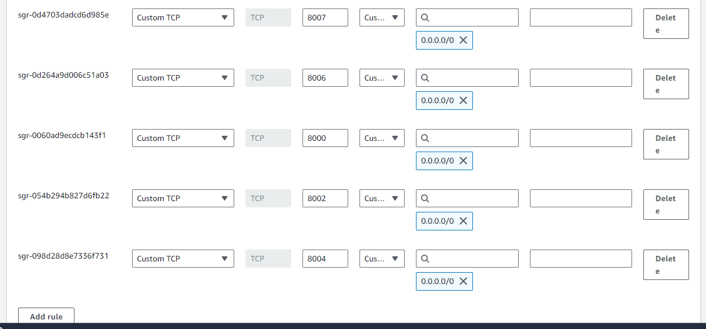
- Here add the required ports for you and select ipv4 for all the ports.
- These are the important steps for installation of kong in redhat

