Ensemble methods : Are machine learning technique that combines several base models in order to produce one optimal predictive model.

Types of Ensemble Methods
- BAGGing, or Bootstrap AGGregating. BAGGing gets its name because it combines Bootstrapping and Aggregation to form one ensemble model. Given a sample of data, multiple bootstrapped subsamples are pulled. A Decision Tree is formed on each of the bootstrapped subsamples. After each subsample Decision Tree has been formed, an algorithm is used to aggregate over the Decision Trees to form the most efficient predictor. The image below will help explain:

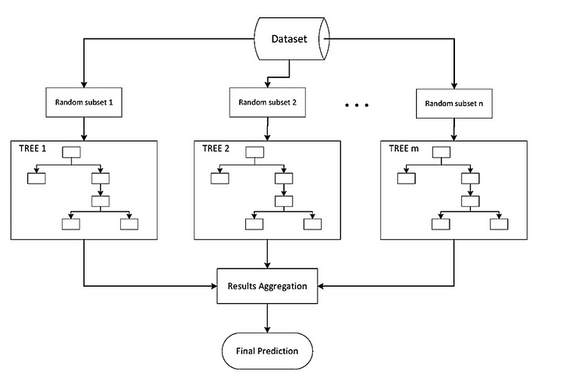

- Random Forest Models:
Random Forest Models can be thought of as BAGGing, with a slight tweak. When deciding where to split and how to make decisions, BAGGed Decision Trees have the full disposal of features to choose from. Therefore, although the bootstrapped samples may be slightly different, the data is largely going to break off at the same features throughout each model. In contrary, Random Forest models decide where to split based on a random selection of features.
Rather than splitting at similar features at each node throughout, Random Forest models implement a level of differentiation because each tree will split based on different features. This level of differentiation provides a greater ensemble to aggregate over, ergo producing a more accurate predictor. Refer to the image for a better understanding.

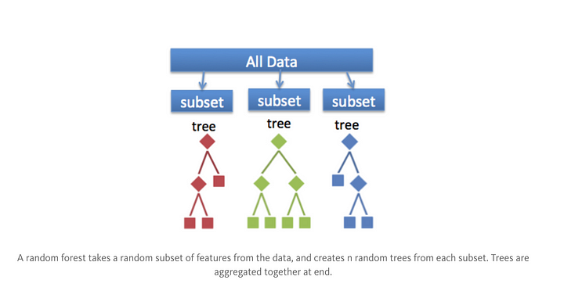
Similar to BAGGing, bootstrapped subsamples are pulled from a larger dataset. A decision tree is formed on each subsample. HOWEVER, the decision tree is split on different features (in this diagram the features are represented by shapes).

In Summary
The goal of any machine learning problem is to find a single model that will best predict our wanted outcome. Rather than making one model and hoping this model is the best/most accurate predictor we can make, ensemble methods take a myriad of models into account, and average those models to produce one final model. It is important to note that Decision Trees are not the only form of ensemble methods, just the most popular and relevant in DataScience today.

Scikit-learn – free software tool, designed to interoperate with the Python numerical and scientific libraries NumPy and SciPy.

Classification – identifying which category an object belongs to
Regression – predicting a continuous-valued attribute associated with an object
Clustering – automatic grouping of similar objects into sets.
Dimensionality reduction – reducing the number of random variables to consider
Model selection -comparing, validating and choosing parameters and models
Preprocessing – feature extraction and normalization

Features provided by scikit learn

Visualizing a Decision Tree in python
The `plot_tree ( )` function in scikit-learn is used to visualize decision trees, which are commonly used in machine learning for classification and regression tasks. This function helps you create a visual representation of a decision tree model. Here's an explanation of its input arguments and return value:

Input Arguments:
1. `decision_tree`: This is the decision tree model you want to visualize. It should be a trained decision tree classifier or regressor.

2. `max_depth`: An optional integer that specifies the maximum depth of the tree to be plotted. If not specified, the entire tree is plotted. This is useful for controlling the depth of the visualization when dealing with deep trees.

3. `feature_names`: An optional list of strings representing the feature names. If provided, it labels the nodes of the tree with the corresponding feature names. If not provided, default feature names (e.g., "X[0]", "X[1]") are used.

4. `class_names`: An optional list of strings representing class names for classification tasks. If provided, it labels the class labels at the leaf nodes of the tree. If not provided, default class labels are used (e.g., "class 0", "class 1").

5. `filled`: A boolean flag indicating whether to fill the boxes representing decision tree nodes with colors to indicate class distributions. Default is `True`.

6. `rounded`: A boolean flag indicating whether to round the box corners for better visualization. Default is `False`.

7. `special_characters`: A boolean flag indicating whether to use special characters for box drawing. Default is `False`.

Return Value:
The `plot_tree` function does not return a value; instead, it generates a visual representation of the decision tree and displays it using Matplotlib. To actually see the tree plot, you typically call `plt.show()` after invoking `plot_tree`.

Example Usage:
from sklearn.datasets import load_iris # inbuilt dataset
from sklearn.tree import DecisionTreeClassifier
from sklearn.tree import plot_tree
import matplotlib.pyplot as plt

# Load the Iris dataset and create a decision tree classifier
iris = load_iris()
X, y = iris.data, iris.target
clf = DecisionTreeClassifier()
clf = clf.fit(X, y)

# Visualize the decision tree
plt.figure(figsize=(12, 6))
plot_tree(clf, feature_names=iris.feature_names, class_names=iris.target_names, filled=True)
plt.show()

In this example, we load the Iris dataset, train a decision tree classifier (`clf`), and then visualize the tree using `plot_tree`. The resulting tree plot will help you understand the decision-making process of the trained model.

Confusion Matrix
A confusion matrix is a table that is used to describe the performance of classification models. The confusion matrix is analyzed with the help of the following 4 terms:

True Positive(TF)
It means the model predicted positive and it is actually positive.

True Negative(TN)
It means the model predicted negative and it is actually negative.

False Positive(FP)
It means the model predicted positive but it is actually negative.

False Negative(FN)
It means the model predicted negative but it is actually positive.

Example:
In a model, 1 represents a patient with heart disease and 0 represents he does not have heart disease. In the dataset there are 600 patients with heart disease and 400 without heart disease, the model predicted 550 patients with 1 and 450 patients 0 out of which 500 patients are correctly classified as 1 and 350 patients are correctly classified as 0, then the true positive is 500, the true negative is 350, the false positive is 50, the false negative is 150.

# implementation in python

from sklearn.metrics import confusion_matrix
confusion_matrix = confusion_matrix(y_test, y_pred)
print(confusion_matrix)
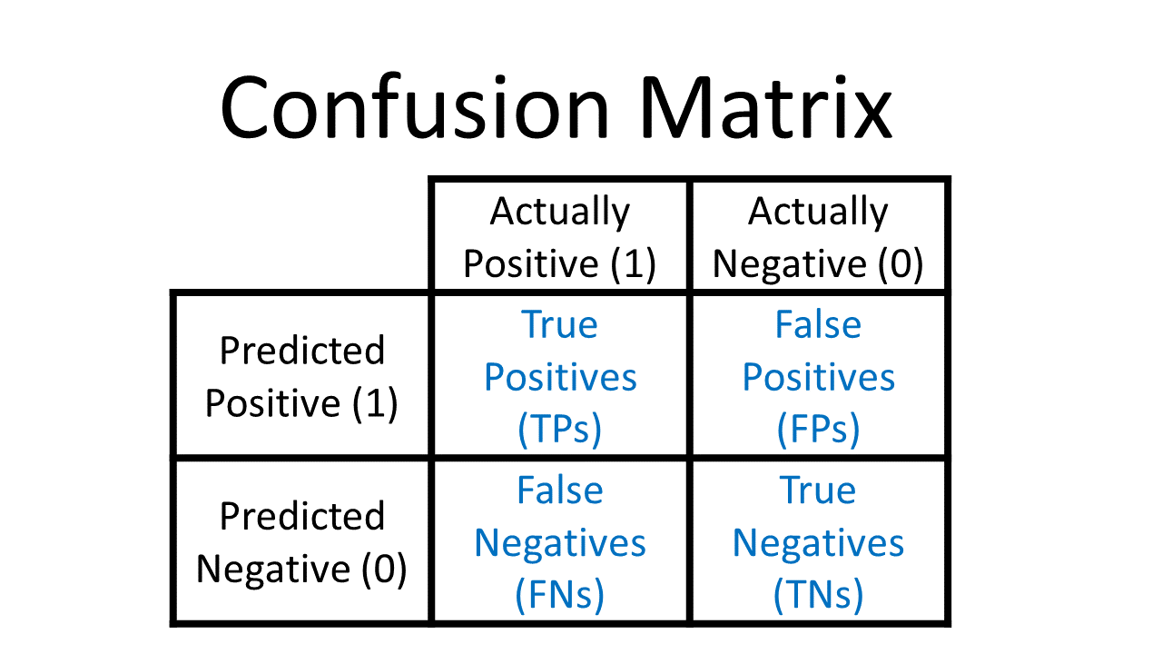

Classification Report
A classification report is used to analyze the predictions of the classification algorithm. It provides the various parameters i.e. accuracy, precision, recall, f1-score through which we can decide whether our model is performing well or not. A classification report is made based on a confusion matrix.

Accuracy
Total predictions (positive or negative) which are correct.
It can be calculated as (TF+TN)/(TF+TN+FP+FN) * 100

Precision
Out of positive predictions, how many you got correct.
It can be calculated as TP/(TP+FP)

Recall
Out of total positives, how much you correctly identified.
It can be calculated as TP/(TP+FN)

F1 Score
It is used to check the balance between precision and recall.
It can be calculated as 2/(Precision + Recall)

It can be implemented in python as:

from sklearn.metrics import classification_report
print(classification_report(y_test, y_pred))

K-Means Clustering
K-Means clustering is an unsupervised ML algorithm used for solving classification problems. An unsupervised algorithm is one in which there is no label or output variable in the dataset. In clustering, the dataset is segregated into various groups, called clusters, based on common characteristics and features. In the k-means algorithm, the dataset is divided into subgroups/clusters based on similarity and their mean distance from the centroid of that particular group. It is the most successful and widely used unsupervised algorithm. There are many applications of k-means clustering such as market segmentation, document clustering, image segmentation.

It can be implemented in python as:

from sklearn.cluster import KMeans
import statsmodels.api as sm
kmeans = KMeans(3)
kmeans.fit(x)
identified_clusters = kmeans.fit_predict(x)

DBSCAN Clustering
DBSCAN is also an unsupervised clustering algorithm that makes clusters based on similarities among data points. In DBSCAN, a cluster is formed only when there is a minimum number of points in the cluster of a specified radius. The minimum number of points and radius of the cluster are the two parameters of DBSCAN which are given by the user. The advantage of DBSCAN is that it is robust to outliers i.e. it can handle outliers on its own, unlike k-means clustering. DBSCAN algorithm is used in creating heatmaps, geospatial analysis, anomaly detection in temperature data.
It can be implemented as
from sklearn.cluster import DBSCAN
from sklearn import metrics
from sklearn.preprocessing import StandardScaler
db = DBSCAN(eps=0.3, min_samples=10).fit(X)
core_samples_mask = np.zeros_like(db.labels_, dtype=bool)
core_samples_mask[db.core_sample_indices_] = True
labels = db.labels_
n_clusters_ = len(set(labels)) - (1 if -1 in labels else 0)
print(labels)

