1. Describe briefly the terms class, objects with respect to java implementation

In Java, "class" and "object" are fundamental concepts related to object-oriented programming:

- Class:
  - A class is a blueprint or template for creating objects in Java.
  - It defines the properties (attributes) and behaviors (methods) that objects of the class will have.
  - Classes are used to encapsulate data and functionality, making it easier to manage and organize code.
- Object:
  - An object is an instance of a class. It is a concrete realization of the class blueprint.
  - Objects have their own unique data and can invoke the methods defined in their class.
  - Objects are used to represent real-world entities and interact with one another in a Java program.

In Java, you define a class by using the class keyword, specifying its attributes and methods.
You can then create objects of that class by using the new keyword, which allocates memory and initializes the object. Objects allow you to work with the data and behaviors defined in the class.

Here's a simple example:
java
// Define a class
class Car{
String name;
String model;

void Start(){
System.out.println(name + "This car is Running");
}
}

// Create objects
public class Main{
public static void main(String[] args){
Car Car1 = new Car();
Car Car2 = new Car();

Car1.name="Honda";
Car1.model="Civic";
Car2.name = "Toyata";
Car2.model = "Comry";

Car1.Start();
Car2.Start();
}
}
2. Design a class for object pen with attributes and methods with the following with minimum three attributes and methods to display the same

public class Pen {
// Attributes
private String brand;
private String color;
private double price;

// Constructor
public Pen(String brand, String color, double price) {
this.brand = brand;
this.color = color;
this.price = price;
}

// Method to display pen information
public void displayInfo() {
System.out.println("Pen Information:");
System.out.println("Brand: " + brand);
System.out.println("Color: " + color);
System.out.println("Price: $" + price);
}

// Method to write with the pen
public void write(String text) {
System.out.println("Writing with the " + brand + " pen: " + text);
}

// Method to refill the pen
public void refillInk() {
System.out.println("Refilling ink in the " + brand + " pen.");
}

public static void main(String[] args) {
// Create a Pen object and display its information
Pen myPen = new Pen("Pilot", "Blue", 2.99);
myPen.displayInfo();

// Use the pen to write and refill it
myPen.write("Hello, World!");
myPen.refillInk();
}
}

3. List the properties of a constructor

Properties of Constructors

A constructors in Java is a special method that is used to initialize objects. The constructor is called when an object of a class is created. It can be used to set initial values for object attributes.

1. Constructor Should not have any return type

2. The access specifier of the constructor can be private, default, protected, public
3. A constructor cannot be declared as final and synchronized
class GFG {
final GFG() {}
public static void main(String[] args)
{
System.out.println("GFG!");
}
}
4. A constructor can invoke another constructor of the same class
Type of Constructor
1. Default Constructor
2. Parameterized Constructor
3. Copy Constructor

4. Illustrate the concept of Encapsulation in Java for a class Person with name, age as attributes and set, get as methods to set the values and get the values

Encapsulation in Java is the process by which data (variables) and the code that acts upon them (methods) are integrated as a single unit. By encapsulating a class's variables, other classes cannot access them, and only the methods of the class can access them.

//Create Class Person
public class Person {
// Private attributes
private String name;
private int age;

// Getter method for name
public String getName() {
return name;
}

// Setter method for name
public void setName(String name) {
this.name = name;
}

// Getter method for age
public int getAge() {
return age;
}

// Setter method for age
public void setAge(int age) {
if (age >= 0) {
this.age = age;
} else {
System.out.println("Age cannot be negative.");
}
}

public static void main(String[] args) {
// Create a Person object
Person person = new Person();

// Set values using the setter methods
person.setName("Alice");
person.setAge(30);

// Get and display the values using getter methods
System.out.println("Name: " + person.getName());
System.out.println("Age: " + person.getAge());

// Try setting an invalid age
person.setAge(-5); // This will print "Age cannot be negative."
}
}

Diffrences between Interfaces and Abstaract Class
Sl.no | Interface | Abstract Class
1 | If we don’t know anything about implementation just we have required specification then we should go for interface. | If we are talking abouth implementation but not completely(Partial implementation) then we should fo for Abstract class
2 | Inside interface every method is always public and abstact whether we are declaring or not. Hence are also considred as 100% pure albstract class. | Every method present in Abstract class need not be public and Abstract. In Addition to abstract methods we can take concrete methods also.
3 | We can’t declare interface method with the following modifiers.  Public --> Private, Protected  Abstract ---> final, Synchornized, native strictpf | There are no restrictions on Abstract class method modifiers.
4 | Every variable present inside interface is always public, static and final whether we are declaring or not. | The variable present inside Abstract class need not be public static and final
5 | We can’t declare the variable with the following modifiers.  Private, protected, transient, volatile. | There are no resitriction on Abstract class variable modifiers.
6 | Interface Test{  int x;  }  Gives an Error  For Interface variable complsory we should perform initialization at the time of declaration otherwise we will get compile time error. | For Abstract class variable it is not require to perform initialization at the time of declaration.
7 | Inside interface we can’t declare instance and static blocks. Otherwise we will get compile time error. | Inside Abstract class we can declare instance and static.
8 | Constructor class not applicable and not require. | Inside Abstract class we can declare constructor, which will be executed at the time of Child Object Creation.

Valatile modifiers

Summerize the Solid Principles In Java/ principles of OOD
The SOLID principles are a set of five design principles in object-oriented programming, aimed at making software more maintainable, flexible, and easier to understand. Let's explain each principle in a simple way using Java:
- Single Responsibility Principle (SRP): A class should have only one reason to change. It means that a class should have a single responsibility or job. If you need to make changes to a class for more than one reason, it's a sign that you should split it into multiple smaller classes.
- Open-Closed Principle (OCP): The Open-Closed Principle (OCP) is one of the SOLID principles of object-oriented design. It states that software entities (classes, modules, functions, etc.) should be open for extension but closed for modification. In other words, you should be able to extend the behavior of a module without changing its source code. This principle promotes the idea that you can add new functionality by creating new code rather than changing existing code.
Here's an example to illustrate the Open-Closed Principle:
Suppose you are building a system for processing different types of shapes, and you have a Shape class with various subclasses for different shapes like Circle and Rectangle. Initially, you may have code like this:
java

class Shape {
// Common properties and methods for all shapes
}

class Circle extends Shape {
// Properties and methods specific to circles
}

class Rectangle extends Shape {
// Properties and methods specific to rectangles
}
Now, let's say you want to add a new shape, a Triangle. To follow the Open-Closed Principle, you should be able to do this without modifying the existing code. You can achieve this by creating a new class that extends Shape:
class Triangle extends Shape {
// Properties and methods specific to triangles
}

In this way, you extended the system to support a new shape without altering the existing Shape, Circle, or Rectangle classes. The existing code remains closed for modification, while it's open for extension by creating new subclasses.

- Liskov Substitution Principle (LSP): Subtypes must be substitutable for their base types. In other words, if you have a class hierarchy or inheritance, you should be able to use derived (sub) classes wherever you use their base (super) class without causing problems or unexpected behavior.
class Bird {
public void fly() {
// Default flying behavior for birds
System.out.println("This bird can fly.");
}
}

class Ostrich extends Bird {
@Override
public void fly() {
// Ostriches cannot fly
System.out.println("Ostriches cannot fly.");
}
}

public class Main {
public static void makeBirdFly(Bird bird) {
bird.fly();
}

public static void main(String[] args) {
Bird eagle = new Bird();
Ostrich ostrich = new Ostrich();

makeBirdFly(eagle); // This works because eagles can fly.
makeBirdFly(ostrich); // This is appropriate for an ostrich, which cannot fly.
}
}

- Interface Segregation Principle (ISP): Clients should not be forced to depend on interfaces they do not use. Instead of creating large, monolithic interfaces, it's better to have smaller, specific interfaces, which are easier for clients to implement. This avoids implementing methods you don't need.

Suppose you're building a system for a document management application, and you have a Document interface, and two classes, TextDocument and PDFDocument, that implement this interface. The Document interface has methods for both reading and writing, which might not be suitable for all document types.

interface Readable {
void read();
}

interface Writable {
void write();
}

class TextDocument implements Readable, Writable {
@Override
public void read() {
// Read text document logic
}

@Override
public void write() {
// Write text document logic
}
}

class PDFDocument implements Readable {
@Override
public void read() {
// Read PDF document logic
}
}

- Dependency Inversion Principle (DIP): High-level modules should not depend on low-level modules. Both should depend on abstractions. Abstractions should not depend on details. Details should depend on abstractions. This principle promotes the use of interfaces or abstract classes to define relationships between classes, making the code more flexible and less tightly coupled.
In Java, you can use interfaces and inheritance to adhere to these principles effectively. By following these principles, you create more maintainable and adaptable code that can be extended and modified with minimal risk of introducing bugs or breaking existing functionality.

CIE 3

1. Disscuss with the Restfull webservices with the help of neat DIagrams
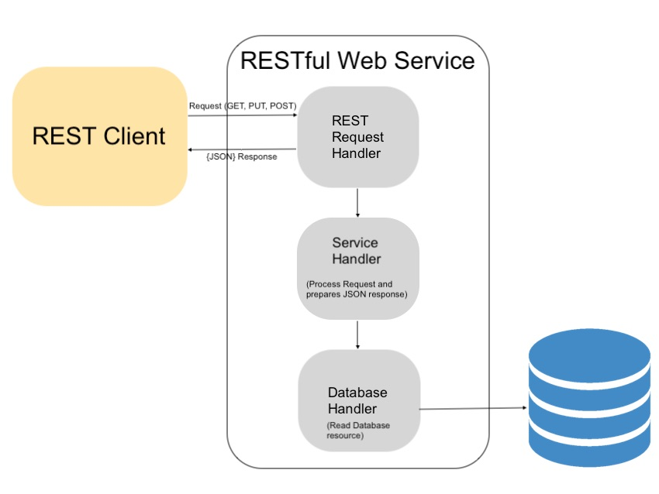
Representational State Transfer (REST) is an architectural style for designing web services. It is based on the idea of using standard HTTP methods (GET, POST, PUT, and DELETE) to represent and manipulate resources.

2. Illustrate the use of Encapsulation operations using Generic class in java with an example.

Advantages of encapsulating operations using generic classes:
- Modularity: Encapsulating operations using generic classes makes our code more modular. This is because we can hide the implementation details of our operations and expose only their public interface. This makes our code easier to understand and maintain.
- Reusability: Encapsulating operations using generic classes makes our code more reusable. This is because we can use the same code with different data types.
- Maintainability: Encapsulating operations using generic classes makes our code more maintainable. This is because we can change the implementation of our operations without affecting their public interface.
Here is an example of a generic class that encapsulates the operation of finding the maximum of two elements:
Java
public class GenericMaxFinder<T extends Comparable<T>> {
public T findMax(T a, T b) {
if (a.compareTo(b) > 0) {
return a;
} else {
return b;
}
}
Conclusion:
Encapsulating operations using generic classes is a powerful technique that can make our code more modular, reusable, and maintainable.

2. Disscuss any four guildlines of REST API – UUHVUCREADT
Guildlines of RestAPI
Creating a well-designed RESTful API requires careful planning and adherence to best practices. Here are some guidelines for designing a RESTful API:
- Use Nouns for Resource Names: Choose resource names that represent the entities in your system, and use nouns in the URL. For example, use /users, /products, or /orders instead of verbs like /getUsers or /createProduct.
- Use Plural Nouns for Collections: For resource collections, use plural nouns in the URL. For example, /users should represent a collection of user resources.
- HTTP Methods for CRUD Operations: Use HTTP methods to perform CRUD operations on resources:
  - GET for retrieving resources.
  - POST for creating resources.
  - PUT or PATCH for updating resources.
  - DELETE for removing resources.
- Versioning: Include versioning in the API to allow for future changes without breaking existing clients. You can do this by adding version numbers in the URL, such as /v1/users.
- Use Proper HTTP Status Codes: Return appropriate HTTP status codes with responses. For example:
  - 201 Created for successful POST requests.
  - 204 No Content for successful DELETE requests.
  - 400 Bad Request for client errors.
  - 404 Not Found for resource not found.
  - 500 Internal Server Error for server errors.
  - 200 OK for successful GET requests.
- Consistent URL Structure: Maintain a consistent URL structure throughout the API. Use subresources to represent hierarchical relationships. For example, /users/{userId}/orders/{orderId} to represent an order belonging to a specific user.
- Request and Response Format: Use a consistent format for request and response data, such as JSON or XML. Include clear and consistent field names in your data structures.
- Error Handling: Provide meaningful error responses with detailed error messages, status codes, and possibly error codes. Clients should be able to understand what went wrong.
- Authentication and Authorization: Implement proper authentication and authorization mechanisms to secure your API. Use tokens, API keys, OAuth, or other methods as needed.
- Rate Limiting: Implement rate limiting to prevent abuse of the API and protect server resources.
- Documentation: Create comprehensive API documentation, preferably using tools like Swagger or OpenAPI. Document endpoints, request and response formats, authentication methods, and usage examples.
- Testing: Thoroughly test your API using various scenarios and edge cases. Automated testing tools can be helpful.

3a. What is Collection fremework ? List the advantages of collection framework
The Java Collections Framework is a set of classes and interfaces provided by Java to handle and manipulate collections of objects. It offers a unified and standardized way to store, manage, and process groups of data efficiently and in a structured manner.
Advantages of the Java Collections Framework
- Consistency and Standardization: The framework defines a consistent set of interfaces and classes for different collection types, making it easier to work with collections. This standardization simplifies the learning curve for developers.
- Efficiency: The collections framework provides efficient implementations of data structures for various use cases. It's designed to be highly performant for common operations like adding, retrieving, and removing elements.
- Type Safety: Generics are used in the framework, providing type safety. This helps prevent type-related errors at compile time, ensuring that you work with the correct data types.
- Interoperability: Collections in the framework can work together seamlessly, making it easier to compose complex data structures. For example, you can use a List to store objects and a Map to associate keys with values.
- Scalability: The framework is designed to be scalable, which means it can handle a wide range of data sizes and adapt to varying requirements.

Example for Collection framework in Java
import java.util.ArrayList;
import java.util.List;
import java.util.Collections;

public class CollectionFrameworkExample {
public static void main(String[] args) {
// Create a list to store names
List<String> names = new ArrayList<>();

// Add names to the list
names.add("Alice");
names.add("Bob");
names.add("Charlie");
names.add("David");
names.add("Eve");

// Display the original list
System.out.println("Original List: " + names);

// Sort the list in alphabetical order
Collections.sort(names);
System.out.println("Sorted List: " + names);

// Check if a name exists in the list
String targetName = "Charlie";
if (names.contains(targetName)) {
System.out.println(targetName + " found in the list.");
} else {
System.out.println(targetName + " not found in the list.");
}

// Remove a name from the list
names.remove("Bob");
System.out.println("List after removing 'Bob': " + names);

// Get the size of the list
System.out.println("Number of names in the list: " + names.size());

// Iterate over the list and display each name
System.out.println("Names in the list:");
for (String name : names) {
System.out.println(name);
}
}
}

Diffrenciate between the Get and Post methods in HTTP in REST API
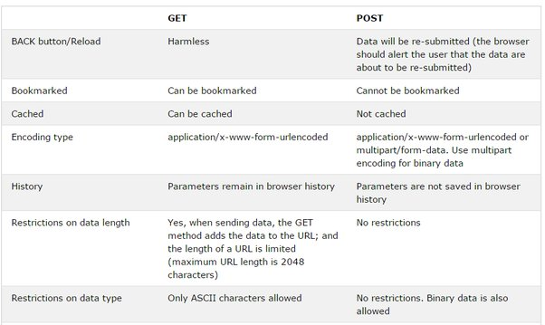
4. Write a program to demonistrate the hierarchy using Generic class by extending a non-generic class.
In simple terms, generics in Java allow you to write code that can work with different data types (like integers, strings, or custom objects) without sacrificing safety.

