**21100130 - Computational Biology Assignment 3**

**1. Biological Networks**

**Q1**.

1. Adjacency matrix for the undirected graph network:

*A B C D*

*A* 0 1 0 0

*B* 1 0 1 1

*C* 0 1 0 1

*D* 0 1 1 0

2. Adjacency matrix for the directed graph network:

*A B C D*

*A* 0 1 0 0

*B* 0 0 1 0

*C* 0 0 0 1

*D* 0 1 0 0

**Q2**.

(a)

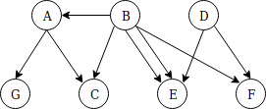

(b)

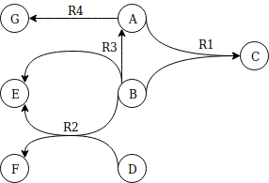

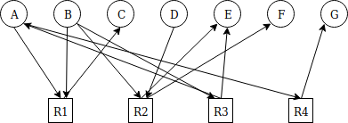(c)

**Q3.** Nodes A,B,C,D,E,F,H,J,I (all nodes except G) will be infected and will stay infected forever, while G will remain in the susceptible state. If it were an undirected network, node G would also be infected (from either node F or H), since the whole connected component of an undirected graph is infected as time t→∞ if it has an infectious node in it.

**Q4.**

(a) Boolean rules for the given network:

a = a

b = ¬c & d

c = a & b

d = ¬c

(b) Sucessive states for the network:

2^4 = 16 (number of rows)

|  |  |  |  |  |  |  |  |
| --- | --- | --- | --- | --- | --- | --- | --- |
| **t** | | | | **t+1** | | | |
| **a** | **b** | **c** | **d** | **a** | **b** | **c** | **d** |
| 0 | 0 | 0 | 0 | 0 | 0 | 0 | 1 |
| 0 | 0 | 0 | 1 | 0 | 1 | 0 | 1 |
| 0 | 0 | 1 | 0 | 0 | 0 | 0 | 0 |
| 0 | 0 | 1 | 1 | 0 | 0 | 0 | 0 |
| 0 | 1 | 0 | 0 | 0 | 0 | 0 | 1 |
| 0 | 1 | 0 | 1 | 0 | 1 | 0 | 1 |
| 0 | 1 | 1 | 0 | 0 | 0 | 0 | 0 |
| 0 | 1 | 1 | 1 | 0 | 0 | 0 | 0 |
| 1 | 0 | 0 | 0 | 1 | 0 | 0 | 1 |
| 1 | 0 | 0 | 1 | 1 | 1 | 0 | 1 |
| 1 | 0 | 1 | 0 | 1 | 0 | 0 | 0 |
| 1 | 0 | 1 | 1 | 1 | 0 | 0 | 0 |
| 1 | 1 | 0 | 0 | 1 | 0 | 1 | 1 |
| 1 | 1 | 0 | 1 | 1 | 1 | 1 | 1 |
| 1 | 1 | 1 | 0 | 1 | 0 | 1 | 0 |
| 1 | 1 | 1 | 1 | 1 | 0 | 1 | 0 |

(c) (i) System trajectory from the initial state of a = 0

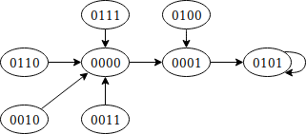

The system behaves in such a way that it always ends up the attractor state 0101 (basin of attraction) from any state in the trajectory, proceeding in that same direction. There are no point or cyclic attractors present.

(ii) System trajectory from the initial state of a = 1

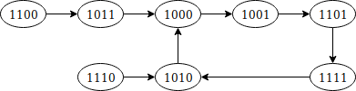

The system behaves in such a way that it directs the network to the big cycle attractor from 1000 to 1001 to 1101 to 1111 to 1010. There are no point attractors or basins of attraction present.

**2. Proteins**

**Q1.**

**(a)** Number of amino acids = 261, can be inferred from the PDB file which shows that the protein has 3 chains A, B, and C, each of length 87 so 87*3 = 261 or can be inferred from the PDB webpage which shows the Residue Count = 261 under Macromolecule Content.

**(b)** Method used to determine this structure = X-Ray Diffraction/Crystallography, inferred from the fields:

EXPDTA X-RAY DIFFRACTION

REMARK 200 EXPERIMENT TYPE : X-RAY DIFFRACTION

**(c)** Resolution = 1.55 Å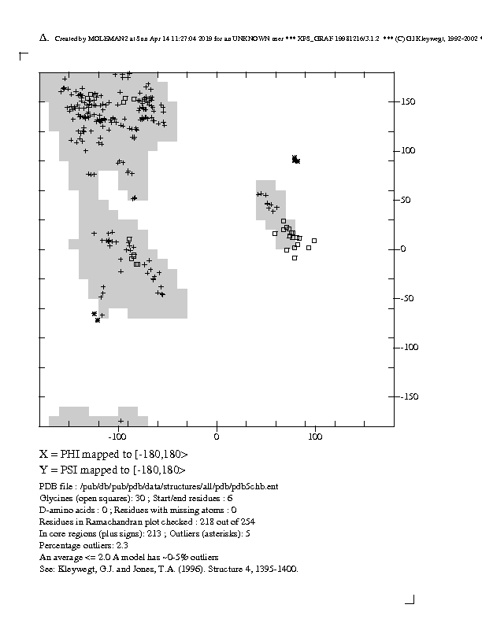, inferred from the field:

REMARK 2 RESOLUTION. 1.55 ANGSTROMS.

This is a good resolution (close to high resolutions of 1 Å which would have been better), so it is easy to see more detail in the diffraction pattern and almost every atom in the protein (individual atoms are distinguishable with 1 to 1.5 Å resolution), while a bad resolution would have been 3 Å or higher, showing only basic outlines of the protein chains and not the exact atomic structure, but that is not the case here.

**(d)** Ramachandran plot for this protein using <http://eds.bmc.uu.se/ramachan.html>

**(e)** This Ramachandran plot shows high density of plots in the alpha helix and beta sheet secondary structure zones mostly, since these shaded regions are the allowed ones. The region where the psi and phi angles are positive and negative respecitively (top-left quadrant) shows the presence of beta sheets, which the top-right quadrant (positive psi and phi) shows left handed alpha-helices and the bottom-left quadrant (negative psi and phi) shows the presence of right handed alpha-helices.

**Q2.** Note: Complete resolution images are also present in the assignment folder.

(a) α Domain

(i) 1bab Chain showing α Domain:

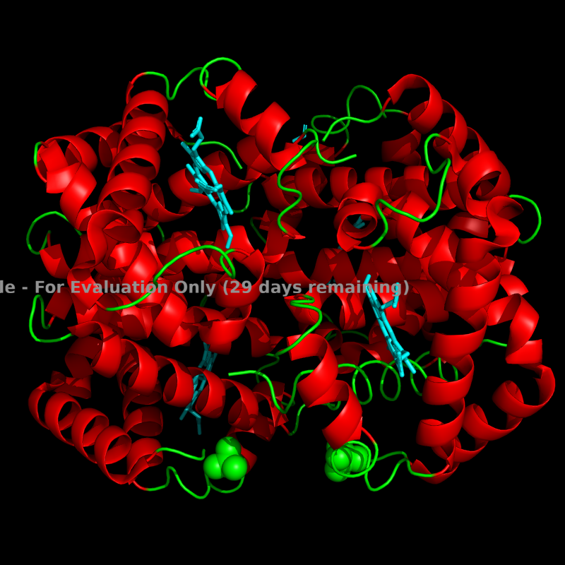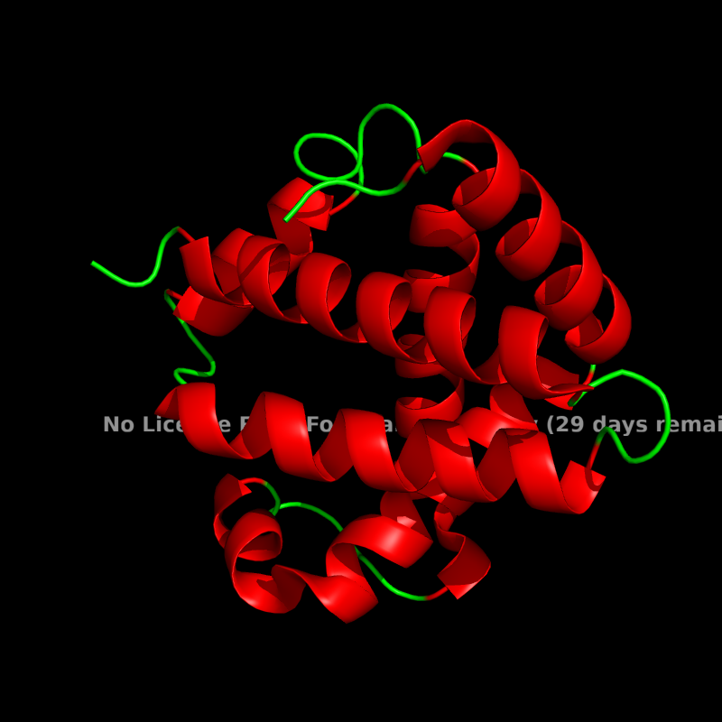

(ii) 1pv7 Chain showing α Domain:

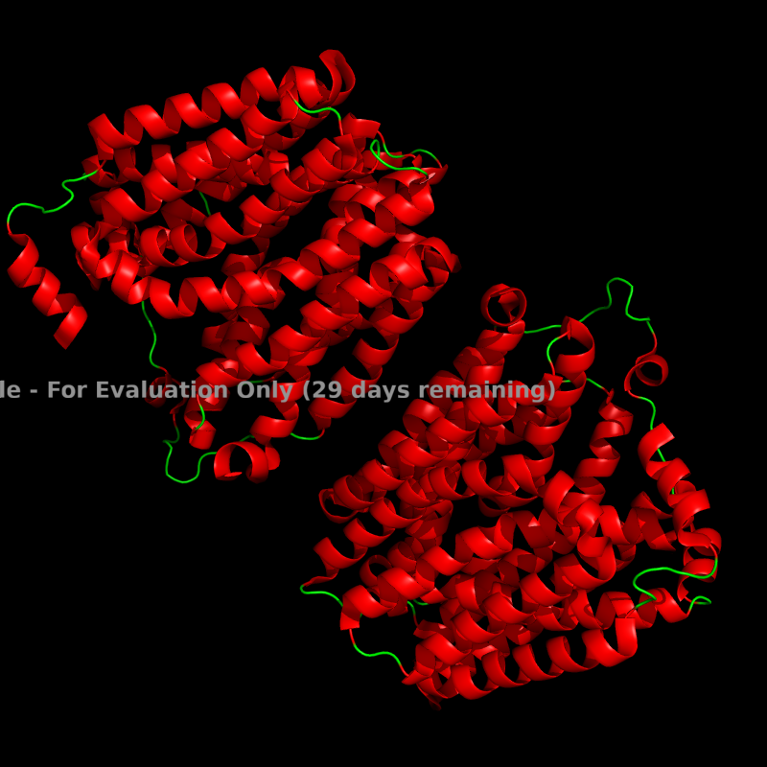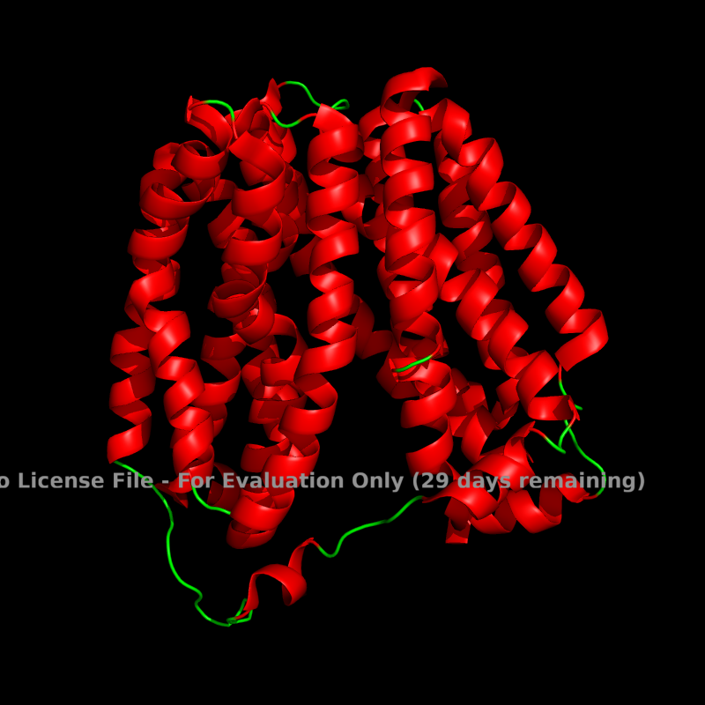

(b) β Domain

(i) 1shg

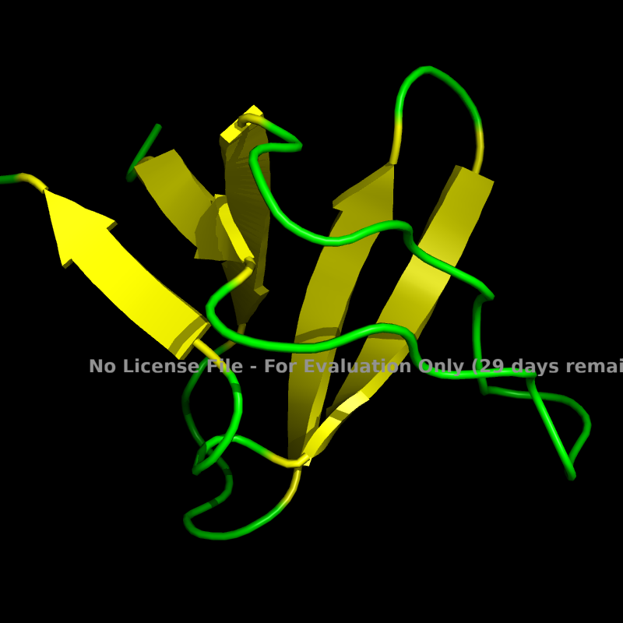

(ii) 8fab Chain showing β Domain:

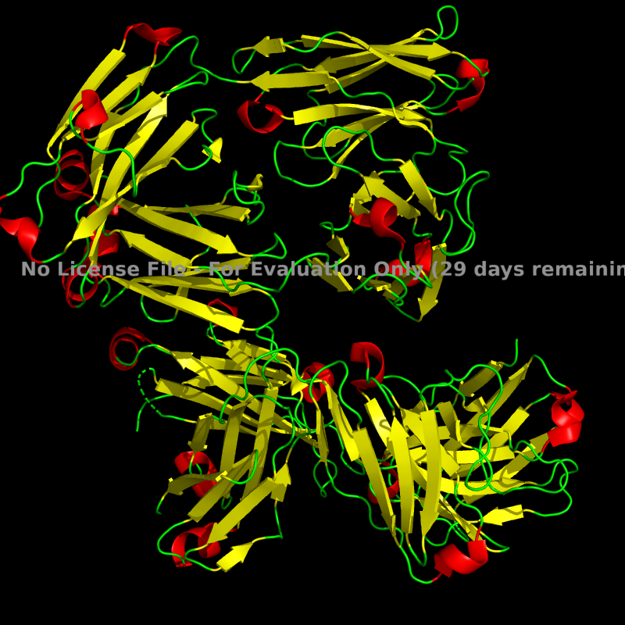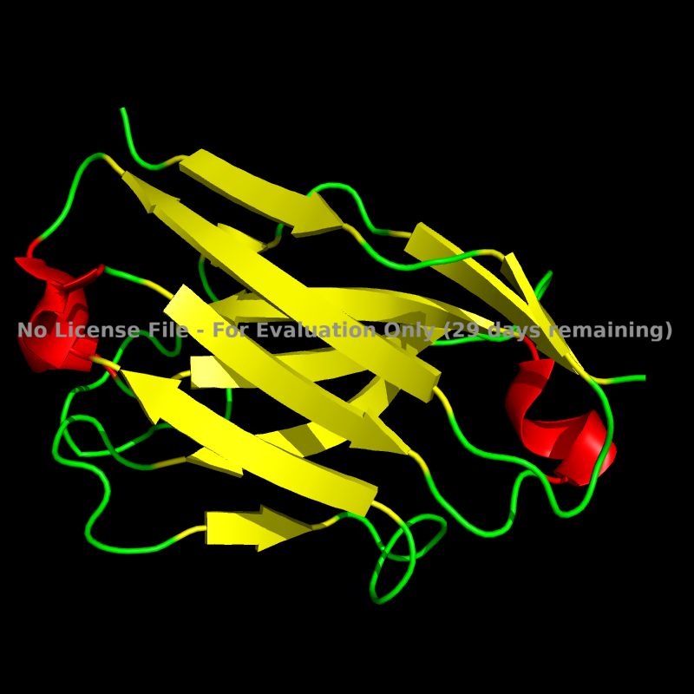

(c) α+β Domain

(i) 1jsf (ii) 1tgh

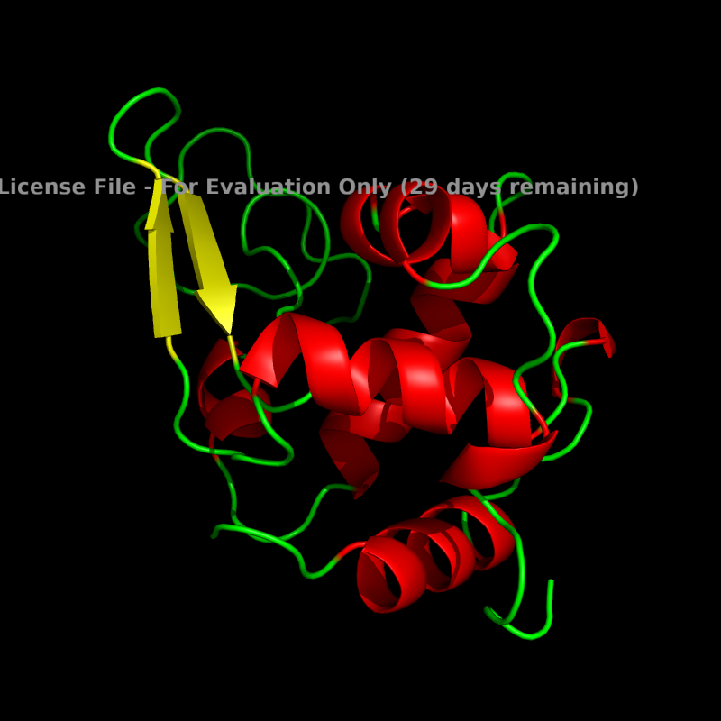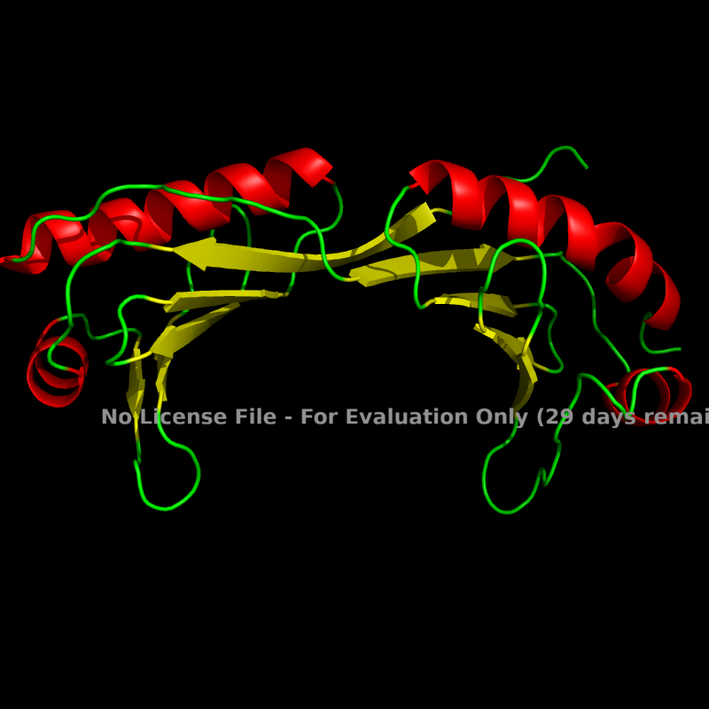

(d) Multi-domain

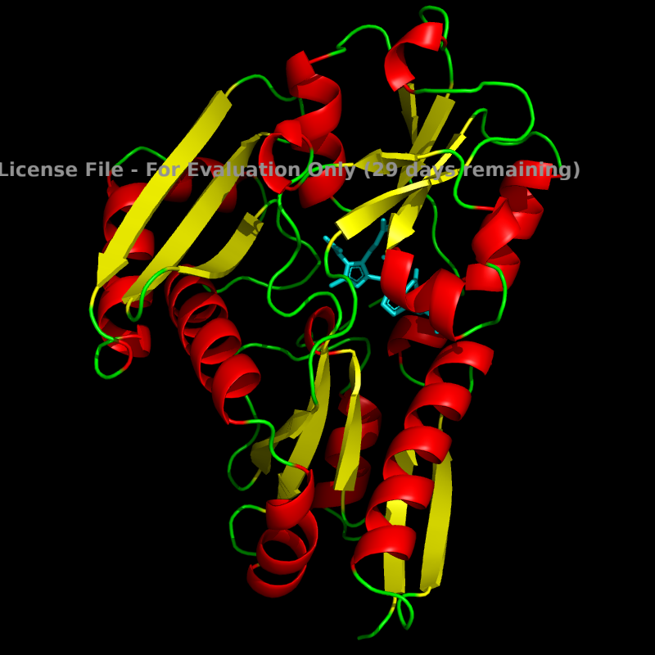(i) 1pkn (1 β domain & 2 α/β domains seen) (ii) 1pda (Multiple α/β domains seen)

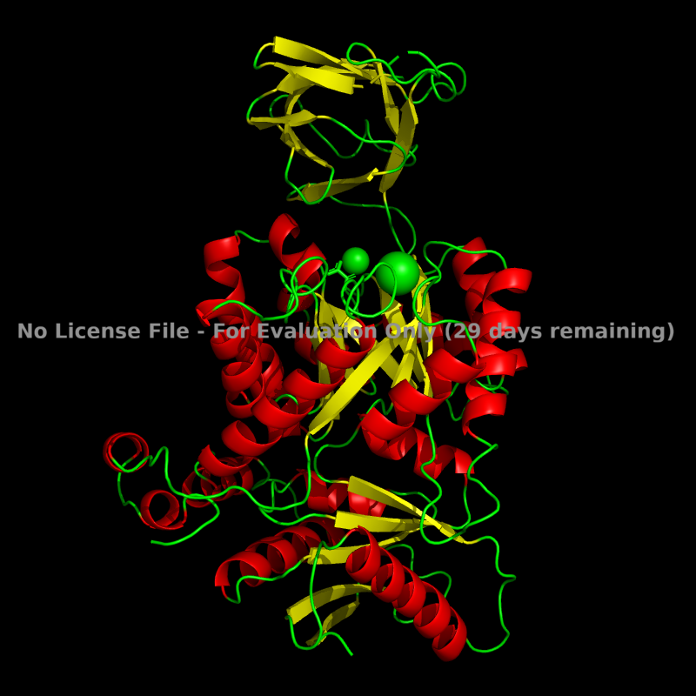

(e) Membrane protein

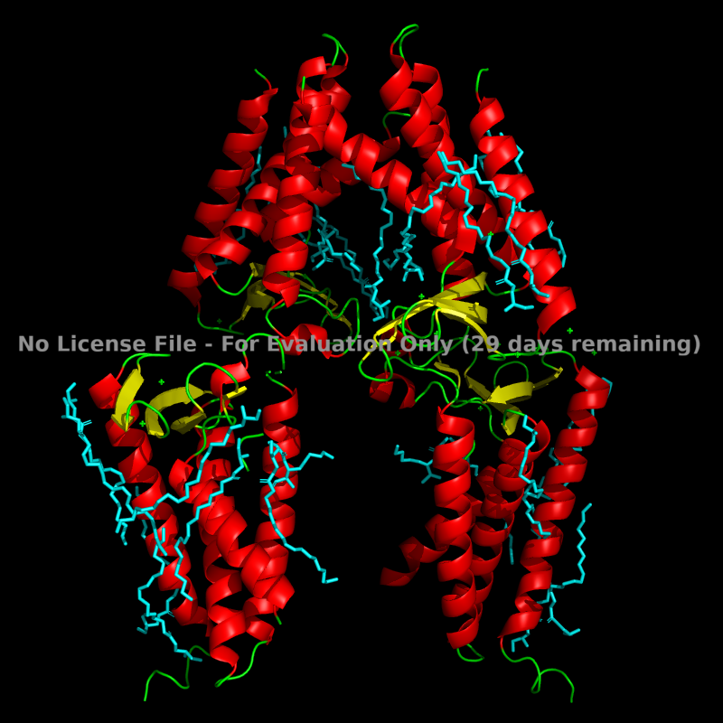(i) 1kzu (ii) 5dir

