Low-Code Experiment
Setting up a Zoho Creator Account and Exploring the Platform Architecture and Interface
SHRIVISHAL SV
241501202
AIML
Abstract
This experiment covers the first steps of working with Zoho Creator, a low-code application platform. It records the creation of a Zoho Creator account, the creation of a new application named HOTEL BOOKING with the environment option enabled, and an exploration of the platform interface and architecture. The experiment describes the main building blocks of the platform, namely forms, reports, pages, workflows, Deluge scripting, integrations and the Development, Stage and Production environments. The same application will be extended in the later experiments of this lab.
1. Aim
To set up a Zoho Creator account, create a new application, and explore the platform architecture and user interface.
2. Introduction
Zoho Creator is a cloud-based low-code platform that lets users build custom business applications through a visual interface. Forms, reports, dashboards and pages are assembled using drag-and-drop builders, and business logic is added through workflows and a scripting language called Deluge. Because hosting, database and deployment are provided by the platform, an application can be built and shared without managing servers.
In this lab, Zoho Creator is used to build a Hotel Room Booking application that collects room booking requests through an online form and presents them to the front office through reports. This experiment prepares the ground for that work by setting up the account and understanding how the platform is organized.
3. Requirements
• A computer with an internet connection and a modern web browser.
• A Zoho account (created using the college email address) with access to Zoho Creator. 4. Procedure
Step 1: Sign in to Zoho Creator. Open the Zoho Creator website, sign up or log in with the Zoho account, and open the Creator home screen. The home screen shows the left navigation menu and the profile panel. Clicking the profile icon at the top right opens the profile panel with the account name, My Account, Help, API Doc, Mobile Apps and Sign Out options (Figure 1).
1
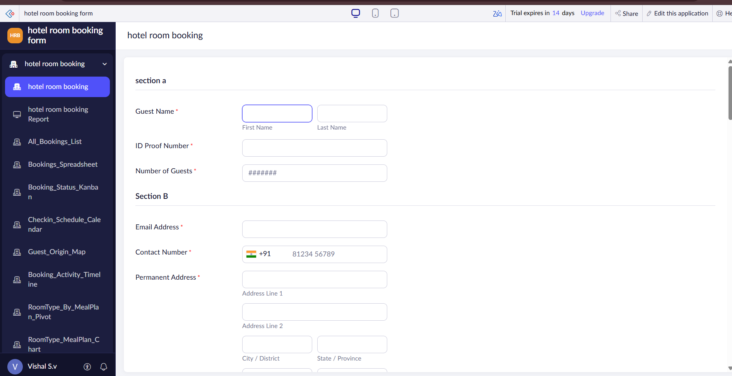

Figure 1: Zoho Creator home screen with the profile panel open
Step 2: Start creating an application. On the home screen, click Create Application and choose Create from scratch.
Step 3: Name the application and enable environments. Enter the application name as HOTEL BOOKING, keep the Enable Environment option ticked so that the application can be moved through Development, Stage and Production later, and click Create Application (Figure 2).
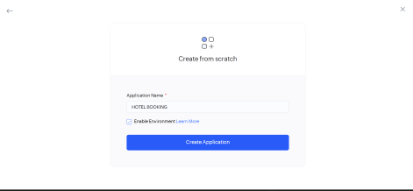

Figure 2: Create from scratch screen with the application name and Enable Environment option
Step 4: Explore the application builder. After creation, the application opens in the builder. The top bar contains the application name and the Design, Workflow and Settings tabs, and an Access Development Live button to run the application. The central area previews the application layout with device icons for desktop, tablet and mobile views, and prompts to start by creating a form through the Create New Form button. Layout thumbnails on the right side let the style of the application be chosen (Figure 3).
2
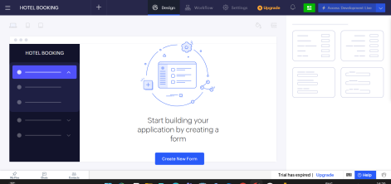

Figure 3: Application builder (Design view) of the HOTEL BOOKING application
Step 5: Check the application in the Applications list. Returning to the home screen, the Applications list shows the new application card, HOTEL BOOKING, created on Oct 15, 2026. The card carries a Dev badge showing that this is the development version, and an Environment drop-down (Figure 4).
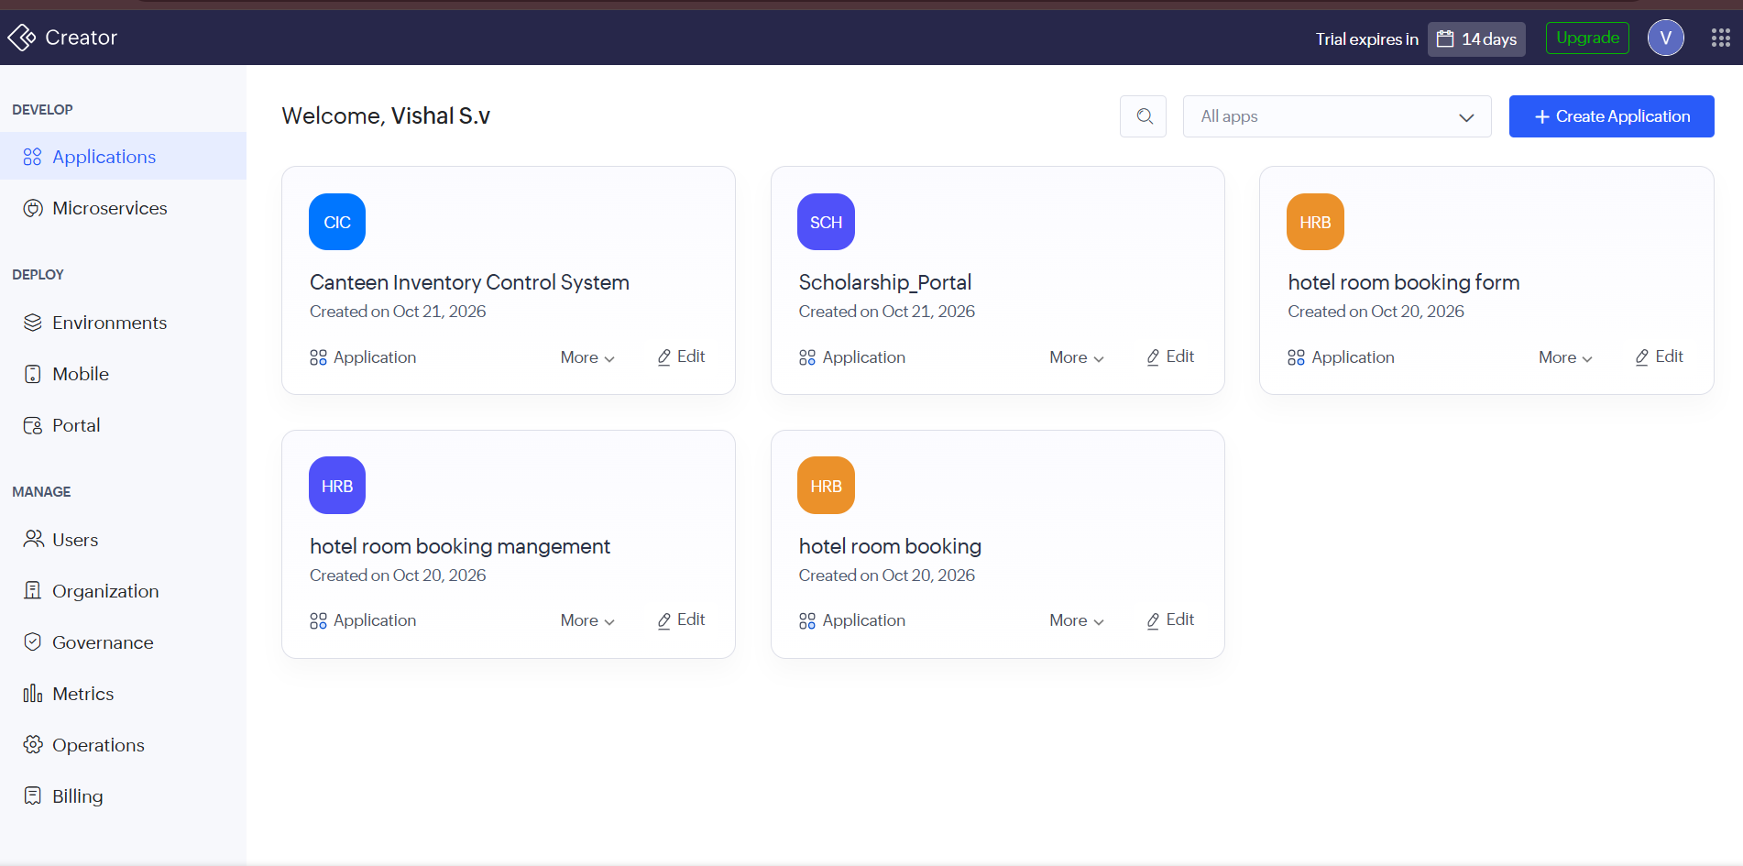

Figure 4: Applications list showing the HOTEL BOOKING application in the Dev environment
Step 6: Explore the Environments section. Selecting Environments from the left menu under Deploy opens the multi-stage deployment space. It lists the application with two stages, Stage and Production, both showing Not yet published because nothing has been deployed yet. The Manage and Publish buttons are used to move the application between stages (Figure 5).
3
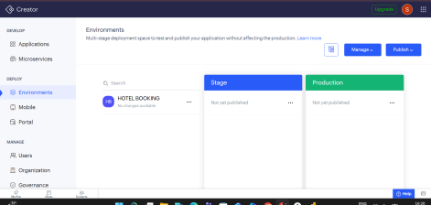

Figure 5: Environments page showing the Stage and Production spaces for the application 5. Platform Architecture
Zoho Creator applications are organized in layers, shown in Figure 6. Users reach the application through a web browser, the mobile app or a portal. The presentation layer holds the forms, reports, pages and dashboards that users see. The logic layer holds the workflows, Deluge scripts, schedules and approvals that react to user actions. The data layer stores the records submitted through the forms in the platform's managed cloud database. The integration layer connects the application to other Zoho applications and external services through connections and REST APIs, and to custom code through Zoho Catalyst. Around these layers, the environments move the application from Development to Stage to Production, and the management tools control users, the organization and governance.
4
USERS
Web Browser | Mobile App | Portal
PRESENTATION LAYER
_{Forms Reports} Pages
_{(UI Builder)} Dashboards
LOGIC LAYER
_{Workflows} Deluge
_{Scripts} Schedules Approvals
DATA LAYER
Form records stored in Zoho's managed cloud database
INTEGRATION LAYER
Connections
REST APIs
Other Zoho apps
Zoho Catalyst
(custom code)
DEPLOYMENT: Development → Stage → Production MANAGEMENT: Users | Organization | Governance Figure 6: Layered architecture of a Zoho Creator application
Component | Description | Role in the Hotel Booking Application
Forms | Data entry screens built from field types such as Name, Email, Date and Drop Down | Room_Booking_Form collects the guest booking request
Reports | Views of the records stored by forms, with filters and sorting | Room_Booking_Report lets the front office review requests
Pages | Custom pages and dashboards built with the UI builder | Occupancy and booking dashboards
Workflows | Actions triggered when records are created, edited or on a schedule | Booking confirmation email after  submission
Deluge | Scripting language for custom business logic | Validation and automation rules
Connections and  APIs | Links to other Zoho services and external systems | Integration with another Zoho service
Environments | Development, Stage and Production spaces for safe deployment | Test the booking app before publishing it to users
Users and  Governance | User accounts, roles, and administration controls | Separate guest and front-office access

5
6. Interface Exploration
Area | Items Observed | Purpose
Left menu:  Develop | Applications, Microservices | Build and manage applications and microservices
Left menu: Deploy | Environments, Mobile, Portal | Move apps through stages, publish mobile apps, and create portals for outside users
Left menu:  Manage | Users, Organization, Governance | Administer people, organization settings and policies
Builder top bar | Design, Workflow, Settings, Access Development Live | Design forms and pages, automate logic, configure the app and run it
Builder canvas | Desktop, tablet and mobile preview icons; Create New Form | Preview responsive layout and start building forms
Profile panel | My Account, Help, API Doc, Mobile Apps, Sign Out | Account management, documentation and the Creator mobile apps

7. Observations
• The application was created from scratch with the environment option enabled, so it begins in the Development space.
• The Environments page shows Stage and Production as Not yet published, which confirms that a new application exists only in Development until it is published.
• The builder is organized around three tabs, Design, Workflow and Settings, which separate what users see from what the application does and how it is configured.
• Forms are the starting point of every application, which is why the builder asks for a form to be created first.
8. Result
A Zoho Creator account was set up and the HOTEL BOOKING application was created with the environment option enabled. The platform interface and architecture were explored, and the application is ready for the form design work of the next experiments.
9. Conclusion
Zoho Creator provides a complete application platform with visual builders, a scripting layer, integrations and a managed deployment path, all within the browser. Understanding its layers and interface makes the later experiments on forms, reports, automation, security and deployment easier to carry out.
10. Summary
The experiment created a Zoho Creator application named HOTEL BOOKING from scratch with environments enabled. It examined the home screen, the application builder and the Environments page,
6
and described the platform in terms of presentation, logic, data and integration layers with a Development, Stage and Production deployment path.
11. Learning Outcome
This experiment gives an understanding of how a Zoho Creator account and application are set up, how the platform interface is organized, and how the architecture of forms, reports, pages, workflows, Deluge, integrations and environments fits together.
7

