Experiment 5
Building Reports, Dashboards and Custom Pages (UI Builder) for the Application Low-Code Lab | Application: HOTEL BOOKING (Zoho Creator, Development environment) Name: Shrivishal Register No: 241501202 Department: AIML Rajalakshmi Engineering College
Abstract
This experiment extends the Room Booking Form built earlier by adding reporting and visualisation layers in Zoho Creator. Two reports (Upcoming Bookings Report and Bookings By Room Type) were created from the form data, and a Booking Dashboard was designed in the UI Builder using a Panel heading, a Board, a pie chart and a column chart. The outputs let the front office see booking volumes by room type and meal plan at a glance.
1. Aim
To build reports, a dashboard and UI elements in Zoho Creator that summarise the room booking records for hotel front-office use.
2. Reports Created
2.1 Upcoming Bookings Report. A list report on the Room Booking Form that shows all booking records with quick filters on Room Type and Check in date, so staff can narrow bookings by room category or arrival date. The live view shows all 3 records (Showing 3 of 3).
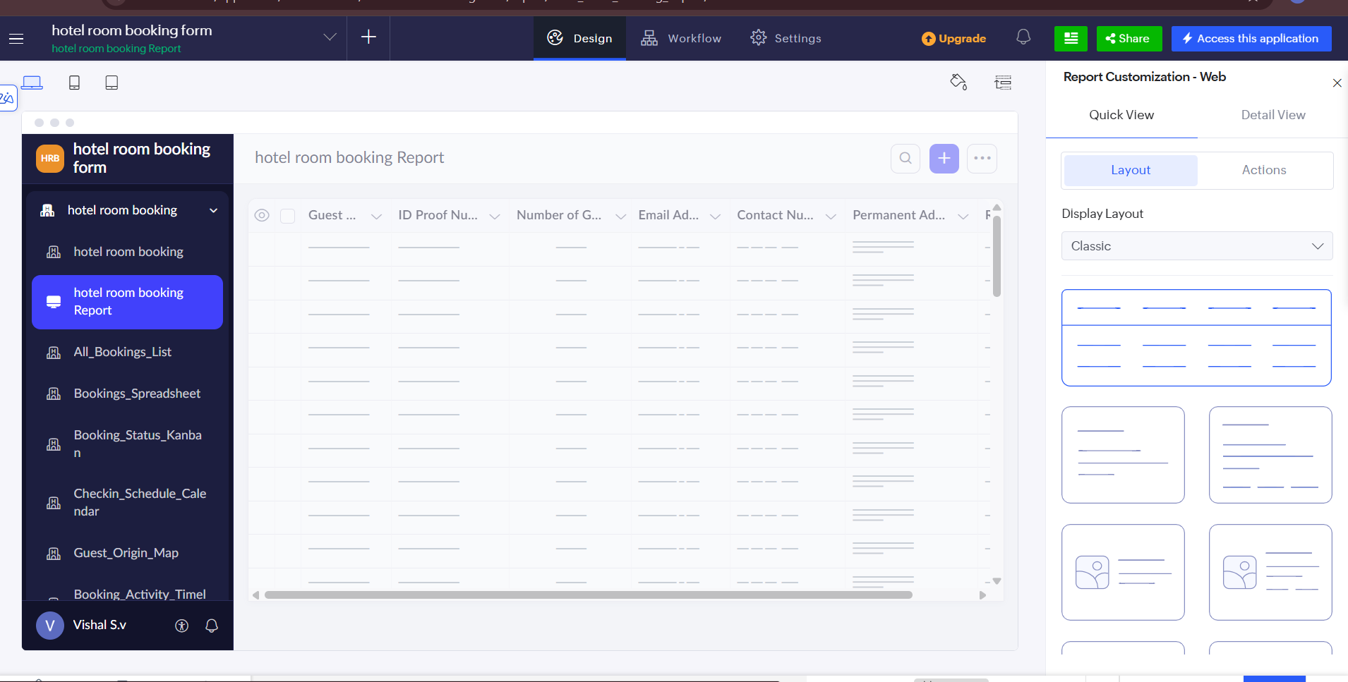

Figure 1: Upcoming Bookings Report (live view) with Room Type and Check in date filters
2.2 Bookings By Room Type. A second report on the same form that lists the booking records, used as the room-type view of the data.
Shrivshal | 241501202 | AIML | Rajalakshmi Engineering College Page 1
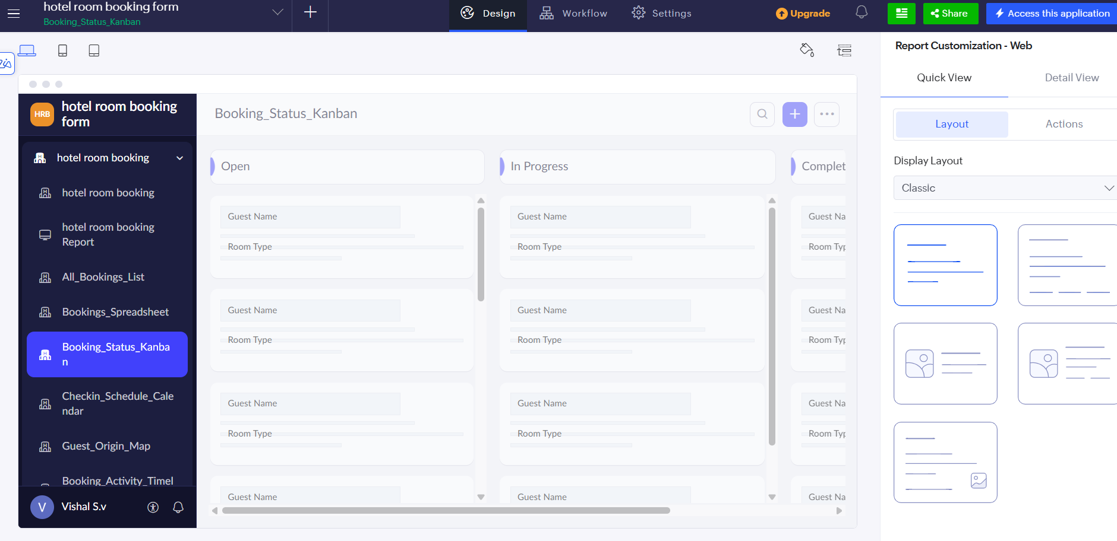

Figure 2: Bookings By Room Type report (live view)
3. Dashboard Design (UI Builder)
The Booking Dashboard was built in the Design tab of the UI Builder. A Panel element holds the heading "HOTEL BOOKING DASHBOARD", a Board element shows booking counts grouped by Room Type, and two Chart elements show a pie chart and a column chart. In the builder the Board displays placeholders (Ct ()) which are replaced by real counts at run time.
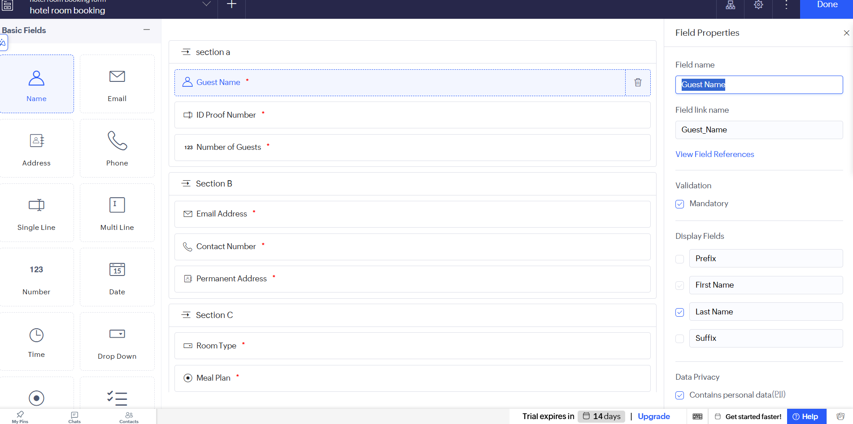

Figure 3: Booking Dashboard in the Design view with page customisation options
Shrivishal sv | 241501202 | AIML | Rajalakshmi Engineering College Page 2
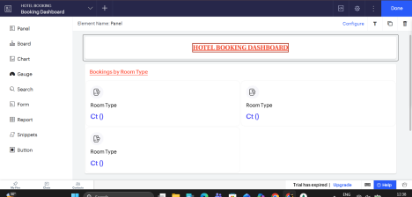

Figure 4: Dashboard builder - Panel heading and Board (top half)
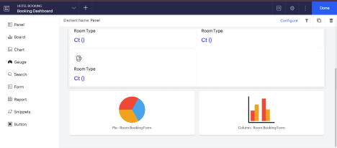

Figure 5: Dashboard builder - pie chart and column chart (lower half)
4. Live Dashboard Output
In the live view the Board shows Standard Room: 2 and Suite: 1 bookings. The pie chart plots Number Of Guests by Room Type; hovering over the Standard Room slice shows 7 guests (3 + 4 from the two Standard Room bookings). The column chart shows Bookings by Meal Plan, with 1 booking for Room Only and 2 for Breakfast Included.
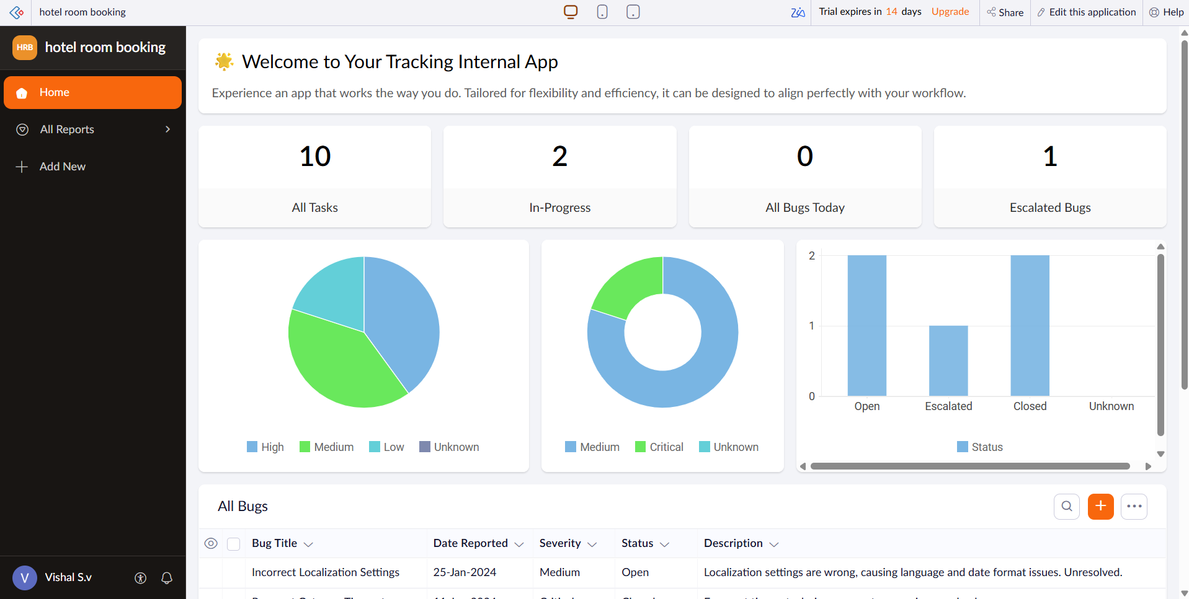

Figure 6: Live Booking Dashboard - Board and charts

Figure 7: Live Booking Dashboard - chart tooltip showing guests for Standard Room
5. Result
Reports and a multi-element dashboard were created in the HOTEL BOOKING application and verified in the live Development view. Booking counts, guest totals and meal-plan distribution are displayed correctly from the three submitted records.
6. Learning Outcome
Learnt how to create list reports with quick filters, and how to use the UI Builder to compose a dashboard from Panel, Board and Chart elements that read live data from a form. This shows how raw form submissions are turned into information the front office can act on.
Shrivishal | 241501202 | AIML | Rajalakshmi Engineering College Page 4

