**SCTR’s Pune Institute of Computer Technology,Pune**

**A PROJECT REPORT ON**

**Face Recognition Attendance System**

**SUBMITTED BY**

Class: TE 2 (K2)

Name:

Abhishek (31201)

Nikhil (31206)

Ameya (31209)

**Under the guidance of**

(Prof. V. Gaikwad)



**DEPARTMENT OF COMPUTER ENGINEERING**

## Contents

**1 Abstract** **3**

**2 Introduction** **4**

**3 ER diagram** **5**

**4 Normalized schema (upto 2nd normal form)** **6**

**5 Technologies used & Description of their use** **7**

**6 Use Case diagram** **9**

**7 Code Snippets** **10**

**8 Screen Shots** **12**

**9 Conclusion & Future scope** **14**

**Abstract**

The face recognition attendance project is a system designed to automate the process of tracking attendance in a classroom or workplace using facial recognition technology. The system uses a camera to capture images of individuals, which are then compared to a database of known faces to determine the identity of the person in question. Once the identity is confirmed, attendance is marked for that individual. The system is accurate, efficient, and user-friendly, providing a seamless experience for both teachers and students/employees. This project has the potential to revolutionize traditional attendance-taking methods and provide a more secure and reliable solution for attendance tracking.

**Introduction**

The traditional method of taking attendance in classrooms or workplaces involves manually recording the presence of individuals, which can be time-consuming and prone to errors. The face recognition attendance project aims to provide an automated solution to this problem by using facial recognition technology to identify individuals and mark their attendance. The project is designed to streamline the attendance management process, saving time and reducing the chances of errors and fraud.

Facial recognition technology has advanced significantly in recent years, making it a reliable and efficient way to identify individuals. The technology works by analysing and comparing unique features of a person's face, such as the distance between the eyes or the shape of the nose. These features are then matched against a pre-stored database of known faces to determine the identity of the person in question.

The face recognition attendance project has significant potential in various industries, including education and corporate sectors. In workplaces, employers can use the system to track employee attendance, monitor work hours, and ensure compliance with company policies. The project can significantly reduce the administrative burden of attendance tracking and provide a secure and reliable solution for attendance management.

**ER – DIAGRAM**

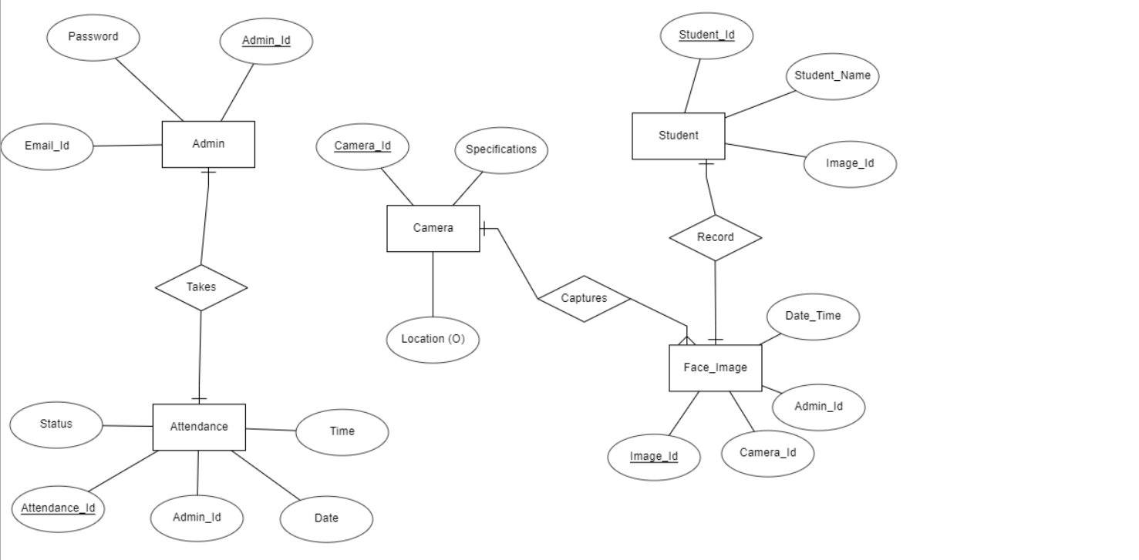

**Normalized schema**

Admin (Admin_ID, Email, Password)

Student (Student_Id, Student_Name, Image_Id )

Attendance (Attendance_ID, Admin_ID, Date, Time, Status)

Camera (Camera_ID, Location, Specifications)

Face_Image (Image_ID, Camera_ID, Admin_ID, Date_Time)

**Technologies used & Description of their use**

Face recognition attendance systems use computer vision technology to identify individuals through their facial features. These systems can be used in a variety of settings, including schools, workplaces, and other organizations. Here are some key points to consider when designing a face recognition attendance system:

1. Hardware: You will need a camera to capture images of individuals' faces. Depending on the size of the group you need to accommodate, you may need multiple cameras or a camera with a wide field of view. You will also need a computer or other device to run the face recognition software.

2. Face recognition algorithm: There are many different algorithms available for face recognition, each with its own strengths and weaknesses. Some popular algorithms include Eigenfaces, Fisher faces, and Local Binary Patterns. You can choose an algorithm that suits your specific needs, or you can use a pre-trained algorithm provided by a face recognition software vendor.

3. Training data: To use a face recognition algorithm, you will need to train it using a set of images of known individuals. These images should be high-quality and well-lit, with the individuals facing the camera directly. You may need to collect this data yourself, or you may be able to purchase pre-collected data from a vendor.

4. User interface: You will need to design a user interface that allows individuals to check in and out using their face. This interface should be intuitive and easy to use, and it should provide feedback to the user to let them know whether their check-in was successful.

5. Data storage and security: You will need to store the attendance data securely, to ensure that it cannot be accessed by unauthorized individuals. You may also need to comply with regulations around data privacy, such as GDPR or HIPAA.

Overall, designing a face recognition attendance system requires careful planning and consideration of a wide range of factors, from the hardware and software to the user interface and data security.

Sure, here are some notes on front-end technologies like HTML, Flask, and CSS for a face recognition attendance system:

1. HTML: HTML (Hypertext Markup Language) is a markup language used to create the structure and content of web pages. In the context of a face recognition attendance system, HTML can be used to create the user interface for the system. For example, you can use HTML to create a login form where users can input their username and password, or a page where users can view their attendance records.

2. Flask: Flask is a web framework for Python that allows you to create web applications quickly and easily. In the context of a face recognition attendance system, Flask can be used to create the back-end of the system. For example, you can use Flask to write the code that connects to the face recognition algorithm, stores attendance data in a database, or handles user authentication.

3. CSS: CSS (Cascading Style Sheets) is a stylesheet language used to describe the presentation of a document written in HTML. In the context of a face recognition attendance system, CSS can be used to style the user interface of the system. For example, you can use CSS to change the colour and font of text, add background images, or adjust the layout of the user interface.

When designing a face recognition attendance system, it's important to consider both the front-end and back-end technologies you'll use. HTML, Flask, and CSS are just a few examples of the many technologies you could use to create a face recognition attendance system. Depending on your specific needs, you may also need to consider other technologies, such as JavaScript for interactive user interfaces or Firebase for real-time data synchronization.

**Use Case diagram**

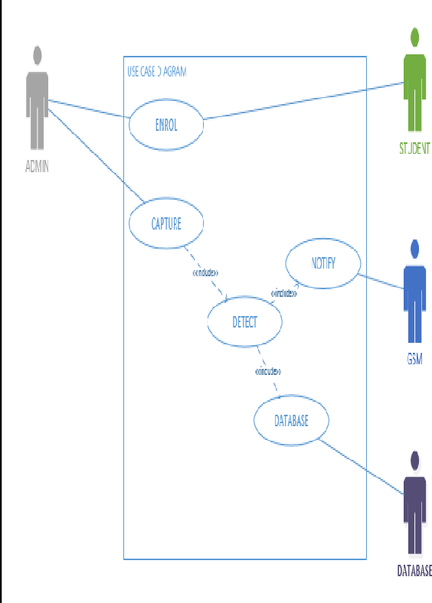

**Code Snippets**

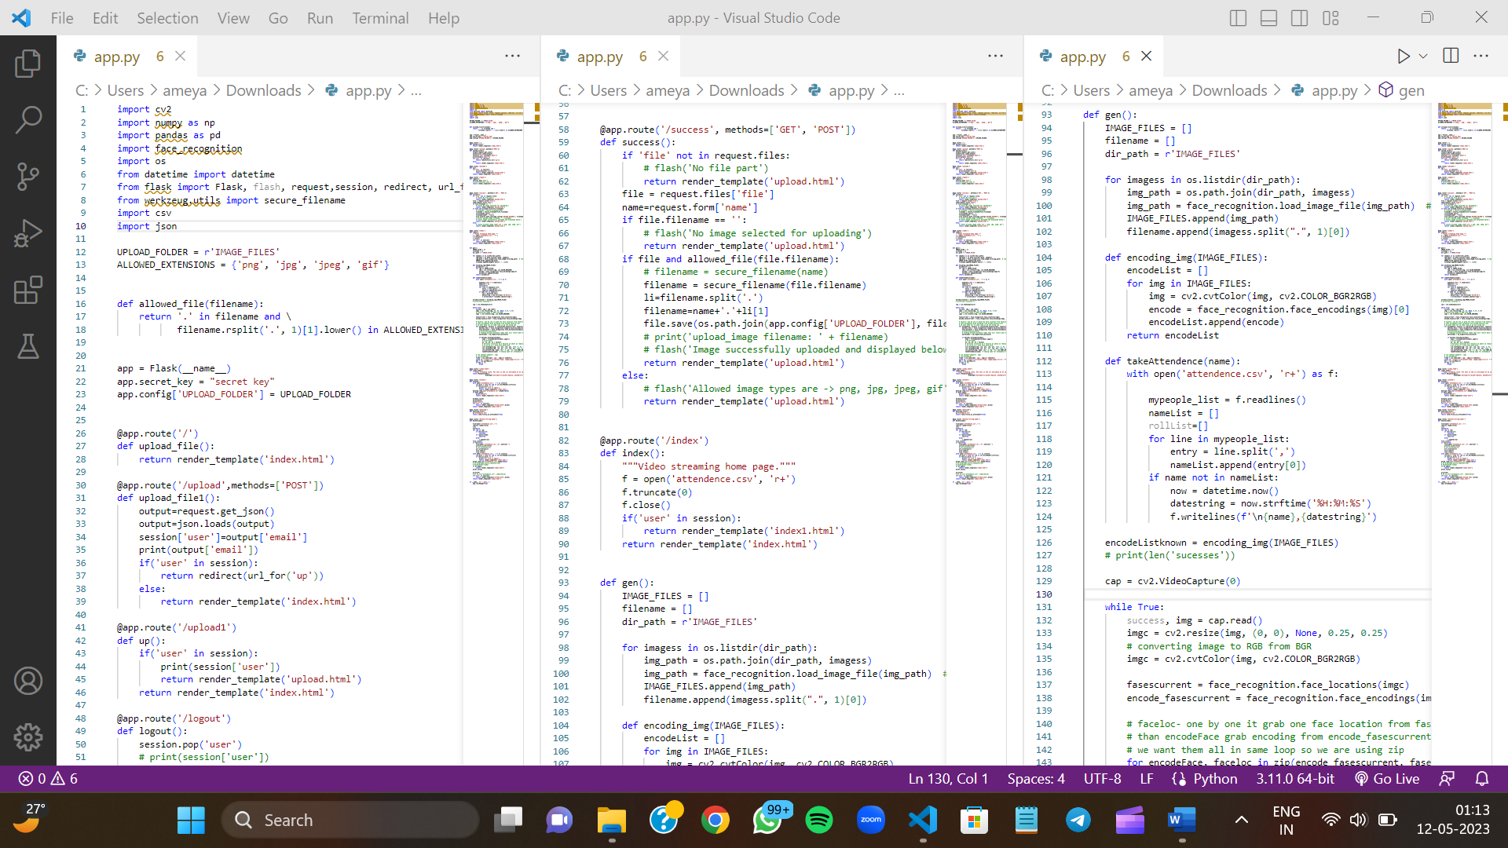

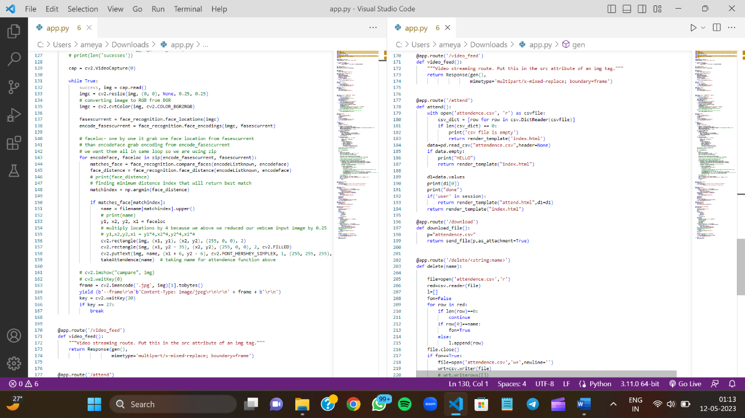

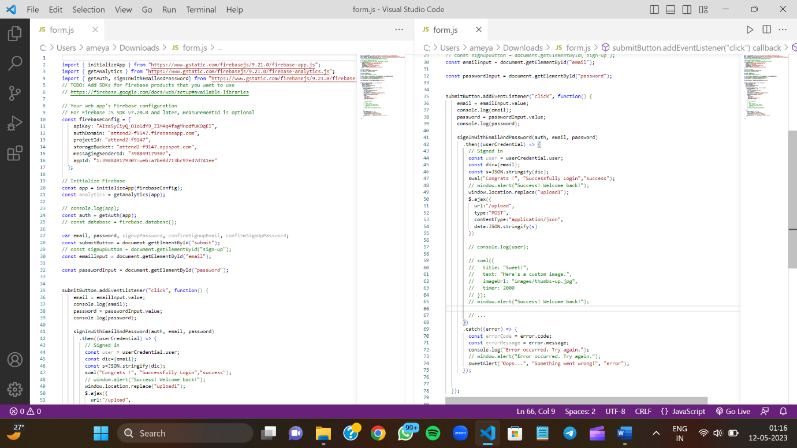

**Screen Shots**

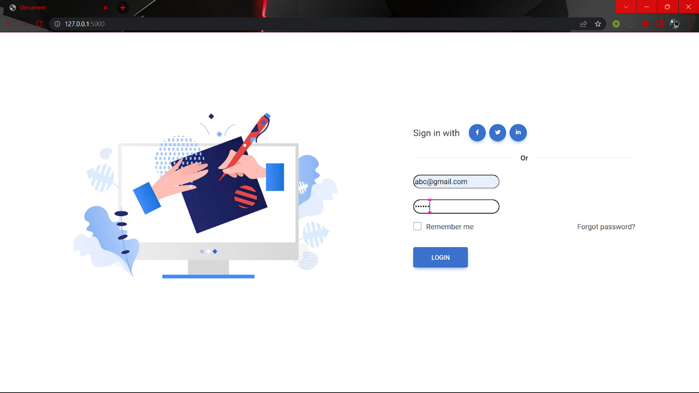

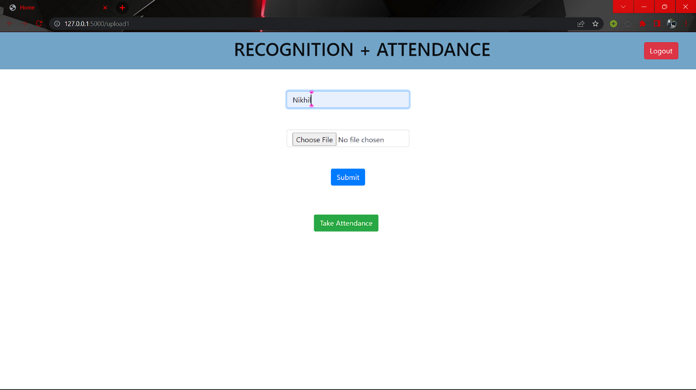

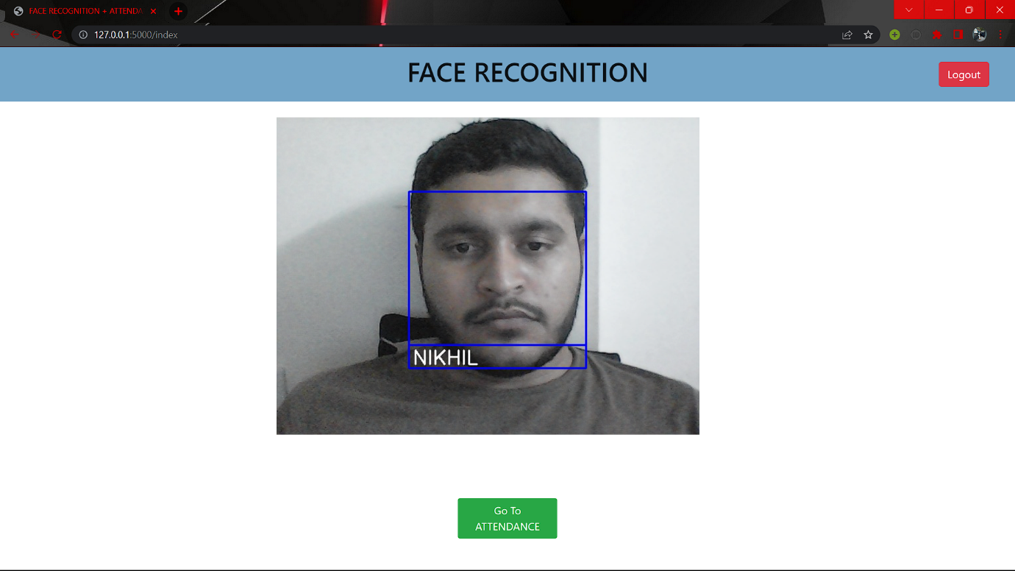

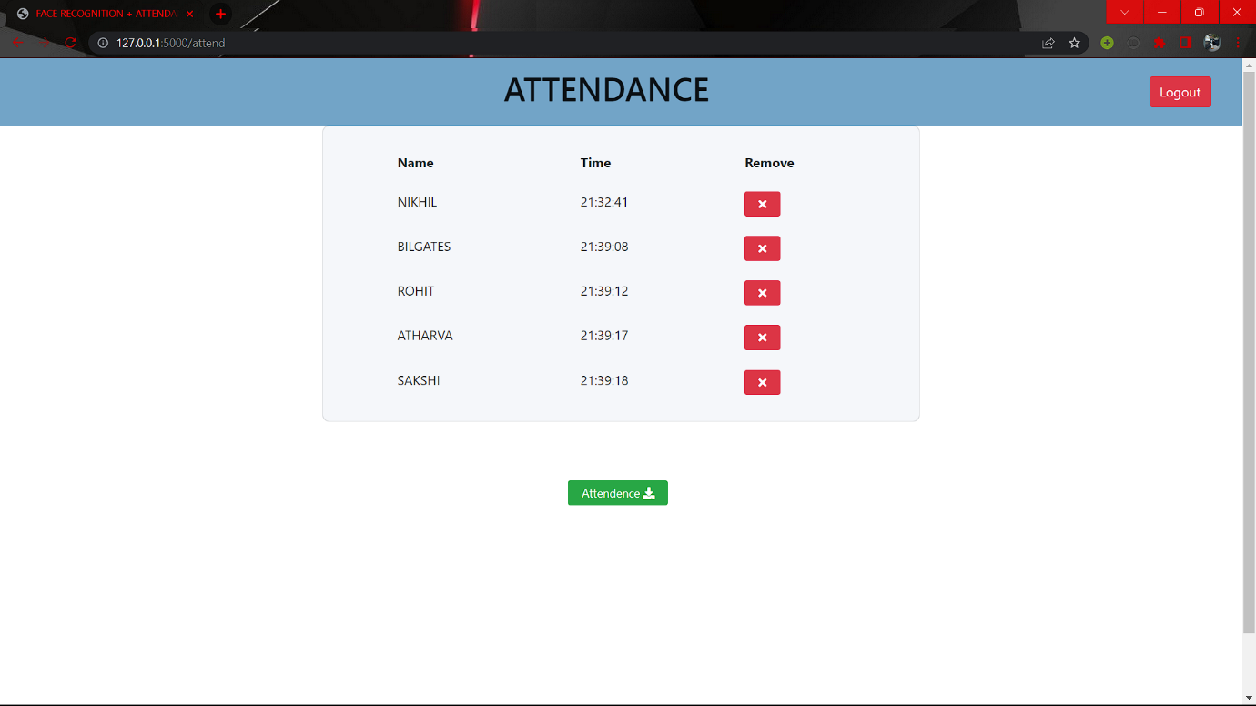

**Conclusion & Future scope**

In conclusion, the face recognition attendance project is an innovative and efficient way to automate the process of attendance tracking. The project uses facial recognition technology to identify individuals and mark their attendance automatically, eliminating the need for manual tracking and reducing the chances of errors and fraud. The project has the potential to be implemented in various settings, including classrooms, workplaces, and events.

As for the future scope of the project, there are several areas that can be improved and expanded upon. Some of the possible future enhancements include:

1. Integration with other systems: The face recognition attendance project can be integrated with other systems, such as payroll, to streamline the process of attendance and salary calculation.

2. Improved accuracy and security: The facial recognition technology used in the project can be improved to increase accuracy and security, such as by using multi-factor authentication and anti-spoofing measures.

3. Mobile application: A mobile application can be developed to enable users to access the attendance records and mark attendance remotely.

4. Real-time analytics: The project can be enhanced to provide real-time analytics and insights into attendance trends, patterns, and performance, helping administrators to make informed decisions.

5. Customization: The system can be customized to meet the specific needs of different organizations, such as by adding new features or modifying existing ones.

Overall, the face recognition attendance project has the potential to revolutionize the way attendance is tracked, providing a more accurate, efficient, and secure alternative to traditional manual methods. With further development and enhancements, the project can be extended to various domains and help to improve productivity, efficiency, and security in a wide range of settings.