**Exercise Shriya Garg (4138)**

1. **Prompt for amount, interest rate and no. of years and calculate simple interest.**

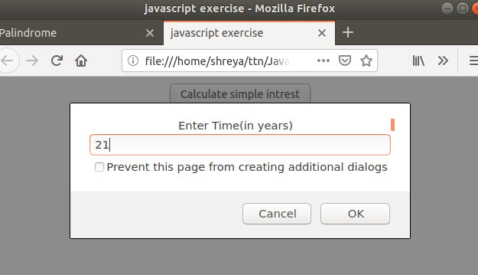

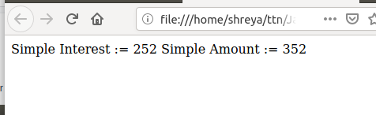

1. **Palindrome string**

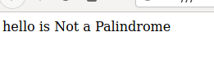

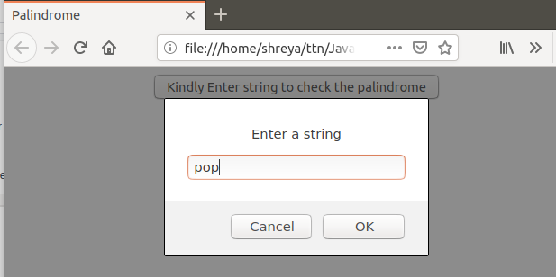



1. **Area of circle**

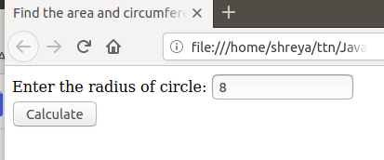

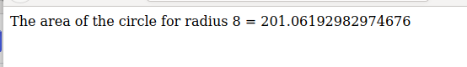

1. **Copy information of one object to another and log it to console.**

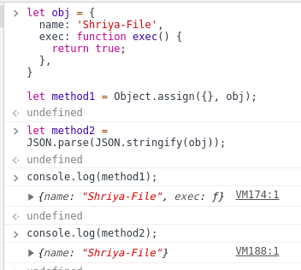

1. **create a list of objects of Employee with info as follow :**
   * **Name, age, salary ,DOB**
   * **filter all employees with salary greater than 5000**
   * **group employee on the basis of their age**
   * **fetch employees with salary less than 1000 and age greater than 20. Then give them an increment 5 times their salary.**

