Exercise
Problem Statement: There can be multiple customers, who can place multiple orders on the site. Now a sales person can handle these orders will distribute into multiple sales persons (One order will be assign to one salesperson only). So a sales person can have multiple orders of multiple customers
- Create Database
create database mydb;
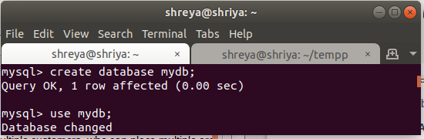
- Design Schema
desc customer;
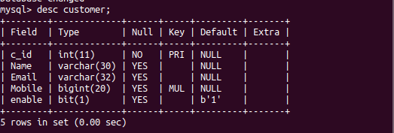

- Create tables
create table customer(Id int, Name VARCHAR(30) ,Email VARCHAR(32), Mobile int(10));
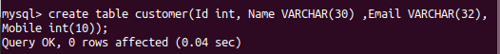

- Insert sample data
insert into customer values (1 , 'Shriya' ,'sg@gmail.com', 9999);
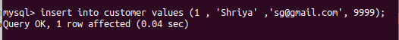

- Find the sales person have multiple orders.
select salesperson.s_name, count(orders.o_id) from salesperson left join orders on salesperson.s_id = orders.s_id group by salesperson.s_id having count(orders.o_id)>1;

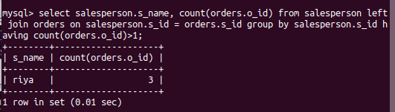

- Find the all sales person details along with order details
select * from salesperson left join orders on salesperson.s_id = orders.s_id;
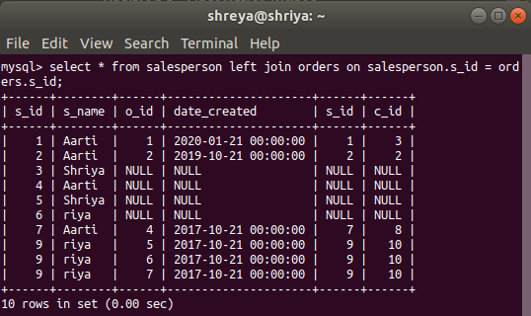

- Create index
create index inx on customer(mobile);

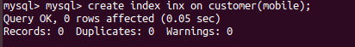

- How to show index on a table
show index from customer;
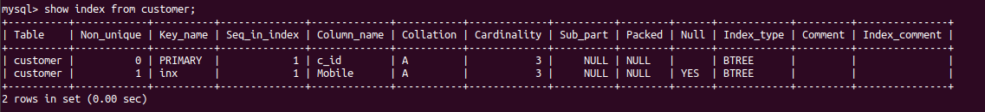

- Find the order number, sale person name, along with the customer to whom that order belongs to
select orders.o_id, salesperson.s_name ,customer.name from orders left join salesperson on salesperson.s_id = orders.s_id left join customer on customer.c_id = orders.c_id;
