CASE STUDY-02

AIM:Develop the webpage for an online shopping website with using HTML, CSS and html tags and calculate bill, customer name, mobile no, invoice no, product no, quantity(kg),rate per kg,discount,GST,packing charges, payment mode(cash/card/UPI), Membership(yes/no).

CODE index.html :
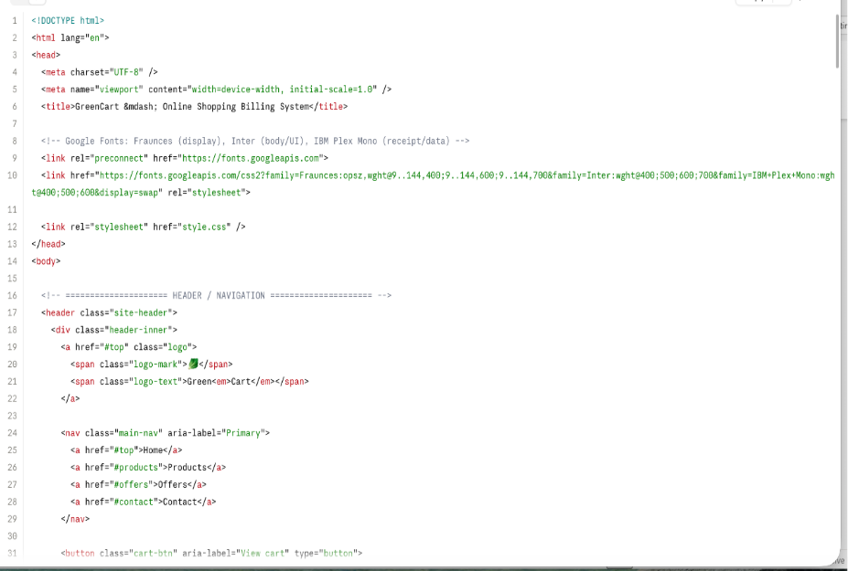
Style.css
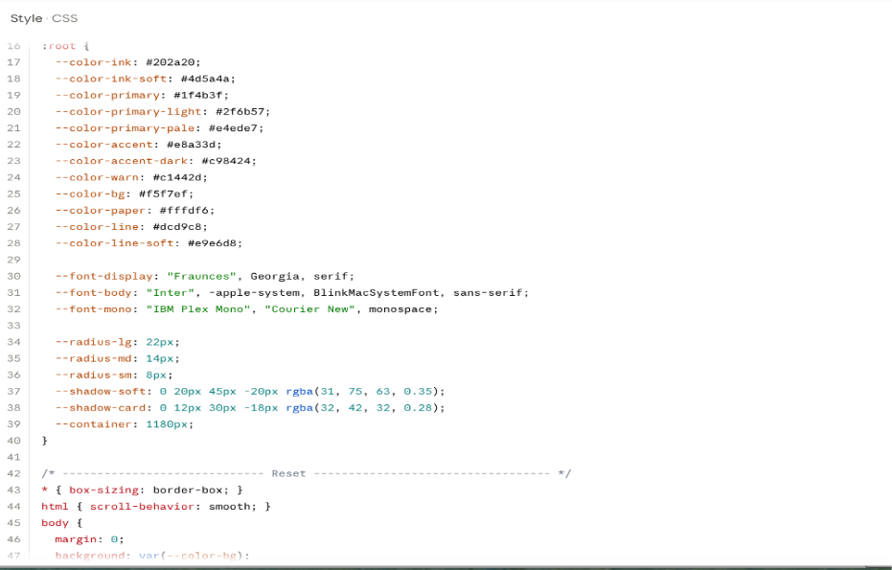
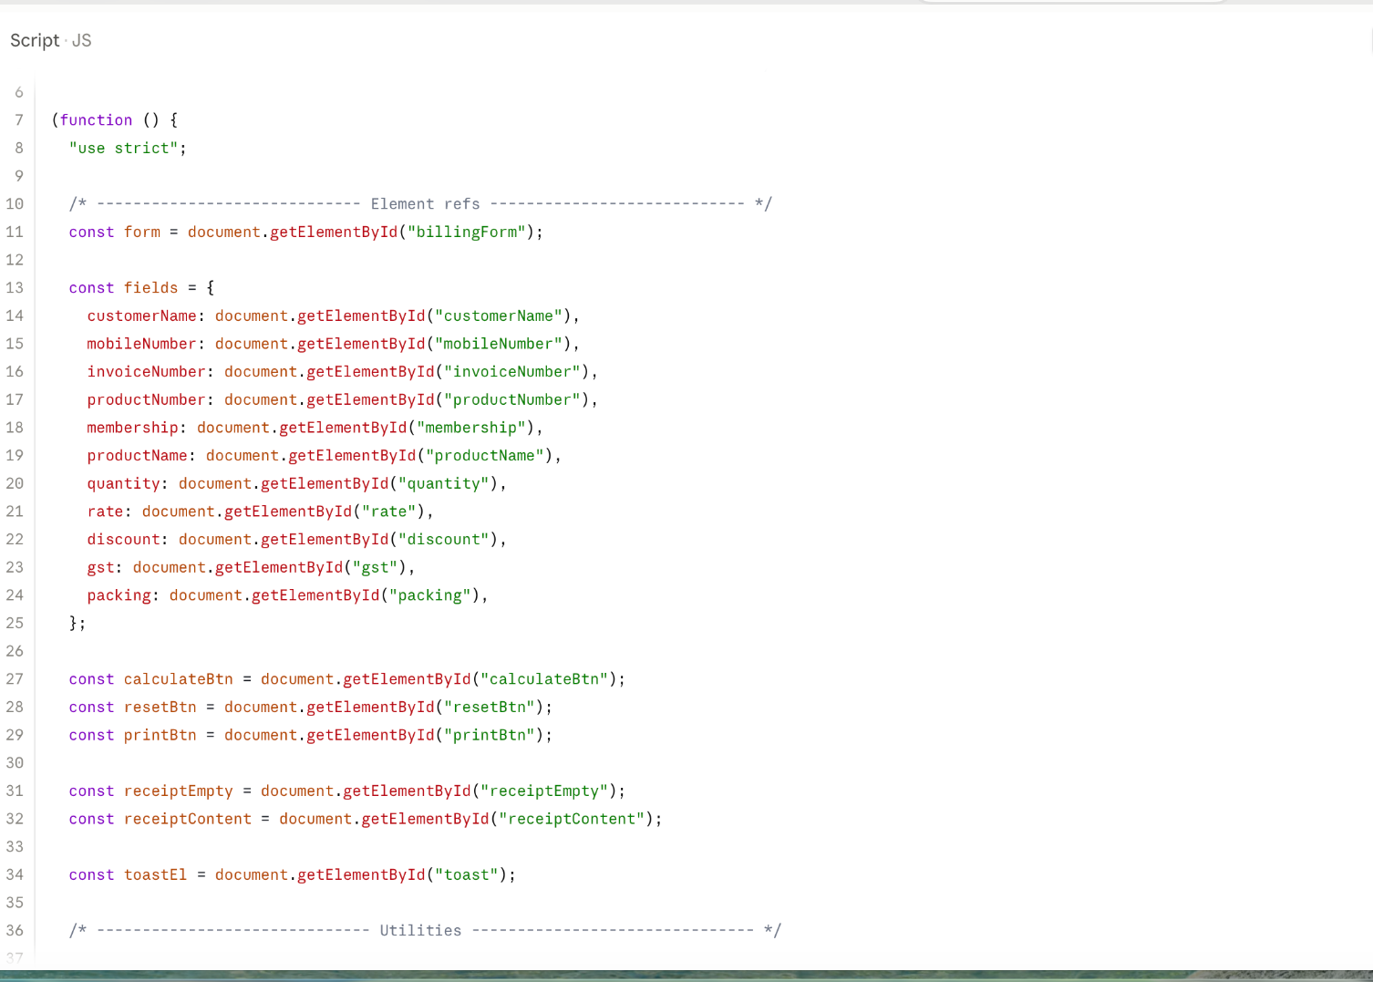

Output
