Experiment No:- 01

AIM: Demonstrate inline, internal, and external JavaScript; use console methods; create a webpage showing user info and a welcome
Software/Tools Required: (VS Code), Web Browser, JavaScript (ES6), HTML
Theory: JavaScript is a scripting language used to make web pages interactive and dynamic. It can be added to an HTML page in three ways: inline JavaScript (inside HTML elements), internal JavaScript (inside the <script> tag), and external JavaScript (in a separate .js file linked to the HTML page). JavaScript also provides console methods such as console.log(), console.warn(), and console.error() for debugging and displaying messages. In this experiment, JavaScript is used to display user information and a welcome message on a webpage while demonstrating different ways of adding JavaScript to HTML.

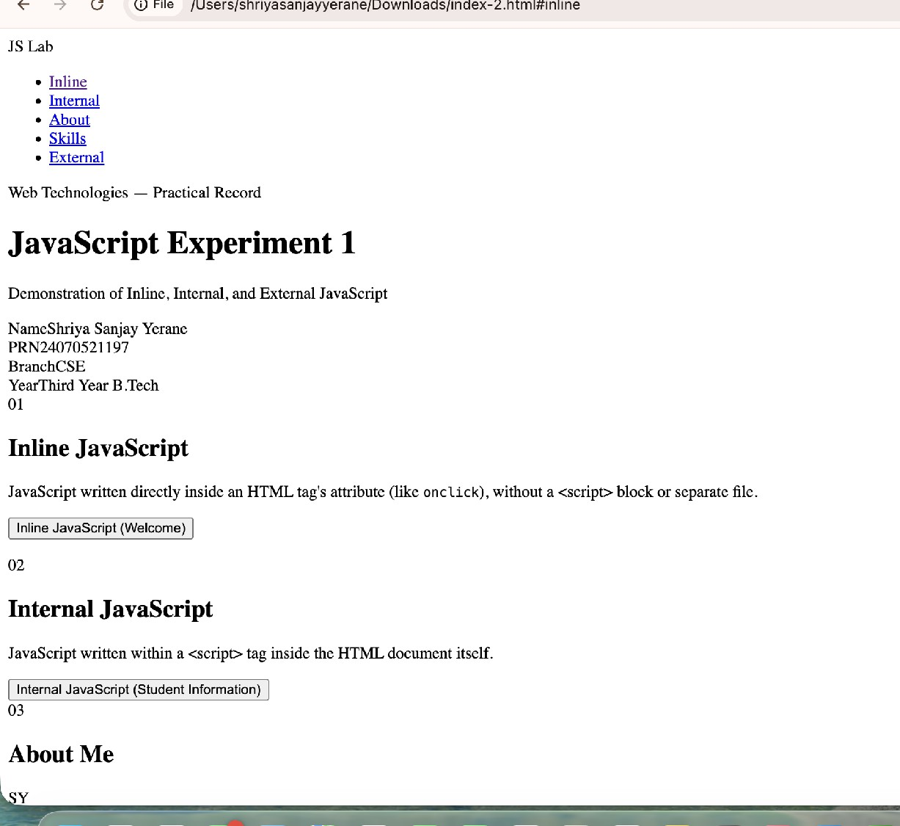
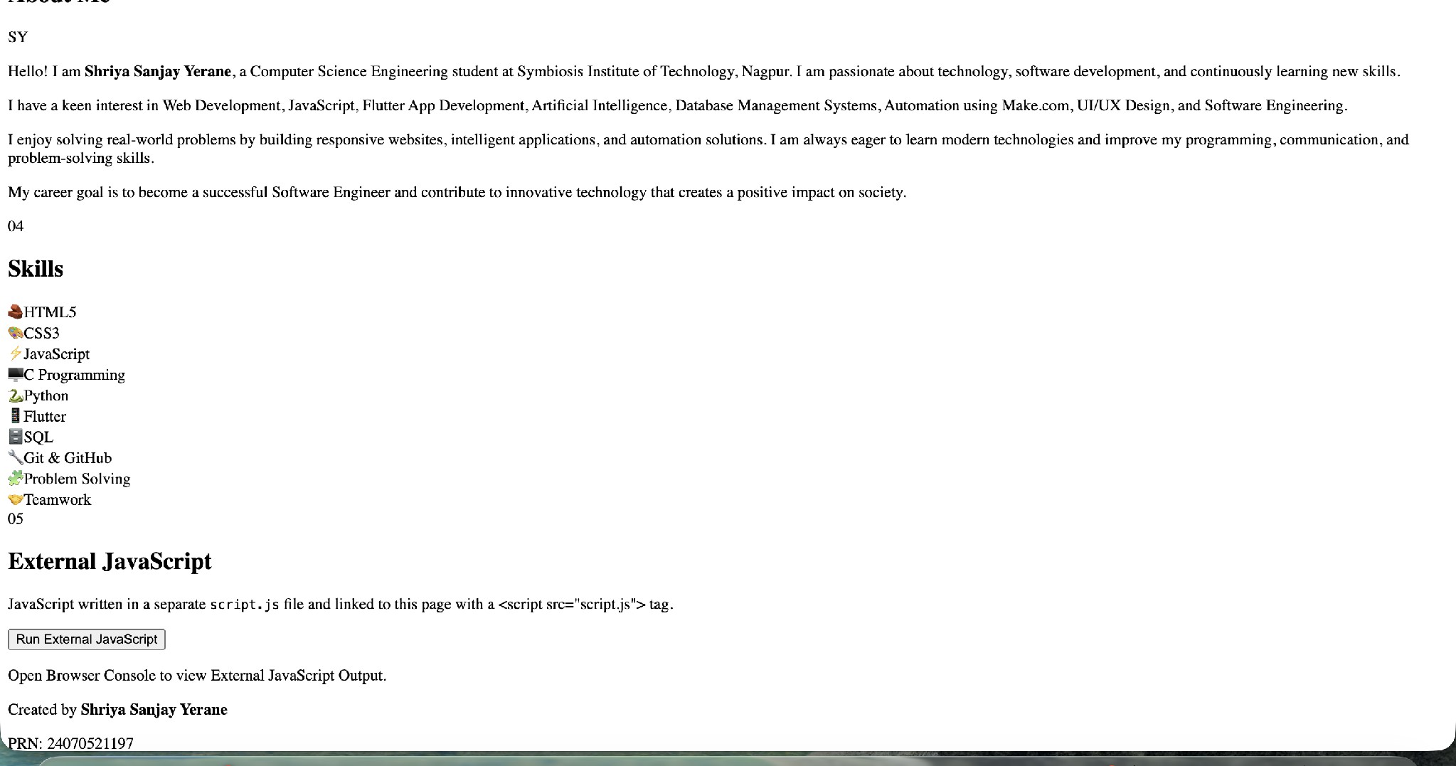
Output:

Result: Successfully demonstrated inline, internal, and external JavaScript, used console methods, and created a webpage displaying user information with a welcome message.

CASE STUDY-01

AIM: create a webpage for college department and link the student information and write a java script program to display”welcome to SIT nagpur “

CODE index.html :
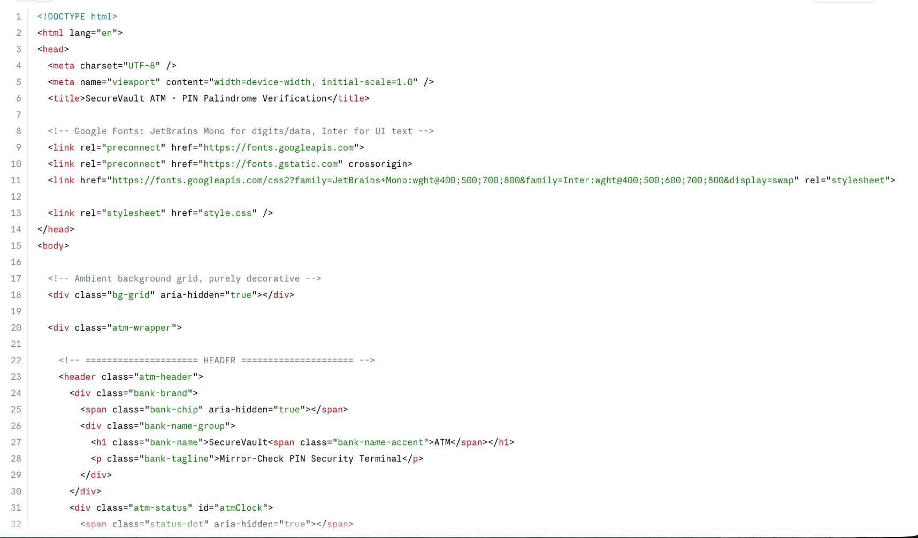

Style.css

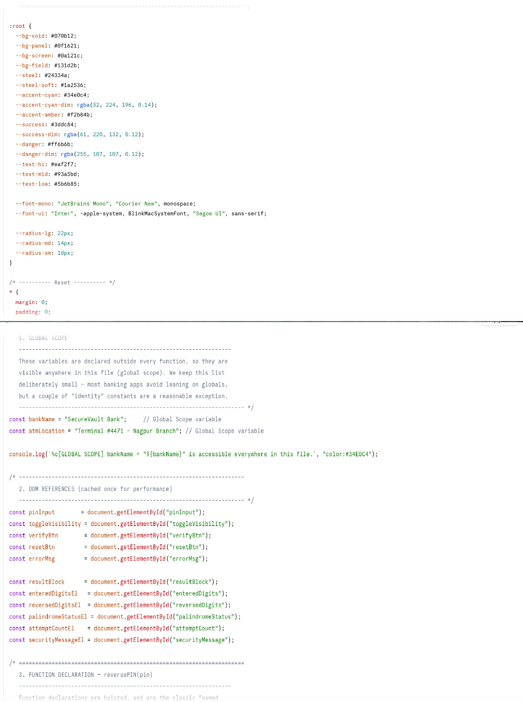

Output
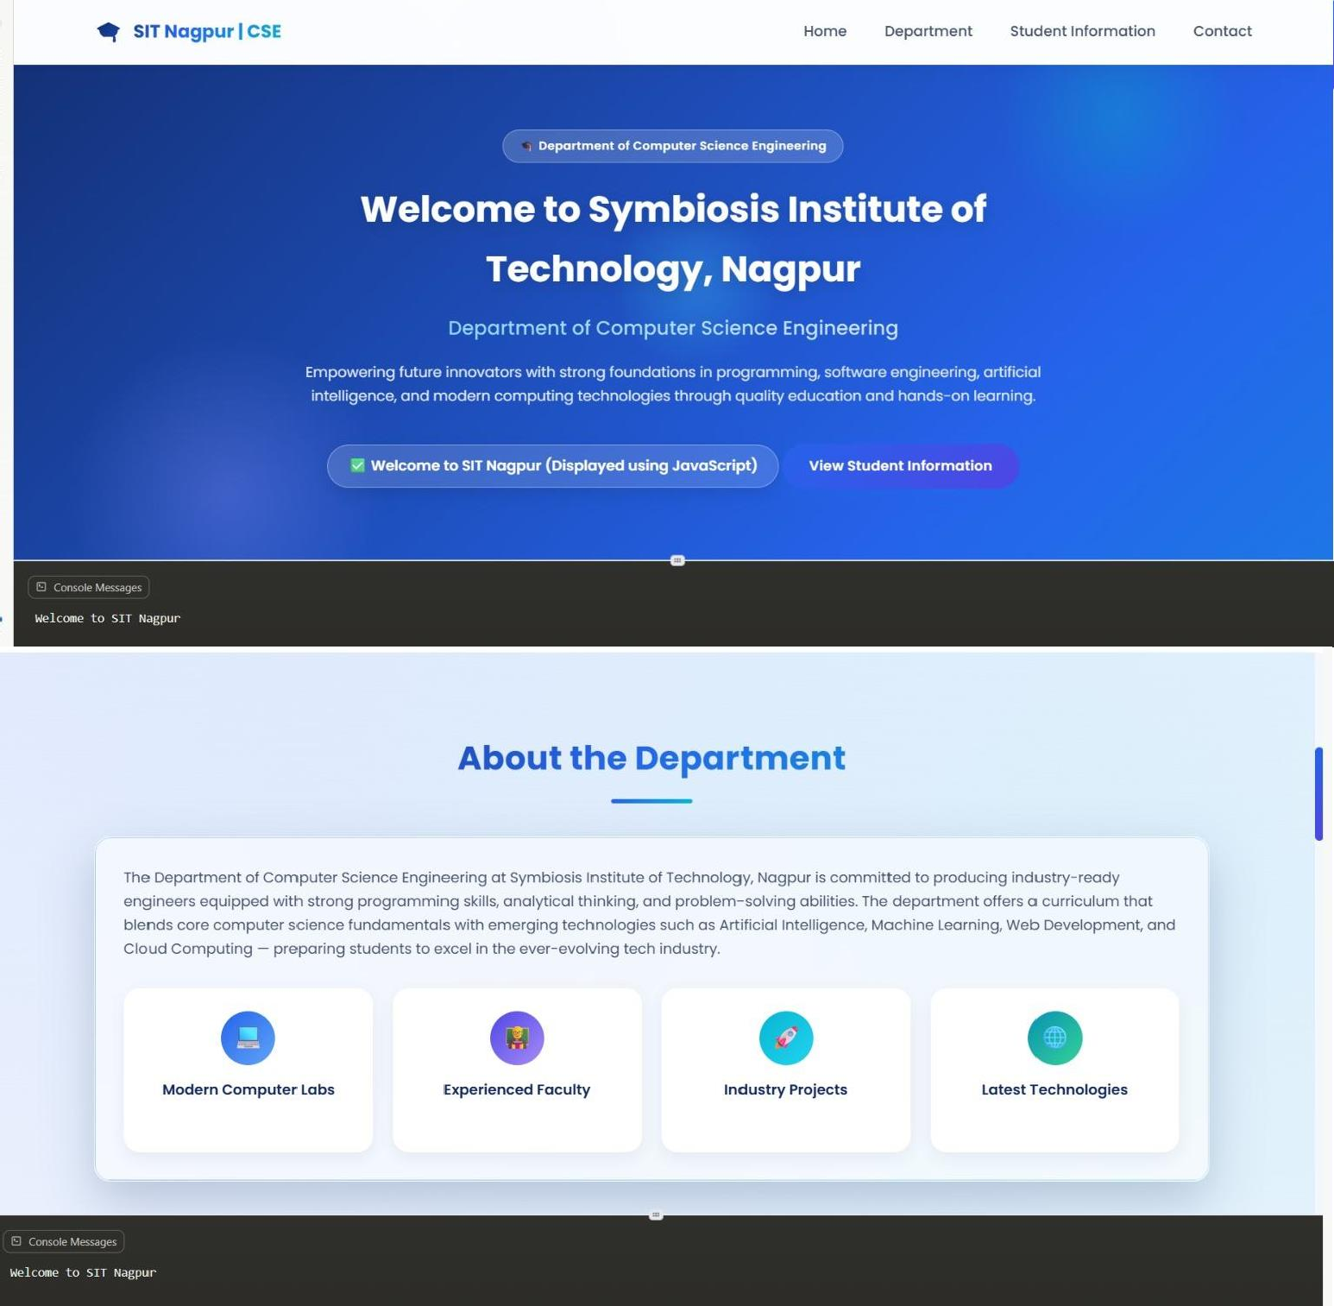

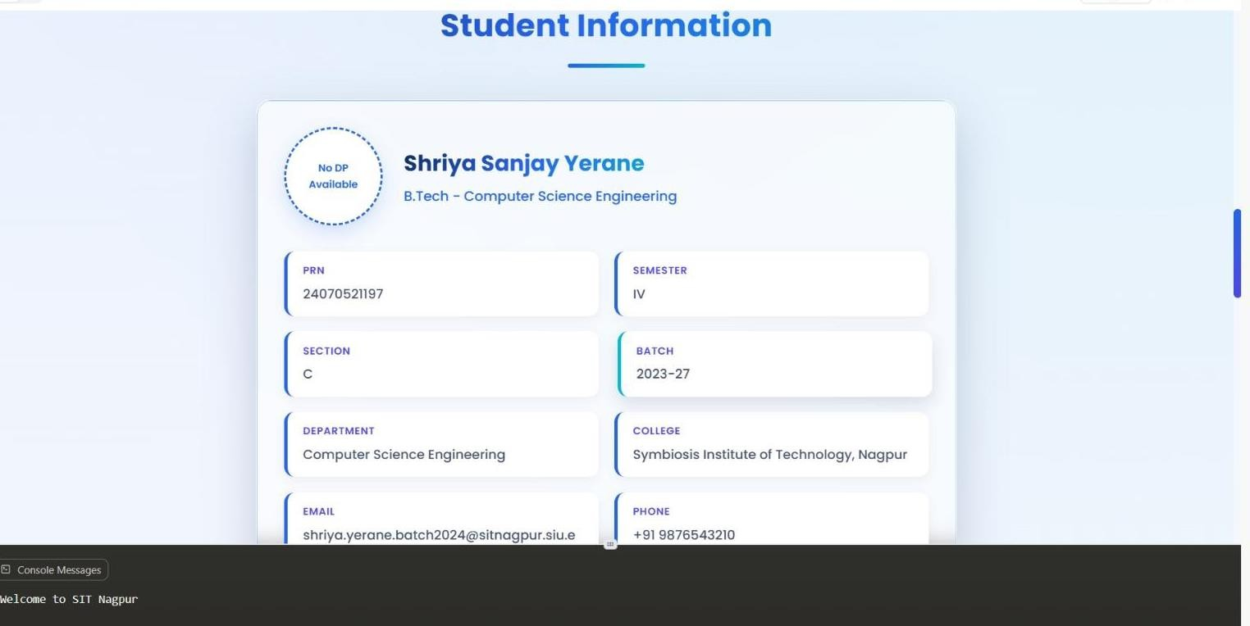

Experiment No:- 02

AIM: Use var, let, const, and demonstrate basic features like template literals and DE structuring; build a billing calculator with

Software/Tools Required: (VS Code), Web Browser, JavaScript (ES6), HTML

Theory: JavaScript provides var, let, and const for declaring variables. Template literals simplify string formatting using backticks ( ), while DE structuring allows easy extraction of object or array values. These features make JavaScript code cleaner, more readable, and efficient.

Output:
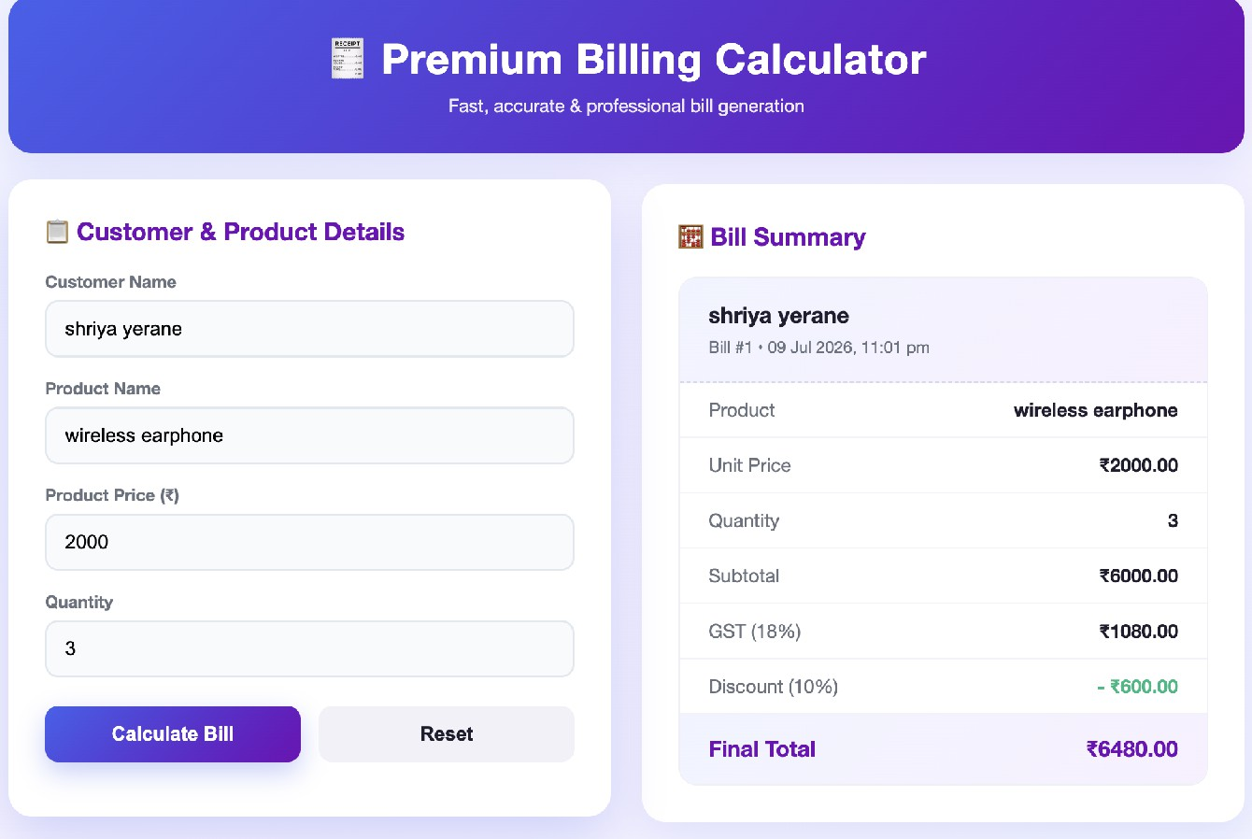

Result: Successfully demonstrated inline, internal, and external JavaScript, used console methods, and created a webpage displaying user information with a welcome message

CASE STUDY-02

AIM:Develop the webpage for an online shopping website with using HTML, CSS and html tags and calculate bill, customer name, mobile no, invoice no, product no, quantity(kg),rate per kg,discount,GST,packing charges, payment mode(cash/card/UPI), Membership(yes/no).
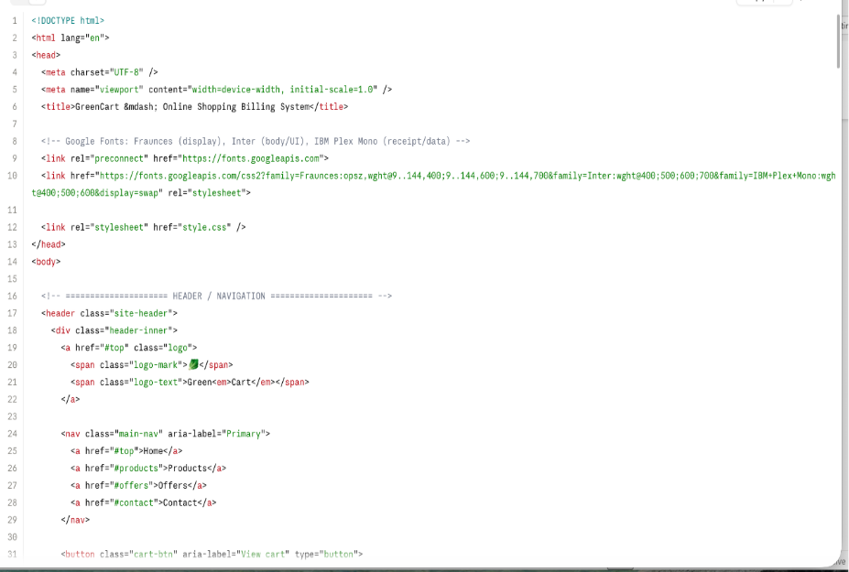
CODE index.html :

Style.css

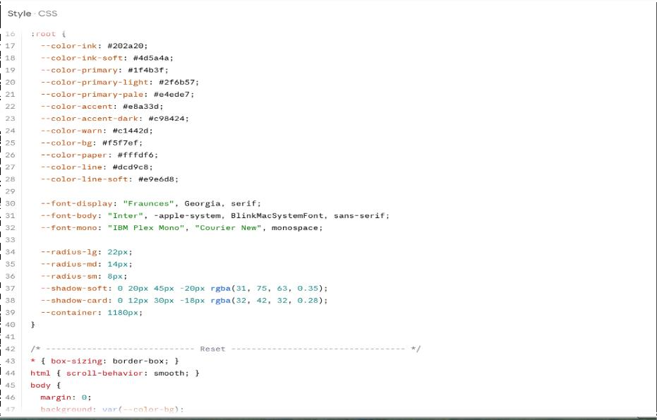
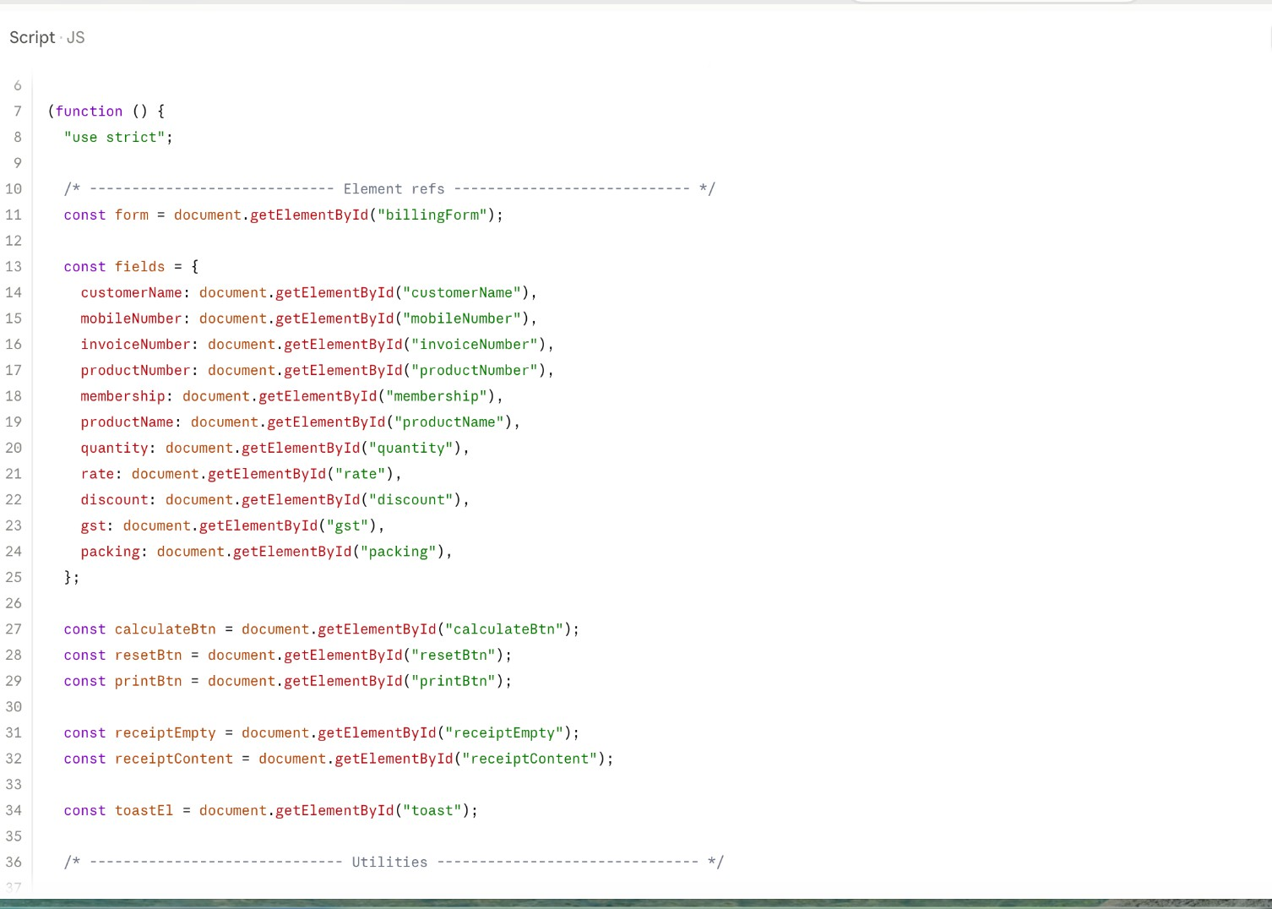

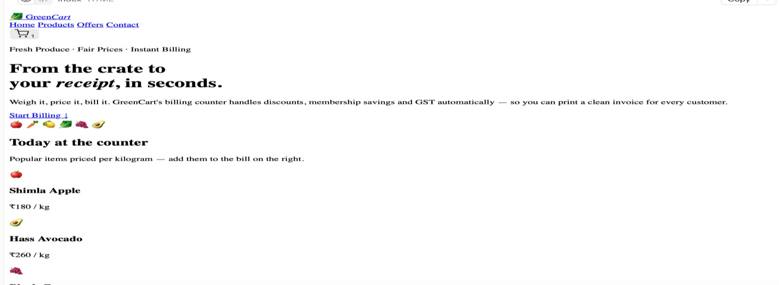
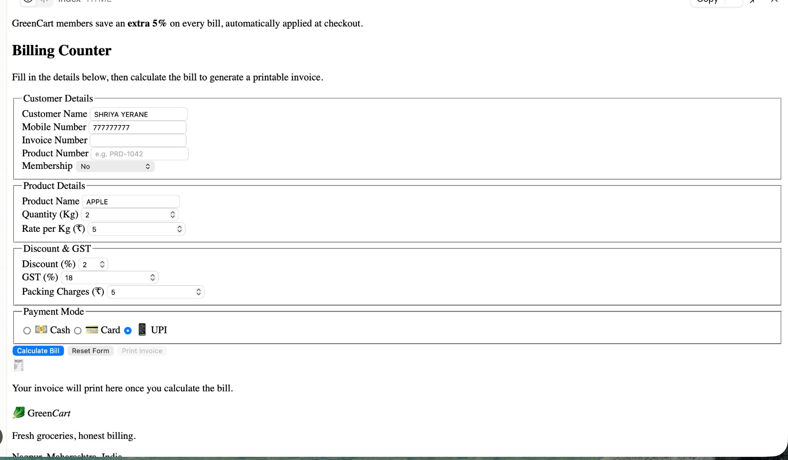
Output

Experiment No:- 03

AIM: To implement JavaScript control structures and form validation by creating a grading system based on user-entered marks."

Software/Tools Required: (VS Code), Web Browser, JavaScript (ES6), HTML

Theory: JavaScript control structures such as if, else if, else, and switch are used to make decisions based on conditions. Form validation ensures that users enter valid data before processing, preventing incorrect or incomplete input. In this experiment, the entered marks are validated, and the total, percentage, grade, and pass/fail status are calculated using JavaScript control structures.

Output:
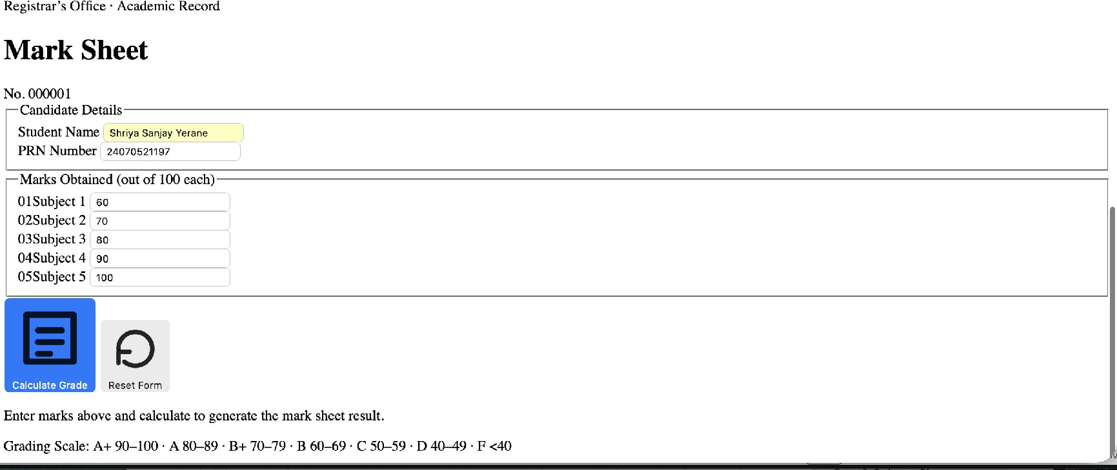
Result: Successfully implemented control structures and form validation to create a grading system based on user-entered marks.

CASE STUDY-03

AIM:Scholarship Eligibility,A college awards scholarships based on marks. Below 50-Not Eligible,
50-69-Bronze,70-84-Silver,85-94-Gold,95-100-Platinum.
Write a JavaScript program that accepts student marks and display the Scholarship category.

CODE index.html :
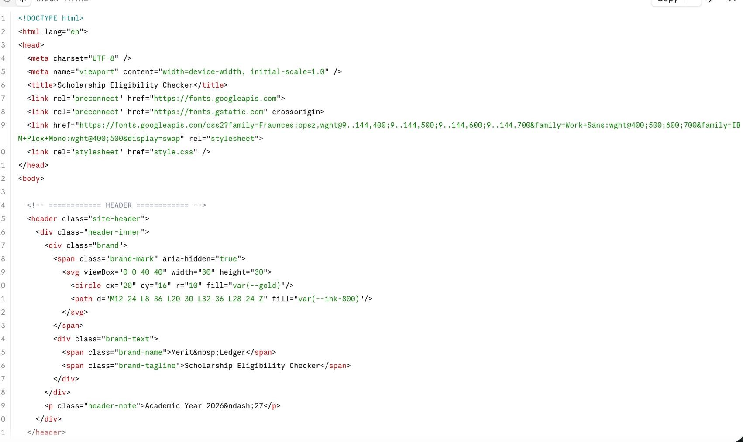

Style.css

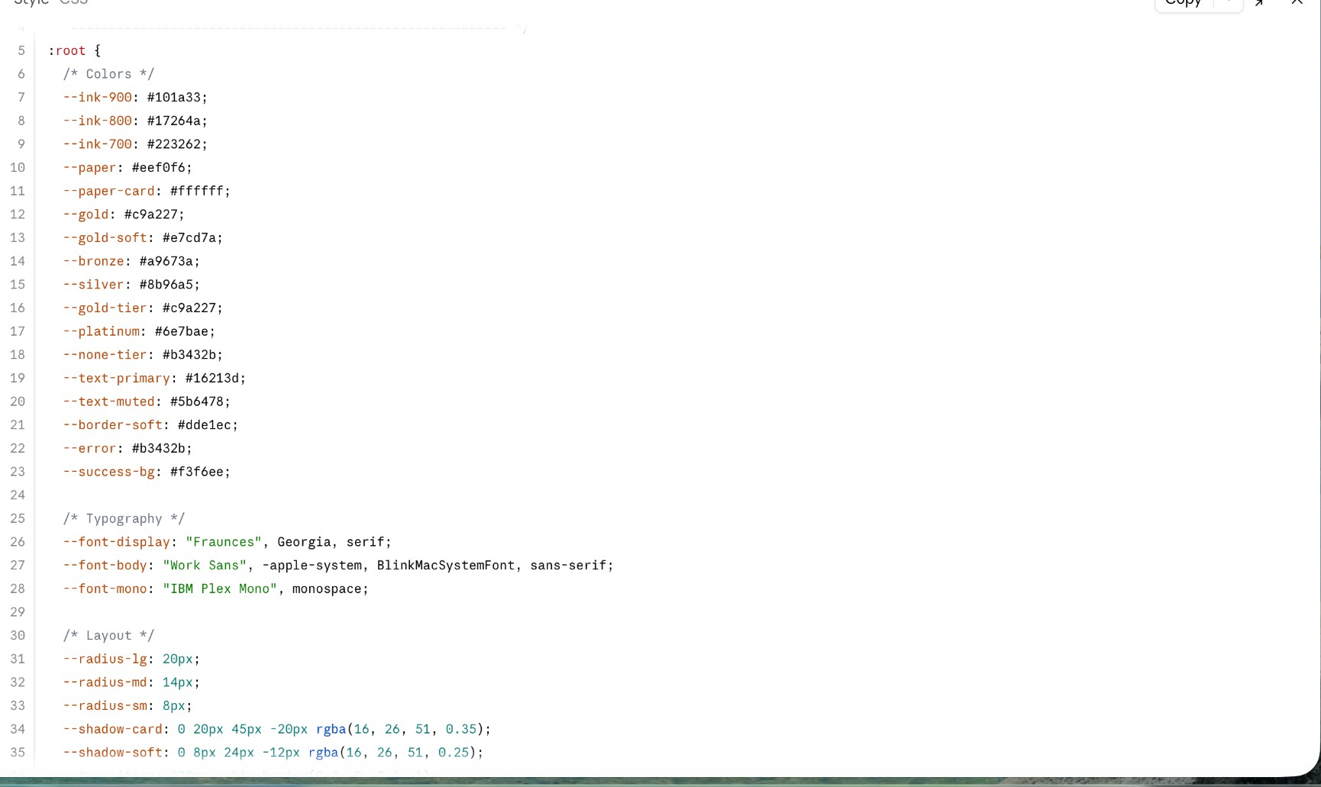

Output
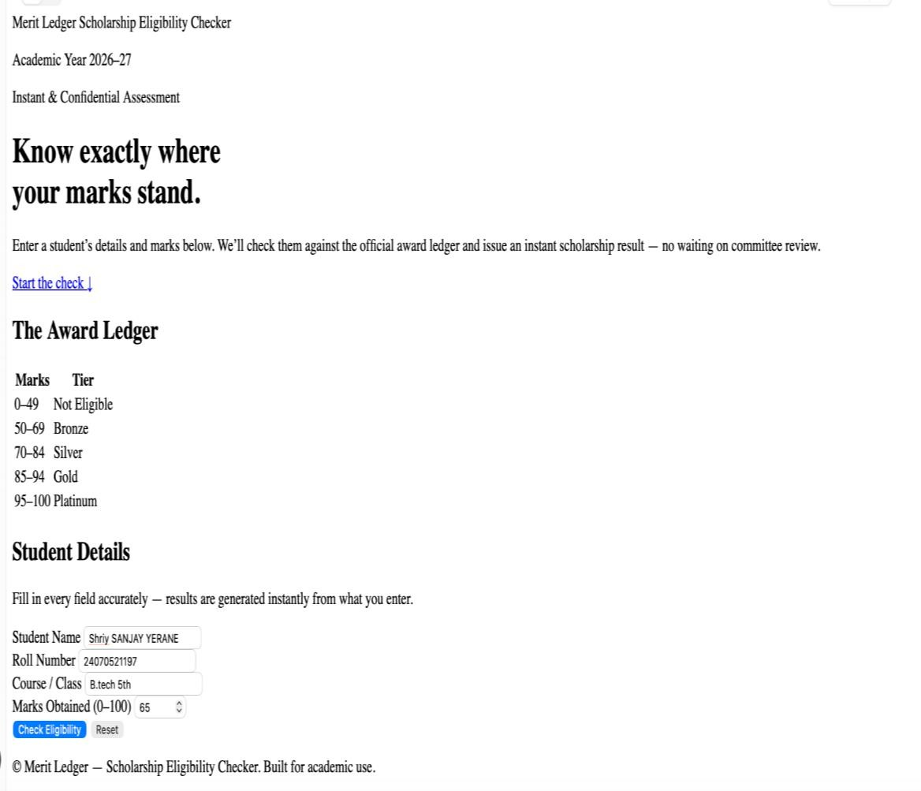

Experiment No:- 04

AIM: generate a profusion prompt to Use function types, scope, and closures; apply try-catch; build a palindrome checker

Software/Tools Required: (VS Code), Web Browser, JavaScript (ES6), HTML

Theory: Function Types:-A function is a reusable block of code used to perform a specific task. JavaScript provides different types of functions such as Function Declaration, Function Expression, Arrow Function, Callback Function, and Higher-Order Function. Functions improve code reusability, readability, and organization.
Scope:-Scope defines the accessibility of variables in a program. JavaScript mainly has three types of scope:
- Global Scope: Variables accessible throughout the program.
- Function Scope: Variables accessible only inside a function.
- Block Scope: Variables accessible within a specific block using let and const.
Closures:-A closure is a JavaScript feature where an inner function can access variables from its outer function even after the outer function has completed execution. Closures are used for data privacy and maintaining state.
try-catch Exception Handling:-try-catch is used to handle errors during program execution. The try block contains risky code, while the catch block handles errors and prevents program failure. The finally block executes after the process is completed.
Palindrome Checker:-A palindrome is a word, number, or sentence that remains the same when read forward and backward. The palindrome checker takes user input, removes unnecessary characters, reverses the text, and compares it to check whether it is a palindrome.

Output:

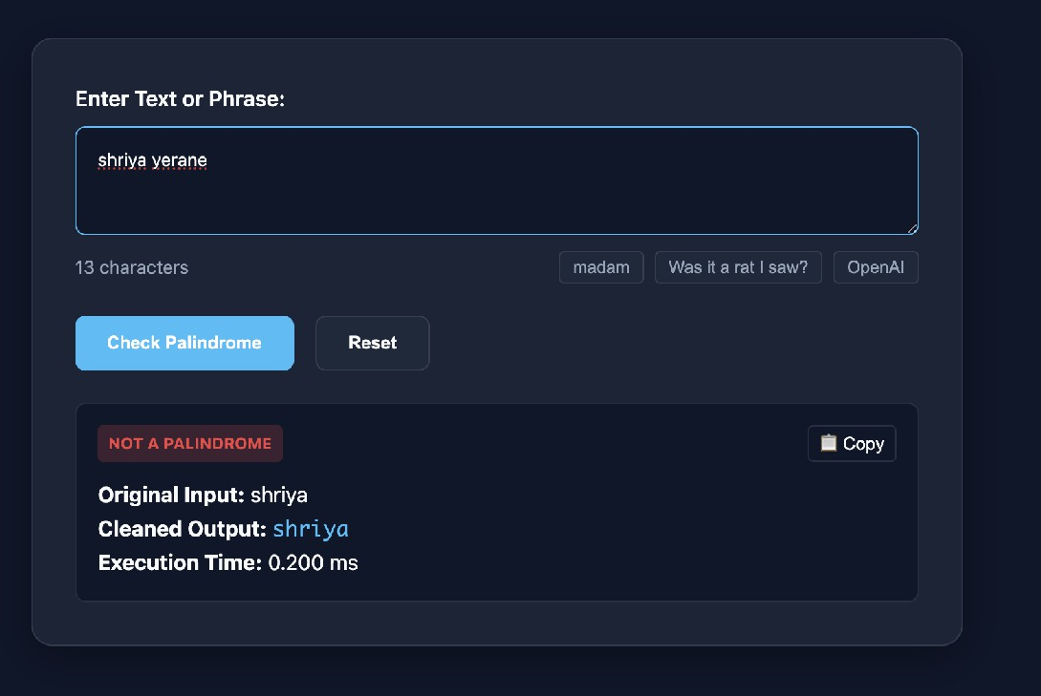

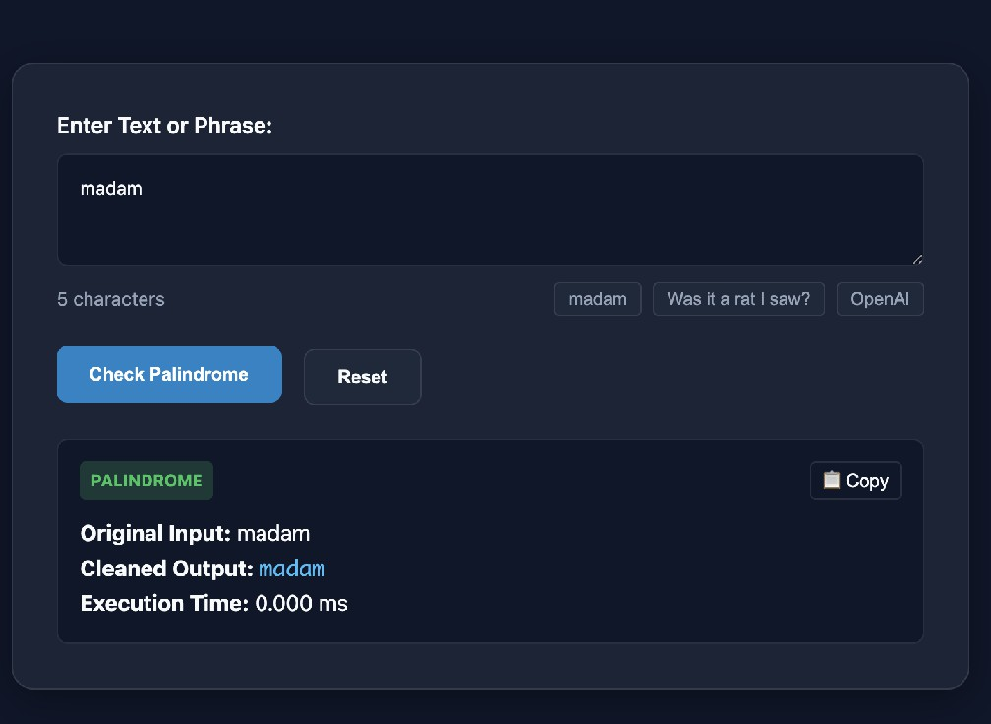

Result: The concepts of function types, scope, closures, and try-catch exception handling were successfully implemented in JavaScript. A Palindrome Checker was developed that validates input and correctly identifies whether the given text is a palindrome.

CASE STUDY-04

AIM:atm system verifies if the pin is palindrome. if palindrome,display security message . To implement this create a function to reverse the entered pin number and another function to check if it is palindrome. use function declaration,function expression ,arrow function and demonstrate scope and closure concepts.

CODE index.html :

Style.css

Output
