CASE STUDY-04

AIM:atm system verifies if the pin is palindrome. if palindrome,display security message . To implement this create a function to reverse the entered pin number and another function to check if it is palindrome. use function declaration,function expression ,arrow function and demonstrate scope and closure concepts.

CODE index.html :
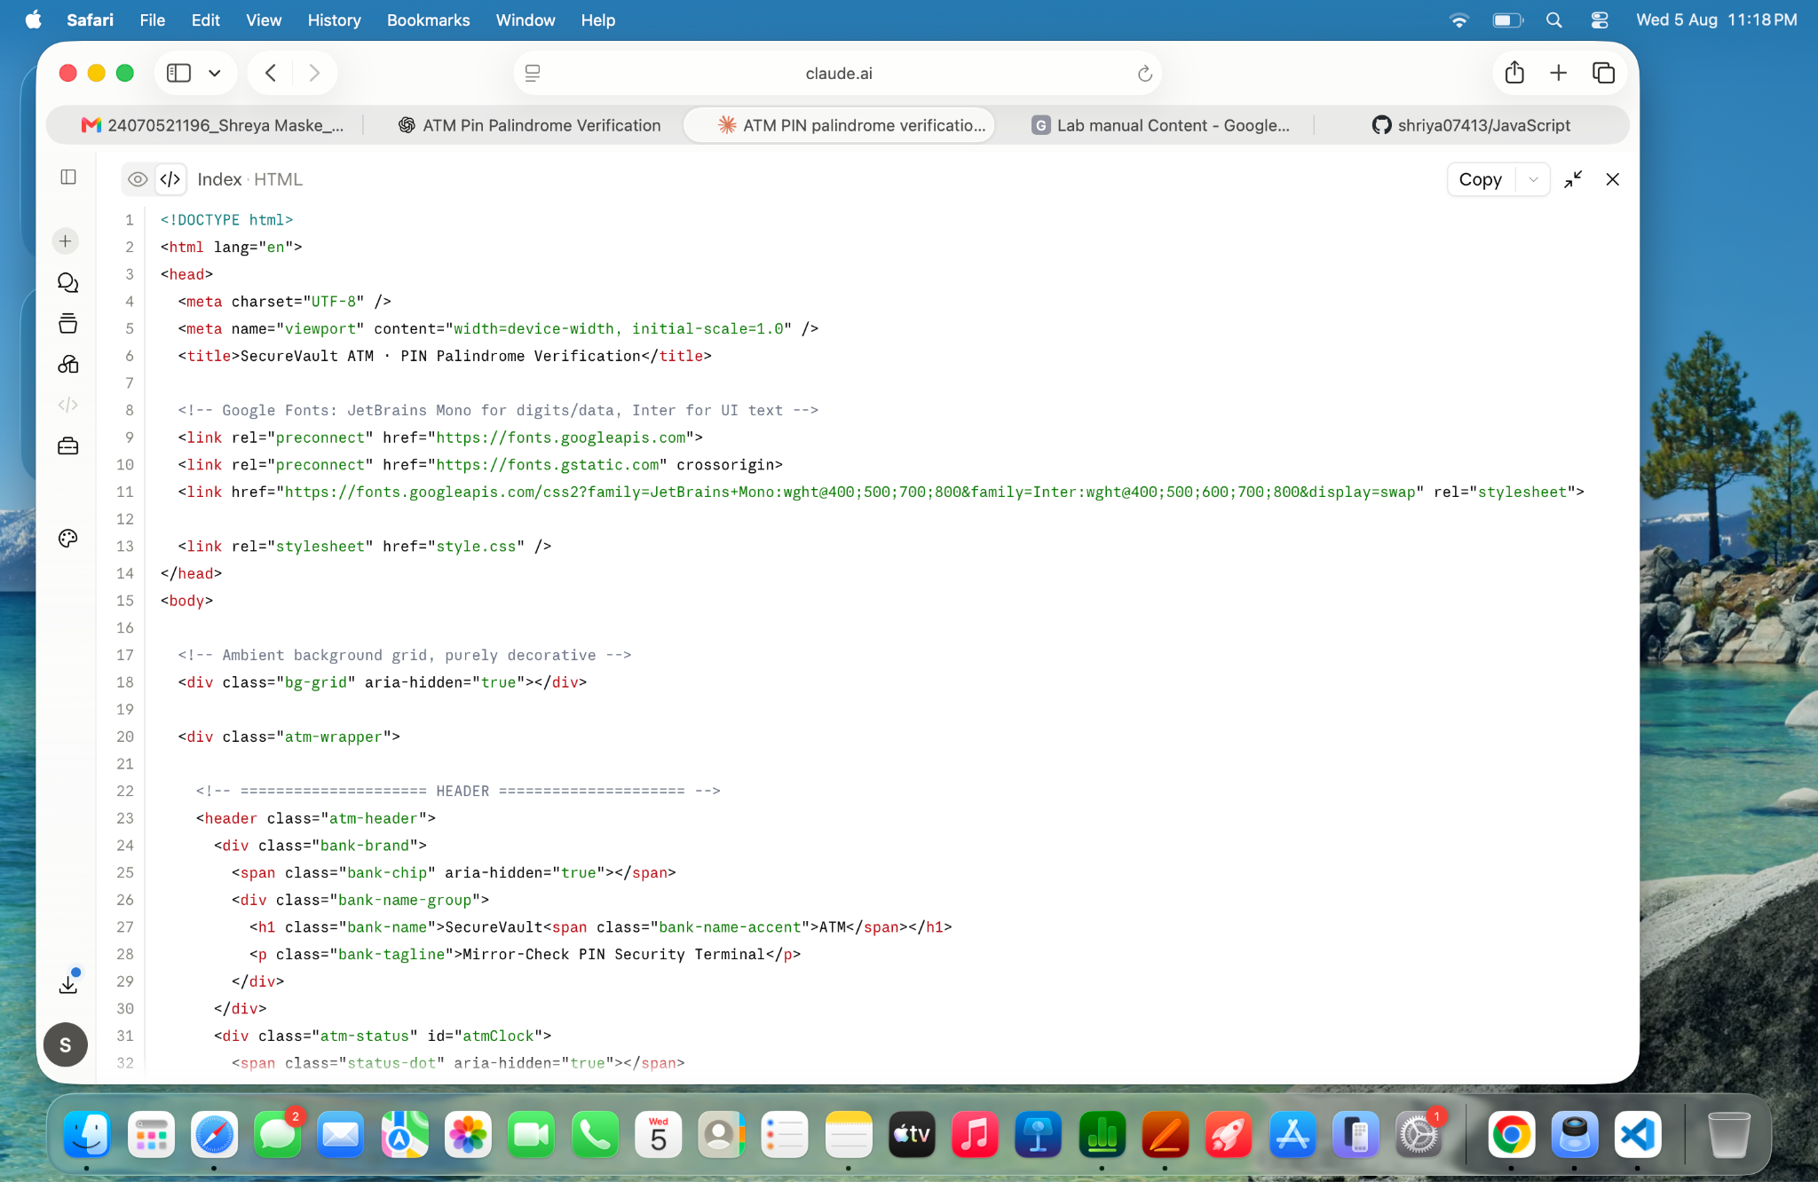
Style.css
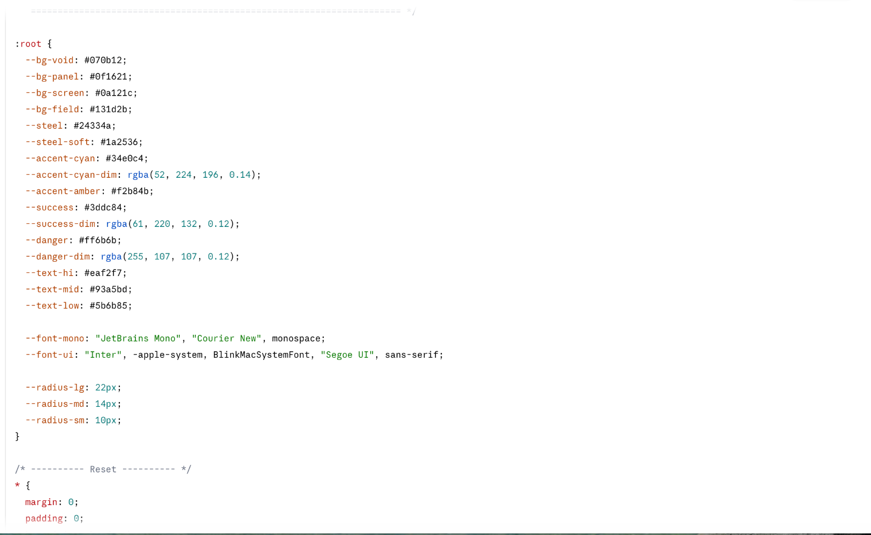
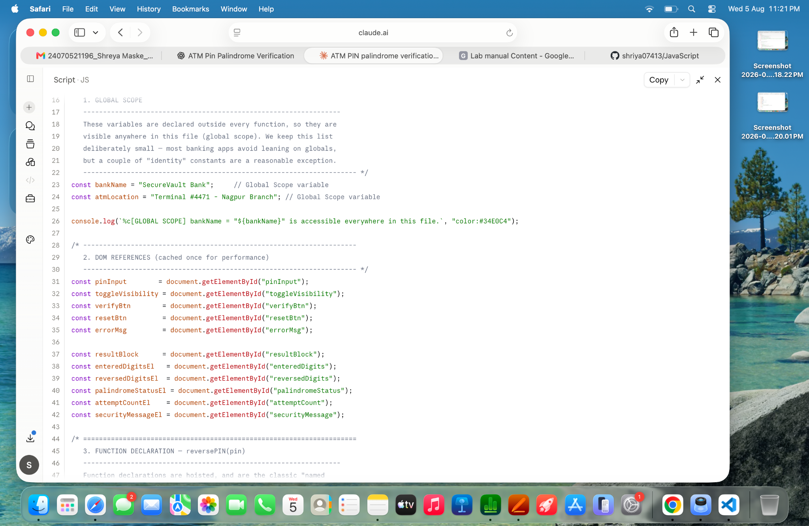

Output

