CASE STUDY-03

AIM:Scholarship Eligibility,A college awards scholarships based on
marks. Below 50-Not Eligible,
50-69-Bronze,70-84-Silver,85-94-Gold,95-100-Platinum.
Write a JavaScript program that accepts student marks and display the
Scholarship category.

CODE index.html :
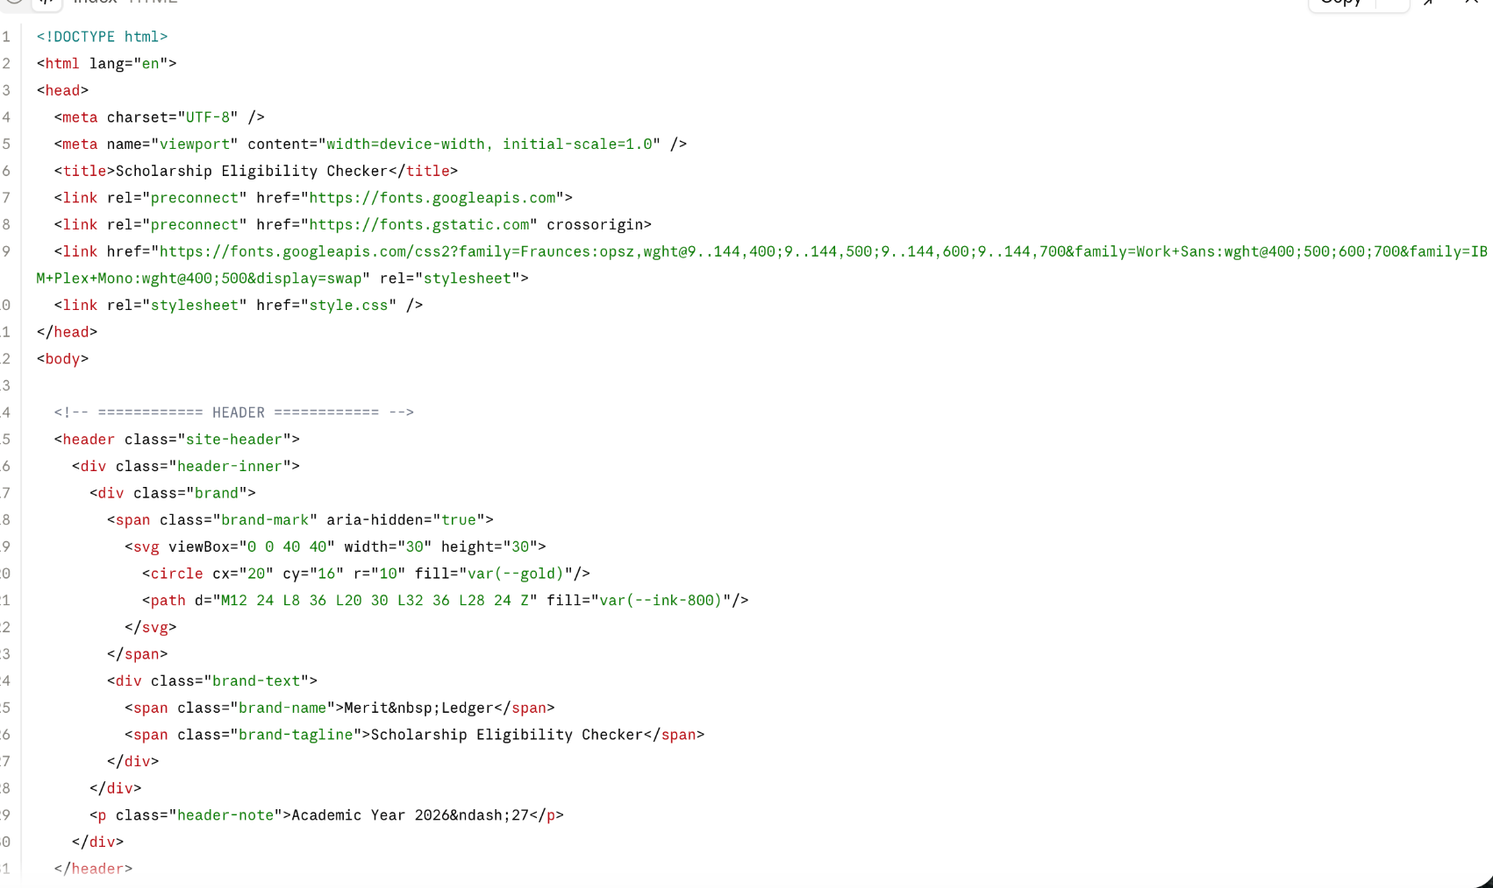
Style.css
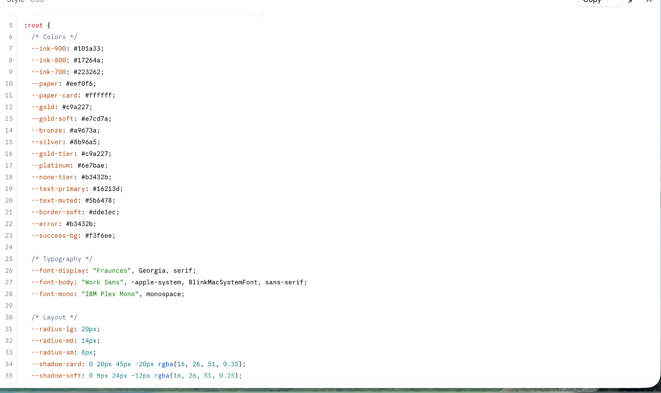
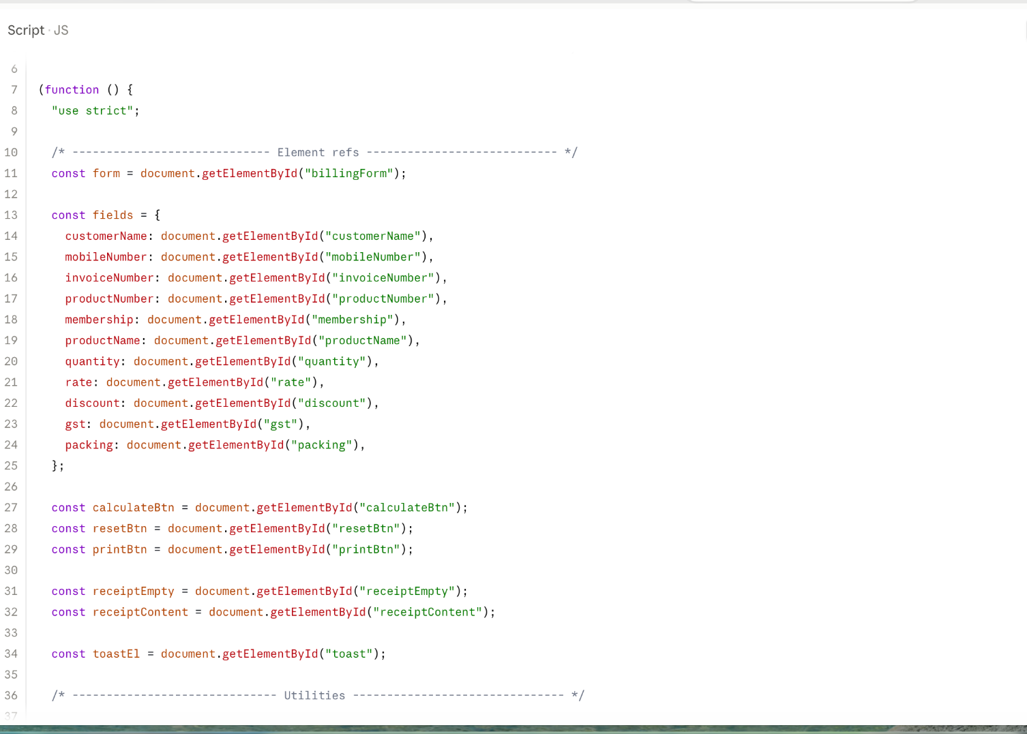

Output
