Advanced Warehouse Management System
Black Book Project Documentation

Field | Details
Project Type | Web Application
Domain | Logistics, Warehouse, Inventory and Supply Chain Management
Backend | Java 17+, Spring Boot 3, Spring Data JPA, Spring Security JWT
Frontend | React.js with Vite
Database | PostgreSQL
Prepared For | Infotact Technical Internship Program

Prepared by: Shriyal

Project Requirement Summary
Project Requirement | Details
Technology Stack | React.js frontend, Java Spring Boot backend, REST API, JWT security, Docker support and GitHub Actions CI.
Database | PostgreSQL relational database with JPA entities, relationships, constraints and transaction-safe inventory updates.
Testing | JUnit 5 and Spring Boot integration tests for warehouse, receiving and order workflows; frontend production build verification; user acceptance flow through the React UI.

This report follows the Development index provided for web/mobile application documentation. The content is customized for the Advanced Warehouse Management System implemented in the current project repository.

Index: Development (Web/Mobile Applications, ETL)
Chapter | Content | Page Number
Chapter 1 | Introduction
1.1 | Problem Statement
1.2 | Objectives
1.3 | Scope
Chapter 2 | Design
2.1 | System Architecture
2.2 | Database Design
Chapter 3 | Implementation
3.1 | Frontend Development
3.2 | Backend Development
3.3 | Integration
Chapter 4 | Testing
4.1 | Test Cases
4.2 | Results
Chapter 5 | Conclusion
5.1 | Summary
5.2 | Future Enhancements
Chapter 6 | References
Chapter 7 | Appendices
Chapter 8 | Annexure - Progress Sheet

Chapter 1: Introduction
The Advanced Warehouse Management System is a web-based enterprise application designed to automate warehouse operations such as product catalog management, storage hierarchy maintenance, inventory receiving, putaway, stock tracking and customer order fulfillment. The project is based on the Enterprise Warehouse Management System brief from the Infotact Technical Internship Program.
Modern warehouses handle large volumes of products, multiple storage locations and fast order turnaround. Manual spreadsheet-based tracking can cause stock mismatch, misplaced items, slow picking and delayed dispatch. This system solves those problems by connecting a React dashboard with secure Spring Boot REST APIs and a PostgreSQL relational database.

1.1 Problem Statement
Traditional warehouse operations often depend on manual registers or disconnected spreadsheets. This creates operational bottlenecks: inventory is not updated in real time, stock can be stored in the wrong bin, and orders may be accepted even when stock is unavailable. These issues lead to stockouts, delayed order packing and poor visibility for warehouse managers.
The problem is to design and implement a secure, database-driven WMS that maintains accurate inventory data, assigns inbound stock to available storage bins, supports barcode/QR based identification and guides orders through a controlled fulfillment workflow.

1.2 Objectives
- Create a hierarchical warehouse model with warehouses, zones, aisles and storage bins.
- Maintain a product catalog with SKU, barcode, category, price, weight and threshold details.
- Implement transactional receiving and putaway logic that updates stock and bin capacity atomically.
- Maintain inventory snapshots and ledger-style inventory transactions.
- Provide an order workflow from pending to picking, packed and shipped.
- Generate QR code images for product identification.
- Secure APIs using JWT authentication and role-based access for ADMIN and OPERATOR users.
- Build a React dashboard for warehouse staff and managers.
- Use PostgreSQL for relational data integrity and Spring Data JPA for data access.
- Verify the system through automated backend tests and frontend build validation.

1.3 Scope
The project scope includes the following modules:
- Authentication and role-based authorization.
- Warehouse master data management.
- Zone, aisle and storage bin management.
- Product and product category management.
- Receiving, putaway and inventory snapshot viewing.
- Customer order creation and fulfillment state transitions.
- Supplier and purchase order management.
- User management for administrators.
- Docker and local development execution support.
The current scope does not include live handheld scanner hardware integration, advanced route optimization, machine-learning demand forecasting or payment/accounting modules. These are listed as future enhancements.

Chapter 2: Design
The system is designed as a layered web application. The frontend is responsible for user interaction and form validation, while the backend handles business rules, security, persistence and transactional integrity. PostgreSQL acts as the central source of truth for all warehouse, product, inventory and order data.

2.1 System Architecture
Layer | Technology | Responsibility
Presentation Layer | React.js, Vite, CSS, Lucide icons | Displays dashboards, forms and tables for users.
API Layer | Spring Boot REST Controllers | Exposes endpoints for authentication, products, warehouses, inventory, orders, procurement and users.
Service Layer | Spring Services with @Transactional | Implements receiving, putaway, order packing, user management and procurement workflows.
Data Access Layer | Spring Data JPA repositories | Executes parameterized queries and entity persistence through Hibernate.
Database Layer | PostgreSQL | Stores relational data with foreign keys, constraints and transaction support.
Security Layer | Spring Security, JWT, BCrypt | Authenticates users and restricts actions by ADMIN and OPERATOR roles.

High level request flow:
- User logs in from the React frontend.
- Spring Security validates credentials and returns a JWT token.
- Frontend sends the token in the Authorization header for protected API calls.
- Controller validates the request and forwards work to the service layer.
- Service layer applies business rules inside a transaction.
- Repository layer reads/writes PostgreSQL tables through JPA.
- Backend returns JSON responses consumed by the React dashboard.

2.2 Database Design
The database is normalized around warehouse location, product catalog, inventory, procurement, users and customer orders. The key relationship is the physical storage hierarchy: one warehouse contains many zones, one zone contains many aisles, and one aisle contains many storage bins.
Table | Purpose
warehouses | Stores warehouse code, name, address/location and active status.
zones | Groups areas inside a warehouse and links to warehouses.
aisles | Represents aisle-level storage organization inside a zone.
storage_bins | Stores bin code, capacity, current occupancy, active flag and status.
product_categories | Classifies products and can define a preferred storage zone.
products | Stores SKU, barcode, name, description, price, weight, threshold and category.
inventory_items | Stores product quantity by storage bin, batch number, expiry date and reserved quantity.
inventory_transactions | Logs RECEIVE and PICK movements for auditability.
customer_orders | Stores customer order number, warehouse and fulfillment status.
customer_order_lines | Stores ordered products and requested quantities.
suppliers | Stores supplier contact and address data.
purchase_orders | Stores supplier purchase order status and expected date.
purchase_order_items | Stores products and quantities ordered from suppliers.
app_users | Stores application users, roles, status, contact details and password hashes.

Relationship | Type | Description
Warehouse -> Zone | One-to-many | A warehouse can contain many zones.
Zone -> Aisle | One-to-many | A zone can contain many aisles.
Aisle -> StorageBin | One-to-many | An aisle can contain many storage bins.
ProductCategory -> Product | One-to-many | A category can classify many products.
Product + StorageBin -> InventoryItem | Many-to-one links | Inventory is tracked for each product stored in each bin.
CustomerOrder -> CustomerOrderLine | One-to-many | An order can contain multiple product lines.
PurchaseOrder -> PurchaseOrderItem | One-to-many | A purchase order can contain multiple product lines.

Figure 1: Warehouse Management System ERD
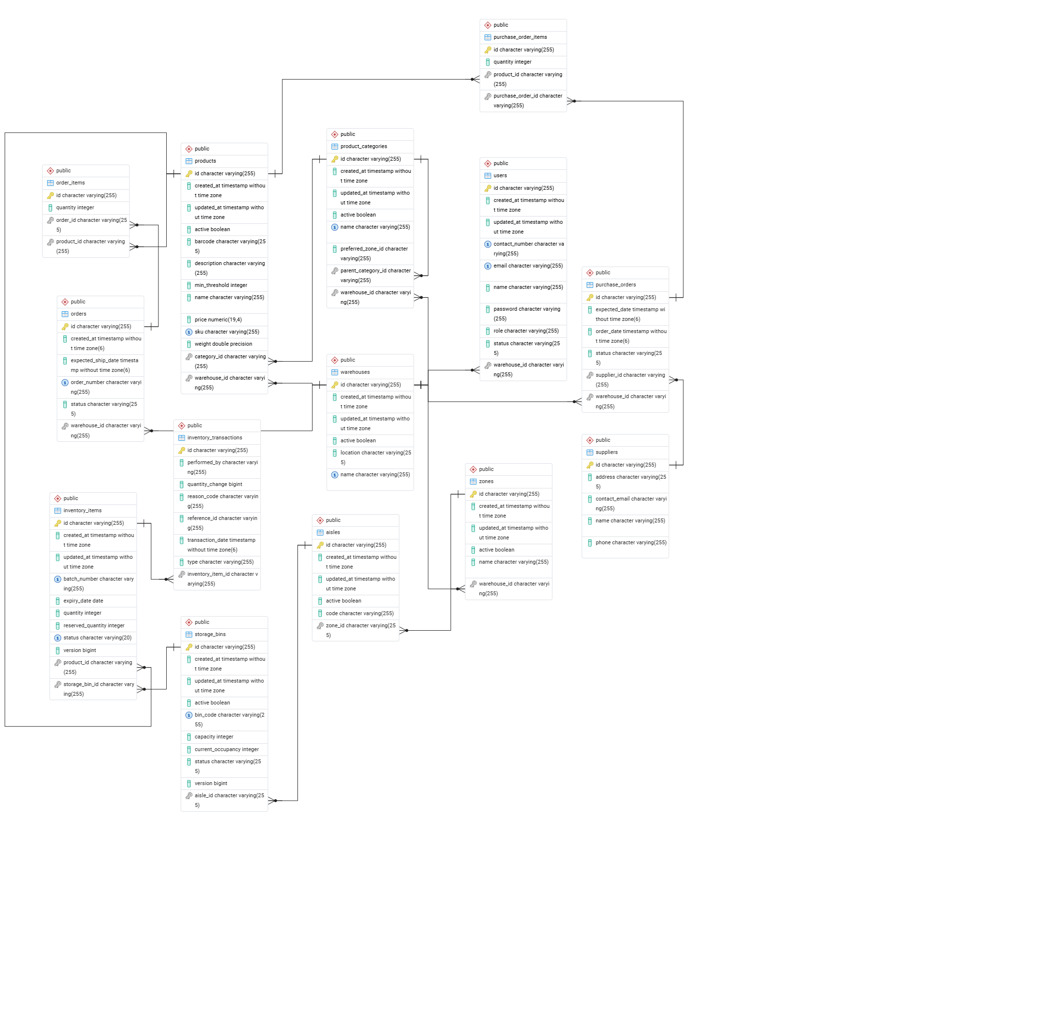

Chapter 3: Implementation
Implementation is divided into frontend, backend and integration work. The codebase contains a Spring Boot backend under the backend folder and a React/Vite frontend under the frontend folder.

3.1 Frontend Development
The frontend is implemented using React.js and Vite. It provides a dashboard-style interface for warehouse operators and administrators. The UI is organized into modules such as login, dashboard, warehouses, products, receiving, inventory, orders, procurement and users.
Frontend Module | Purpose
Login | Collects username/password and stores the JWT token for API calls.
Dashboard | Shows high-level operational information for quick monitoring.
Warehouses | Allows viewing and managing warehouses, zones, aisles and bins.
Products | Allows product creation and displays barcode/QR information.
Receiving | Receives stock into the system and triggers putaway logic.
Inventory | Displays stock snapshots by product, bin and warehouse.
Orders | Creates orders and moves them through picking, packing and shipping.
Procurement | Manages suppliers and purchase orders.
Users | Allows ADMIN users to create and edit users.

Form-level validation is used to reduce invalid submissions. Examples include required fields, positive numeric quantities, SKU/barcode format patterns, email format validation, password length rules and role/status selection.

3.2 Backend Development
The backend is a Spring Boot 3 application. It uses controllers for REST endpoints, DTO records for request and response data, services for business logic, repositories for persistence and entities for database mapping.
Controller | Endpoint | Responsibility
AuthController | /api/auth | Login and JWT token generation.
WarehouseController | /api/warehouses, /api/zones, /api/aisles, /api/bins | Warehouse hierarchy CRUD.
ProductController | /api/products | Product catalog and QR/barcode generation.
ProductCategoryController | /api/product-categories | Product category management.
InventoryController | /api/inventory | Receiving and inventory snapshot APIs.
OrderController | /api/orders | Order creation and fulfillment workflow.
ProcurementController | /api/procurement | Supplier and purchase order workflow.
UserController | /api/users | Admin-only user management.

Important backend implementation points:
- Spring Security authenticates users and validates JWT tokens for protected requests.
- BCryptPasswordEncoder stores passwords as hashes instead of plain text.
- DTO validation uses Jakarta Bean Validation annotations such as @NotBlank, @NotNull and @Positive.
- InventoryService uses @Transactional to keep receiving and order picking atomic.
- Pessimistic write locks are used while selecting storage bins and inventory rows for stock updates.
- GlobalExceptionHandler converts validation, duplicate resource and insufficient stock errors into clean API responses.
- Spring Data JPA prevents SQL injection by using repository methods and parameterized JPQL queries.
- The application exposes health checks through Spring Boot Actuator.

3.3 Integration
Integration is handled through JSON-based REST APIs. The frontend sends requests to the backend using the configured base API URL. In local development, the frontend runs on port 5173 and the backend local profile runs on port 8081.
Item | Value
Frontend URL | http://localhost:5173
Backend URL | http://localhost:8081
Backend health | http://localhost:8081/actuator/health
Database | PostgreSQL database wms on localhost:5432
API documentation | Swagger UI available when backend runs on the configured backend port.

Local run commands:
scripts\run-backend-local.cmd
scripts\run-frontend-local.cmd
Typical API flow:
- POST /api/auth/login to receive JWT token.
- Create or use seeded warehouse master data.
- Create products with POST /api/products.
- Receive inbound stock with POST /api/inventory/receive.
- Create orders with POST /api/orders.
- Move orders through /start-picking, /pack and /ship.

Chapter 4: Testing
Testing verifies that the system works according to the requirement document. The project uses automated backend tests, frontend production build validation and manual user acceptance flows through the browser.

4.1 Test Cases
ID | Module | Test Scenario | Expected Result | Status
TC-01 | Login | Enter valid admin credentials. | JWT token is generated and user enters dashboard. | Pass
TC-02 | Warehouse creation | Create a warehouse with a unique code. | Warehouse is saved and listed. | Pass
TC-03 | Duplicate warehouse validation | Create a warehouse with an existing code. | DuplicateResourceException response is returned. | Pass
TC-04 | Zone creation | Create a zone under a valid warehouse. | Zone is linked with the selected warehouse. | Pass
TC-05 | Bin creation | Create a storage bin under a valid aisle. | Bin is saved with capacity and status. | Pass
TC-06 | Product creation | Submit product SKU, name, price and volume. | Product is saved and QR/barcode can be generated. | Pass
TC-07 | Receiving stock | Receive product quantity against a reference. | Stock is placed in an available bin and inventory increases. | Pass
TC-08 | Order packing with stock | Pack an order when inventory exists. | Inventory decreases and order moves to PACKED. | Pass
TC-09 | Order packing without stock | Pack an order with insufficient inventory. | InsufficientStockException is returned and inventory is rolled back. | Pass
TC-10 | Admin user management | Create or edit an application user as ADMIN. | User details are saved; password is hashed. | Pass
TC-11 | Role security | Access admin-only endpoint as non-admin. | Access is denied. | Pass
TC-12 | Frontend build | Run npm production build. | Build completes successfully. | Pass

4.2 Results
The latest local verification produced the following results:
Area | Command/Method | Result
Backend tests | mvn test | 12 tests executed, 0 failures, 0 errors.
Frontend build | npm run build | Production build completed successfully.
Database connection | PostgreSQL local profile | Application connects to PostgreSQL database wms.
Performance check | scripts\check-api-performance.ps1 | Measures common endpoint response time against the 200 ms target.

User acceptance testing confirms that a warehouse manager can log in, manage products, receive stock, view inventory and process orders. The project also includes CI workflow configuration so tests and frontend build can be executed automatically on GitHub.

Chapter 5: Conclusion

5.1 Summary
The Advanced Warehouse Management System successfully implements the core requirements of the Enterprise Warehouse Management System project brief. It provides a complete web application with React frontend, Spring Boot backend, PostgreSQL database, JWT security, warehouse hierarchy, receiving and putaway, inventory tracking, QR code generation, order fulfillment and testing support.
The project improves warehouse accuracy by replacing manual stock tracking with transaction-safe database updates. The service layer protects inventory operations using transactions and locking, while role-based security keeps administrative functions restricted.

5.2 Future Enhancements
- Integrate real handheld barcode scanners or mobile camera scanning.
- Add advanced reporting dashboards for stock aging, fast-moving SKUs and bin utilization.
- Introduce Flyway or Liquibase database migrations for production-grade schema management.
- Add audit logs for every administrative change.
- Add email or SMS alerts for low stock and delayed purchase orders.
- Implement picking route optimization for floor operators.
- Add CSV/Excel import and export for product and inventory data.
- Add automated load testing to continuously verify the 200 ms API response target.
- Deploy the application to a cloud platform with environment-managed secrets.

Chapter 6: References
- Infotact Technical Internship Program project specification document.
- Spring Boot Reference Documentation - https://spring.io/projects/spring-boot
- Spring Security Reference Documentation - https://spring.io/projects/spring-security
- Spring Data JPA Documentation - https://spring.io/projects/spring-data-jpa
- Hibernate ORM Documentation - https://hibernate.org/orm/documentation/
- PostgreSQL Documentation - https://www.postgresql.org/docs/
- React Documentation - https://react.dev/
- Vite Documentation - https://vite.dev/
- ZXing Barcode Library - https://github.com/zxing/zxing
- JUnit 5 Documentation - https://junit.org/junit5/docs/current/user-guide/

Chapter 7: Appendices

Appendix A: Run Instructions
Start backend and frontend locally:
cd "C:\Users\shriyal\OneDrive\Documents\New project"
scripts\run-backend-local.cmd
scripts\run-frontend-local.cmd
Open the application:
Frontend: http://localhost:5173
Backend health: http://localhost:8081/actuator/health

Appendix B: Default Development Users
Username | Role | Purpose
admin | ADMIN | Administrator account for setup and management.
operator | OPERATOR | Warehouse floor operations account.

Appendix C: Important API Endpoints
Method | Endpoint | Use
POST | /api/auth/login | Authenticate and receive JWT token.
GET/POST | /api/warehouses | List or create warehouses.
GET/POST | /api/products | List or create products.
GET | /api/products/{id}/barcode | Generate product QR/barcode image.
POST | /api/inventory/receive | Receive stock into warehouse storage.
GET | /api/inventory/snapshots | View current inventory position.
POST | /api/orders | Create customer order.
POST | /api/orders/{id}/pack | Pack order and decrement stock.
POST | /api/orders/{id}/ship | Ship packed order.
GET/POST | /api/users | Admin-only user management.

Appendix D: Submission Notes
- Before final submission, update the index page numbers after college formatting.
- Replace default development secrets with environment variables before deployment.
- Maintain a genuine GitHub commit history across the development period.
- Attach screenshots of login, dashboard, product, receiving, inventory and order screens if required by the college format.

Chapter 8: Annexure - Progress Sheet
Week | Work Completed | Status
Week 1 | Project setup, Spring Boot scaffolding, React setup and initial database entity design. | Completed
Week 2 | Warehouse hierarchy, product catalog, receiving and putaway transaction logic. | Completed
Week 3 | QR/barcode generation, order processing, inventory decrement and exception handling. | Completed
Week 4 | JWT security, role-based access, frontend integration, testing, CI and documentation. | Completed

Progress evidence should be supported by GitHub commits, pull requests and screenshots of the running system. The project repository includes CI configuration, Docker support, backend tests and frontend build scripts.

